ELEV-8 V2 Quadcopter Assembly Guide
Congratulations and thank you for purchasing a Parallax ELEV-8 Quadcopter, designed and manufactured in California, USA. We at Parallax pride ourselves on producing high-quality products with industry-leading documentation and support. If you require assistance, please do not hesitate to e-mail or call us [1].
These instructions are for assembling the Parallax ELEV-8 Quadcopter Version 2 (#80200) in its most standard configuration. The ELEV-8 platform is designed for creative experimentation and adaptation; however, we recommend that you try the standard configuration first, and then experiment at your own educated risk.
Warning! Do not use any assembly instructions or guides other than those provided by Parallax Inc. for your exact part number. Doing so may result in hardware failure and/or personal injury. Also note that there are small but extremely important differences between Version 1 (#80000) and Version 2 (#80200) of the ELEV-8; do not use this web guide for assembling Version 1.
This guide consists of thirty-nine discrete assembly steps, organized into nine sections. The introduction page of each section will explain what will be done in the steps within and why, and list all of the tools and parts you will need for that particular section. If you prefer to work from a printed version of these instructions, scroll to the bottom right-hand corner of this page and click on the "Printer-Friendly Version" link (it may take several minutes for the page to load).
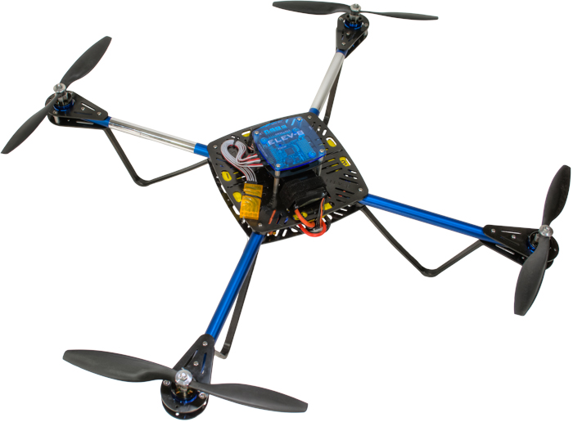

Preparation
- Read the important Safety Information sheet included with your kit. Building a Quadcopter is a rewarding but potentially dangerous undertaking, so it is critical that you have an understanding of the risks involved to maximize enjoyment and minimize danger. Please always wear eye protection when assembling, soldering, or operating your ELEV-8.
- Carefully cross-check the contents of you kit with the enclosed Bill of Materials (BOM). If you are missing any components, e-mail [2] or call our sales department (888-512-1024). (Note that some items are small sub-kits with parts not listed separately. Parts and quantities subject to change without notice.)
- Read the entire assembly instructions before beginning. Assembly and testing takes 6 –12 hours, depending on skill level, equipment, and work space. If you do not have prior experience soldering, we recommend you take some time to learn and practice before beginning this project.
- Gather your kit and all of the additional items and tools required in a well-lit and comfortable work area.
- After educating yourself on the safe and proper use of Lithium-Polymer (LiPo) batteries, charge your LiPo battery.
Please do not rush through the assembly and testing process. If you go slowly, and exactly follow these instructions, you should experience few or no issues with your ELEV-8. But if you accidentally overlook any part of these steps, you may end up with a dysfunctional quadcopter that could require considerable troubleshooting before it can fly. It never hurts to double-check your work at each step!

Additional Items Required
- Radio Control Transmitter and Receiver; 5-channel minimum required for flight. We recommend (and will provide instruction for) the Spektrum DX6i transmitter and matching Spektrum AR610 receiver (or OrangeRX R615); this setup will accommodate simple projects requiring one extra servo. If you anticipate building more sophisticated projects, such as controlled camera gimbals, we recommend the Spektrum DX8 and matching Spektrum AR8000 receiver (or OrangeRC R800X) and Spektrum TM1000 telemetry transmitter. While this equipment is somewhat expensive, it is high-quality and will accommodate both your current and future needs.
- Lithium Polymer (LiPo) battery with 3000 to 4400 mAh capacity and minimum 20C discharge rate, such as Parallax product #752-00010.
- “LiPo Balance Charger” (packaging should have those exact words), such as Parallax product #752-00009. Using a charger not designed for LiPo batteries will cause the battery to flame and release toxic smoke.
- A LiPo Low-Voltage Alarm. These will alert you with a very loud buzzer when your battery voltage gets low, significantly reducing the risk of damaging your battery or crashing your ELEV-8.
We recommend you acquire the ELEV-8 Crash Pack (#80080). Crashes are an inevitable part of the learning process, and having to wait around for replacement parts is always a bummer.

Tools Required
- Safety Eyewear (#700-10003)
- Wire Strippers/Cutters (12-16 AWG) [3]
- Ruler or Measuring Tape [4]
- Soldering Iron [5] (We recommend the Parallax Basic Soldering Kit, #700-10011)
- Rosin-Core Solder [6], see note in Section 1 (Also in the Parallax Basic Soldering Kit)
- Work-Holding Vise [7] (Also in the Parallax Basic Soldering Kit)
- Metal or Wood Block with 5/32” (4 mm) hole [8] (optional)
- Electrical Tape [9] or Heat-Shrink Tubing
- Heat Gun [10], Hair Dryer, or Soldering Iron
- Small Flat-Head Screwdriver [11]
- #1 Philips Head Screwdriver [12]
- Pencil [13]
- Permanent Marker [14]
- Scissors [15]
- 1/4” Wrench, 1/4" Socket, or Adjustable Wrench [16]
- Diagonal Cutters ("Dikes") [17]
- Sharp Knife, Razor Blade, or Sandpaper [18] (between 80 and 200 grit)
- 5/16" Wrench, 5/16" Socket, or Adjustable Wrench [19]
- Flat-Nose Pliers [20]
Loctite and 242 are trademarks or registered trademarks of Henkel Corporation, U.S.A. Spektrum is a trademark or registered trademark of Horizon Hobby, Inc. and Bachmann Industries, Inc. Hoverfly is a registered trademark of Hoverfly Technologies, Inc. Futaba is a registered trademark of Futaba Denshi Kogyo Kabushiki Kaisha Corporation of Japan. Hitec is a trademark or registered trademark of Hitec RCD USA, Inc.

Section 1: Soldering the Connections
All steps in Section 1 will focus on the ELEV-8 V2 electrical connections. All of the high-voltage connections between components will be made using gold-plated bullet connectors (“male” and “female” on the left and right of the below image, respectively), which must be soldered onto the wires and covered with heat-shrink tubing. This will ensure a reliable connection while providing flexibility to change motor polarity and replace or upgrade components as desired.
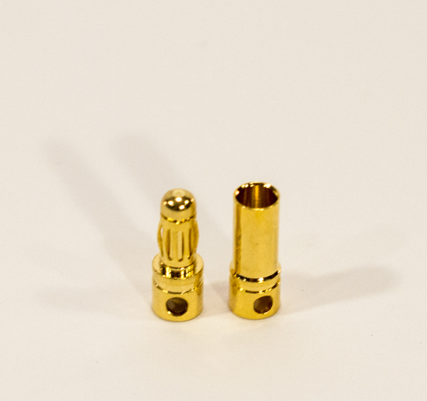
You will have to make an educated decision on whether to use leaded vs. lead-free solder. Traditionally, solder was composed mostly of tin and lead. As it has become known that lead is a toxin harmful to humans (only if ingested, in any form), lead-free solder has risen in popularity. Many people still prefer to use leaded solder for its superior ability to create strong solder joints, while others prioritize safety over performance and choose lead-free. There is an abundance of material available on the subject, and we suggest you conduct your own research and make your own choice.
These six steps will take approximately 2 to 6 hours, depending on your skill level and equipment.

Tools Needed in this Section
- Wire Strippers/Cutters (12-16 AWG)
- Ruler or Measuring Tape
- Soldering Iron
- Rosin-Core Solder
- Work-Holding Vise
- Metal or Wood Block with 5/32” (4 mm) hole (optional)

Parts Needed in this Section
- 1 – 16 AWG Silicone Wire, Blue (#750-00061)
- 4 – 1050 kV Brushless Motor and Accessories (#750-90008)
- 20 – 3.5 mm “Male” Bullet Connector (#450-00050)
- 24 – 3.5 mm “Female” Bullet Connector (#450-00050)
- 4 – 30A Electronic Speed Controller (ESC) (#750-90009)
- 1 – EC3 "Male"/Female" Connector Pair (#452-00088)
- 1 – LiPo Battery (Not Included)
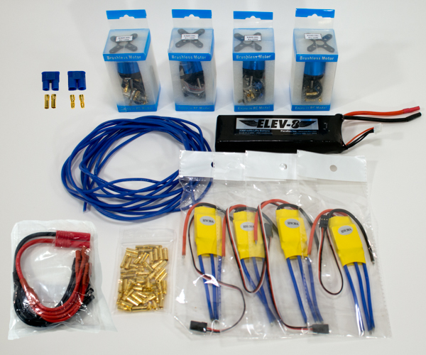

Step 1: Prepare Extension Wires
In this step, you will cut to length and strip the Extension Wires to be used to connect the Motors to the Electronic Speed Controllers.

Tools Needed
- Wire Strippers/Cutters (12-16 AWG)
- Ruler or Measuring Tape

Parts Needed
- 15' – 16 AWG Silicone Wire, Blue (#750-00061)

Instructions
- Using the ruler or measuring tape and wire cutter, measure and cut 12 lengths of wire, each 12 inches (30.5 cm) long.
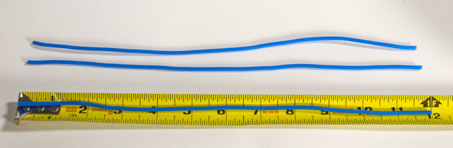
- Using the wire strippers, remove 1/8” (3 mm) of insulation from both ends to expose the metal wire.
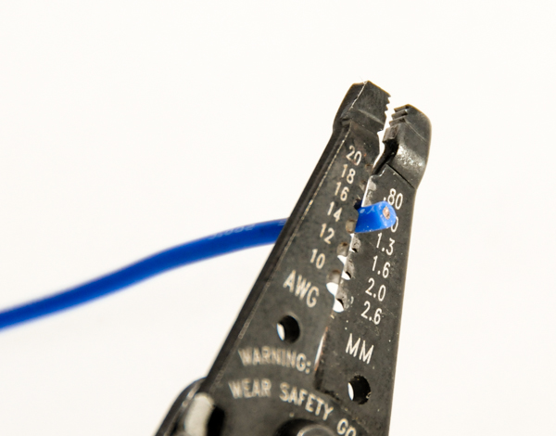
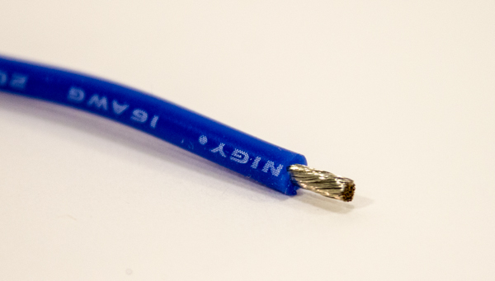
- Repeat for the 11 remaining wires.
At the end of this step, you should have some extra wire. You may want to cut a few short pieces from it and strip the ends. You can use it to practice soldering in the next step.

Step 2: Soldering Motor Bullet Connectors
Over the course of the remaining Section 1 steps, you will solder all of the electrical connections for the ELEV-8. Here, you will be soldering “male” bullet connectors to the Motors’ wire leads.
Warning!
Risk of severe burns. Soldering iron tips become extremely hot when used. NEVER touch the iron tip.
Risk of lung irritation. Avoid direct inhalation of solder fumes; always solder in a well-ventilated area.
Regardless of your choice of solder, do not eat or drink in your work area, and wash your hands thoroughly after soldering.

Tools Needed
- Soldering Iron
- Rosin-Core Solder
- Work-Holding Vise
- Metal or Wood Block with 5/32” (4 mm) hole (optional)

Parts Needed
- 4 – 1050 kV Brushless Motor (# 750-90008)
- 12 – 3.5 mm "Male" Bullet Connectors (# 450-00050)
When you remove the motors from their packaging, keep all of the included accessories. You will need to use the bullet connectors, heat-shrink tubing, and propeller adapters w/screws included with each motor in later steps.

Instructions
If you have never soldered bullet connectors before, use some extra wire mentioned in the note at the end of the previous step and a few bullet connectors to practice with (you have extra of both).
- Take the wire at the tip of each motor lead and twist it using your fingers to bring all of the individual wires together.
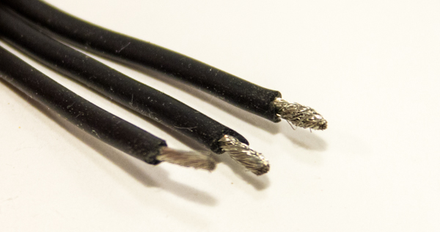
- Clamp one of the wires into the vise so that the exposed metal wire is pointing upwards.
- After cleaning the tip of the soldering iron, apply a small amount of solder to the tip to "tin" it (this will provide better heat conduction from the iron to the connection).
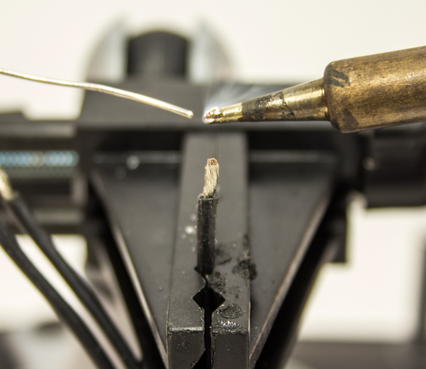
- Apply a small amount of solder to the tip of the wire. You want to see the wire "absorb" the solder and become covered in a thin layer of molten solder before removing the soldering iron. It may take some time (up to 30 seconds or more), but it should be clear when the solder suddenly starts to "flow" around the tip of the wire. Repeat this "tinning" process with every wire.
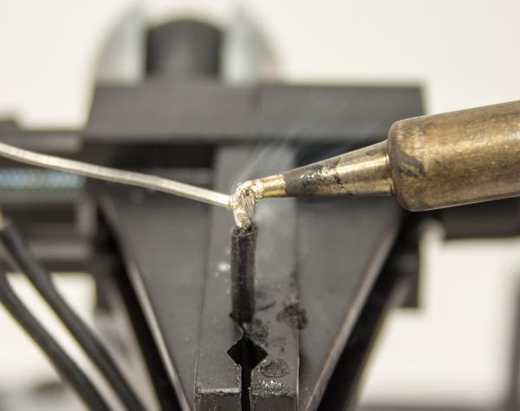
- Place a bullet connector into the vise, with the shallow “cup” end facing up. If you are using the block, clamp it into the vise and seat the bullet connector into the hole.
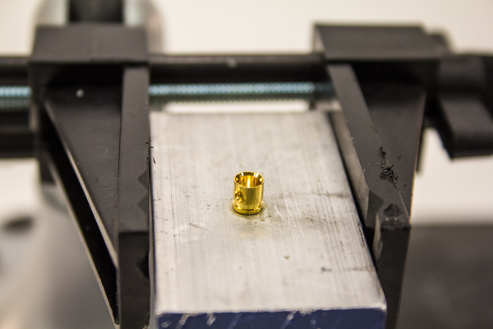
- Hold the soldering iron to the small hole on the side of the “cup” of the bullet connector, and apply solder slowly into the “cup” until it is half full. Put the solder down.
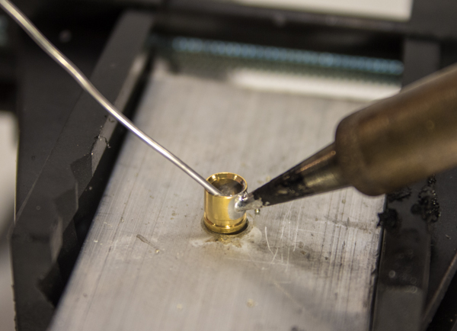
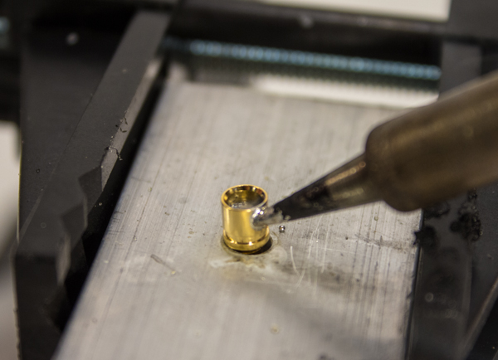
- Continuing to hold the soldering iron to the hole, slowly insert a Motor lead fully into the “cup” and continue to hold the soldering iron to the hole for approximately 15 seconds. This will help to prevent a "cold" solder joint (poor quality, where the solder has not properly fused to both surfaces).
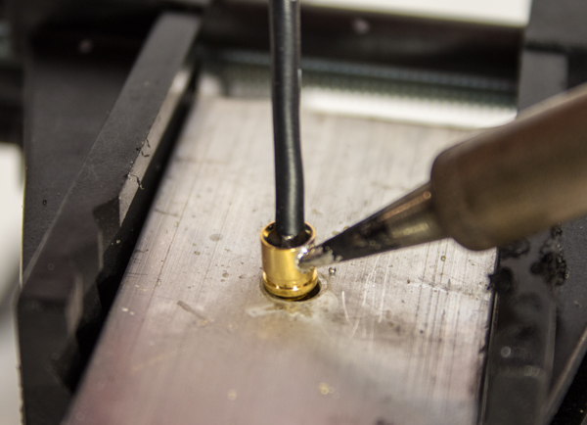
- Remove the soldering iron, but hold the motor lead until the solder has cooled and set, approximately 10 seconds. A good solder joint should appear as shown in the image below; you can always re-do a joint if you are not satisfied.
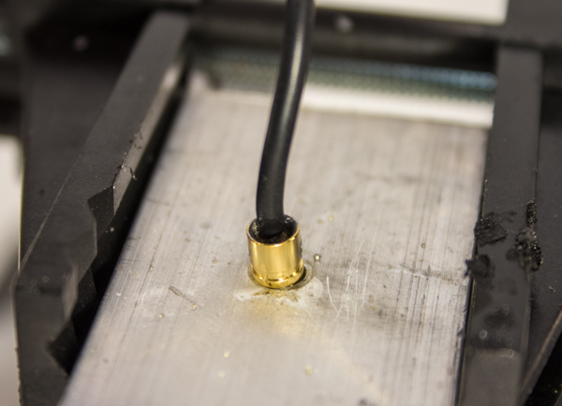
- Repeat this process to solder a "male" bullet connector to each of the three leads on each Motor, for a total of twelve connections.
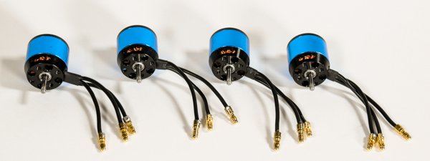

Step 3: Soldering Extension Wire Bullet Connectors
You’ll be using the same soldering techniques you learned in Step 2 to solder "male" and "female" bullet connectors to opposite ends of the extension wires.

Tools Needed
- Soldering Iron
- Rosin-Core Solder
- Work-Holding Vise
- Metal or Wood Block with 5/32” (4 mm) hole (optional)

Parts Needed
- 12 – Extension Wires, prepared in Step 2
- 12 – 3.5 mm "Male" Bullet Connectors (#450-00050)
- 12 – 3.5 mm "Female" Bullet Connectors (#450-00050)

Instructions
- Prepare the wires for soldering by twisting and tinning them. (same procedure as in Step 2)
  - Take the wire at the end of each wire and twist it using your fingers to bring all of the individual wires together.
  - Clamp one of the wires into the vise so that the exposed metal wire is pointing upwards.
  - After cleaning the tip of the soldering iron, apply a small amount of solder to the tip to "tin" it (this will provide better heat conduction from the iron to the connection).
  - Apply a small amount of solder to the tip of the wire. You want to see the wire "absorb" the solder and become covered in a thin layer of molten solder before removing the soldering iron. It may take some time (up to 30 seconds or more), but it should be clear when the solder suddenly starts to "flow" around the tip of the wire.
  - Repeat this process with every wire.
- Solder a "male" bullet connector to one end of each of the twelve extension wires (same procedure as in Step 2);
  - Place a bullet connector into the vise, with the shallow “cup” end facing up. If you are using the block, clamp it into the vise and seat the bullet connector into the hole.
  - Hold the soldering iron to the small hole on the side of the “cup” of the bullet connector, and apply solder slowly into the “cup” until it is half full. Put the solder down.
  - Continuing to hold the soldering iron to the hole, slowly insert the end of an extension wire fully into the “cup” and continue to hold the soldering iron to the hole for approximately 15 seconds. This will help to prevent a "cold" solder joint (poor quality, where the solder has not properly fused to both surfaces).
  - Remove the soldering iron, but hold the motor lead until the solder has cooled and set, approximately 10 seconds.
- Solder a "female" bullet connector to the other end of each of the twelve extension wires, using the same procedure.
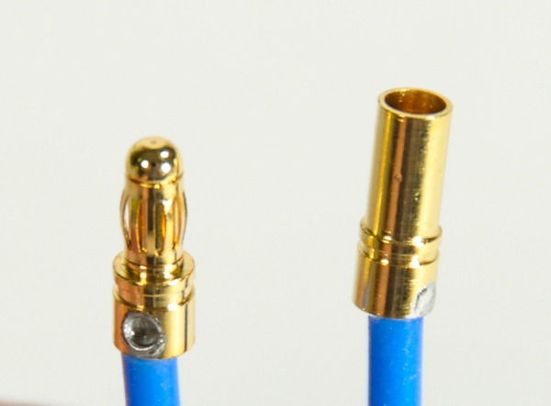
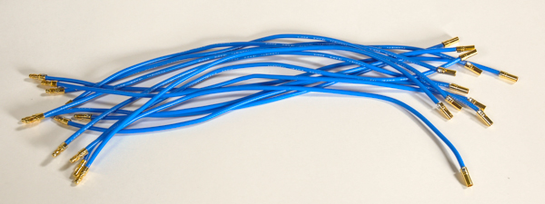

Step 4: Soldering ESC Bullet Connectors
In this step, you’ll again be using the same soldering techniques you learned in Step 2, but this time to solder "male" and "female" bullet connectors to opposite ends of the ESCs.

Tools Needed
- Soldering Iron
- Rosin-Core Solder
- Work-Holding Vise
- Metal or Wood Block with 5/32” (4 mm) hole (optional)

Parts Needed
- 4 – 30A Electronic Speed Controller (ESC) (#750-90009)
- 8 – 3.5 mm "Male" Bullet Connectors (#450-00050)
- 12 – 3.5 mm "Female" Bullet Connectors (#450-00050)

Instructions
- Prepare the wires for soldering by twisting and tinning them. (same procedure as in Step 2)
  - Take the wire at the end of each wire and twist it using your fingers to bring all of the individual wires together.
  - Clamp one of the wires into the vise so that the exposed metal wire is pointing upwards.
  - After cleaning the tip of the soldering iron, apply a small amount of solder to the tip to "tin" it (this will provide better heat conduction from the iron to the connection).
  - Apply a small amount of solder to the tip of the wire. You want to see the wire "absorb" the solder and become covered in a thin layer of molten solder before removing the soldering iron. It may take some time (up to 30 seconds or more), but it should be clear when the solder suddenly starts to "flow" around the tip of the wire.
  - Repeat this process with every wire.
- ​Solder "male" bullet connectors to the red and black input leads on each ESC (same procedure as in Step 2);
  - ​Place a bullet connector into the vise, with the shallow “cup” end facing up. If you are using the block, clamp it into the vise and seat the bullet connector into the hole.
  - Hold the soldering iron to the small hole on the side of the “cup” of the bullet connector, and apply solder slowly into the “cup” until it is half full. Put the solder down.
  - Continuing to hold the soldering iron to the hole, slowly insert the end of an input lead into the “cup” and continue to hold the soldering iron to the hole for approximately 15 seconds. This will help to prevent a "cold" solder joint (poor quality, where the solder has not properly fused to both surfaces).
  - Remove the soldering iron, but hold the motor lead until the solder has cooled and set, approximately 10 seconds.
​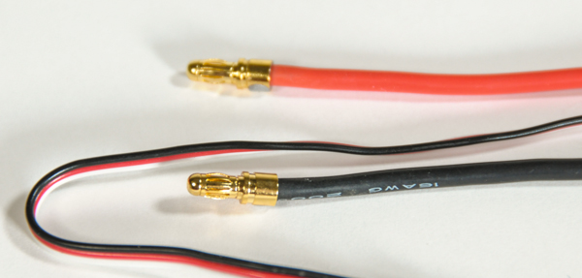
- Solder "female" bullet connectors to the to the blue output leads on each ESC, using the same procedure.
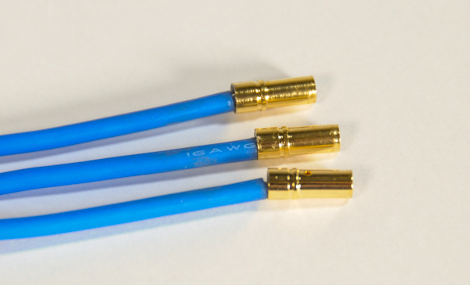
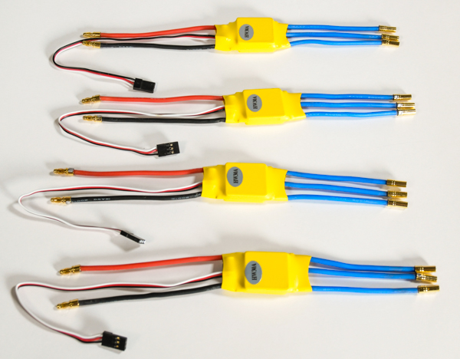

Step 5: Soldering Power Breakout EC3 Connector
The last of the soldering for ELEV-8 assembly is soldering EC3 connectors (image below) to the Power Breakout Cable (this Step) and battery leads (Step 6). This is one of the most difficult assembly steps, so we strongly suggest you take your time and do some research of your own (watch some videos on "soldering EC3 connectors", etc).
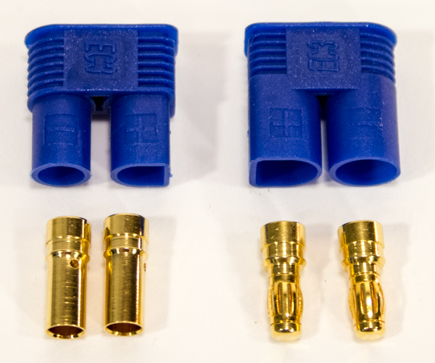
An EC3 Connector presents an issue when trying to identify the "gender" of each side of the connection. The housing at left in the above image is inserted into the housing on the right, so one would be inclined to call the left housing "male" and the right housing "female". However, the housing at left is for "female" contacts (bullet connectors) and the housing at right is for "male" contacts. Since the gender of a plug is defined by the gender of the contacts, the plug to the left is "female" and to the right is "male."

Tools Needed
- Wire Strippers/Cutters (12-16 AWG)
- Ruler or Measuring Tape
- Soldering Iron
- Rosin-Core Solder
- Work-Holding Vise
- Metal or Wood Block with 5/32” (4 mm) hole (optional)
- Small Flat-Head Screwdriver
- Flat-Nose Pliers

Parts Needed
- 1 - Power Breakout Cable (#800-00006)
- 1 – "Male"/"Female" EC3 pair w/cover and bullet connectors (not interchangeable with other bullet connectors) (#452-00088)

Instructions
- Carefully cut the HXT connector off of the Power Breakout Cable just behind the connector.
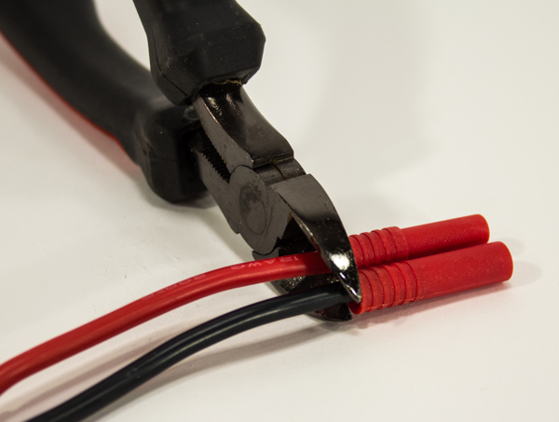
- Using the wire strippers, remove 1/8” (3 mm) of insulation from the end of the each lead.
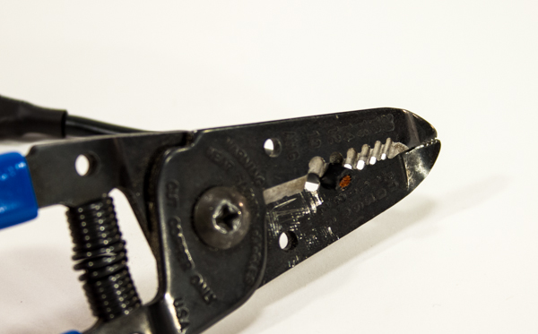
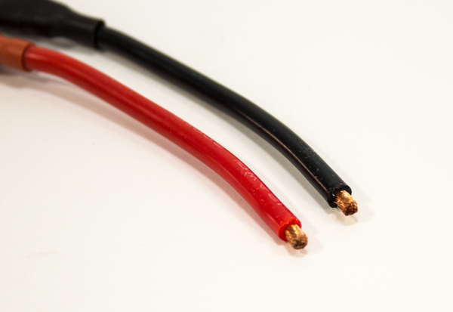
- For both leads of the power breakout cable, take the metal wire you just exposed and twist it using your fingers to bring all of the individual wire strands together.
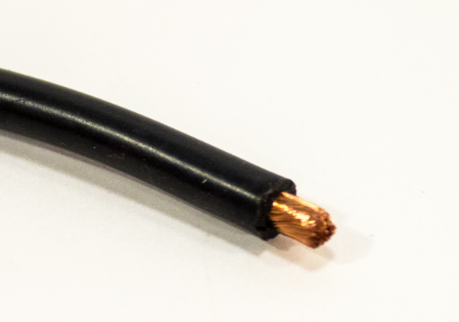
- Clamp one of the wires into the vise so that the exposed metal wire is pointing upwards.
- After cleaning the tip of the soldering iron, apply a small amount of solder to the tip to "tin" it.
- Apply a small amount of solder to the tip of the wire. You want to see the wire "absorb" the solder and become covered in a thin layer of molten solder before removing the soldering iron. It may take some time (up to 30 seconds or more), but it should be clear when the solder suddenly starts to "flow" around the tip of the wire. Repeat this "tinning" process with the other lead of the Power Breakout Cable.
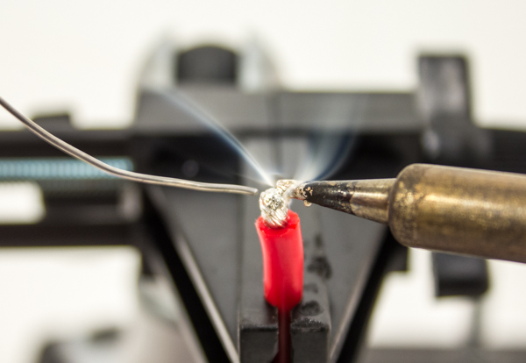
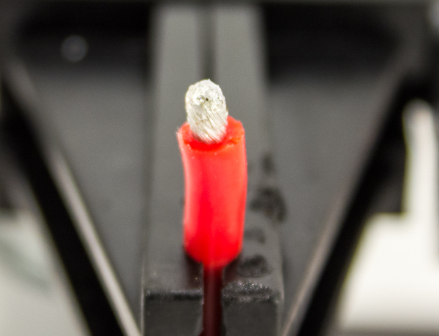
- Now take one of the "male" bullet connectors supplied with the EC3 connector and place it in your vise.
- After tinning the tip of the soldering iron, hold it on the rim of the bullet connector, and apply solder slowly into the “cup” until it is 1/3 full. Put the solder down. (try not to use too much solder in order to prevent excess solder from flowing to the outside of the bullet connector in the next instruction)
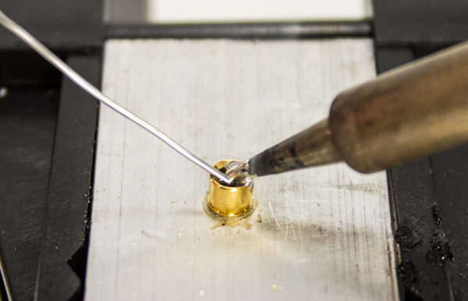
- Continuing to hold the soldering iron in place, bring one of the leads of the Power Breakout Cable to connector and slowly insert into the cup.
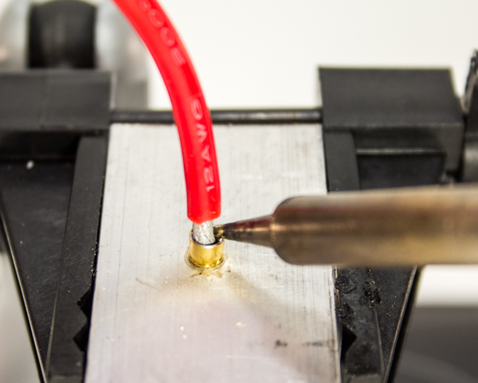
- Once fully inserted into the cup, continue to hold the soldering iron against the cup rim and wire for another 10 seconds. This will help to prevent what is known as a cold solder joint.
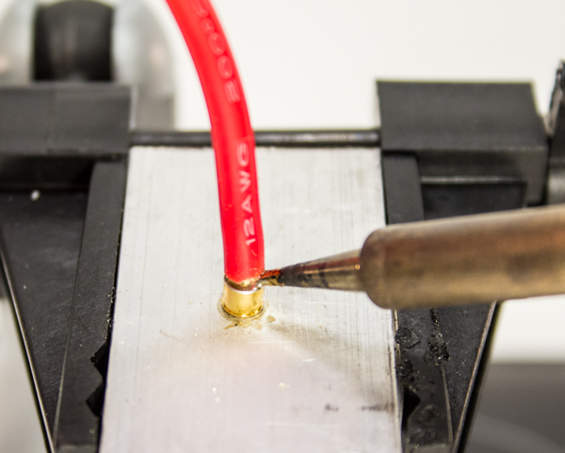
Be sure to keep excess solder from flowing onto the outside of the bullet connector. Excess solder on the outside of the bullet connector will make it difficult/impossible to install the bullet connector into the plastic connector housing. Use a sharp hobby knife (and extreme care) or a rotary tool with a grinding stone or cutting wheel to remove any excess solder from the outside of the bullet connector.
- Remove the soldering iron and continue to hold the wire until the solder hardens.
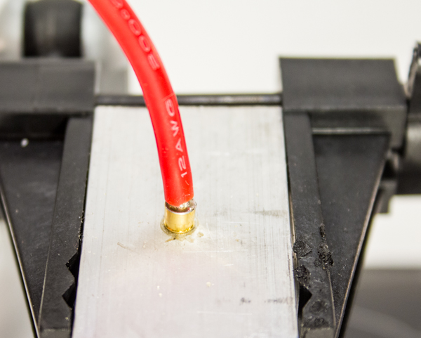
- While the bullet connector is still warm from the soldering process (do not directly touch it; it will burn you), insert it into the back of the plastic connector housing. The red (positive) lead goes into the back of "D" shaped hole in the larger ("female") of the two housings (there are +/- markings on the housings as well).
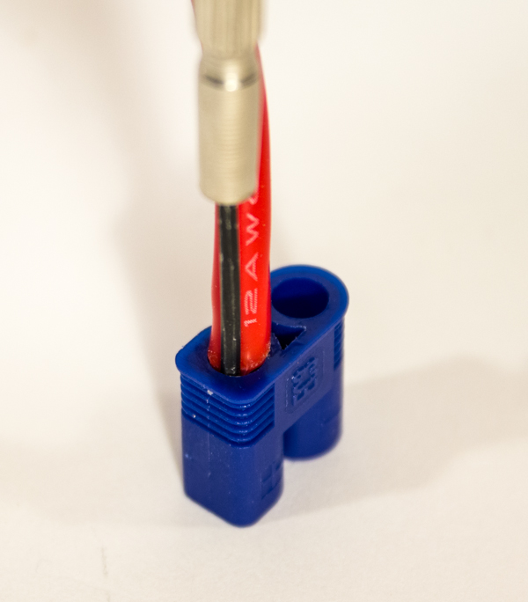
- Set the connector on a firm surface (the floor, preferably concrete), and hold in place with pliers. Do not hold the housing with your hands, or you may accidently stab yourself. Push the bullet connector into the plastic housing with a small flat head screwdriver and strong pressure (a hammer may be carefully used). You will feel (and may hear) a “pop” when the bullet connector is properly locked into the plastic housing, and should appear as shown below.
- Repeat steps 8 through 13 to solder another "male" bullet connector onto the other lead of your Power Breakout cable.
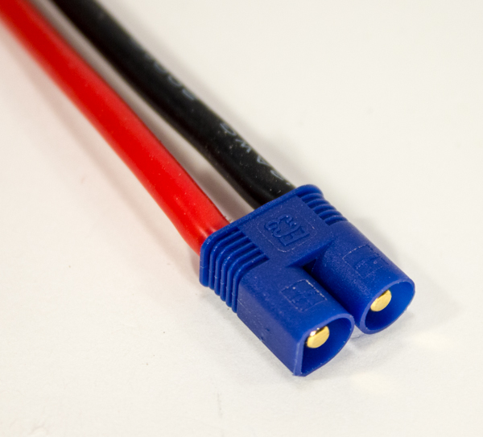

Step 5.5: Soldering Battery EC3 Connector
In the final soldering step of ELEV-8 assembly, you will be soldering an EC3 connector to the battery leads. This is one of the most difficult assembly steps, so we strongly suggest you take your time and do some research of your own (watch some videos on "soldering EC3 connectors", etc). You can skip this step if your battery came pre-installed with an EC3 connector. Even though the Parallax LiPo batteries (#752-00010) come with bullet connectors, they do not quite fit into the EC3 connector housings, so they have to be replaced.
WARNING! NEVER create a situation where both battery leads are exposed. If the two leads were to touch (directly or through any conductive object, such as wire cutters), it would result in a dangerous short circuit which will catastrophically damage the battery, and could cause flames or toxic fumes. Keep one lead properly isolated and protected at ALL TIMES to prevent this.

Tools Needed
- Wire Strippers/Cutters (12-16 AWG)
- Ruler or Measuring Tape
- Soldering Iron
- Rosin-Core Solder
- Work-Holding Vise
- Metal or Wood Block with 5/32” (4 mm) hole (optional)
- Electrical Tape or Heat-Shrink Tubing
- Small Flat-Head Screwdriver
- Flat-Nose Pliers

Parts Needed
- 1 – LiPo Battery
- 1 – "Male"/"Female" EC3 pair w/cover and bullet connectors (not interchangeable with other bullet connectors) (#452-00088)

Instructions
- Carefully cut ONLY the positive (red) lead just behind any connector on the battery leads; DO NOT cut both wires at the same time. If your battery did not come with any connectors pre-soldered, wrap electrical tape or slide heat-shrink tubing over the tip of the negative (black) lead.
- Using the wire strippers, remove 1/8” (3 mm) of insulation from the end of the lead.
- Take the metal wire you just exposed and twist it using your fingers to bring all of the individual wire strands together.
- Clamp one of the wires into the vise so that the exposed metal wire is pointing upwards.
- After cleaning the tip of the soldering iron, apply a small amount of solder to the tip to "tin" it.
- Apply a small amount of solder to the tip of the wire. You want to see the wire "absorb" the solder and become covered in a thin layer of molten solder before removing the soldering iron. It may take some time (up to 30 seconds or more), but it should be clear when the solder suddenly starts to "flow" around the tip of the wire. Repeat this "tinning" process with the other lead of the Power Breakout Cable.
- Now take one of the "female" bullet connectors supplied with the EC3 connector and place it in your vise.
- After tinning the tip of the soldering iron, hold it on the rim of the bullet connector, and apply solder slowly into the “cup” until it is 1/3 full. Put the solder down. (try not to use too much solder in order to prevent excess solder from flowing to the outside of the bullet connector in the next instruction)
- Continuing to hold the soldering iron in place, bring the battery lead to connector and slowly insert into the cup.
- Once fully inserted into the cup, continue to hold the soldering iron against the cup rim and wire for another 10 seconds. This will help to prevent what is known as a cold solder joint.
Be sure to keep excess solder from flowing onto the outside of the bullet connector. Excess solder on the outside of the bullet connector will make it difficult/impossible to install the bullet connector in the plastic connector housing. Use a solder wick or a rotary tool with a grinding stone or cutting wheel to remove any excess solder from the outside of the bullet connector.
- Remove the soldering iron and continue to hold the wire until the solder hardens.
- While the bullet connector is still warm from the soldering process (do not directly touch it; it will burn you), insert it into the back of the plastic connector housing. The red (positive) lead goes into the back of "D" shaped hole in the smaller ("Male") of the two housings (there are +/- markings on the housings as well).
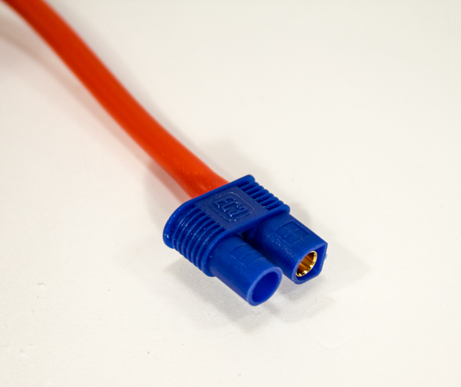
- Set the connector on a firm surface (the floor, preferably concrete), and hold in place with pliers. Do not hold the housing with your hands, or you may accidently stab yourself. Push the bullet connector into the plastic housing with a small flat head screwdriver and strong pressure (a hammer may be carefully used). You will feel (and may hear) a “pop” when the bullet connector is properly locked into the plastic housing, and should appear as shown below.
- Repeat steps 1 through 13, this time to solder another "female" bullet connector onto the other lead of your battery.
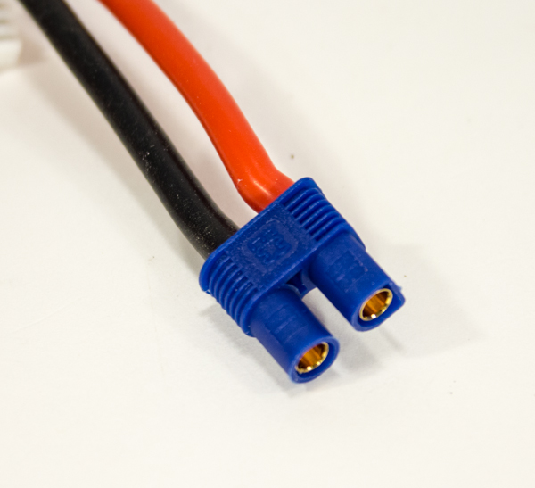

Section 2: Applying the Heat-Shrink Tubing
Now that you have soldered on bullet connectors to the wires, you will cover them with heat-shrink tubing to protect the solder joints and prevent unintended electrical contact.
These next two steps will take between 45 minutes and 2 hours to complete, depending on your skill level and equipment.

Tools Needed in this Section
- Wire Strippers/Cutters or Scissors
- Ruler or Measuring Tape
- Heat Gun, Hair Dryer, or Soldering Iron

Parts Needed in this Section
- 30” – Heat-shrink Tubing, 3/16" (#800-00023)
- 4 – 1050 kV Brushless Motor (#750-90008)
- 12 – Extension Wires, prepared in Step 3
- 4 – Electronic Speed Controller (ESC) (#750-90009)
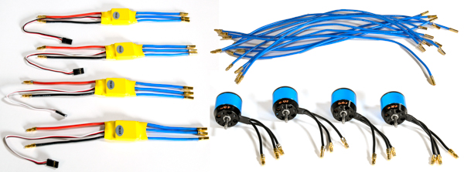

Step 6: Cut Heat-Shrink Tubing to Length
The heat-shrink tubing must be cut from the long roll included in the kit into small lengths before it can be applied to the connections.

Tools Needed
- Scissors
- Ruler or Measuring Tape

Parts Needed
- 18” – Heat-shrink Tubing, 3/16" (#800-00023)

Instructions
- Using the ruler or measuring tape and scissors, measure and cut 32 lengths of heat-shrink tubing, each 1/2 inches (13 mm) long.
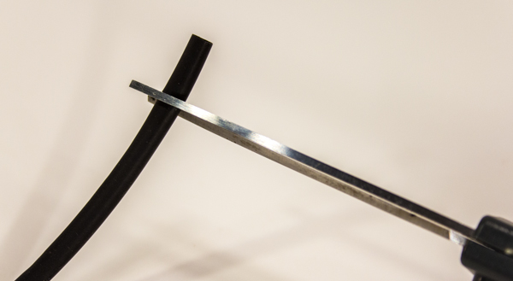
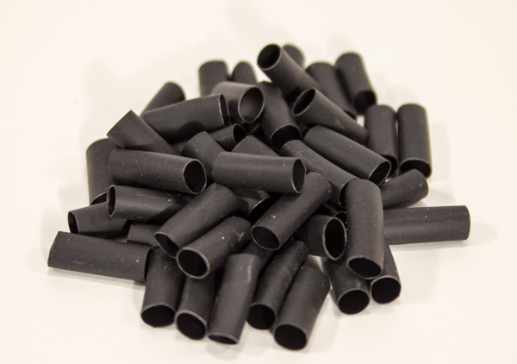

Step 7: Apply Heat-Shrink Tubing to all Connectors
In this step, the heat-shrink tubing will be applied to all of the bullet connectors that were soldered in Section 1.
Warning! Risk of severe burns. Heat guns become extremely hot when used and produce air at several hundred degrees. Never put any body part or flammable item near the nozzle of the unit.

Tools Needed
- Heat Gun, Hair Dryer, or Soldering Iron

Parts Needed
- 32 – 1/2 inch (13 mm) lengths of 3/16” Heat-shrink Tubing, prepared in Step 6
- 24 - Heat-shrink Tubing, 3/16" x 1/2" (part of accessories provided with each motor)
- 4 – 1050 kV Brushless Motor (#750-90008)
- 12 – Extension Wires, prepared in Step 4
- 4 – Electronic Speed Controller (ESC) (#750-90009)

Instructions
- For the “female” bullet connectors on the ESCs and extension wires: slide a piece of heat-shrink tubing (HST) onto the connector until it is flush with the end of the connector.
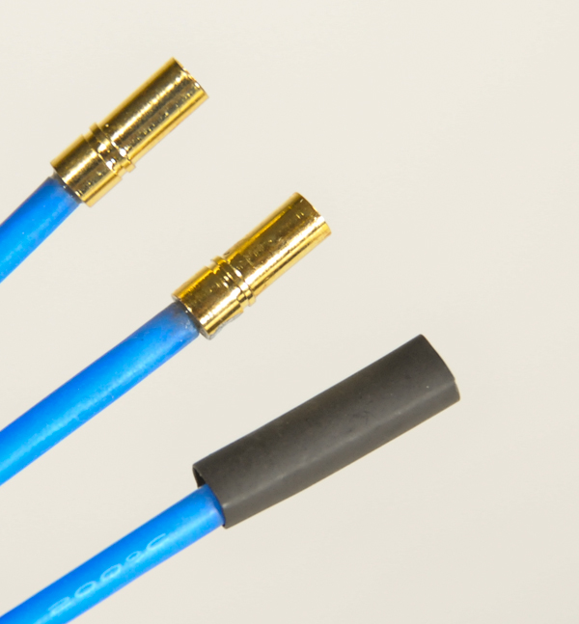
- For the “male” bullet connectors on the ESCs, extension wires, and motors: slide a piece of HST onto the connector until it is flush with the “lip” on the connector.
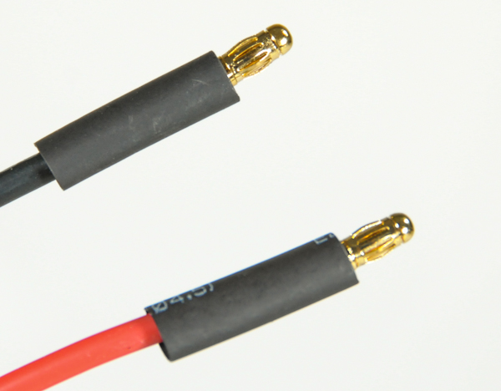
- To shrink using a heat gun carefully apply heat to all sides of the connector until the HST stops shrinking, holding the tip of the heat gun about 1 -3 inches away,
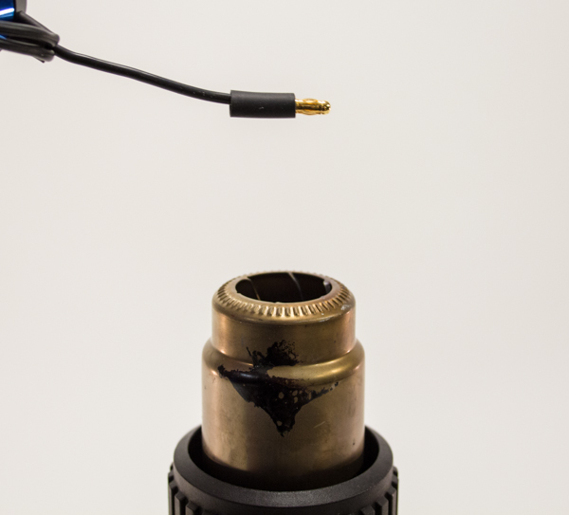
- To shrink using using a hair dryer carefully apply heat to all sides of the connector until the HST stops shrinking, holding the tip of the heat gun about ¼ inch away.
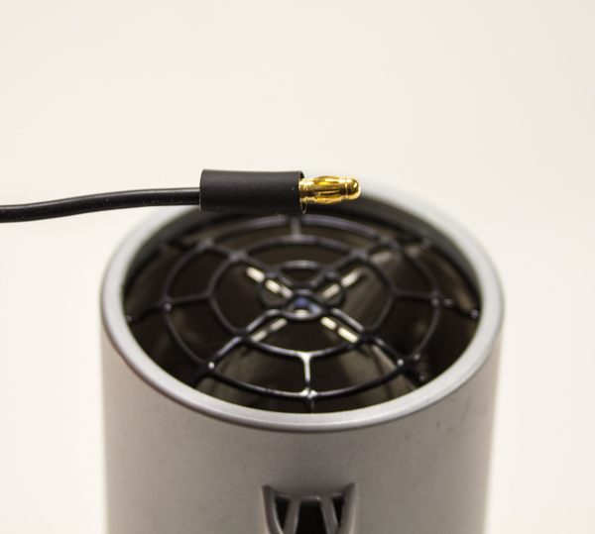
- To shrink using a soldering iron, gently rub the side of the tip of the soldering iron against the HST, slowly rotating the connector to shrink all sides.
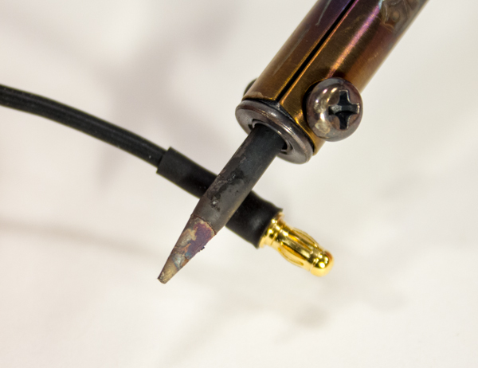
- Inspect all of the applied HST, they should appear as in the the first photo below with the check mark. All of the photos with X are examples of bad HST applications and should be re-done.
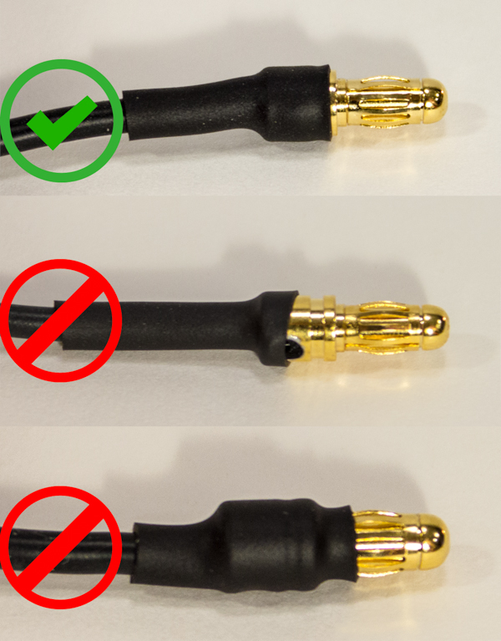
Results at end of this step:
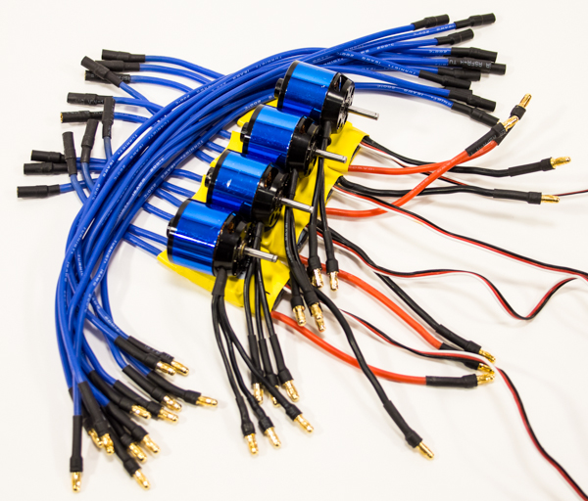

Section 3: Assembling the Booms
In this section, you’ll be mounting the motors into aptly named motor mounts, which will serve to protect the motors in the event of a crash. After that’s all set, you will attach chrome stickers to two of the booms, which will serve to indicate the front of the Quadcopter; otherwise there’s no way to know what direction the ELEV-8 is facing during flight, which would not be ideal. Finally, the motor mounts and landing gear will be bolted to the booms.
Warning! As tempting as it may be, DO NOT attach the propellers to the motor yet. In fact, you won’t need them until the very last step, so go ahead and stash them away for the moment.
This section will take approximately 1 to 2 hours, depending on your skill level and equipment.

Tools Needed in this Section
- 1.5 mm Hex Key (#725-00067)
- #1 Philips-Head Screwdriver
- Ruler or Measuring Tape
- Pencil or Pen
- Scissors
- 1/4” Wrench, 1/4" Socket, or Adjustable Wrench

Parts Needed in this Section
- 1 – Chrome Sticker (#120-00008)
- 1 – Loctite® Threadlocker Blue 242® (#700-00106)
- 16 – Machine Screw, #4-40 x 3/8” (#710-00036), #1 in drawing below
- 16 – Internal Lock Washer, #4 (#700-00059), #2 in drawing below
- 4 – Machine Screw, #4-40 x 1" (#710-00002), #3 in drawing below
- 4 – Machine Screw, #4-40 x 1 1/4” (#710-00042), #4 in drawing below
- 4 – Motor Mount Top & Bottom (#721-80005), #5 and #10 (respectively) in drawing below
- 8 – Aluminum Standoff, #4-40 x 5/8” (#713-00001), #6 in drawing below
- 4 – 1050 kV Brushless Motor (#750-90008), #7 in drawing below
- 4 – Blue Aluminum Boom (#730-00060), #8 in drawing below
- 9 - Extension Wires, prepared in Step 7, #9 in drawing below
- 4 – Landing Gear (#721-80007), #11 in drawing below
- 16 – Machine Screw, M3-0.5 x 6mm (#710-00039), #12 in drawing below
- 8 – Locknut, #4-40 (#700-00024), #13 in drawing below
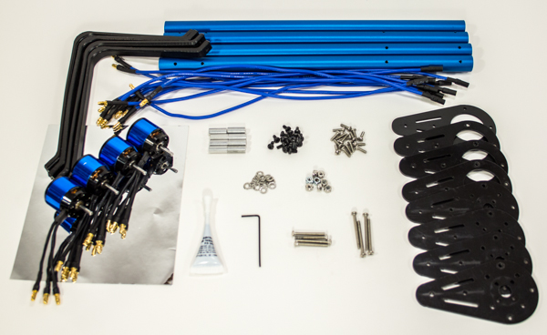
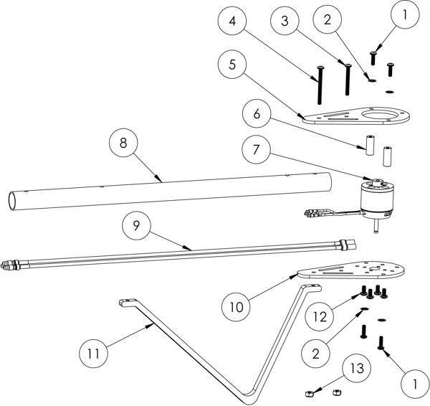

Step 8: Loctite® Motor Set Screws
Apply Loctite® to the motor set screws to prevent them from loosening during flight and potentially causing equipment failure.

Tools Needed
- 1 – 1.5 mm Hex Key

Parts Needed
- 4 – 1050 kV Brushless Motor (#750-90008)
- 1 – Loctite® Threadlocker Blue 242® (#700-00106)

Instructions
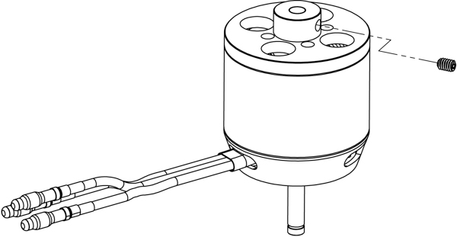
- Using the hex key, carefully remove the motor set screw from each motor. The screws may be very tight; be careful not to break your hex key.
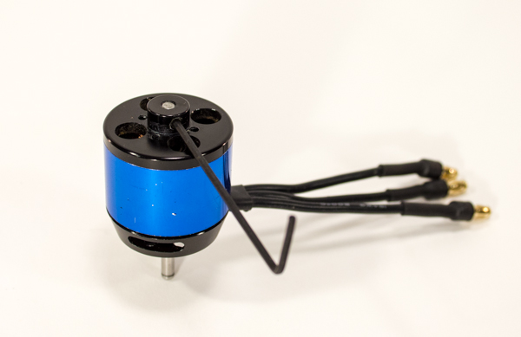
- For each motor, apply a small amount of Loctite® to the set screw threads and carefully reinstall the screws. Seat each screw firmly but do not over-tighten. Allow the Loctite® to set for 10 minutes; it will fully cure in 24 hours.
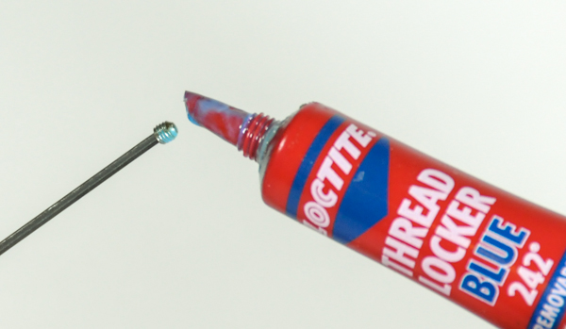

Step 9: Connect Motors to Extension Wires
Now, attach the extension wires to the motors, as you won’t be able to reach these connections once the motors are mounted to the Booms.

Parts Needed
- 4 – Brushless 1050 kV Motor, prepared in Step 8
- 12 – Extension Wires, prepared in Step 7

Instructions
- Taking one Motor and one Extension Wire, insert the "male" bullet connector on the Motor lead into the "female" bullet connector on an Extension wire, until fully seated.
<IMG 36>
- Repeat this process to plug an Extension Wire into each lead of this motor, and then the three remaining motors.
<IMG 37>

Step 10: Bolt Motors to Bottom Motor Mounts
At last, you can finally begin attaching things together. First, you will bolt the Motors to the Motor Mount Bottom.

Tools Needed
- #1 Philips Head Screwdriver

Parts Needed
- 4 – 1050 kV Brushless Motors w/ Extension Wires, prepared in Step 9
- 4 – Motor Mount Bottom (#721-80005)
- 16 – Machine Screw, M3-0.5 x 6mm (#710-00039)

Instructions
- Feed the shaft of a Motor through the hole at the center of the Motor Mount Bottom, lining up the wires with the Motor mount plate. Hold in place. Note that the holes in the bottom of the motor will only line up with the holes in the mount plate in one configuration, so you may have to flip the mount plate over in order for everything to line up.
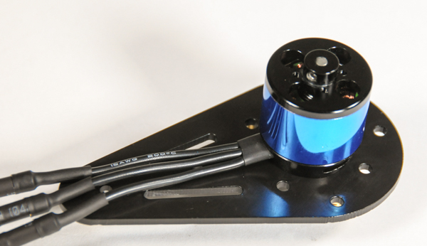
- One at a time, insert four screws into the inner-most holes on the Motor Mount Bottom, making sure to line up with the threaded holes in the bottom of the Motor, and tighten with the screwdriver.
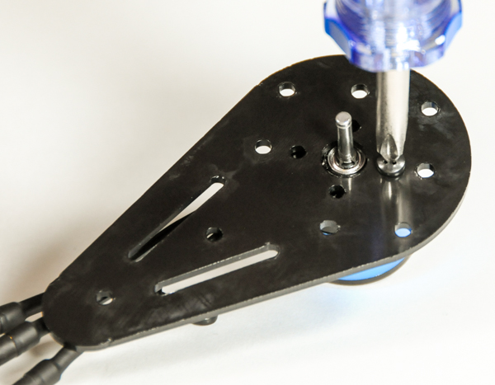
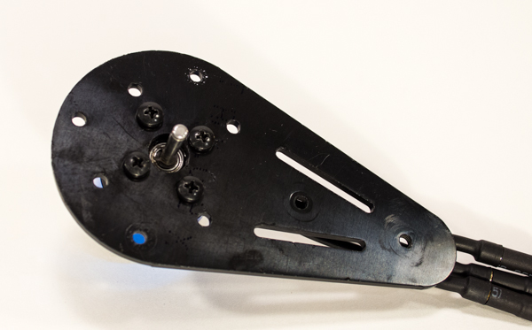
- Repeat this process for the three remaining motors.
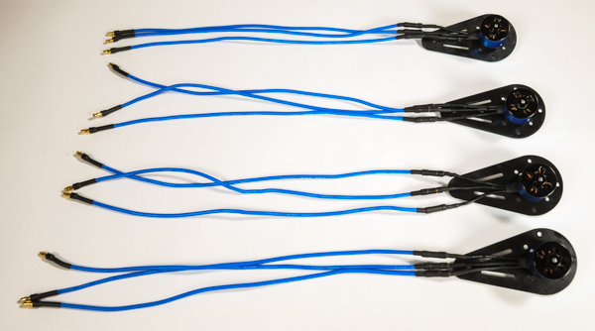

Step 11: Bolt Standoffs to Top Motor Mounts
Now that the motors are safely secured to the Bottom Motor Mount, you can attach the standoffs to the Top Motor Mount, which will be used to connect the top and Bottom Motor Mounts together in the next step. Both Loctite® and lock-washers are used here because these screws were known to sometimes vibrate loose during flight until we began using Loctite® and lock-washers together.

Tools Needed
- #1 Philips Head Screwdriver
- Flat-Nose Pliers

Parts Needed
- 8 – Aluminum Standoff, #4-40 x 5/8” (#713-00001)
- 4 – Motor Mount Top (#721-80005)
- 8 – Machine Screw, #4-40 x 3/8” (#710-00036)
- 8 – Internal Lock Washer, #4 (#700-00059)
- 1 – Loctite® Threadlocker Blue 242® (#700-00106)

Instructions
- Slide a lock washer onto a bolt, and then feed the bolt through the hole on the side of a Top Motor Mount.
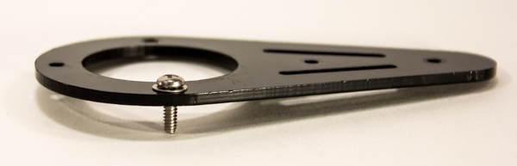
- Apply a drop of Loctite® to the screw thread.

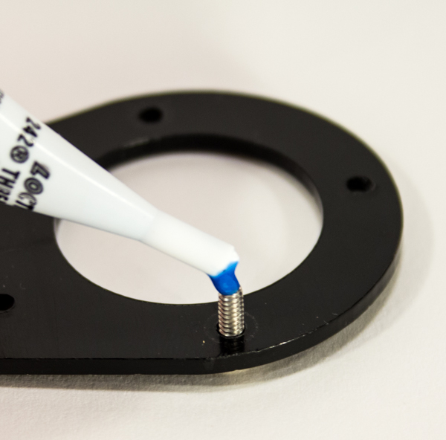
- Screw on a standoff and tighten until snug using the pliers and screwdriver
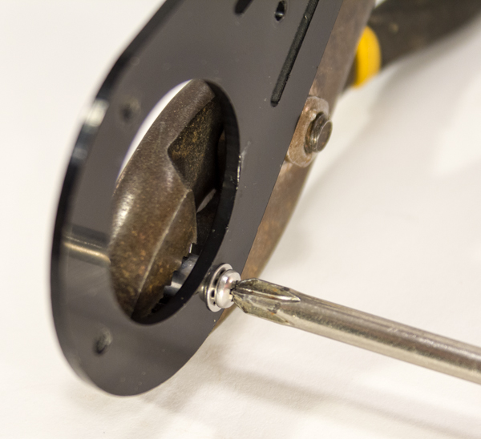
- Repeat this for the opposite side of the Top Motor Mount, and then for the three other Top Motor Mount.
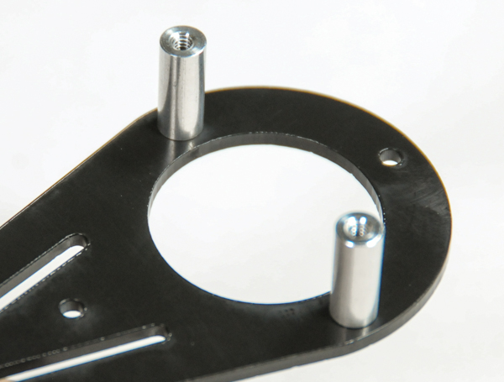
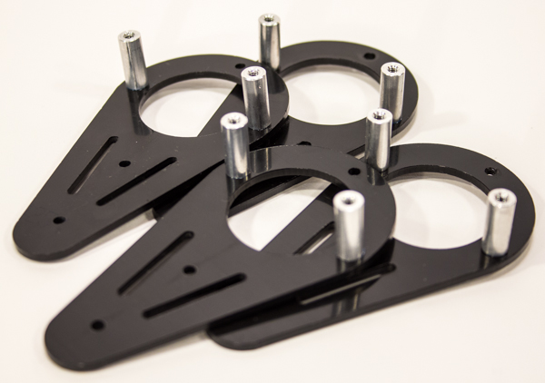

Step 12: Bolt Together Motor Mount Tops and Bottoms
As previously mentioned, you will now join the Top and Bottom Motor Mount assemblies.

Tools Needed
- #1 Philips Head Screwdriver

Parts Needed
- 4 – Motor Mount Bottom w/ Motor Assembly, prepared in Step 10
- 4 – Motor Mount Top w/ Standoff Assembly, prepared in Step 11
- 8 – Machine Screw, #4-40 x 3/8” (#710-00036)
- 8 – Internal Lock Washer, #4 (#700-00059)
- 1 – Loctite® Threadlocker Blue 242® (#700-00106)

Instructions
- Take a Top Motor Mount and place it over a Bottom Motor Mount, so that the standoffs come into contact with the Bottom Motor Mount and line up with the holes on the sides.
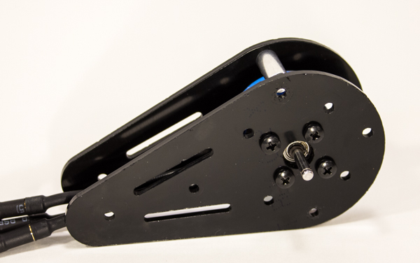
- Apply a drop of Loctite® to the top of the standoff through the hole in the Bottom Motor Mount.
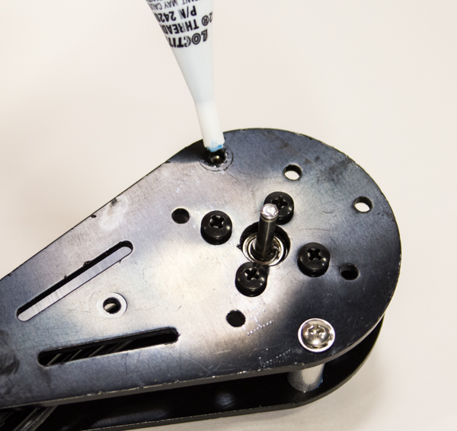
- Slide a lock washer onto a bolt, feed the bolt through the hole on the side of a Bottom Motor Mount, and screw into the standoff until snug.
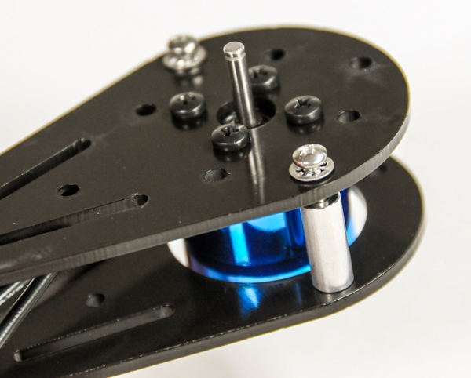
- Repeat this for the opposite side of the Motor Mount, and then for the three other Motor Mounts.
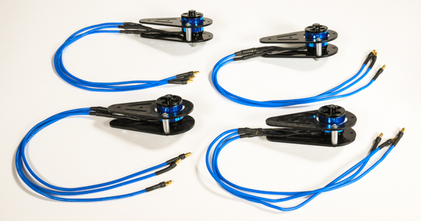

Step 13: Affix Chrome Stickers to Two Booms
Before you mount the Motors onto the Booms, attach the Chrome Stickers to two of the Booms. Once mounted to the chassis, the two Chrome Booms will indicate the front of the ELEV-8.

Tools Needed
- Ruler or Measuring Tape
- Pencil or Pen
- Scissors

Parts Needed
- 2 – Blue Aluminum Boom (#730-00060)
- 1 – Chrome Sticker (#120-00008)

Instructions
- Use the pencil to make a small mark on the Booms 2 1/4” (5.7 cm) from the end of the Boom that has the holes closest together.
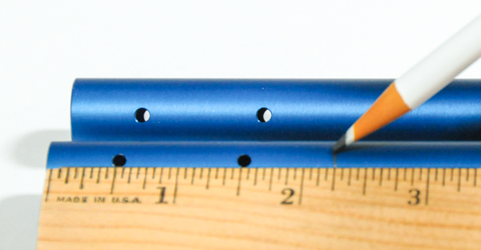
- Cut the Chrome Sticker into two pieces, each measuring 5” (12.7 cm) by 2 1/4” (5.7 cm).
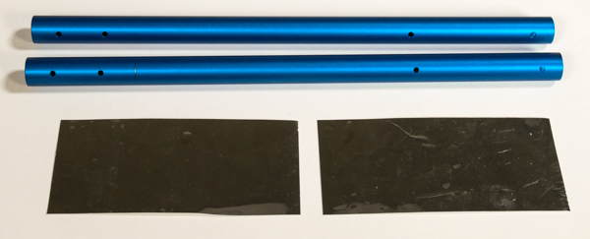
- Peel the paper backing partially off, and line up with the pencil mark and the axis of the Boom, press lightly to adhere.
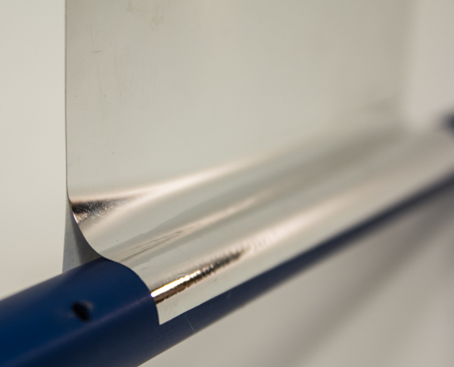
- Slowly pull the backing off as you rotate the boom, pressing the sticker on as you go.
- Repeat for the second Boom.
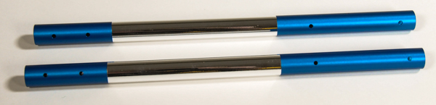

Step 14: Feed Extension Wires Through Booms
Now, you will feed the Extension Wires attached to each Motor through the Booms, which will protect them from getting damaged.

Parts Needed
- 2 – Blue Aluminum Boom (#730-00060)
- 2 – Aluminum Boom w/ Chrome Sticker, prepared in Step 13
- 4 – Motor and Motor Mount Assembly, prepared in Step 12

Instructions
- Feed the three cables of one of the Motor Assemblies through one of the Booms, inserting the cables into the Boom end with the holes closest together. Note that the Extension Wires should come out of the end with the holes farther apart.
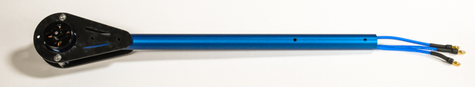
- Repeat this for the other three Booms.
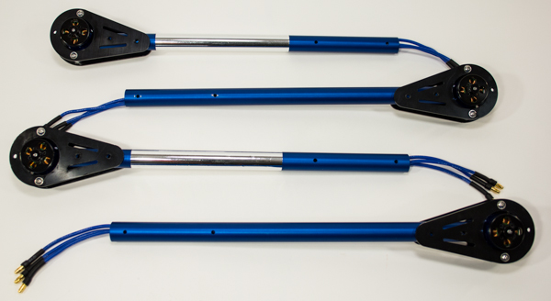

Step 15: Bolt Motor Mount and Landing Gear to Booms
In the final step of Boom assembly, you will be fastening the Motor Mounts to the Booms and attaching one side of the Landing Gear.

Tools Needed
- #1 Philips Head Screwdriver
- 1/4” Wrench, 1/4” Socket, or Adjustable Wrench

Parts Needed
- 4 – Boom and Motor Mount w/ Motor Assembly, prepared in Step 14
- 8 – Locknut, #4-40 (#700-00024)
- 4 – Machine Screw, #4-40 x 1" (#710-00002)
- 4 – Machine Screw, #4-40 x 1 1/4” (#710-00042)
- 4 – Landing Gear (#721-80007)

Instructions
- Slide the Motor Mount over the Boom, aligning the two holes in the Motor Mount with those in the Boom.
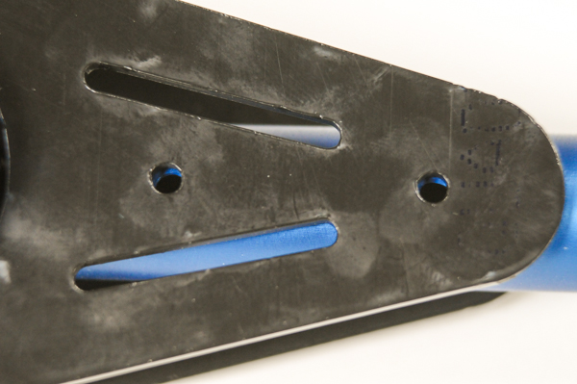
- Insert the 1” screw through the hole closest to the Motor. Insert the 1 1/4” screw through the hole farthest from the motor. If you feel any resistance trying to push the bolt through, STOP. You are likely hitting the wires running through the Boom; “jiggle” things around until you can feed the screw all the way though with ease.
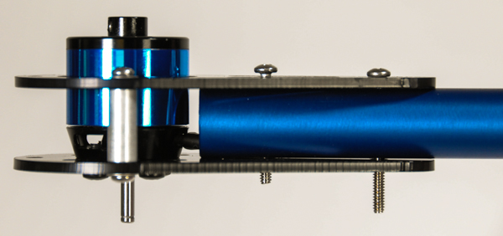
- Screw a locknut onto the screw closest to the Motor. Using the screwdriver and wrench, tighten (clockwise) until there is no longer a gap between any parts (including nut or screw-head). Then turn the locknut one more full rotation and stop. Any more and you may begin to crush the Boom.
- Take the short side of the Landing Gear and feed it over the other screw, followed by the other locknut. Tighten as described above.
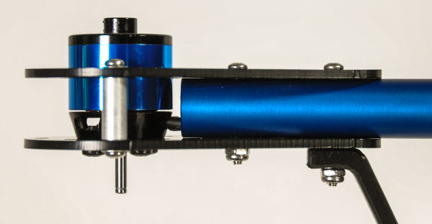
- Repeat Instructions 1-4 for the three remaining Booms.
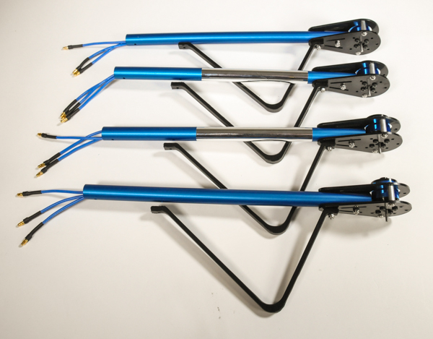

Section 4: Mounting the Booms and ESCs to the Chassis
With the Motors assembled and mounted to the Booms, you are now ready to begin mounting the Booms to the central Chassis and wire the ESCs.
This section will take approximately 1 to 2 hours to complete, depending on skill level and equipment.

Tools Needed in this Section
- #1 Philips Head Screwdriver
- Flat-Nose Pliers
- Scissors or Diagonal Cutters
- Permanent Marker

Parts Needed in this Section
- 1 – Top/Bottom Chassis Plate (#721-80003)
- 4 – Aluminum Standoff, #4-40 x 1 1/4” (#710-00042)
- 4 – Machine Screw, #4-40 x 3/8” (#710-00036)
- 4 – Boom and Motor Assemblies, prepared in Step 15
- 8 – Saddle Washer, 3/4" (#712-00010)
- 8 – Nylon Spacer, #4 x 1/8" (#713-00019)
- 8 – Aluminum Standoff, #4-40 x 1/8" (#700-00014)
- 4 - Machine Screw, #4-40 x 1 1/2” (#710-00037)
- 4 – Machine Screw, #4-40 x 1 1/4” (#710-00042)
- 4 – 30A Electronic Speed Controller (ESC), prepared in Step 7
- 4 – Zip Tie, 4” Black (#700-00093)
- 1 – HXT to 3.5mm Power Breakout Cable (#800-00006)
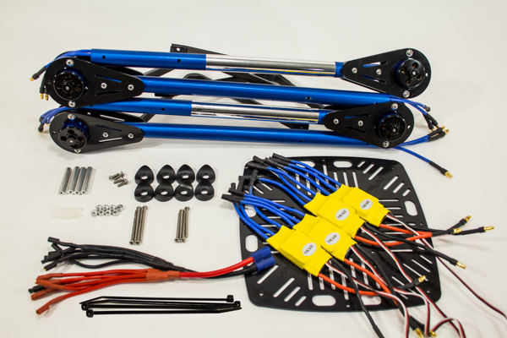

Step 16: Bolt FC Mount Standoffs to Top Chassis Plate
Before you can begin mounting the Booms to the Chassis, standoffs that will support the Flight Controller (FC) need to be bolted on, as they will become inaccessible once the Booms are attached.

Tools Needed
- #1 Philips Head Screwdriver

Parts Needed
- 4 – Aluminum Standoff, #4-40 x 1 1/4” (#713-00002)(#1 in the drawing below)
- 1 – Chassis Plate (#721-80003)(#2 in the drawing below)
- 4 – Machine Screw, #4-40 x 3/8” (#710-00036)(#3 in the drawing below)

Instructions
- Feed a screw through one of the holes indicated in the figure below. Thread on a standoff from the opposite side and hold with one hand while you use the screwdriver in the other hand to tighten. As a rule of thumb, tighten until you start to feel resistance, and then one more full turn.
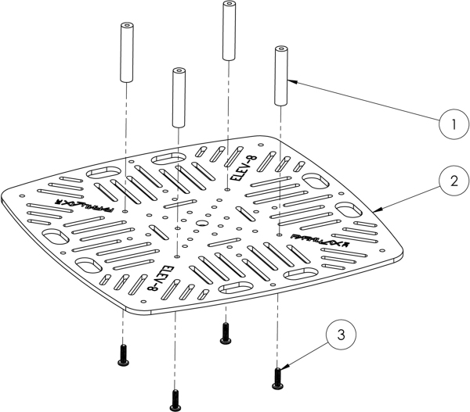
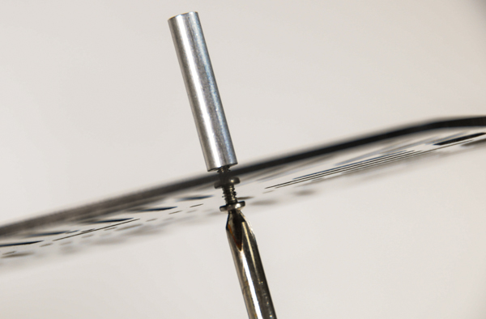
- Repeat this for the remaining three standoffs.
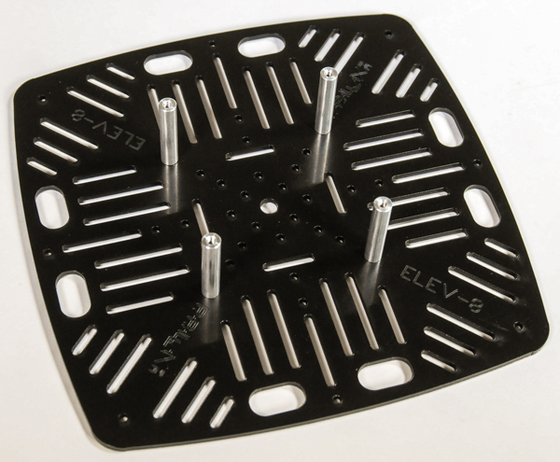

Step 17: Mount Boom Assemblies to Top Chassis Plate
In this step, you’ll bolt the Motor and Boom Assemblies to the Top Chassis Plate so that you can then begin working on making the electrical connections.

Tools Needed
- #1 Philips Head Screwdriver
- Flat-Nose Pliers

Parts Needed
- 4 – Machine Screw, #4-40 x 1 1/4” (#710-00042)(#1 in the drawing below)
- 4 - Machine Screw, #4-40 x 1 1/2” (#710-00037)(#2 in the drawing below)
- 1 – Upper Quad Chassis, prepared in Step 16 (#3 in the drawing below)
- 8 – Nylon Spacer, #4 x 1/8" (#713-00019)(#4 in the drawing below)
- 8 – Saddle Washer, 3/4" (#712-00010)(#5 in the drawing below)
- 4 – Boom and Motor Assemblies, prepared in Step 15 (#6 in the drawing below)
- 8 – Aluminum Standoff, #4-40 x 1/8" (#700-00014)(#7 in the drawing below)

Instructions
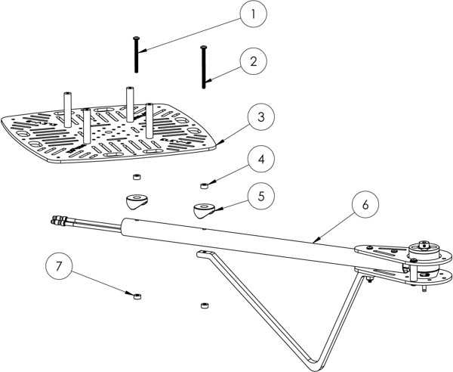
- With the Upper Quad Chassis upside-down (the FC standoffs facing down), use the figure below to locate the two holes for one of the Boom positions. The blue circles indicate positions for the 1 1/2” screws, red circles indicate positions for 1 1/4” screws.
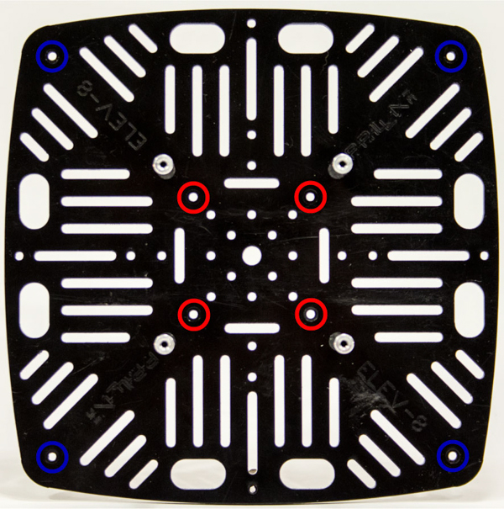
- Feed one of each of the screws through their respective holes in the Top Frame Plate, so that the screw-heads are on the same side as the FC mount standoffs.
- Slide a nylon spacer over each screw followed by a saddle washer.
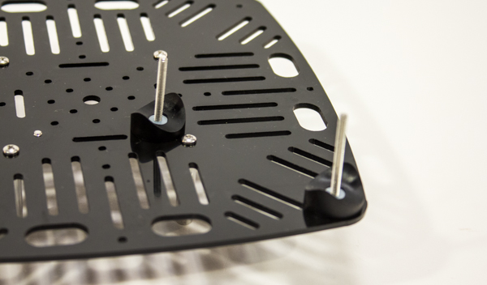
- Slide a Boom over the screws, so that the Landing Gear is pointing upwards.
- Thread a standoff onto each screw. Using the flat-nose pliars to keep the standoff from spinning and a screwdriver on the bottom of the Chassis, tighten (clockwise) until there is no longer a gap between any parts (including standoff or screw-head), you should feel an increase in resistance. Then turn the locknut one more rotation and stop. Any more and you may begin to crush the Boom.
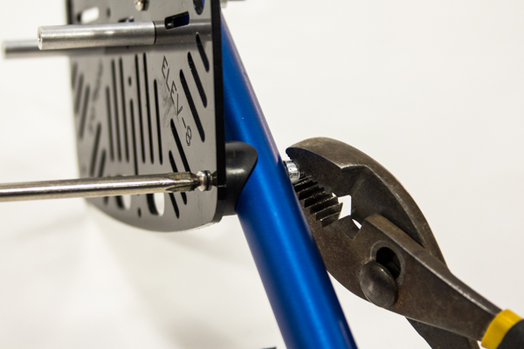
- Repeat instructions 2 through 5 for the three remaining Booms, making sure that the two Booms with the Chrome Stickers are adjacent to one another
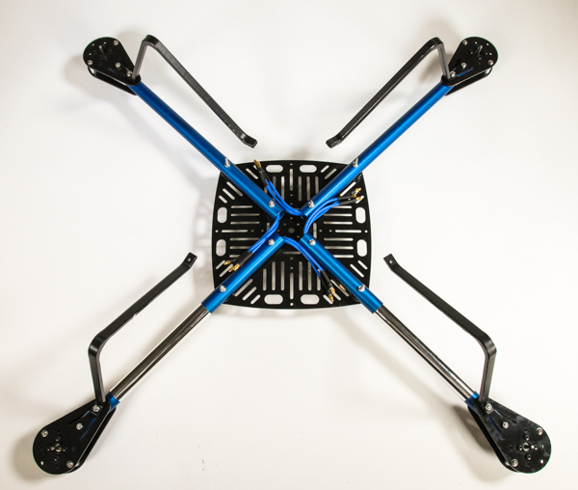

Step 18: Mount ESCs to Top Chassis Plate
In this step, you will use zip ties to affix the four ESCs to the Chassis to prevent them from shifting during flight.

Tools Needed
- Scissors or Diagonal Cutters (“Dikes”)
- Flat-Nose Pliers

Parts Needed
- 1 – Top Chassis Plate and Boom Assembly, prepared in Step 17
- 4 – 30A Electronic Speed Controller (ESC), prepared in Step 7
- 4 – Zip Tie, 4” (#700-00093)

Instructions
- Using the image below as a guide for orientation, place one of the ESCs into one of the spaces on the Chassis plate between the Booms.
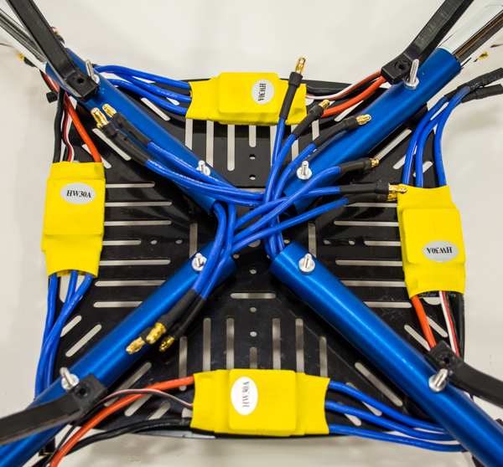
- Thread a zip tie through the Chassis and around the ESC. Thread the tail of the zip tie into the fastener and pull until tight (you may use flat-nose pliers to tighten, if necessary).
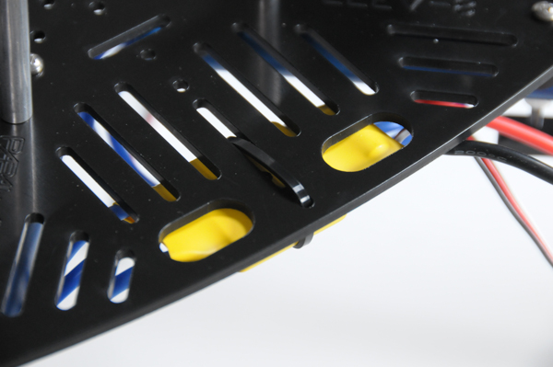
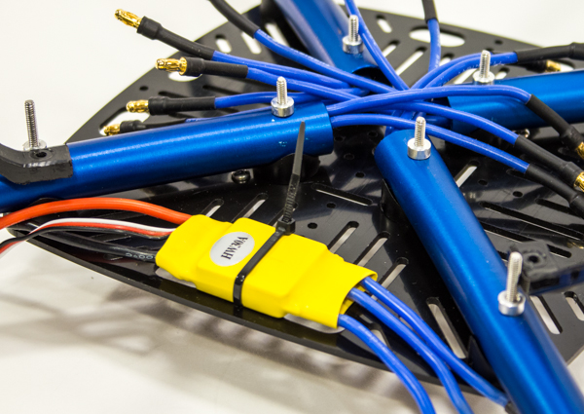
- Cut off the tail of the zip tie.
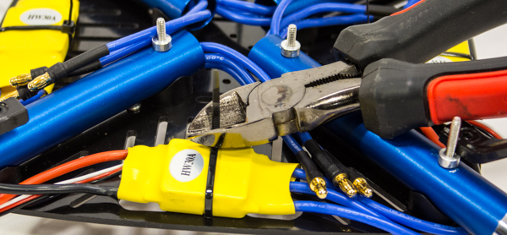
- Repeat steps 1-3 to mount the three remaining ESCs.
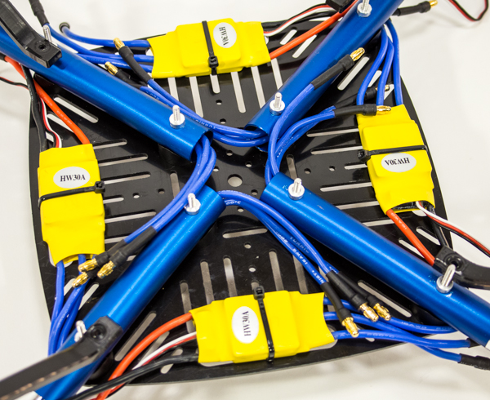

Step 19: Connect ESCs to Extension Wires
With the ESCs mounted to the ELEV-8 Top Chassis Plate, it is time to connect the Extension Wires to the ESCs.

Parts Needed
- 1 – Top Chassis Plate and Boom Assembly w/ ESCs, prepared in Step 18.

Instructions
- Each ESC will be connected to the Extension Wires coming out of the Boom adjacent to the ESC’s output (blue wires).
- To make the three connections for each ESC; firmly insert each of the connectors from the extension wires into one of the ESC’s output leads.
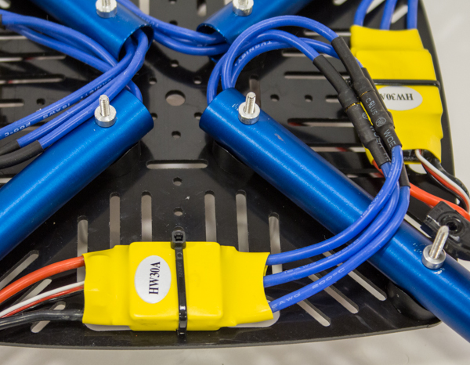
- Arrange the wires so that they appear exactly as in the figure below; this will make the rest of the wiring easier.
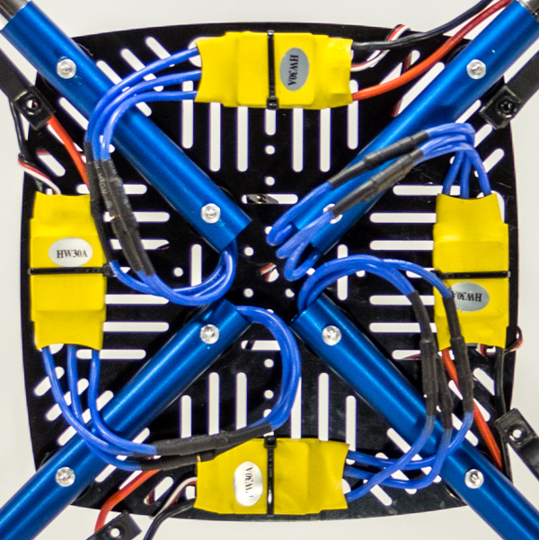

Step 20: Determine Front and Number the Electronics
As the number of wires and connections grows, it becomes increasingly easy to make minor mistakes in setting up the electrical connections. To minimize the risk of such a mishap, you will now number all of the electrical components and connections, with respect to the front of your ELEV-8.

Tools Needed
- Permanent Marker

Parts Needed
- 1 – Top Chassis Plate and Boom Assembly w/ ESCs, prepared in Step 19

Instructions
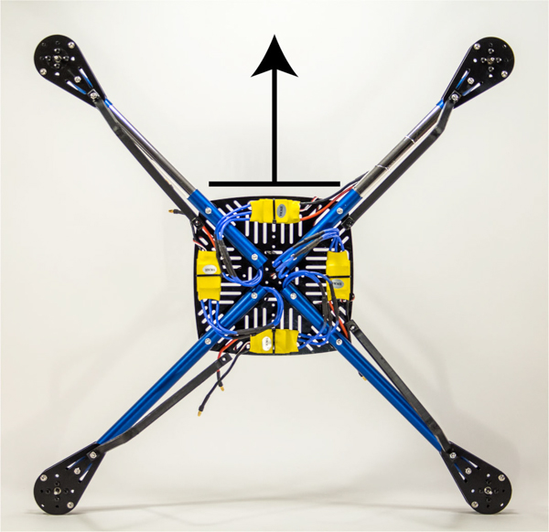
- Place the ELEV-8 upright with the two Chrome Booms facing away (far) from you. The front (and forward direction) of the ELEV-8 is defined by the side of the Chassis between the two Chrome Booms, as shown in the image above (note that the quad is upside down in the image)
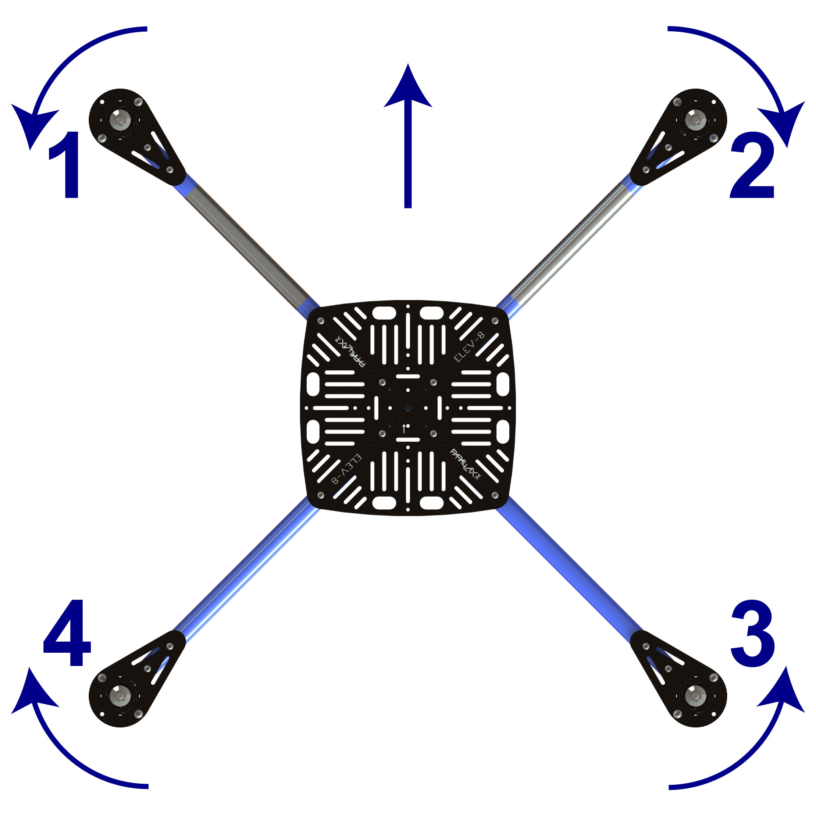
- Using the above graphic for reference (Note the ELEV-8 is viewed from the top in the above graphic), number the top and bottom of the corresponding ESCs and the signal cable connectors for the ESCs, as shown in the images below.
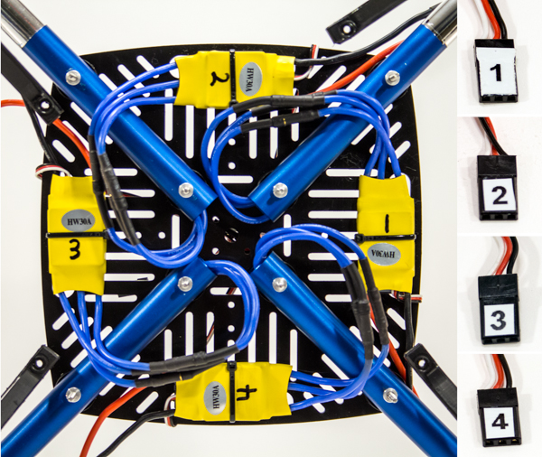
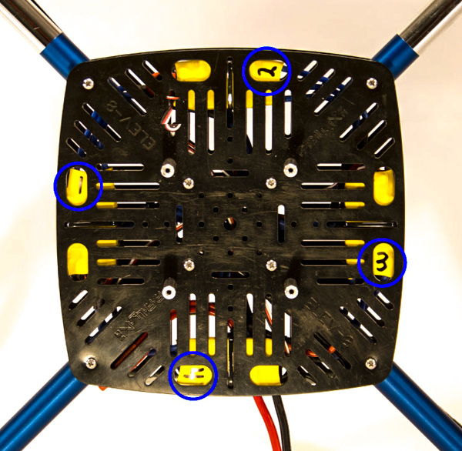
- Now label the top of each Motor Mount with their number and an arrow indicating the direction of rotation, as shown in the image below.
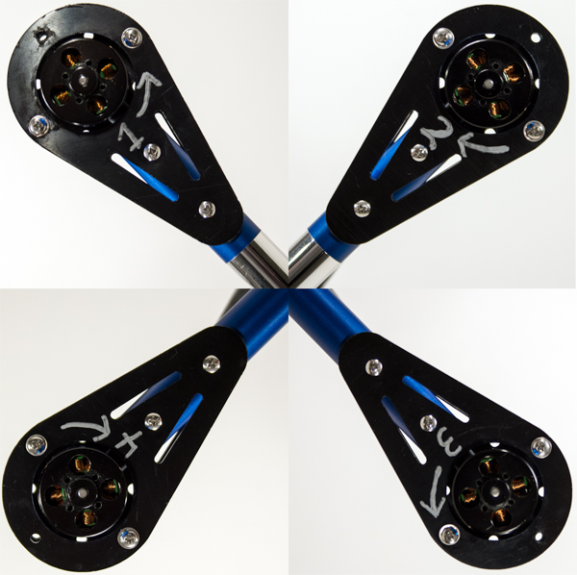

Step 21: Install Power Breakout and Connect to ESCs
The Power Breakout Cable, sometimes referred to as a "squid" will provide power to the four ESCs from the battery. Two of its six outputs (an "output" is a pair of positive (red) and negative (black) wires) will be left unused; allowing for future expansions like lights, video equipment, etc.
Warning! Be very careful when connecting the Power Harness to the ESCs. Switching the polarity of the wires will cause permanent and catastrophic damage to the battery and/or ESCs.

Parts Needed
- 1 – Top Chassis Plate and Boom Assembly w/ ESCs, prepared in Step 20
- 1 – HXT to 3.5mm Power Breakout Cable (#800-00006)

Instructions
- Flip the ELEV-8 over so that it is upside-down.
- Locate the red (positive) inputs of the ESCs. Carefully and firmly connect one of the red Power Harness wires to each input.
- Locate the black (negative) inputs of the ESCs. Carefully and firmly connect one of the black Power Harness wires to each input.
- Carefully double-check that all of the red ESC inputs are connected to red Power Harness wires and all of the black ESC inputs are connected black Power Harness wires. No need to secure the Power Harness just yet; you will do that just before you attach the Bottom Chassis Plate.
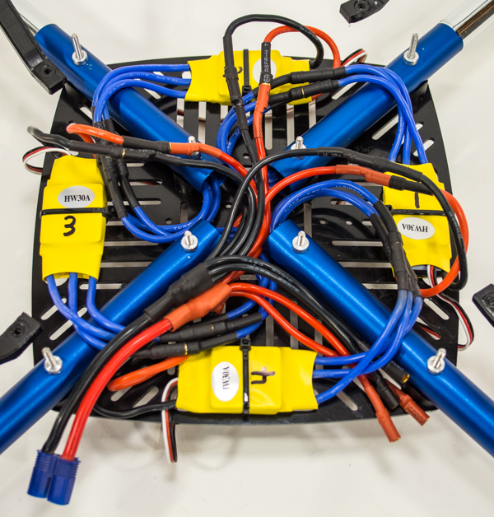

Section 5: Configuring the Transmitter, Motors, and Flight Controller
Before you can continue with the mechanical assembly, the Motors must be checked to ensure they are spinning in the correcting direction. Before doing so, the transmitter and receiver must be properly configured. The Flight Controller must also be set up before it can control the ELEV-8.
This section will take approximately 45 minutes to 1 hour 30 minutes to complete depending on skill level and equipment.

Parts Needed in this Section
- RC Radio Transmitter and Receiver w/ Bind Plug (See Introduction for Details [21])
- Lithium Polymer (LiPo) Battery, prepared in Step 5
- Computer with Windows operating system and Internet access
- USB (A) to USB Mini (B) Cable (not included)
- HoverflyOPEN Board (#31500)
- ELEV-8 assembly, prepared in Step 21

Step 22: Configure the Transmitter and Bind to Receiver
Radio transmitters come with an overwhelming array of settings. This step will guide you through configuring your transmitter so that it can properly control your ELEV-8. Below is a table of transmitter setting recommendations for flying the ELEV-8, regardless of transmitter selection. You will also “bind” your transmitter to your receiver, which enables your particular transmitter to control your particular receiver for the ELEV-8.
We’ll guide you through making these settings on a Spektrum DX6i and DX8 transmitter in the following instructions. For other receivers, refer to the literature provided by the manufacturer. If you are new to radio control, many of these terms may be foreign to you. For the sake of brevity we won’t go into those terms now, but we do strongly recommend that you take the time to research any term or concept that is unfamiliar. Lastly, please read and abide by your RC transmitter’s instruction manual, as every system is different.
Box Model Type | ACRO (Plane Mode)
End Point (Travel) Adjustment | Set aileron and elevator to 50% initially. If the ELEV-8 still seems too reactive, reduce to 30% until you get used to flying it
Dual-Rates (D/R) | 100%
Channel Reverse | Normal for the following brands: HiTec, Spektrum, JR.  Reverse for the following brands: Futaba
Trims | Centered
Sub-Trims | Centered
Gain Adjustment | Set gain on 5th channel. Start with 25%, add or subtract based on flying stability
Exponential | After gaining experience, add up to 30% into aileron and elevator

Parts Needed
- RC Radio Transmitter and Receiver (w/ Bind Plug)
- ELEV-8 assembly, prepared in Step 21
- LiPo Battery, prepared in Step 5

Instructions for Spektrum DX6i Configuration
- Turn on the transmitter by sliding the "Power" switch to the right.
- Click the roller once to access the "Adjust List".
- Scroll right to highlight "Model Select" and click again.
- Scroll right until you find an empty model (there should be nothing written under "Model #").
- Scroll right to highlight "Setup List" and click again.
- Rotate the roller to “Model Type” and click once.
- Select “Acro” by rotating the roller to highlight it and click once. (Note: unfortunately, there is no way to disable the beeping noise the transmitter makes every time you scroll or click).
- Return to the “Setup List” by clicking on “List” in the upper-right hand corner of the screen.
- Scroll to “Model Name” and click once. Use the roller to name your model; we suggest “ELEV-8 V2”.
- Return to the main screen by holding down the roller for 4 seconds, then releasing.
- Press and release the roller to enter the “Adjust List.” Rotate the roller to the right until “Travel Adj” is highlighted and click once.
  - Scroll to the “Aile” setting; while holding the right (aileron/elevator) stick all the way left, click once, scroll until the screen reads “50%,” click again to save. Now, while holding the right (aileron/elevator) stick all the way right, click once, scroll until the screen reads “50%,” click again to save.
  - Scroll to the “Elev” setting; while holding the right (aileron/elevator) stick all the way up, click once, scroll until the screen reads “50%,” click again to save. Now, while holding the right (aileron/elevator) stick all the way down, click once, scroll until the screen reads “50%,” click again to save.
  - Scroll to the “Gear” setting; set the “Gear/Flight Mode” switch to 0, click once, scroll until the screen reads “25%,” click again to save. Now, set the “Gear/Flight Mode” switch to 1, click once, scroll until the screen reads “25%,” click again to save. You will need to keep this switch in the “1” position for normal flight operation.

Instructions for Spektrum DX8 Configuration
- Press the roller while turning on the transmitter. When “Setup List” appears, release the roller.
- Rotate the roller to “Model Select” and click once. Scroll to the first unused model and click once. (Note: unfortunately, there is no way to disable the beeping noise the transmitter makes every time you scroll or click).
- Rotate the roller to “Model Type” and click once. Select “Acro” by rotating the roller to highlight it and click once. When prompted "Data will be reset", select "Yes".
- Scroll to “Model Name” and click once. Use the roller to name your model (we suggest “ELEV-8 V2”); scroll until the cursor is under the character you wish to edit, the click once; scroll until the character you want appears, then click again to save. Scroll to move the cursor to the next character and repeat. Once done, scroll to "Back" in the upper-right corner and click.
- Scroll to "Main" in the upper-right hand corner and click once.
- With the transmitter powered on and in the main screen, press and release the roller to enter the “Function List.” Rotate the roller to the right until “Servo Setup” is highlighted and click once.
  - Scroll right to "Throttle" and click once. Scroll right until "Aileron" appears then click again. Scroll right to "100% 100%" and click once. Scroll left until "50% 50%" is displayed, then click again.
  - Scroll left to "Aileron" and click once. Scroll right until "Elevator" appears then click again. Scroll right to "100% 100%" and click once. Scroll left until "50% 50%" is displayed, then click again.
  - Scroll left to "Elevator" and click once. Scroll right until "Gear" appears then click again. Scroll right to "100%" and click once. Scroll left until "25%" is displayed, then click again. Locate the "Gear" switch on the top left of the unit and switch it. The highlight box on screen should now highlight the other "100%", click once. Scroll left until "25%" is displayed, then click again. Set the "Gear" switch to the "0" position. You will need to keep this switch in the “0” position for normal flight operation.

General Instructions for Binding your Transmitter and Receiver
- Plug one of the ESC Signal Cables into the throttle (THRO) jack on your receiver. Be careful to connect the wire in the correct orientation. There will be a symbol such as “^ + –” to indicate orientation, where ^ corresponds to the white signal wire, + corresponds to the red positive wire, and – corresponds to the black negative wire.
- Insert the bind plug supplied with your receiver into the bind (BND/DAT) jack on your receiver.
- Follow the binding instructions supplied with your transmitter or receiver.

Instructions for Binding a Spektrum Transmitter and Receiver
- Plug one of the ESC Signal Cables into the throttle (THRO) jack on your receiver. Be careful to connect the wire in the correct orientation. There will be a symbol such as “^ + –” to indicate orientation, where ^ corresponds to the white signal wire, + corresponds to the red positive wire, and – corresponds to the black negative wire.
- Insert the bind plug supplied with your receiver into the bind (BND/DAT) jack on your receiver.
- Make sure your transmitter is switched off and the throttle is all the way down.
- Plug the battery into the Power Harness to provide power to the ELEV-8. The LED in the receiver should be flashing rapidly.
- Locate the "Trainer/Bind" switch/button on your receiver. Hold the switch in the "1" position / depress the button while turning on the transmitter. Continue holding until the LED on the receiver stops flashing. (You may need to be at least 6 feet (2m) away from the receiver).
- Unplug the battery, remove the bind plug, and turn off your transmitter.

Step 23: Configure Spin Direction of Motors
Now you will check that the Motors are spinning in the desired direction. If any Motors are spinning in the wrong direction, it is a simple matter of switching any two of the ESC outputs to fix the issue.
Warning! The propellers should NOT be mounted on the motors. If for some reason they are, remove them immediately before proceeding.

Parts Needed
- RC Radio Transmitter and Receiver
- ELEV-8 assembly, prepared in Step 21
- LiPo Battery, prepared in Step 5

Instructions
- Set the ELEV-8 upright and facing away from you.
- Connect an ESC’s Signal Cable to the throttle channel of your receiver (it doesn't matter which ESC cable you choose, but remember to keep track of them). Be careful to connect the wire in the correct orientation. There will be a symbol such as “^ + –” to indicate orientation, where ^ corresponds to the white signal wire, + corresponds to the red positive wire, and – corresponds to the black negative wire.
- Switch on your transmitter (make sure the throttle is all the way down). Plug the battery into the wire harness on the ELEV-8. You should hear the ESC beep a number of times.
- Very slowly, throttle up on your transmitter just until the Motor starts to turn, observing the direction of rotation, then throttle back down and unplug the battery.
- Compare the direction of rotation you noted with what is shown in the diagram below. If the Motor spun in the correct direction (as indicated by the diagram), skip to Instruction 9.
- If the Motor did not spin in the correct direction, turn the ELEV-8 over and locate the ESC corresponding to (matching the number of) the Motor in question.
- Locate any two of the (three) blue Extension Wires running to the ESC and unplug them from the ESC.
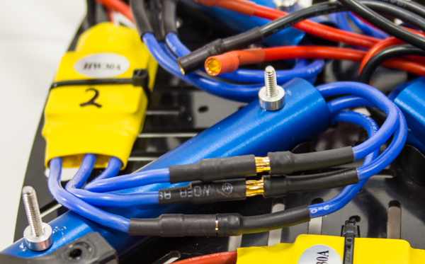
- ​Switch the Extension Wires for one another, and plug them back in. You have now reversed (corrected) the Motor’s spin direction.
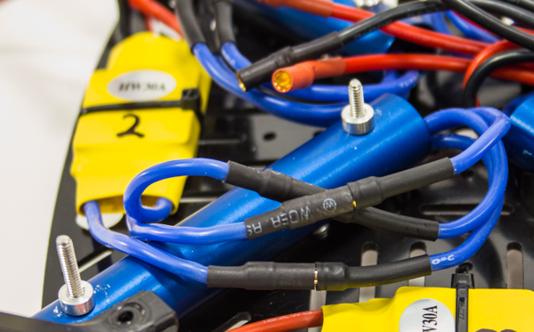
- Repeat Instructions 1-8 as necessary for the three remaining Motors/ESCs.

Step 24: Configure the Flight Controller
The Flight Controller (FC), in this case the HoverflyOPEN, is the "brain" of the ELEV-8. The Parallax Propeller 1 microcontroller mounted on it receives signals from the radio receiver that it processes, in conjunction with data from the onboard three-axis gyroscope, to keep the ELEV-8 in stable flight. Before it can do all this, it must be configured for the ELEV-8 using a computer.
Warning! Printed circuit boards (PCBs) are sensitive to accidental electro-static discharge (ESD), which can destroy the electronics. To minimize this risk, avoid synthetic clothing, and touch a faucet or other grounded metal object before handling.

Tools Needed
- Computer with Windows operating system and Internet access
- USB (A) to USB Mini (B) Cable (not included)

Parts Needed
- HoverflyOPEN Board (#31500)
Warning! Do not connect any batteries to the HoverflyOPEN board while it is connected to your computer, as this will overload the board.

Instructions
- Follow this link [22] to directly launch the Hoverfly Firmware Update Client.
- You may get a warning dialog such as "This type of file can harm your computer. Do you want to keep Hoverfly Firmware Update Client.application?". Click "Keep"/"Yes".
- Once the download has completed, click on "Hoverfly Firmware Update Client.application" (usually at the bottom of your screen or in your downloads folder).
- If you encounter an error stating that you do not have the prerequisite software, follow this link [23] to Hoverfly's client download page and click "Install" on the bottom of the page to obtain it.
- You may encounter a security warning that the "Publisher cannot be verified...". Click "Install".
- Once the installation has completed, the "Hoverfly Update Client" window should appear.
- Remove the HoverfyOPEN from its ESD-safe bag.
- Plug your USB mini cable into the USB port on your HoverflyOPEN board and plug the other end into your computer. The board will beep periodically and the LED will flash.
- Click "Next" on the bottom of the Hoverfly Update Client window and read and agree to the Hoverfly License Agreement. Then click "Next".
- On the drop-down list under "Board" select "HF Open". Then click "Next".
- On the drop-down list under "Mode" select "X". Then click "Next".
- Now make sure the HoverflyOPEN board is connected to your computer (this should not take more than 30 seconds). If it does not connect, you may need to download more current drivers using the link provided. Note: your board will not match the picture provided. Then click "Next".
- On the drop-down list under "Software Version" select "2.0". Then click "Flash".
- Once the flash has finished and the "Flash Log" reads "Success", you may disconnect your board from your computer and exit the Hoverfly Update Client.
- Return the HoverflyOPEN to its ESD-safe bag.

Section 6: Final Wiring and Attaching the Bottom Chassis Plate
With the ESC/Motor direction properly configured, you are ready to secure all of the wires in preparation for mounting the Bottom Chassis Plate.
This section will take approximately 30 minutes to 1 hour, depending on skill level and equipment.

Tools Needed in this Section
- Flat-Nose Pliers
- Diagonal Cutters ("Dikes") or Scissors
- #1 Philips Head Screwdriver
- 1/4" Wrench, 1/4" Socket, or Adjustable Wrench

Parts Needed in this Section
- ELEV-8 assembly, prepared in Step 21
- 4 – Zip Tie, 4” (#700-00093)
- 1 – Bottom Chassis Plate (#721-80003)
- 8 – Saddle Washer, 3/4” (#712-00010)
- 8 – Locknut, #4-40 (#700-00024)
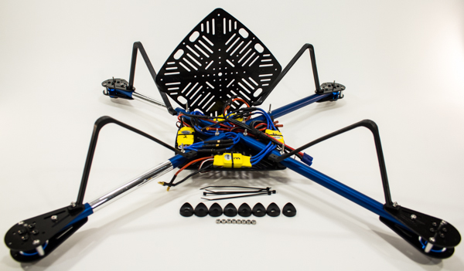

Step 25: Route ESC Signal Cables through Chassis
The ESC signal cables eventually have to be plugged into the Flight Controller. Since the ESCs are on the opposite side of the Top Chassis Plate from the Flight Controller, they first must be fed through a slot in the Top Chassis Plate before they can be connected.

Parts Needed
- ELEV-8 assembly, prepared in Step 21

Instructions
- Orient the ELEV-8 so that it is upside-down and facing away from you.
- Feed the signal cable from the #3 ESC underneath the Wire Harness and the blue wires, towards the center of the Chassis.
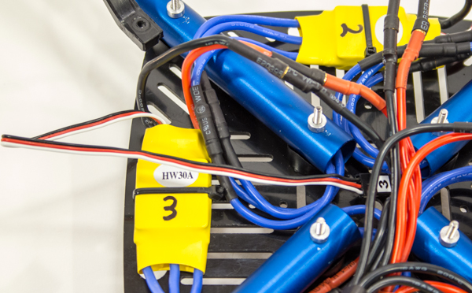
- Now feed the cable towards the #2 ESC, keeping it under the wire harness and all the blue wires, as shown below.
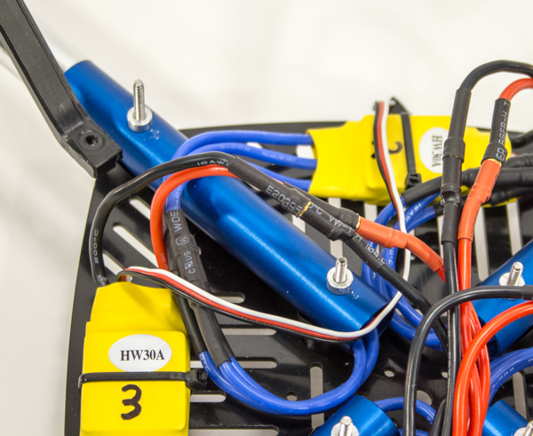
- Repeat Instructions 2 and 3 with ESCs #1 and #4; feeding the signal cable to the center and then towards ESC #2.
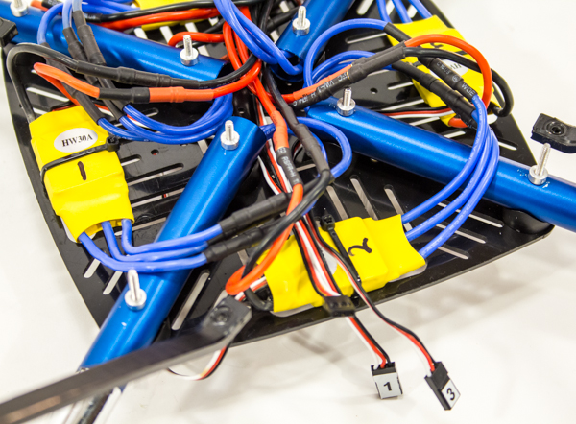
- One by one, push the wires through one of the slots in the Top Chassis Plate just to the right of the ESC #2.
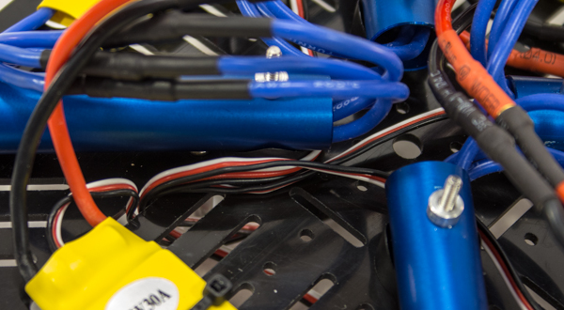
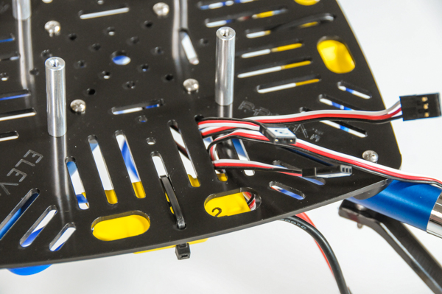

Step 26: Route and Secure all other Wires
Before bolting on the Bottom Chassis Plate, you need to secure all of the wires so that they do not get pinched by the plate or come loose during flight.

Tools Needed
- Flat-Nose Pliers
- Diagonal Cutters ("Dikes") or Scissors

Parts Needed
- 4 – Zip Tie, 4” (#700-00093)
- ELEV-8 assembly, prepared in Step 25

Instructions
- Orient the ELEV-8 so that it is upside-down and facing away from you. Situate the Wire Harness so that it matches the image below. Be sure that only the blue ESC output wires run over the Booms.
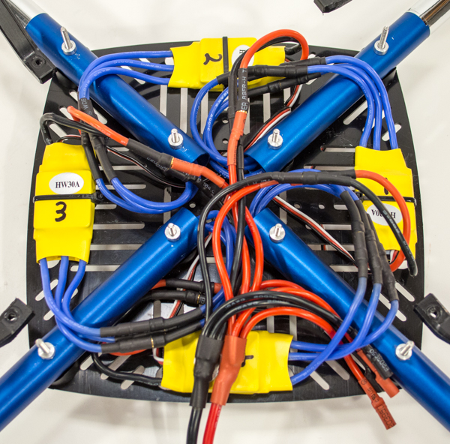
- Use a zip tie to secure the Extension Wires running into Boom #4 to the input wires for ESC #1.
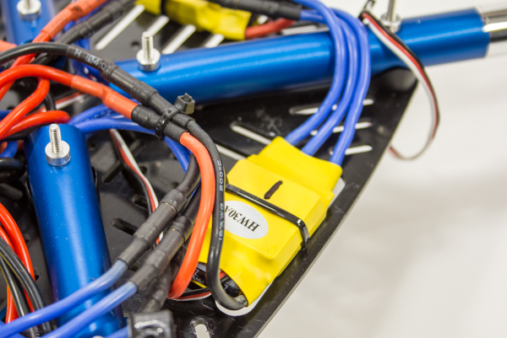
- Use another zip tie to secure the Extension Wires running into Boom #1 to the input wires for ESC #2.
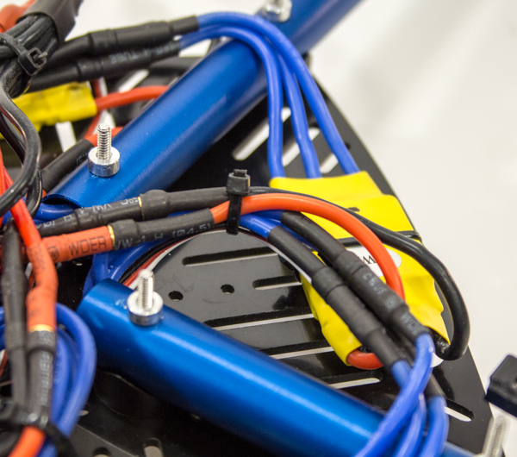
- Use another zip tie to secure the Extension Wires running into Boom #2 to the input wires for ESC #3.
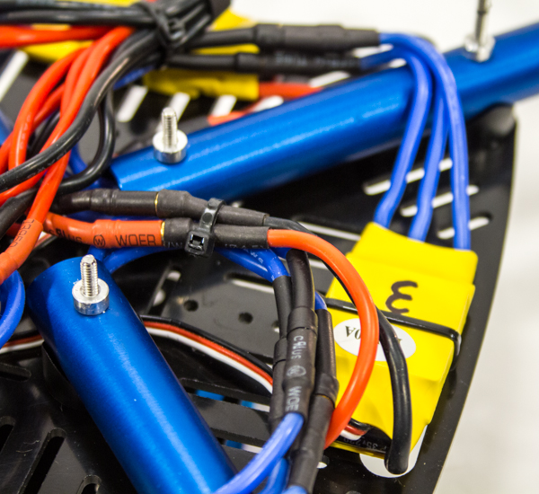
- Use another zip tie to secure the Extension Wires running into Boom #1 to the input wires for ESC #4 and the Wire Harness.
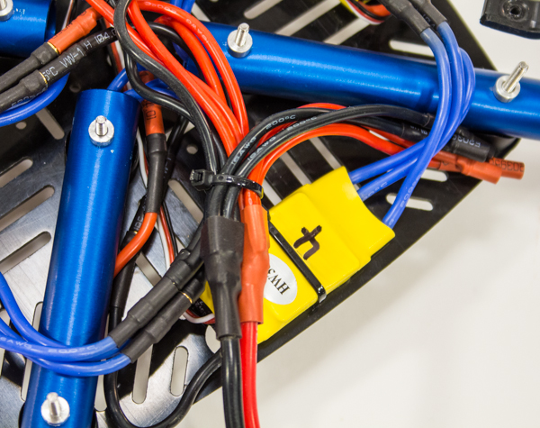
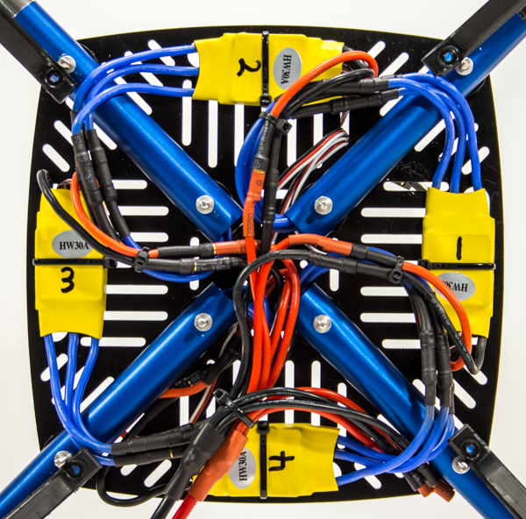

Step 27: Mount Bottom Chassis Plate to Main Assembly
Finally, you can mount the Bottom Chassis Plate to the Main Assembly and secure the Landing Gear.

Tools Needed
- #1 Philips Head Screwdriver
- 1/4” Wrench, 1/4" Socket, or Adjustable Wrench

Parts Needed
- 8 – Locknut, #4-40 (#700-00093)(#1 in drawing below)
- 1 – Bottom Chassis Plate (#721-80003)(#2 in drawing below)
- 8 – Saddle Washer, 3/4” (#712-00010)(#3 in drawing below)
- 4 – ELEV-8 assembly, prepared in Step 26 (#4 in drawing below)

Instructions
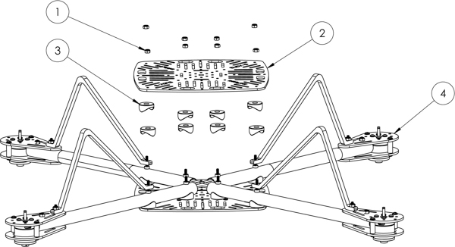
- Orient the ELEV-8 so that it is upside-down and facing away from you.
- Place a saddle washer over each of the screws running through the Booms.
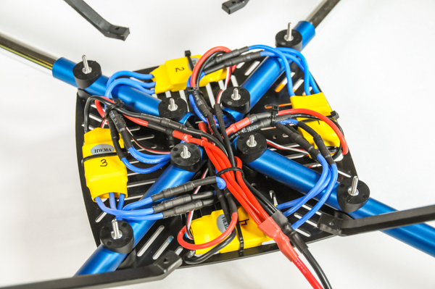
- Slide the Bottom Quad Chassis over the screws, making sure that it doesn’t pinch any wires and that the writing on the plate is facing upwards.
- Thread locknuts onto the four center screws (no need to tighten yet).
- Place the Landing Gear over the outer screws.
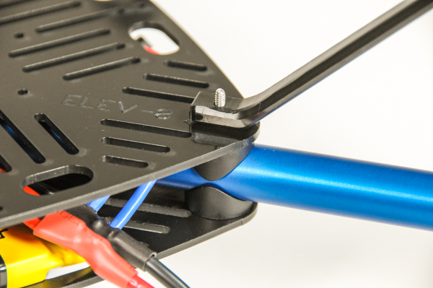
- Thread locknuts onto the four outer screws.
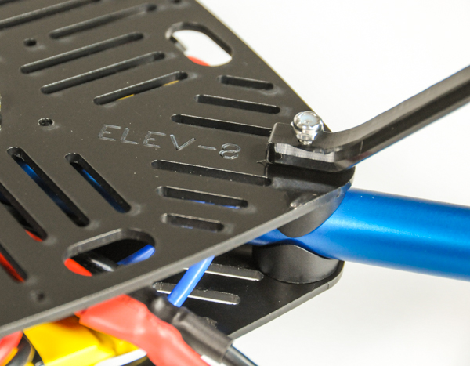
- Use the wrench to tighten all 8 screws. You will need to use the screwdriver to keep the screw-heads (on Top Chassis Plate) from spinning.
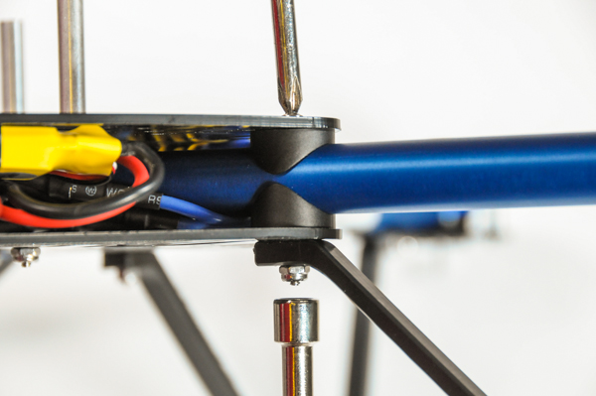

Section 7: Installing the Flight Controller and Receiver
With the mechanical assembly largely completed, it is time to move on to the control system. When you move the joysticks on the transmitter, it broadcasts a radio signal that is picked up by the receiver, which in turn sends the signal to the Flight Controller. It then processes the signal in combination with its internal sensors before sending it to the ESCs, which feed power to the motors. The Flight Controller, which you configured in Section 5 along with the transmitter, is the "heart" of this system, so you will start there.
This section will take approximately 45 minutes to 1 hour 30 minutes, depending on your skill level and equipment.

Tools Needed in this Section
- #1 Philips Head Screwdriver
- 1/4” Wrench, 1/4" Socket, or Adjustable Wrench
- Wire Cutters or Diagonal Cutters (“Dikes”)
- Sharp Knife, Razor Blade, or Sandpaper (between 80 and 200 grit)

Parts Needed in this Section
- 1 – Hoverfly OPEN Flight Controller w/ Grommets (#31500)
- 1 – Flight Controller Mounting Plate (#721-80002)
- 4 – Machine Screw, #4-40 x 1/2" (#710-00006)
- 4 – Metal Washer, #4 (#712-00002)
- 4 – Locknut, #4-40 (#700-00024)
- ELEV-8 assembly, prepared in Step 27
- 1 – Flight Controller Cover Plate (#721-80010)
- 4 – Machine Screw, #4-40 x 1" (#710-00002)
- 4 – Aluminum Spacer, #4 x 1/2" (#713-00007)
- 1 – RC Radio Receiver
- 5 – Servo Cable, 8" (#800-00080)
- 2 – Zip Tie, 4” (#700-00093)
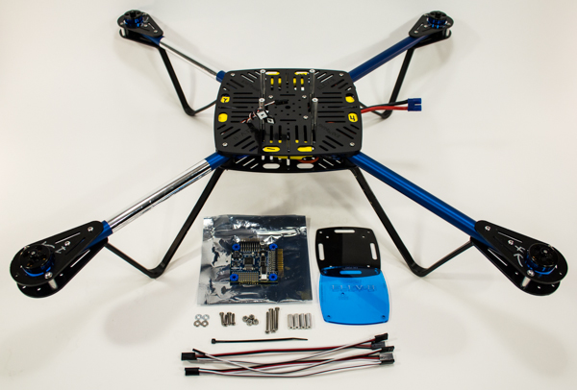

Step 28: Fit Grommets to the Flight Controller
The Flight Controller (HoverflyOPEN) has a gyroscope sensor that is extremely sensitive to vibration, which negatively impacts its accuracy. To reduce such vibrations, the HoverflyOPEN comes with rubber grommets that fit into the mounting holes.
Some boards come with the grommets pre-installed; if that is the case with your HoverflyOPEN, you can skip this step and move onto Step 29.

Parts Needed
- HoverflyOPEN Flight Controller w/ Grommets (#31500)

Instructions
- Remove the HoverflyOPEN from its ESD-safe bag.
- Hold the HoverflyOPEN in one hand, careful not to bend any of the pins.
- Using your other hand, take one of the grommets and squeeze one side as you push it through one of the four grommet holes.
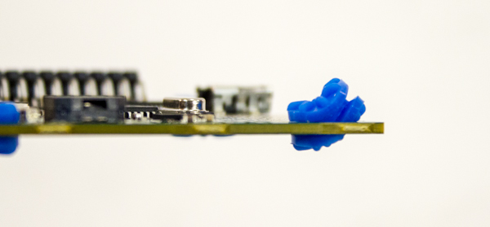
- Push/pull the flanges of the grommet as necessary until it sits properly into the hole.
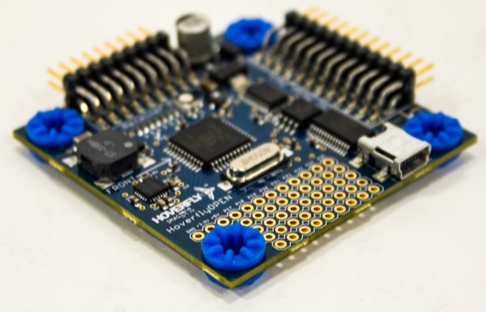

Step 29: Bolt Flight Controller to Bottom Mount
The HoverflyOPEN Flight Controller will now be bolted to the Bottom Plate of its Mount, which will serve to secure and protect it from damage.

Tools Needed
- #1 Philips Head Screwdriver
- 1/4” Wrench, 1/4" Socket, or Adjustable Wrench

Parts Needed
- 4 – Machine Screw, #4-40 x 1/2" (#710-00006)(#1 in assembly drawing below)
- 4 – Metal Washer, #4 (#712-00002)(#2 in assembly drawing below)
- HoverflyOPEN Board with grommets installed, prepared in Step 28 (#4 & #3 in assembly drawing below)
- 1 – Flight Controller Mounting Plate (#721-80002)(#5 in assembly drawing below)
- 4 – Locknut #4-40 (#700-00024)(#6 in assembly drawing below)

Instructions
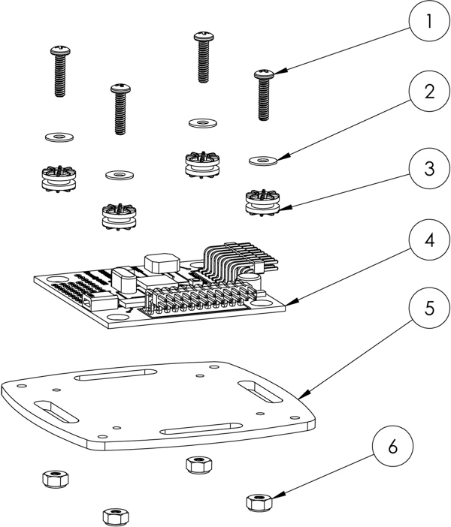
- Place the HoverflyOPEN over the Mount Plate and line up the screw holes.
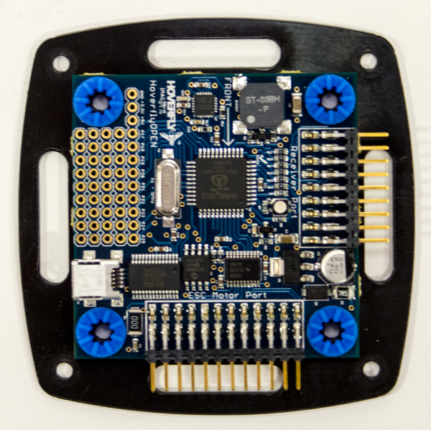
- Slide a washer over a screw, and insert through one of the four holes on the HoverflyOPEN and Mount Plate.
- Thread on a locknut and tighten just until there is no longer a gap. Do not over tighten such that the grommet begins to compress.
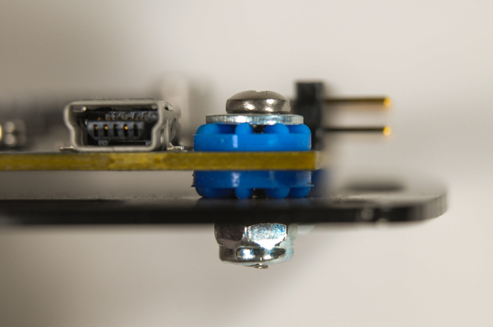
- Repeat instructions 2 and 3 for the remaining holes.
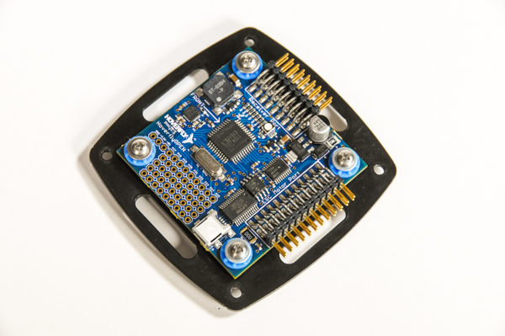

Step 30: Mount FC Assembly to Top Chassis Plate
Now you will mount the HoverflyOPEN Flight Controller assembly and the Flight Controller Cover Plate to the ELEV-8 assembly.

Tools Needed
- #1 Philips Head Screwdriver

Parts Needed
- 4 – Machine Screw, #4-40 x 1" (#710-00002)(#1 in the assembly drawing below)
- 1 – Flight Controller Cover Plate (#721-80010)(#2 in the assembly drawing below)
- 4 – Aluminum Spacer, #4 x 1/2" (#713-00007) (#3 in the assembly drawing below)
- HoverflyOPEN Flight Controller assembly, prepared in Step 29 (#4 in the assembly drawing below)
- ELEV-8 assembly, prepared in Step 27 (#5 in the assembly drawing below)

Instructions
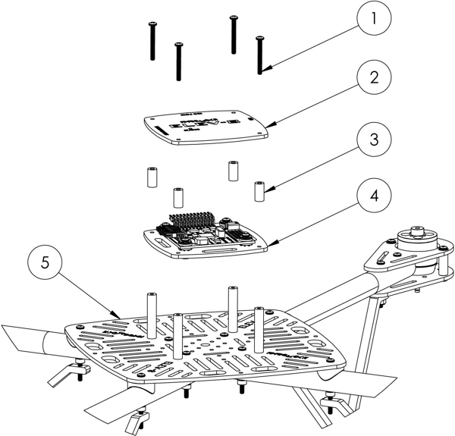
- Orient the ELEV-8 so that it is upright and facing away from you (the Booms with Chrome Stickers are farthest from you).
- Slide the four screws through the FC Top Plate, then slide on the four spacers.
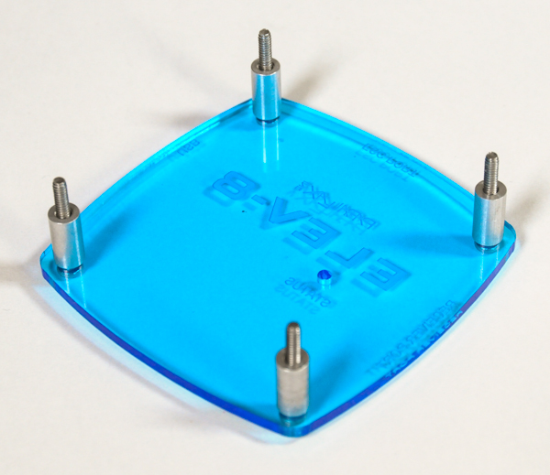
- Place this assembly over the FC/mount assembly, lining up the holes with the screws. Make sure that the arrow on the FC points away from you when the writing on the Top Plate is oriented towards you.
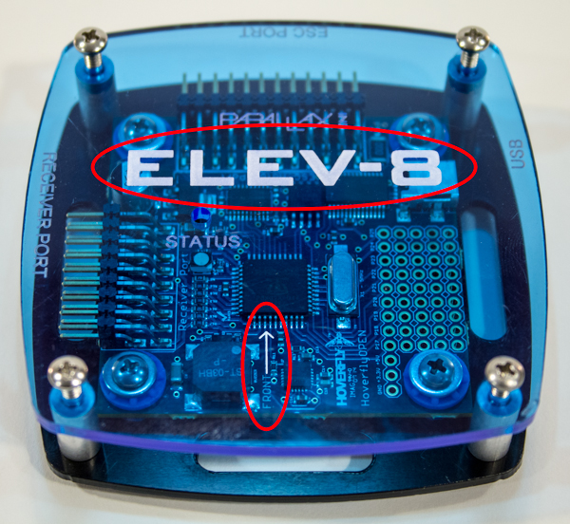
- Take this assembly and place it over the standoffs on the ELEV-8 assembly. With the ELEV-8 oriented as instructed above, the arrow on the FC must point away from you (towards the front of the ELEV-8).
- Thread the screws into the standoffs with your screwdriver, just until snug. Do not overtighten.
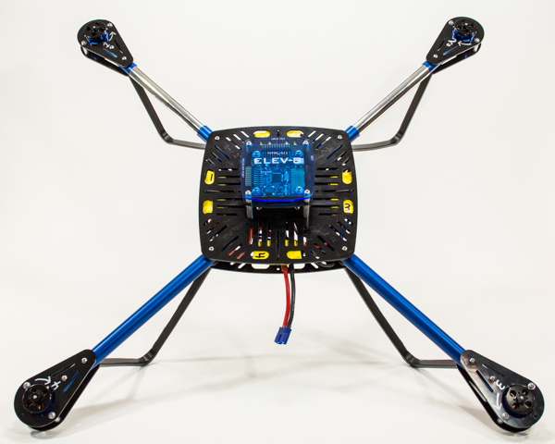

Step 31: Connect ESC Signal Cables to Flight Controller
You will now begin making the final connections between the flight electronics and HoverflyOPEN flight controller, starting with the Signal Cables for the Electronic Speed Controllers.

Parts Needed
- ELEV-8 Assembly, prepared in Step 30

Instructions
- Orient your ELEV-8 so that it is upright and facing towards you.
- Locate the pins of the "ESC Port" (as labeled on the Flight Controller Cover Plate) on the front of the HoverflyOPEN Flight Controller (the side closest to you).
- Take the ESC Signal Cable that you labeled “3” and insert into the bottom left pins, oriented horizontally so that the black wire is to the left and white wire is to the right.
- Plug in the three remaining Signal Cables maintaining the same orientation and using the image above for the correct order.
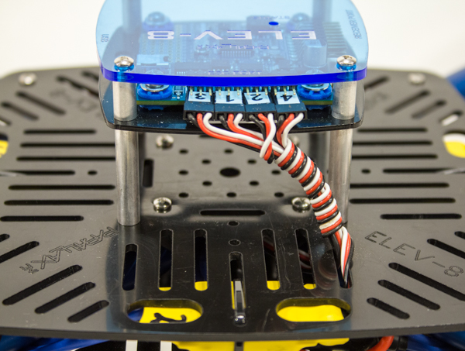

Step 32: Connect Receiver Signal Cables
In this step you will connect the Signal Cables for the receiver to both the HoverflyOPEN Flight Controller and the Receiver.

Tools Needed
- Sharp Knife, Razor Blade, or Sandpaper (between 80 and 200 grit)

Parts Needed
- 1 – RC Radio Receiver (Images provided are of Orange RX receiver; your receiver may differ)
- 5 – Servo Cable, 8" (#800-00080)
- ELEV-8 Assembly, prepared in Step 31

Instructions
- Take your receiver and determine the correct orientation to plug the cables into the unit. Many receivers have some sort of symbol such as “^ + –” to indicate orientation, where ^ corresponds to the white signal wire, + corresponds to the red positive wire, and - corresponds to the black negative wire. On most Spektrum, Orange RX, and Futaba Receivers, the white signal wires are on “top” as is the case in the image below.

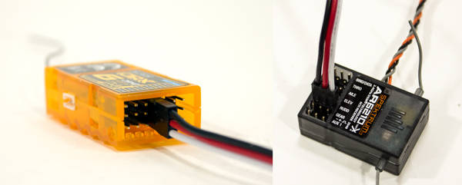
- You may have to trim the bottom two edges of the Signal Cables at an angle to fit them in the receiver (not necesssary for OrangeRX recievers, necessary for Spektrum recievers). This can be done by either shaving the two corners down with a sharp blade, or sanding them with sandpaper. The result should appear as shown in the third image below.
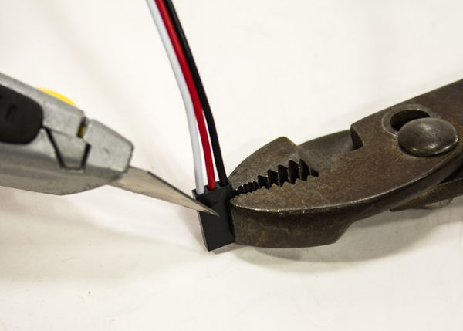
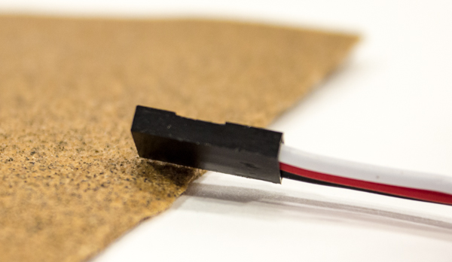
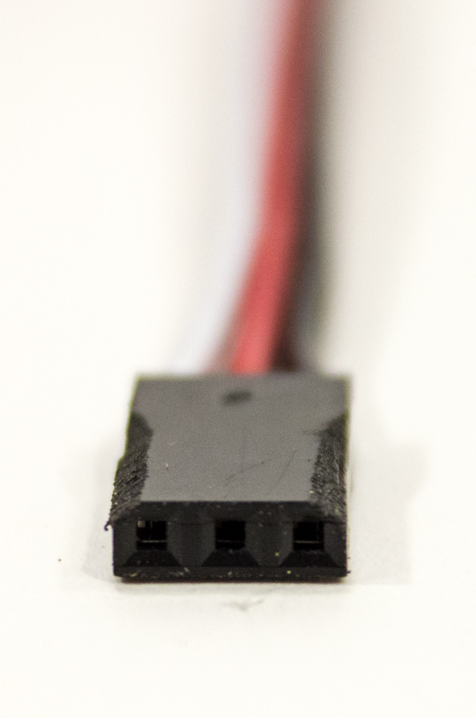
- Plug a Signal Cable into the Throttle, Aileron, Elevator, Rudder, and Gear Channels (often abbreviated as THRO, AILE, ELEV, RUDD, and GEAR, respectively), keeping the orientation you determined in Instruction 1.
- Now, locate the pins for the receiver Signal Cables on the left side of the HoverflyOPEN Flight Controller (below where "Reciever Port" is written on the top plate).
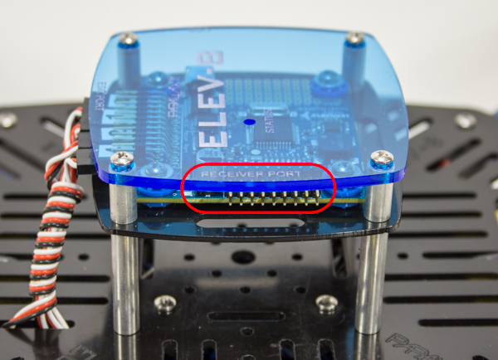
- Using the image below as a reference, carefully plug the cables in, paying close attention to orientation and order.

Step 33: Mount Receiver to Top Chassis Plate
With the receiver wired to the HoverflyOPEN Flight Controller, it is time to mount it to the Top Chassis Plate where it will be out of the way of the battery and where the bind plug is still accessible.

Tools Needed
- Diagonal Cutters (“Dikes”) or Scissors

Parts Needed
- 2 – Zip Tie, 4” (#700-00093)
- ELEV-8 Assembly, prepared in Step 32

Instructions
- Use your fingers to bend the tip of the zip tie into the shape shown below.
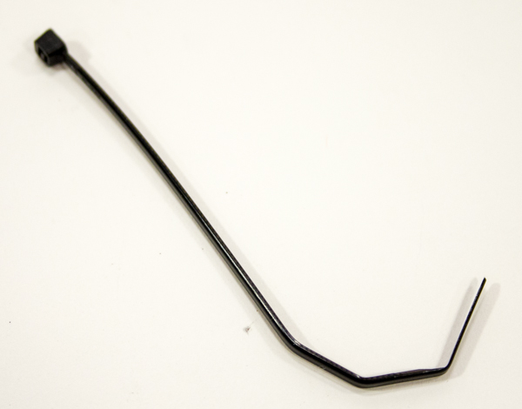
- Feed the zip tie through the back left corner of the Top Chassis Plate, as shown below. If you are using a different receiver, you may need to alter the spacing of the zip tie, and thus the slot through which you put it.
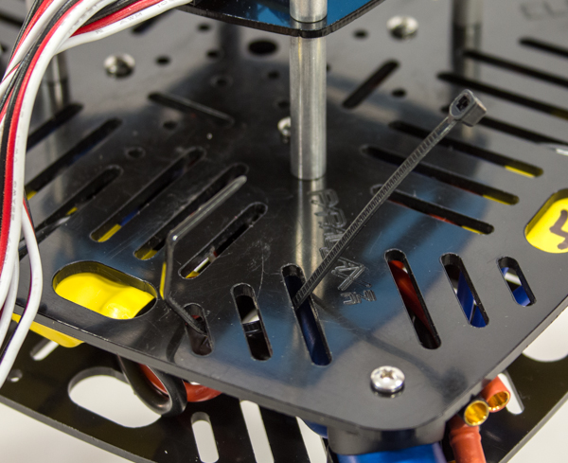
- Place the receiver in the zip tie and tighten.
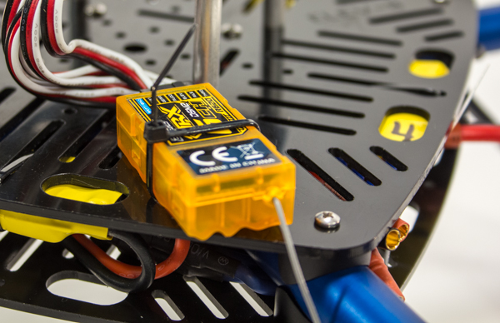
- Cut off the “tail” of the zip tie.
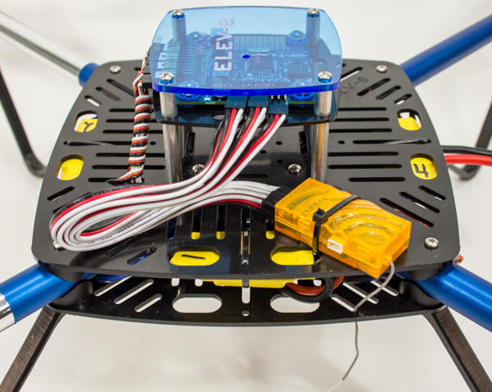

Instructions for Satellite Receiver
If your Receiver came with a satellite module, you can mount it as shown below.
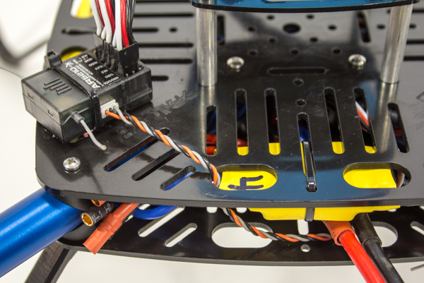
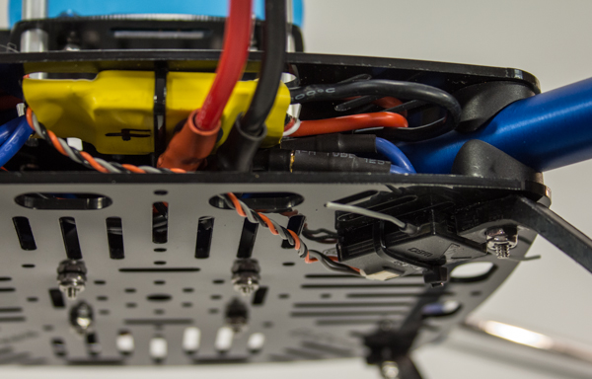
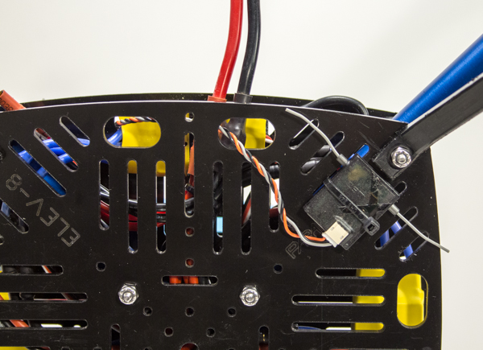

Section 8: Attaching the Battery
It is now time to add the battery straps and foam pads (foam pads are optional), then secure the LiPo battery into the ELEV-8 Chassis. The priority here is to ensure that the battery will not move or shift during flight, as this would result in the ELEV-8 becoming unbalanced and increasing the likelihood of a crash.
This section will take approximately 10 to 30 minutes, depending on your skill level and equipment.

Tools Needed
- Scissors

Parts Needed in this Section
- ELEV-8 assembly, prepared in Step 33
- 2 – Hook & Loop Strap (#900-00021)
- 2 – Adhesive-Backed Foam Padding, approximately 1" (2.5 cm) wide, 2" (5 cm) long, and 3/8" (1cm) thick, (optional, weather-stripping works great)
- 1 – LiPo Battery, prepared in Step 5
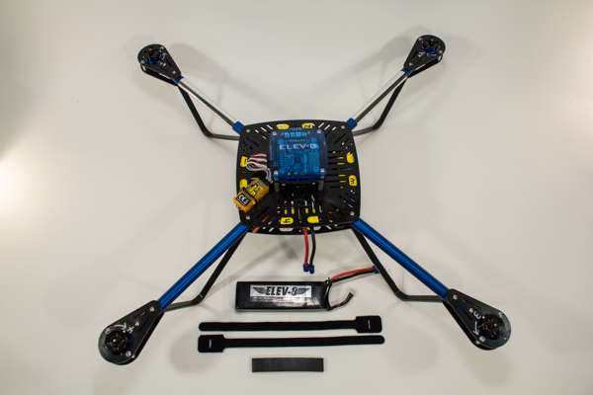

Step 34: Mount Foam Pads to Top Chassis Plate (optional)
While the two hook and loop straps normally secure the battery well, some users prefer the extra security provided by the addition of two foam pads underneath the battery. Adding the foam pads more firmly secures the battery in place and also works to prevent slipping. For this reason, this step is optional and the foam padding is not included in the kit of parts.

Tools Needed
- Scissors

Parts Needed
- ELEV-8 assembly, prepared in Step 33
- 2 – Adhesive-Backed Foam Padding, approximately 1" (2.5 cm) wide, 2" (5 cm) long, and 3/8" (1cm) thick, (weather-stripping works great)

Instructions
- Orient the ELEV-8 so that it is upright and facing away from you.
- Remove the protective paper backing from one of the pieces of Foam Padding and attach to the Top Chassis Plate just behind the Flight Controller, as shown in the figure below.
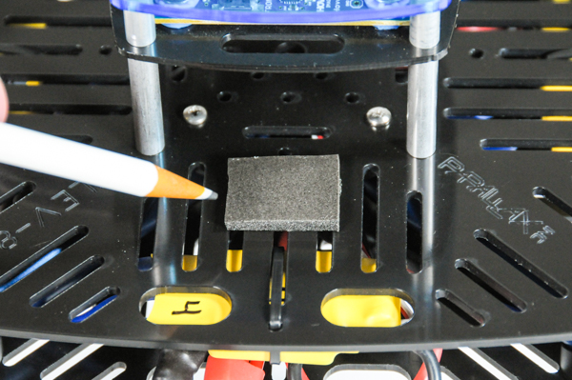
- Turn the ELEV-8 around so that it is now facing you.
- Remove the protective paper backing from the other piece of Foam Padding and attach to the Top Chassis Plate just in front of the Flight Controller, as shown in the figure below.
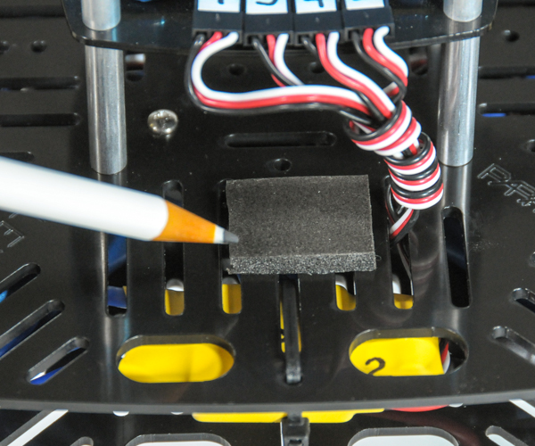

Step 35: Thread Straps through Chassis
You will now thread the two straps used to secure the battery through the Chassis.

Parts Needed
- ELEV-8 assembly, prepared in Step 34
- 2 – Hook & Loop Strap (#900-00021)

Instructions
- Orient the ELEV-8 so that it is upright and facing you.
- Taking the narrow end of one of the straps, feed it through the slot in the Top Chassis Plate shown in the image below, and all the way through the Chassis.
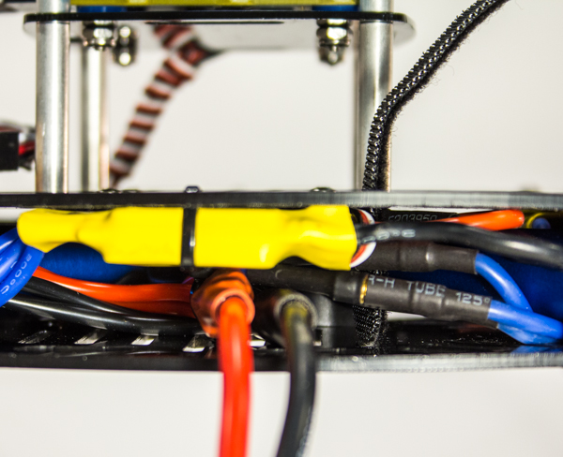
- Insert the strap back into a slot six spaces away from the current one, and feed it up through the Chassis.
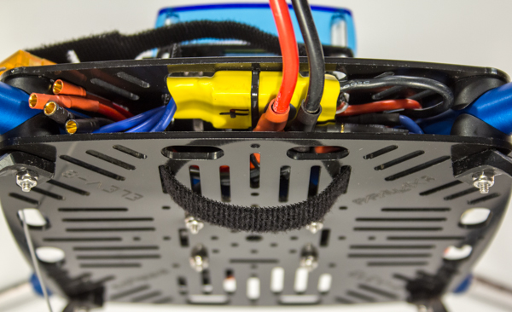
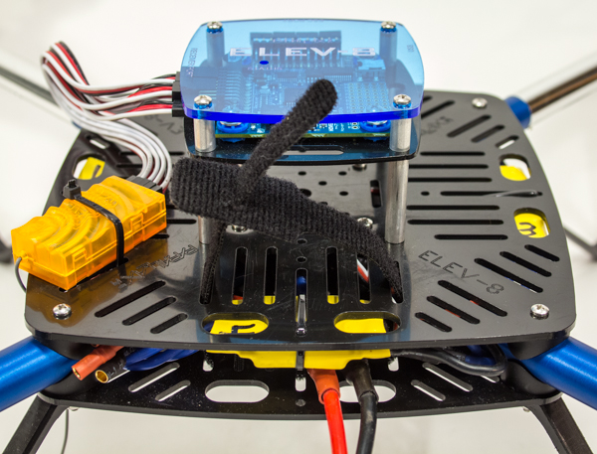
- Turn the ELEV-8 so that it is upright and facing away from you.
- Use the same procedure to install a second strap on the side of the Flight Controller now facing you.
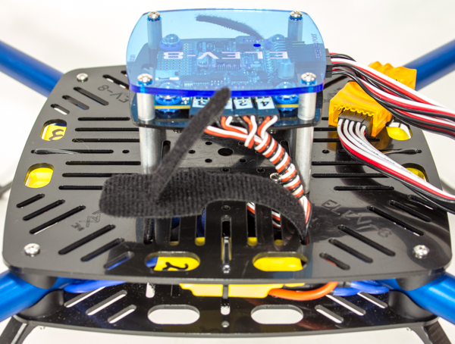

Step 36: Secure Battery into Chassis
It is now time to install the battery into its position on the Chassis. Thanks to the hook-and-loop straps, it can be easily removed for charging and storage.

Parts Needed
- ELEV-8 assembly, prepared in Step 35
- 1 – LiPo Battery, prepared in Step 5

Instructions
- Orient the ELEV-8 so that it is upright and facing away from you.
- Slide the battery under the Flight Controller mount, so that the battery leads face the back of the ELEV-8.
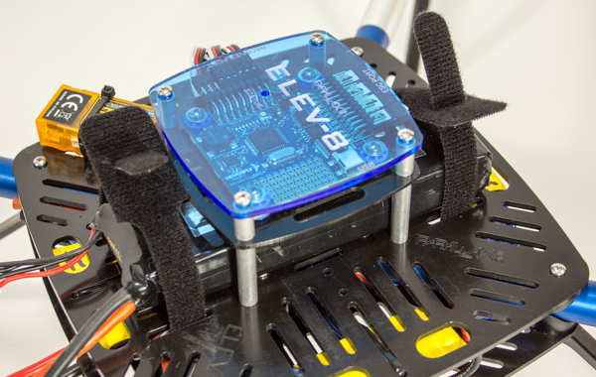
- Take one end of the strap in each hand and pull firmly apart and slightly up to tighten, and then push down to secure.
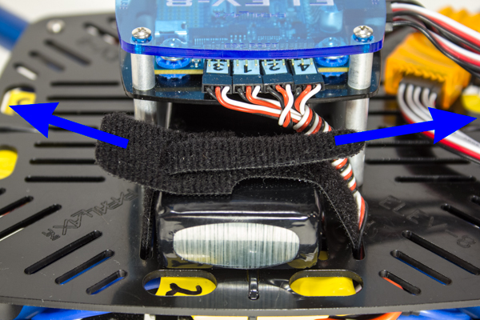
- Repeat instructions 2-3 for the remaining battery strap.
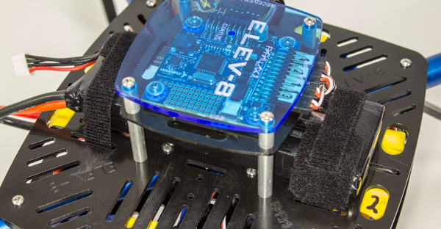

Section 9: Synchronizing the ESCs and Mounting the Propellers
In this final section of electro-mechanical assembly, you will synchronize the ESCs, perform a range check of the radio control system, and then bolt on the Propeller adapters and Propellers.
This section will take approximately 15 minutes to 1 hour, depending on your skill level and equipment.

Tools Needed in this Section
- #1 Philips Head Screwdriver
- 5/16" Wrench, 5/16" Socket, or Adjustable Wrench
- Flat-Nose Pliers

Parts Needed in this Section
- RC Radio Transmitter, prepared in Step 22
- LiPo Battery, prepared in Step 5
- 4 - Propeller Adapter Locknut, included with each motor (#1 in assembly drawing below)
- 4 - Propeller Adapter Washer, included with each motor (#2 in assembly drawing below)
- 2 – 1045C (Clockwise) Propeller (#721-80000)(#3 in assembly drawing below)
- 2 – 1045CR (Counter-Clockwise) Propeller (#721-80001)(#3 in assembly drawing below)
- 16 - Flat Head Phillips Screws, M2 x12mm, included with each motor (#4 in assembly drawing below)
- 4 - Propeller Spacer Ring, included with each propeller (#5 in assembly drawing below)
- 4 – Propeller Adapters, included with each motor (#6 in assembly drawing below)
- ELEV-8 Assembly, prepared in Step 36 (#7 in assembly drawing below)
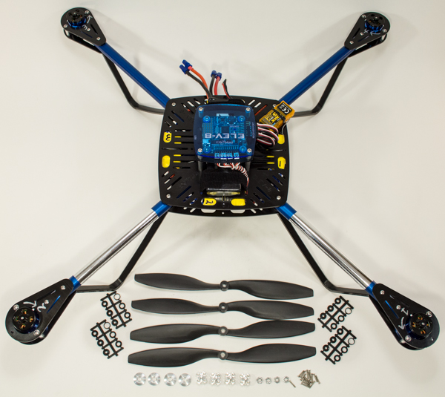
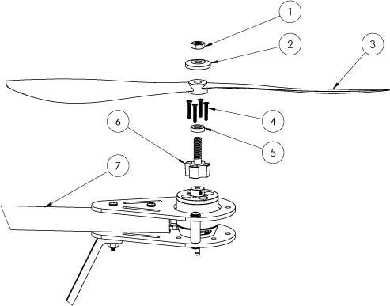

Step 37: ESC Synchronization and Range Check
Before attaching the Propellers, you must synchronize the maximum and minimum throttle signal between the ESCs and your transmitter. Then, you need to perform a radio control system range check, which will ensure that your transmitter and receiver are working properly. This step is often overlooked, but failing to perform this check can be have significant, and often dangerous, consequences.

Parts Needed
- RC Radio Transmitter, prepared in Step 22
- Manual for your RC Radio Transmitter
- LiPo Battery, prepared in Step 5
- ELEV-8 Assembly, prepared in Step 36

Instructions
- Turn your transmitter on and make sure your 5th channel is in the correct value. For Spektrum DX6i Transmitters, the gear switch should be on; for Spektrum DX8 Transmitters, the gear switch should be off.
- Make sure that the trim on the throttle channel of your transmitter is at zero. The LiPo battery on your ELEV-8 should not be plugged in yet.
- Move the throttle stick all the way up to maximum throttle and leave it there.
- Connect your battery to the Power Breakout Cable to supply power to the ELEV-8.
- You will hear two beeps. Imediatly after the beeps, move the throttle all the way down. You should hear one more long beep, confirming the ESCs have been synchronized correctly.
- Power-cycle the ELEV-8 by unplugging the battery then plugging it back in.
- Follow the instructions in your RC radio transmitter manual to perform a range check.

Range Check Instructions for Spektrum DX8 Transmitters.
- Stand about 30 paces (90 feet/30 meters) away from your powered ELEV-8.
- Face your ELEV-8 with your transmitter in normal flying position.
- Go to the "Range Test" screen from the "Function List."
- Press the "Trainer/Bind" button on the top of the transmitter. This will cause a reduction in the output signal power.
- You should have full control of your ELEV-8 from this distance. You should be able to arm/disarm the model by sweeping the left stick from bottom left to bottom right. If you do not have full control, do not fly the model! Some component of your system is malfunctioning and you should begin troubleshooting.

Step 38: Bolt Propeller Adapters to Motors
The Propeller adapters allow you to easily attach and remove the Propellers, and ensure that they stay centered on the Motors.

Tools Needed
- #1 Philips Head Screwdriver

Parts Needed
- ELEV-8 Assembly, prepared in Step 37
- 16 - Flat Head Phillips Screws, M2 x12mm, included with each motor
- 4 – Propeller Adapters, included with each motor

Instructions
- Remove the nut and washer from the top of each Propeller adapter and set aside for use in the next step.
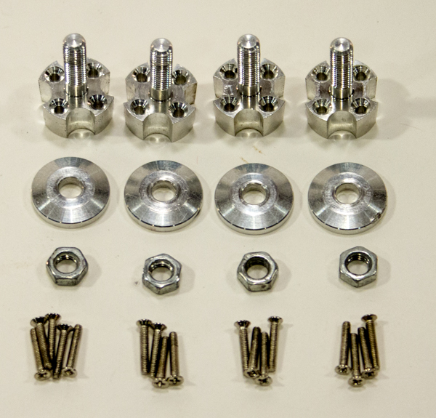
- Place a Propeller adapter over the top of a Motor, and align the screw holes with the motor.
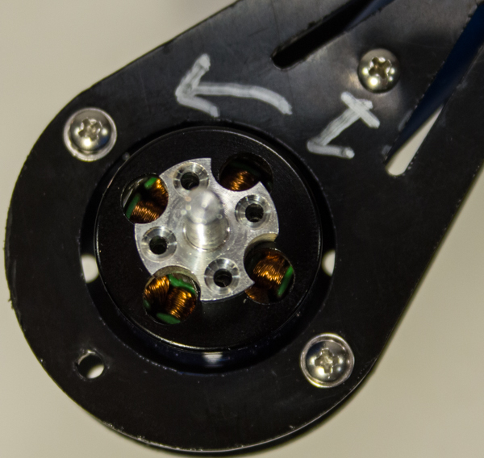
- Use the supplied screws to bolt the Propeller adapter to the motor with the screwdriver. Tighten each screw until you begin to feel resistance, and then turn 1/8 of a turn more.
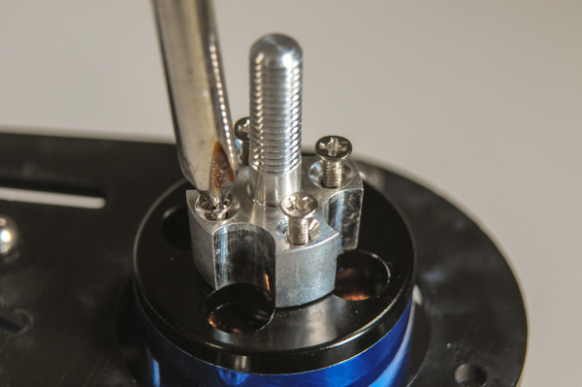
- Repeat for the remaining three motors.

Step 39: Attach Propellers to Propeller Adapters
This is it. You’ve made it. All that’s left is to attach the Propellers in their correct positions (the #1 most common mistake), and you are done!
Warning! The Propellers are sharp, so handle with care.

Tools Needed
- 5/16" Wrench, 5/16" Socket, or Adjustable Wrench
- Flat-nose Pliers

Parts Needed
- 4 – Propeller Adapter Nuts
- 4 – Propeller Adapter Washers
- 2 – 1045C (Clockwise) Propeller (#721-80000)
- 2 – 1045CR (Counter-Clockwise) Propeller (#721-80001)
- 4 - Propeller Spacer Ring, included with each propeller (#5 in assembly drawing below)

Instructions
- Remove the spacer rings from the Propeller bags and place the one indicated in the figure below over each Propeller adapter shaft.
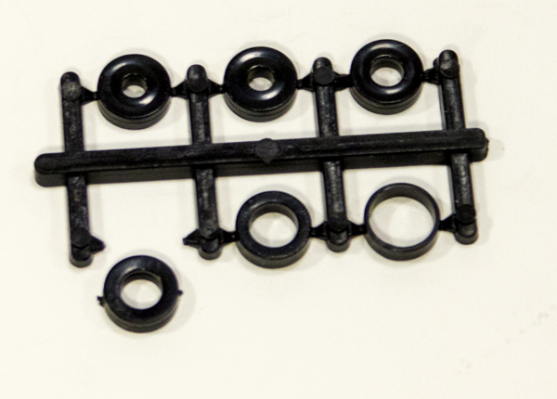
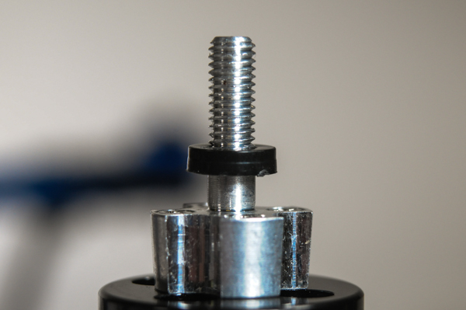
- Attach a 1045C Propeller to Motor #1. Place the Propeller over the adapter shaft so that the small writing near the center of the Propeller is upright, as shown in the image below (the sharper edges of the Propeller should be on the bottom). Place a washer over the Propeller so that the flat side is down. Thread a nut onto the adapter and tighten until it makes contact with the washer and Propeller, and the resistance increases; then tighten another 1/4 turn.
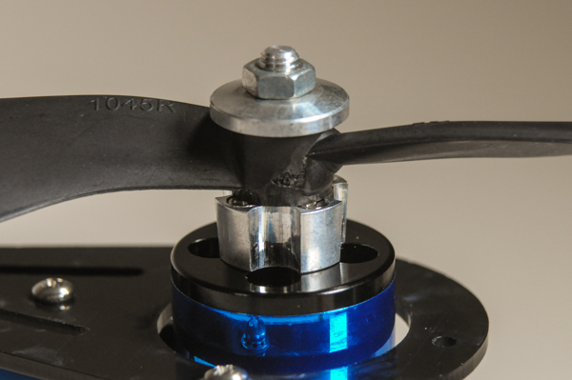
- Using the same procedure, attach a 1045C Propeller to Motor #3. Attach a 1045CR Propeller to Motors #2 and #4.
VISIT THE FORUMS ♦ SHOP IN THE STORE
Terms of Use ♦ Feedback: learn@parallax.com ♦ Copyright©Parallax Inc. 2014 (unless otherwise noted)

Source URL: http://www.learn.parallax.com/elev-8-v2-quadcopter-assembly-guide
Links:
[1] http://www.parallax.com/support
[2] mailto:sales@parallax.com?subject=80200%20Missing%20Components
[3] http://www.learn.parallax.com/sites/default/files/content/ELEV-8/Tools/tool_strippers.jpg
[4] http://www.learn.parallax.com/sites/default/files/content/ELEV-8/Tools/tool_ruler.jpg
[5] http://www.learn.parallax.com/sites/default/files/content/ELEV-8/Tools/tool_solderingiron.jpg
[6] http://www.learn.parallax.com/sites/default/files/content/ELEV-8/Tools/tool_solder.jpg
[7] http://www.learn.parallax.com/sites/default/files/content/ELEV-8/Tools/tool_clamp.jpg
[8] http://www.learn.parallax.com/sites/default/files/content/ELEV-8/Tools/tool_block.jpg
[9] http://www.learn.parallax.com/sites/default/files/content/ELEV-8/Tools/tool_etape.jpg
[10] http://www.learn.parallax.com/sites/default/files/content/ELEV-8/Tools/tool_heatgun.jpg
[11] http://www.learn.parallax.com/sites/default/files/content/ELEV-8/Tools/tool_flathead.jpg
[12] http://www.learn.parallax.com/sites/default/files/content/ELEV-8/Tools/tool_screwdriver.jpg
[13] http://www.learn.parallax.com/sites/default/files/content/ELEV-8/Tools/tool_pencil.jpg
[14] http://www.learn.parallax.com/sites/default/files/content/ELEV-8/Tools/tool_marker.jpg
[15] http://www.learn.parallax.com/sites/default/files/content/ELEV-8/Tools/tool_scissors.jpg
[16] http://www.learn.parallax.com/sites/default/files/content/ELEV-8/Tools/tool_wrench1.jpg
[17] http://www.learn.parallax.com/sites/default/files/content/ELEV-8/Tools/tool_dikes.jpg
[18] http://www.learn.parallax.com/sites/default/files/content/ELEV-8/Tools/tool_razor.jpg
[19] http://www.learn.parallax.com/sites/default/files/content/ELEV-8/Tools/tool_wrench2.jpg
[20] http://www.learn.parallax.com/sites/default/files/content/ELEV-8/Tools/tool_pliers.jpg
[21] http://www.learn.parallax.com/elev-8-v2-quadcopter-assembly-guide
[22] http://www.hoverflyupdate.com/updateClient/Hoverfly%20Firmware%20Update%20Client.application
[23] http://www.hoverflyupdate.com/updateClient/publish.htm

