University of Minnesota and MN Space Grant Consortium

AEM 1905 Freshman Seminar: Fall 2012
High-Power Rocketry
Team Project Documentation

Redshift Seven
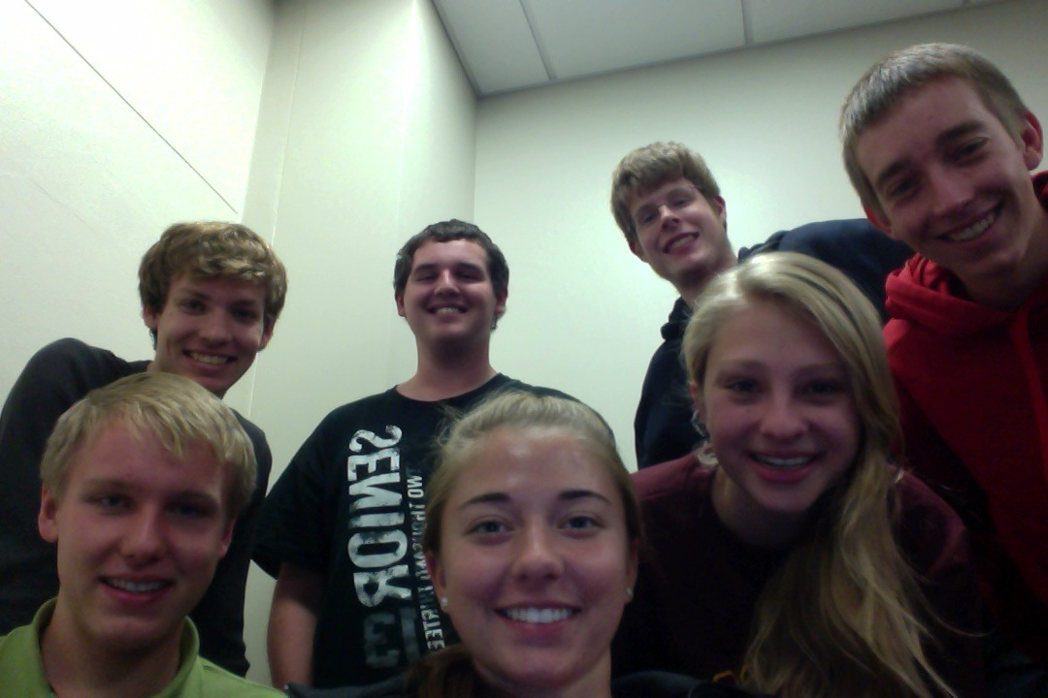

Written by:
Matthew Bruffey, Tyler Kraut, Chad Serba, Mike Siirila, Jacqueline Sotraidis, Zach Tollefson, and Stephanie Wegner

Report Date: 12/11/13
Revision C

Revision Log

Revision | Contents | Due Date
0 | Declaration of Team Assignments | October 22nd
A | Conceptual / Preliminary Design Report | November 4th
B | Construction Progress / Pre-Flight Report | November 20th
C | Post-Flight / Final Report | December 11th

Table of Contents

0.0 Team Roles/Writing Assignments………………………………………………...4
- Introduction 5
- Rocket Design Overview 6
- Rocket Design Specifics 7
- Project Management 15
- Project Budget 17
- Construction Photographs 19
- Failure Modes and Risk Mitigation 23
- Expected Flight Results 25
- Ejection Testing and Launch Day 27
- Results and Analysis 31
- Conclusions and Lessons Learned 33
- Appendix – Supporting Calculations 34

- Team Project Documentation Roles/Writing Assignments (Rev. 0)

Team Name: Redshift Seven

Overall Team Lead: Stephanie Wegner

Other Team Members:
Mike Siirila Zach Tollefson
Tyler Kraut Jacqueline Sotraidis
Chad Serba Matthew Bruffey

Section Lead Authors
Introduction Stephanie Wegner
Rocket Design Overview Mike Siirila
Rocket Design Specifics Mike Siirila & Tyler Kraut
Project Management Stephanie Wegner
Project Budgets Jacqueline Sotraidis
Construction Photographs Tyler Kraut
Failure Modes & Risk Mitigation Zach Tollefson
Expected Flight Results Mike Siirila
Launch Day Matthew Bruffey
Results and Analysis Matthew Bruffey
Conclusions and Lessons Learned Chad Serba
Appendix – Supporting Calculations Zach Tollefson

Oral Presentation Assignment Coordinators
Flight Readiness Review Jacqueline Sotraidis & Stephanie Wegner
Post-Flight Analysis Review Chad Serba & Zach Tollefson

Design/Build/Fly Roles
Overall team lead (AKA “team contact”) Stephanie Wegner
RockSim (simulation) guru Mike Siirila
CAD guru Tyler Kraut & Chad Serba
Budget and parts ordering lead Jacqueline Sotraidis
Construction Lead Stephanie Wegner
Construction Main Photographer Tyler Kraut
Av-bay/altimeter gurus Chad Serba & Jacqueline Sotraidis
GPS tracking installation and use guru Zach Tollefson
Launch day rocket prep lead Mike Siirila
Launch day main photographer Tyler Kraut
Post-launch data analysis lead Matthew Bruffey

- Introduction

High power rocketry is different from simple model rocketry by using higher impulse range motors. Motors are considered higher impulse as they go farther down in the alphabet. Motors known as “high power” are classified under H through O impulses, or 320 to 40,960 Newton seconds. The farther down the alphabet of motors, the more certification one needs to fly them. In high power rocketry, there are 3 levels of certification. Also, there are two main companies in the U.S. that certify people: Tripoli and NAR. One is not able to achieve a level 2 certification before completing level 1, and level 3 can only be gained after level 2. Level 1 certification allows one to fly through an I impulse motor, while level 2 covers J, K, and L motors. Level 2 rockets must be built by the candidate getting certified, and for each level a written test must also be taken. Lastly, level 3 allows one to fly an M or larger motor. A lot of data is required to obtain a level 3 certification and these rockets are typically more expensive.

Each year, the Wisconsin Space Grant Consortium sponsors the Space Grant Midwest Regional Rocketry Competition. The goal of team Redshift Seven will be to design and build a preliminary rocket that can qualify for the competition. The qualifications, including an altitude goal and motor and dimension restrictions, are described in detail in section 2.0. After we fly the rocket, we plan to modify it before the competition in order to more closely reach the altitude goal of 3000 feet. Within our restrictions of motor options, dimensions, and budget, we hope to fly our rocket as close to 3000 feet as possible. In order to do this, we will need a way to manipulate the height our rocket is supposed to reach with the original restrictions. This may include speeding it up by making it as small and light as possible, or slowing it down by making it larger and heavier. The options will be discussed and decided upon as we begin to construct the rocket. After this semester’s preliminary flight, we will be able to adjust the rocket design or weight to fly closer to our goal height of 3000 feet at the competition. We will also leave out some gadgets during the preliminary flight that will be used next semester. These measurement systems will have to report speed vs. altitude as well as acceleration vs. altitude. There are a few recommended on the competition outline, such as flight video and pilot probes, however these will be determined after this semester’s flight. Next semester, we will also adjust the weight added to the rocket according to the altitude it reaches this semester as well as the weight that the new measurement tools take up.

- Rocket Design Overview

The RedShift 7 rocket will be designed to compete in the Wisconsin Space Grant Midwest Regional Rocketry Competition. As such, it must meet the criteria of the competition – namely: utilize one of eight allowed motors, have a diameter between four and six inches, have a maximum length in launch configuration of 72 inches, and utilize a dual deploy, electronic recovery with motor-charge backup. The goal of the competition is to design a rocket that will have a maximum altitude as close as possible to 3000 feet and design a payload that will capture the performance data of the flight using multiple measurement systems. The flight measurement systems will be designed next semester and consequently, the goal for this semester is to design a rocket that will fly to 3000 feet with capacity to carry the future measurement systems.

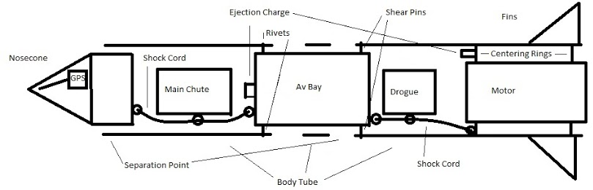
The current design of the RedShift 7 is a 4-inch diameter, 71.175-inch long rocket powered by a Cesaroni 1364-K-454-19A Skidmark motor. A K motor was chosen as the I motor and J motors would have a difficult time achieving the target altitude of 3000 feet. This particular K motor was chosen as it has the lowest total impulse of the available K motors and the rocket tends to go well over the target altitude on the other K motors. The rocket can be separated into a nosecone, main chute bay, altimeter bay, and the drogue chute/motor bay. The drogue chute separation point is between the drogue/motor bay and altimeter bay. As such, wiring will run from the altimeter to an ejection canister lying next to the motor and will be broken upon separation. The main chute separation point is between the drogue bay and nosecone. A 60-inch parachute will be used for the main chute and a 24-inch parachute will be used for the drogue chute. A 12-inch altimeter bay was chosen to allow room for competition instrumentation to be added at a later date. In the meantime, the remainder of the altimeter bay will be filled with a dummy weight. The rocket has a four-fin configuration. Surface rail mounts are utilized for simplicity. The current design utilizes Quantum tubing for all body tubes, G10 fiberglass for the fins, a plastic nosecone, phenolic coupler tubes, motor mount tubes, and altimeter bay, and wood centering rings and bulkheads.

- Rocket Design Specifics

Requirements/Limitations
The rocket must:
· Utilize one of eight allowed motors
· Measure between 4 and 6 inches in diameter
· Measure no more than 72 inches long in launch configuration
· Utilize dual deploy recovery with motor-charge backup
· Reach an altitude as close to 3000 feet as possible
· Be able to accommodate additional avionics that will be added next semester

Trade Studies
Trade Study 1: Motor and dimension combinations for the rocket that will allow it to reach 3000 feet.
The rocket’s basic dimensions will be dependent on the type of motor used. In essence, a sleeker, less massive rocket will be required for less powerful motors because the motor delivers less power. That loss in power will need to be made up in the rocket’s dimensions. The two levels of motors allowed by the competition for use are the K and J class motors.
A K motor is more powerful than a J motor, so there is less of a problem of it reaching the required altitude. However, the major problem lies in it being too powerful. The K motor is capable of reaching 6000 feet, so methods to scale the rocket’s max altitude will need to be studied. A J motor, on the other hand, will require ideal launch conditions and a sleek, light rocket for it to reach 3000 feet.
A table comparing the pros and cons of each motor is below.
Type of Motor | Advantages | Disadvantages
K | Under any practical launch conditions, the rocket will fly higher than 3000 feet | Will need to find methods to stop the rocket at 3000 feet; more expensive
J | Won’t have to deal with airbrakes and drastic overshooting issues | Rocket will need to be much smaller; under windy conditions may not reach 3000 feet

Using the K motor is the safest bet, regardless if the J motor is theoretically able to make the rocket reach 3000 feet. It is easier to find a way to slow a rocket down than it is to make it as small as possible and hope for optimal wind conditions. Now it is necessary to consider the dimensions of the rocket within the constraints of the K motor: the length, diameter, and weight of the rocket. For the competition, the length of the rocket must be less than or equal to 72”, the diameter must be between 4” and 6”, and the weight should fulfill the 5:1 thrust to weight ratio to maintain safety.
To slow the rocket down as much as possible (a K motor could make our rocket reach 6000 feet), we will likely scale the rocket to be as big as possible within financial means. This will slow the rocket down, but some other method for slowing the rocket will be necessary. The absolute maximum dimensions are listed in the table below.
Dimensions | Advantages | Disadvantages
Length (72”) | A longer body increases stability and weight, more room for parts | Slightly more expensive than a shorter one
Diameter (6”) | A larger diameter increases drag | Reduces stability, more expensive than a smaller diameter
Weight (Relatively high) | Higher weight decreases altitude | A 5:1 thrust ratio still needs to be met for safety reasons

After weighing the advantages and disadvantages of these dimensions, we decided that we will build a 72” long rocket with a diameter of 4” and a relatively high weight. A longer rocket adds stability and weight to the rocket and also allows for more room for devices, only at a slightly higher cost than a rocket with a shorter length. We will go with the minimum diameter (4”) because it costs much more for a wider airframe, and the increase in drag gained from the larger diameter can easily be made up for in added weight. We will add as much weight as needed to the rocket while still being within the 5:1 thrust ratio constraint and consistent to safety regulations. Of course reaching 3000 feet is key, but safety is the most important priority.

Trade Study 2: Motor
In the last trade study, we already have decided to use a K motor. This leaves three possible motor choices (all Cesaroni 54 mm) according to competition regulations: K454, K530, K400, or K445.
K454:
Pros – Has 139 pounds of peak thrust. This is one of the highest possible of all K motors we could purchase, so it would get us closer to our 3000 feet target. It also has the lowest total impulse at 1364 Newton seconds.
Cons – Most expensive motor at $114.99
K530:
Pros – Only has 134 pounds of peak thrust. This is the only slightly lower than K454’s 139 pounds.
Cons – It costs $112.95, so it is one of the more expensive motors we are considering. It has a total impulse of 1412 Ns, which will cause it to go higher than the K454.
K400:
Pros – It burns a green color, so that would look cool as we launch it.
Cons – It costs $112.95, which is the same as K530’s cost; and it has a peak thrust of 109 pounds so it would make us go much higher than the K530. It has a total impulse of 1596.7 Ns, which will cause it to go much higher than the K454, which is closest to our 3000 feet target.
K445:
Pros – Costs $106.95, which is the cheapest of all K motors we are considering. Has a peak thrust of 150 pounds, which is the highest possible of all that we are considering. It would get us closest to our 3000 feet target.
Cons – It has the highest total impulse, 1635 Newton seconds, of all the available motors. This will cause it to go a lot higher than our wanted altitude.

MOTOR | PROS | CONS
K454 | 139 lbs. peak thrust, lowest impulse at 1364 Ns. | Most expensive at $114.99
K530 | 134 lbs. peak thrust | Costs $112.95, total impulse of 1412 Ns
K400 | Burns a green color if we purchase this motor | Costs $112.95, peak thrust of 109 lbs., total impulse of 1596.7 Ns
K445 | Costs $106.95, peak thrust of 150 lbs. | Highest total impulse at 1635 Ns.

We have decided to purchase the 1364K454-19A Skidmark motor. It has one of the highest peak thrusts that we are looking for, and our budget can allow for the extra money it costs from the other motor considerations. Most importantly, it has the lowest total impulse, so it will reach the lowest altitude of all the K motors (closest to our 3000 feet target).

Trade Study 3: Airframe Tubing Material

Phenolic | Quantum | Fiberglass Wrapped Phenolic
+Good for base rockets  +About five times stronger than cardboard tubing  -Will not withstand flight about 0.85 Mach for our diameter.  -May need to be strengthened with another material | +Does not have the spiral groves that need to be filled for phenolic  +Very strong, can withstand rough handling and hard landings  + Easier to use than fiberglass  -Should not exceed 0.85 Mach | +Incredibly durable  +Come ready to paint and use  +Ability to withstand flights above Mach 1  -Very heavy  -Very expensive

We have decided to use the quantum airframe for our rocket. The quantum airframe is stronger than the phenolic tubing, giving our rocket the strength and durability needed to withstand multiple flights. It is also less expensive than the fiberglass wrapped tubing, which will save us money. We do not need the rocket to withstand flights above 0.85 Mach, so the fiberglass tubing is unnecessary. The quantum tubing is the perfect choice for the needs of our rocket and the limitations of our budget.

Trade Study 4: Methods to prevent rocket from overshooting the 3000 ft. target height.
In order to prevent the rocket from overshooting the target height of 3000 ft., our team will need some way to slow down the rocket, which with the motor is slightly overpowered. Four main methods will be discussed.

First, one method is to leave open space in the nose cone for additional weights to be added onsite. This method would allow us to change the predicted height of the rocket fairly easily. Using RockSim we would run simulations, varying the surface conditions and changing the vehicle weight to get as close to 3000 ft. as possible. Some concerns include: inaccuracies in RockSim itself. From our previous launch, we know RockSim tends to overestimate how high a rocket will fly for any given condition. Another concern is variation in the engines. Not all engines have exactly the impulse listed on the package; it can vary as much as 10%, according to Gary Stroich. Weighing down the rocket would be unable to compensate with inaccuracies in RockSim and the motors.

A second method is to modify the rocket shape to increase drag and reduce altitude. The most obvious method is to add extra canard/main fins. Doing this would increase the drag of the rocket. Using RockSim we would be able to modify the rocket until its maximum height is 3000 ft. An advantage of this method is it is easy to do, and is over and done with early in construction. However this is also a disadvantage, as we would be unable to modify the rocket to adjust for onsite conditions.

Third, we could purposely rough up the rocket to increase drag. This method is also very easy to do, and would likely not take much time. However this is hard/impossible to model in RockSim, and would therefore make it a guess as to how much it would affect the maximum altitude of our rocket.

A final option is the addition of air brakes. This is the only option considered that is an active system; it has the capability of deploying mid-flight to adjust for changing flight conditions. Because it is an active system, air braking is likely to be the most accurate way of limiting apogee. This method is not without its drawbacks, however. Air brakes are easily the most complicated method considered. Because of the complexity, they would be the most time-consuming and costly of the four methods. Also, they need to be well thought out, because airbrakes need to be low down on the rocket, as to not destabilize it in flight.
Method | Advantages | Disadvantages
Add Weight to nosecone | Simple, can adjust onsite | May be an unreliable way to accurately reach altitude
Add Fins | Very simple/easy to build | Unable to compensate to on-site conditions
Rough up the rocket body | Very Easy | Unable to accurately control, unable to change for varying conditions easily
Air brakes | Active System | The most involved/hardest method to design/build

Our final decision is to add weight to the nosecone in order to limit the rocket’s altitude. We made this choice mainly because it is easier to implement than the air brakes, yet is more precise than the other two options (add fins, rough-up the rocket body). Additionally it is very inexpensive to build; all the required materials are either in the shop or can be purchased cheaply. Finally, this method is much simpler technically to design and manufacture than the airbrake system would be. In summary, we chose to add variable weights to the rocket because it is a low-cost and reasonably precise way to limit the rocket’s apogee.

Trade Study 5: Motor Retention Systems
Motor Retention Method | Pros | Cons
Highly Adaptive Motor Retainer (HAMR) | Durable  Reliable  Easy to use  We used it on our Round One rocket | More expensive than other options $32.95  Might be able to only buy sleeve for $18.95 (separate cap is $17.95 if cap from round one doesn’t work)
Washer and screw | Cheap  Easy to install | No one in the group has experience using it  Requires something to screw into (centering ring may or may not be enough)
Centering Ring with blind nuts | Materials are inexpensive  Relatively easy to build | Needs to be securely screwed into something (centering ring may or may not be enough)  No one has experience with it  It is the most complex thing to build on this list
Aero Pack Quick Change | Similar to HAMR | Requires screws (HAMR does not)  More expensive than HAMR
We decided to go with the HAMR system because we are familiar with it, it is very durable relative to the other systems, and it is a good financial option because we only need to purchase the sleeve since we already have the cap.

Trade Study 6: Fins
When compiling a list of viable fin options, the non-viable option must be identified. Balsa wood fins and plastic fins (used in most low powered rockets) though extremely cheap, are completely insufficient, in terms of strength, for the stress of high-speed flight. Therefore we did not even need to consider them as options.
The first viable option is plywood fins. Plywood would be very cheap to obtain and fairly simple to customize and cut out. However, the amount of plywood required for each to have the necessary strength causes the weight of the fins to be on the high side. Additionally, much sanding would have to be done to make the leading edge small enough to not introduce major air-resistance.
The second viable option is G-10 Fiberglass fins. Since Dr. Flaten already has some sheets, we could buy what we need from him. He could sell it to us by the inch, so we wouldn’t have to pay for an entire sheet we weren’t going to use. G-10 is lightweight and sufficiently sturdy for our purposes. Additionally, since the fiberglass is stronger, it does not have to be nearly as thick as the plywood, so very little sanding is necessary. We will still have to cut the fins out ourselves, which could be slightly more difficult than the plywood and will still take up time.
The third option is to buy pre-fashioned G-10 Fiberglass fins from PML. Again, the G-10 is lightweight and sturdy as mentioned in the previous paragraph. Additionally, we will not have to take the extra time necessary to cut out the fins because they will be cut out already for us. Unfortunately, these pre-made fins will cost a bit more than they would if we cut them out ourselves, and we do not have as much customizability in our fin design.
We decided to buy 4 pre-made G-10 fins from PML in spite of the extra cost because we decided the extra cost was worth the amount of time we would save having to design, trace, and cut out the fins as well as being stronger than the plywood fins (which are generally uncommon in high-powered rocketry). Additionally, the fins we chose also have a PRISM finish which makes them very colorful and reflective, which will aid in visual contact while in flight.

Fin Type | Price (approximate) | Pros | Cons
Wooden (plywood) | < $10 | Very cheap | A bit heavy and not strong enough to handle the stress of high speed flight.
G-10 Fiberglass  (sheets) | ~ $18 | Lightweight and very Sturdy, Dr. Flaten already has some sheets, so we would only have to pay for what we need. | Have to cut fins out ourselves.
G-10 Fiberglass  (4 precut fins) | ~ $21 | Light-weight and very sturdy, saves time since we won’t need to cut them out ourselves | Costs a little more than the uncut fiberglass, and we don’t have as much customizability.

RockSim Design Drawing

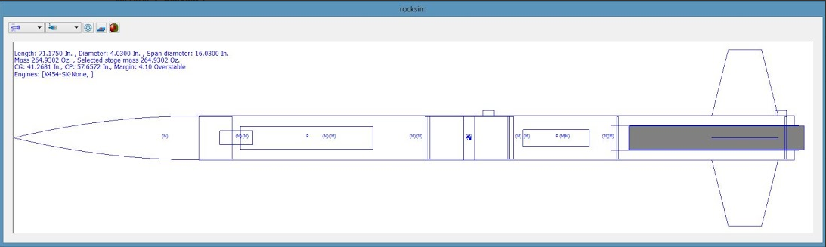

CAD Drawings

Assembled Rocket

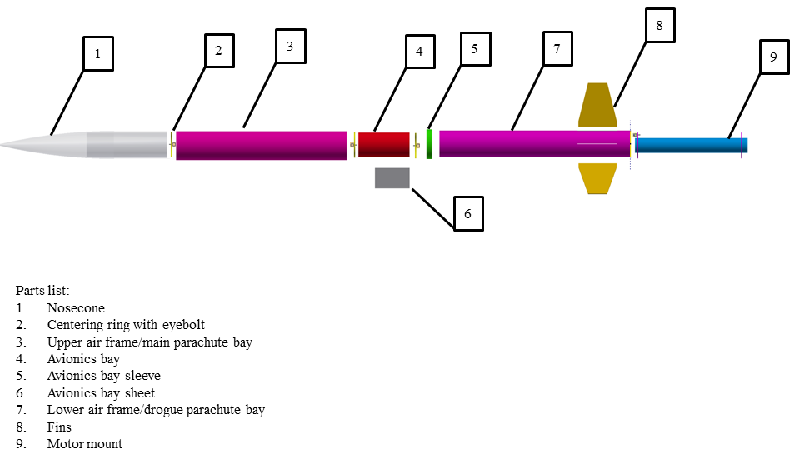
Exploded View

Construction Materials
- 1364K454-19A Skidmark Motor
- Nose Cone
- Quantum Airframe Tubing (3.9” x 36”)
- Phenolic Avionics Bay (7" long)
- 54 mm Motor Mount Tube
- Pair of Centering Rings (3.90"-2.14", Pair)
- Acme Conformal Rail Guides (3.90", Pair)
- Main Parachute (60")
- Drogue Parachute (24")
- Nomex flame protectors
- HAMR Sleeve
- E-match
- Fins
- Paint/Primer
- DP 420 Epoxy
- Raven3 altimeter
- Ejection charge canisters and pryodex (wgt for two)
- Siren
- Altimeter Two
- Motor casing
- Gloves, wipes, sandpaper, stir cups, tongue depressors
- West Systems epoxy
- JB Weld
- Rivets and shear pins
- 40 feet of shock cord (to be cut in 2 20-foot sections)
- 4 eyebolts

- Project Management

Org Chart
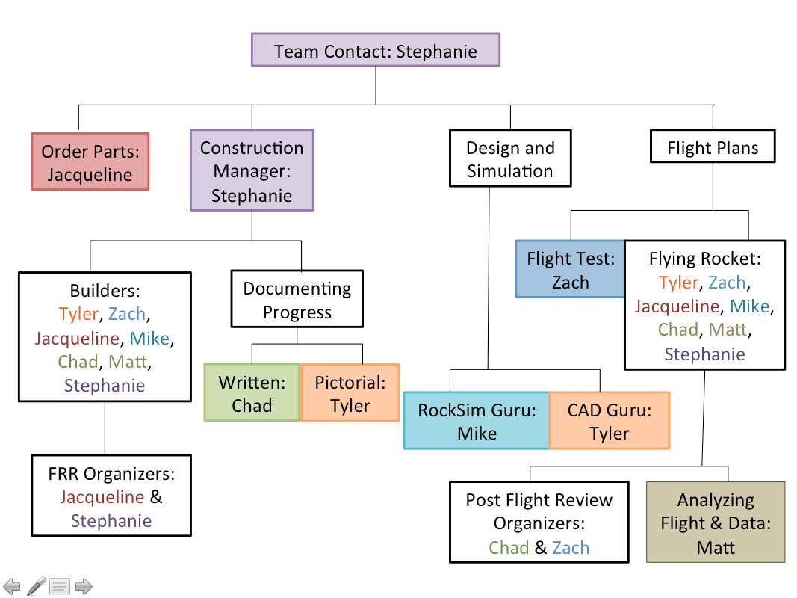

Schedule

Week 1: October 15-22
- Complete Revision 0 and assign team roles
- Begin designing process and completing Revision A tasks

Week 2: October 22-29
- Share information gathered about different parts and design ideas
- Complete trade studies for different decisions that need to be made

Week 3: October 29-November 5
- Finalize rocket design
- Finish Revision A tasks
- Write Revision A

Week 4: November 5-12
- Order all parts needed for rocket
- Begin Revision B – CAD design, risks, etc.
- Begin analyzing expected flight results

Week 5: November 12-19
- Receive and cut all parts to proper sizes
- Begin epoxying relevant parts
- Document progress (pictures and writing)
- Finish Revision B

Week 6: November 19-26
- Finish construction progress (epoxy, most weights, overall assembly)
- Document progress (pictures and writing)

Week 7: November 26-December 3
- Sand rocket & finish any last minute construction
- Epoxy in HAMR retention system
- Ejection Testing
- Complete Flight Readiness Review
- Paint rocket and apply decals

Week 8: December 3-10
- Finish painting/decals if necessary (BY December 5)
- Launch rocket
- Complete Post Flight Review
- Complete Revision C
- Project Budgets
Round 2 Rocket Components:
(Budget Items)
Part: | Supplier: |  | Qty: | Unit Price: | Price: | Weight(oz.)
1364K454-19A Skidmark | OWGR |  | 1 | 114.99 | 114.99 | 48.69
Nose Cone | PML |  | 1 | 21.95 | 21.95 | 13.7392
Quantum Airframe Tubing (3.9” x 36”) | PML |  | 2 | 25.95 | 51.9 | 27.8002
Custom Airframe Cutting | PML |  | 3 | 0.5 | 1.5 | N/A
Custom Airframe Slotting | PML |  | 4 | 1.5 | 6 | N/A
Avionics Bay 8” | HH |  | 1 | 33.50 | 33.50 | 16
54 mm Motor Mount Tube | LOC |  | 1 | 7.35 | 7.35 | 4.5693
Centering Ring (3.90"-2.14") | PML |  | 1 | 3.26 | 6.52 | 1.2516
Acme Conformal Rail Guides (3.90", Pair) | GLR |  | 1 | 3.49 | 3.49 | 0.699
Parachute (84”) | OFWR |  | 1 | 80 | 80 | 3.5
Parachute (24") | OWGR |  | 1 | 33 | 33 | 1.3
HAMR Sleeve | PML |  | 1 | 18.95 | 18.95 | 1.3
E-match | OWGR |  | 1 | 2 | 2 | Negligible
Prism Fins | PML |  | 4 | 14.89 | 59.55 | 11.06
Paint/Primer | HD |  | 2 | 4 | 8 | Negligible
DP 420 Epoxy | B&S |  | 1 | 22 | 22 | Negligible
Nomex Cloth (16”) | LOC |  | 2 | 19.00 | 38.00
Shock Cord | LOC |  | 40ft | 0.30 | 12.00 | 3.6
Eyebolts | OWGR |  | 4 | 1.50 | 6.00 | 5.2
 |  |  |  | TOTAL: | 526.7 | 138.7
Non-Budget Items |  | Supplier |  |  | Price | Weight (oz.)
Raven3 altimeter |  | Featherweight |  |  | 160 | 4
Ejection charge canisters and pryodex |  | we have pyrodex, will make canisters |  |  | 2 | 2
Siren |  | Lowes |  |  | 6 | 1
Altimeter Two |  | Apogee Components |  |  | 70
Motor casing |  | Off We Go Rocketry |  |  | varies
gloves, wipes, sandpaper, stir cups, tongue depressors |  | Home Depot, Michaels |  |  | varies | NA
West Systems epoxy |  | Hub Hobby |  |  | 20
JB Weld |  | Home Depot |  |  | 4 | negligible
Rivets and shear pins |  | Off We Go Rocketry |  |  | 2 | negligible
GPS |  | Garmin |  |  | 150
Switch, wiring, battery, charge canister |  | Msc. |  |  | 10
Water Gremlin 1-3/4 oz. Dipsey Sinkers |  | Joe’s Sporting Goods |  |  | 26 | 40
 |  | TOTAL: |  |  | 450 | 47

Total for Budget Items + Non-Budget Items | TOTAL: | 976.7 | 185.7

- Construction Photographs

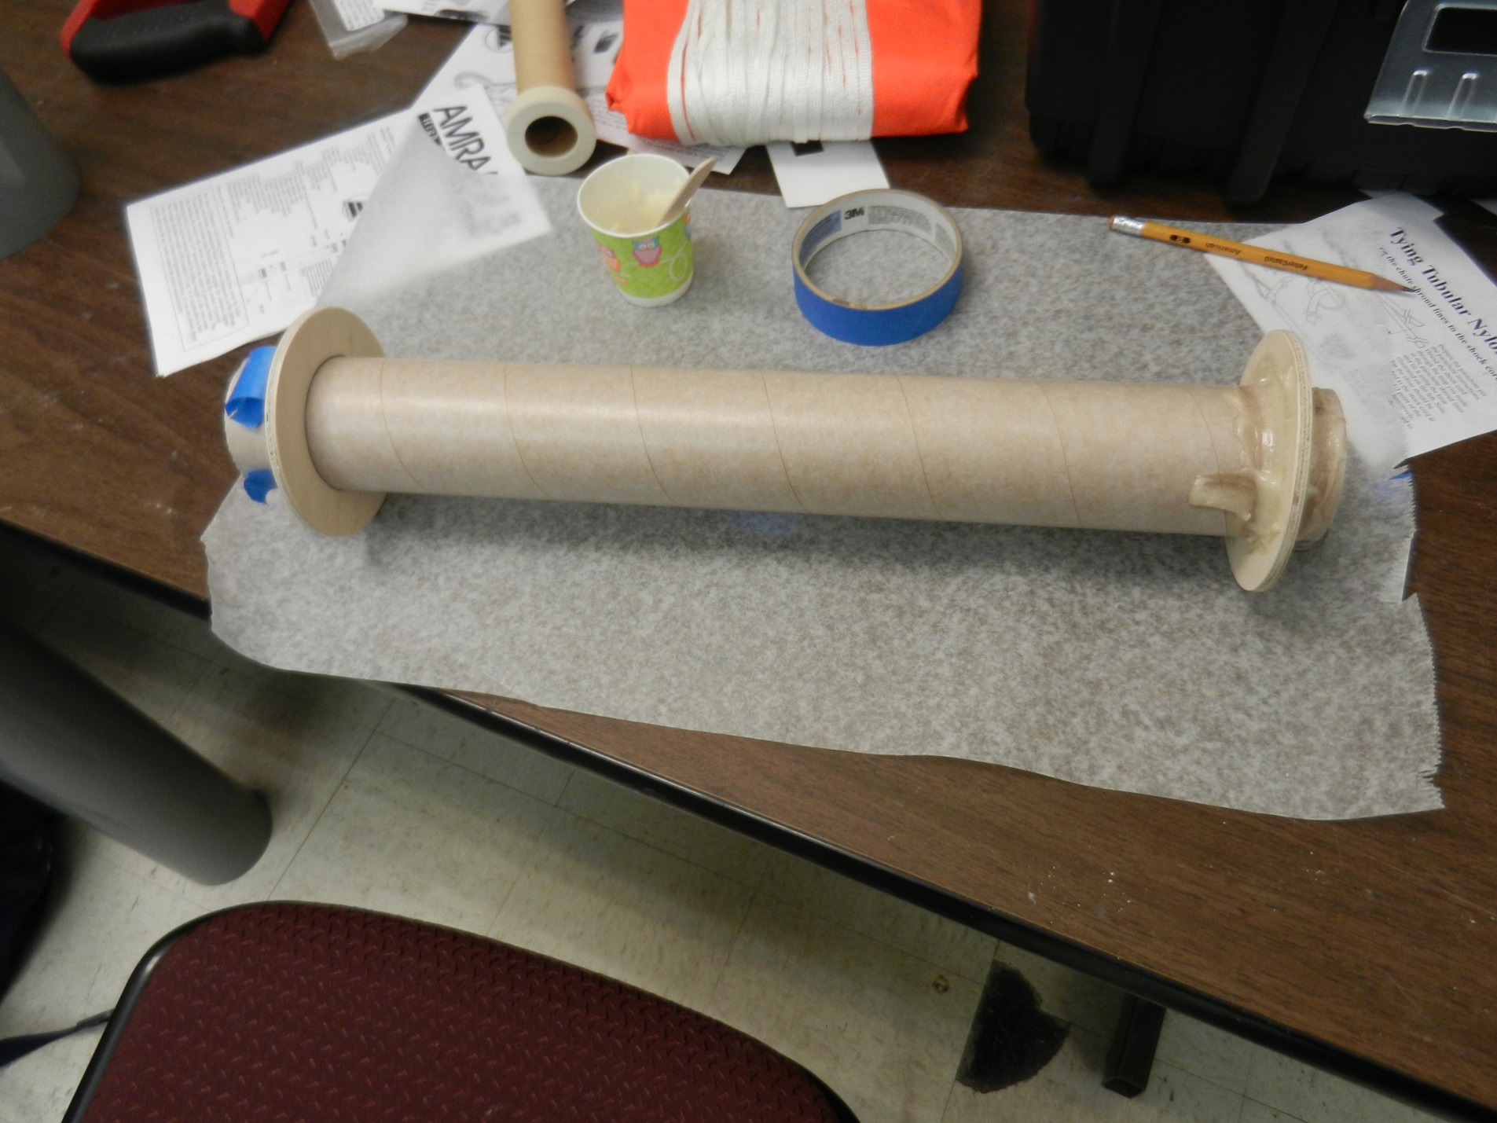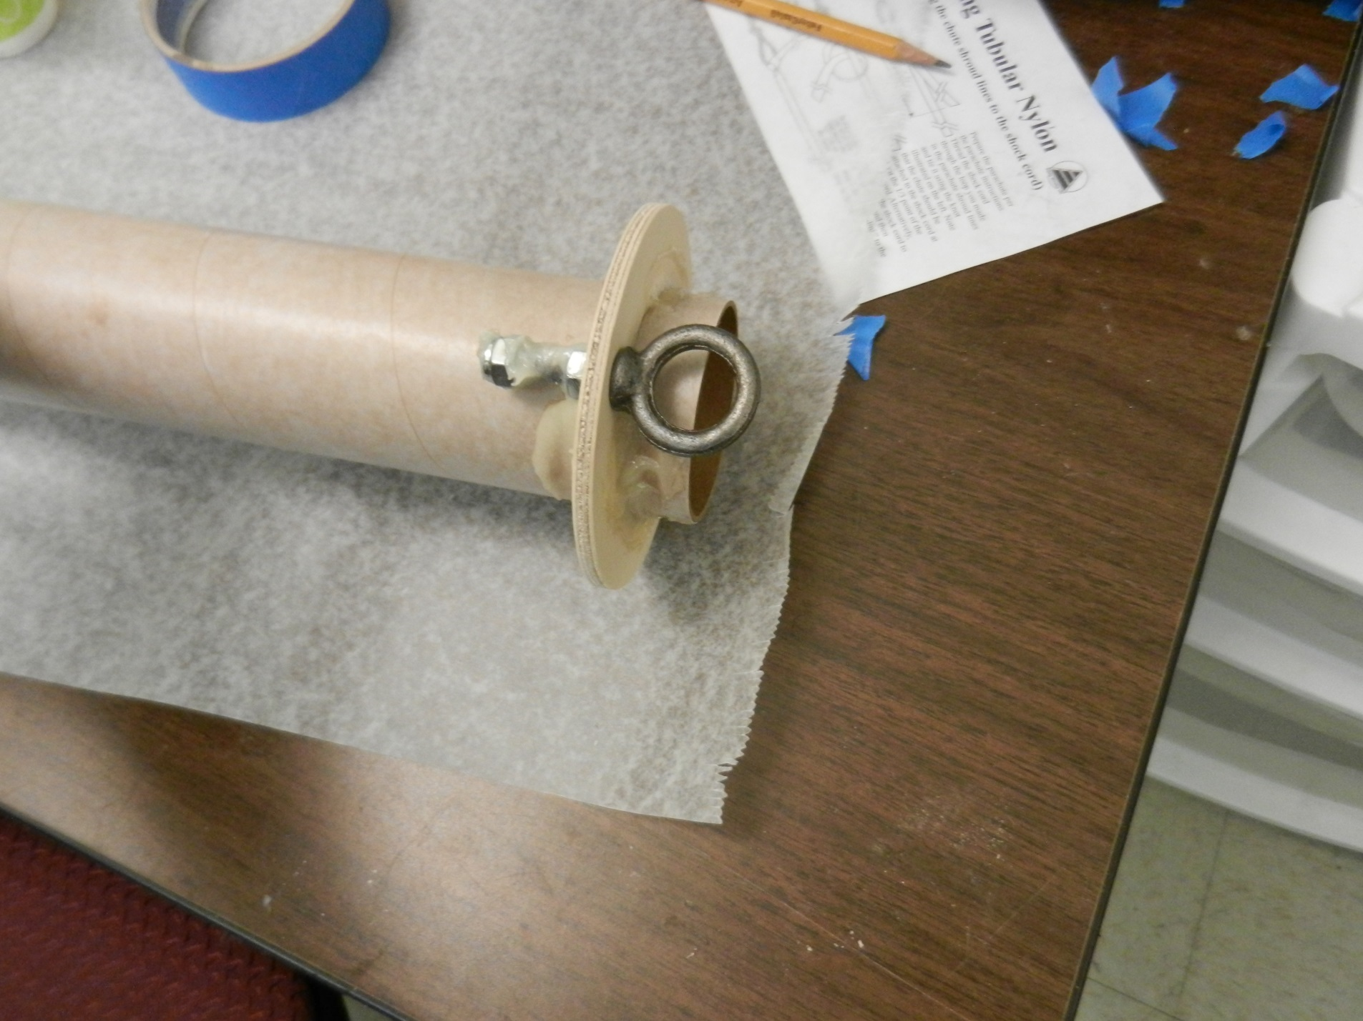
Centering rings on motor tube Eyebolt on motor tube
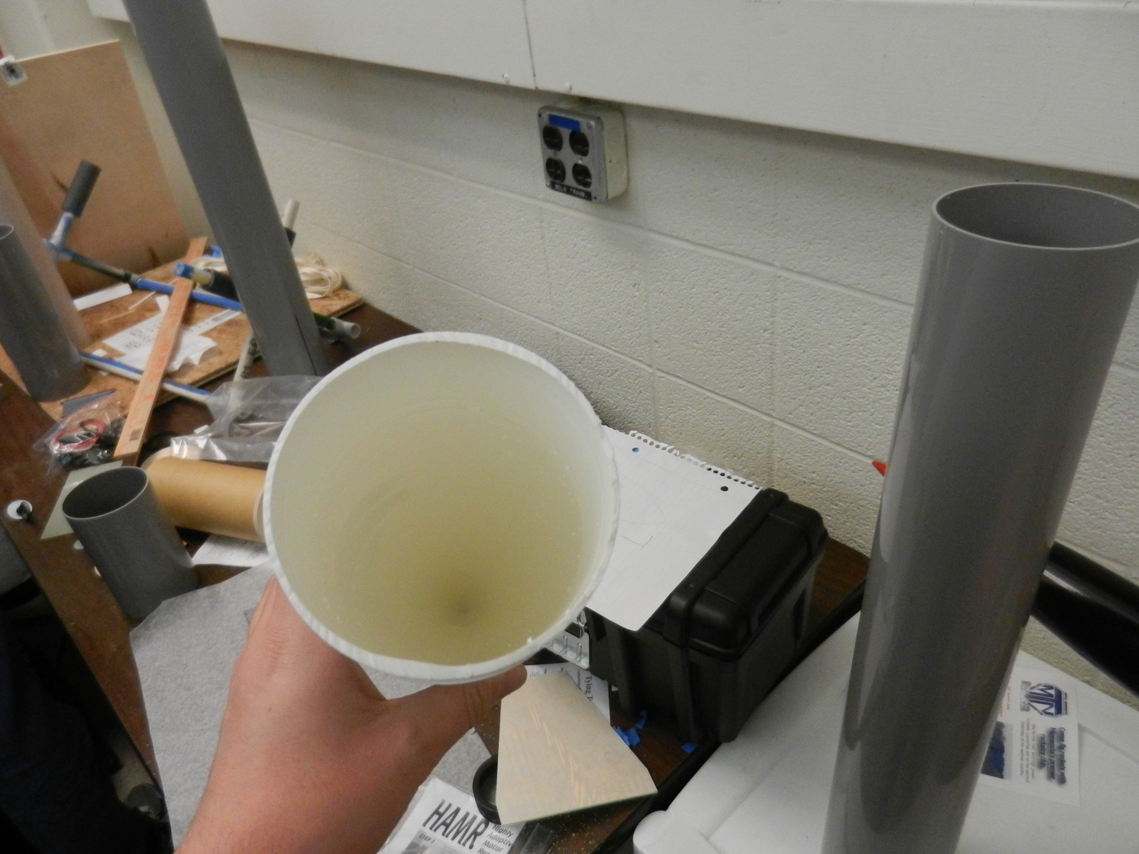
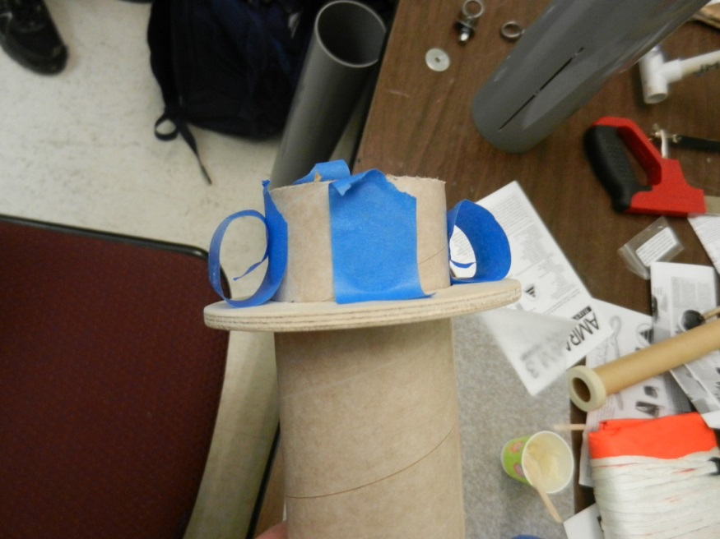
Motor mount tube early in construction End of nosecone removed so mass and GPS can fit inside it
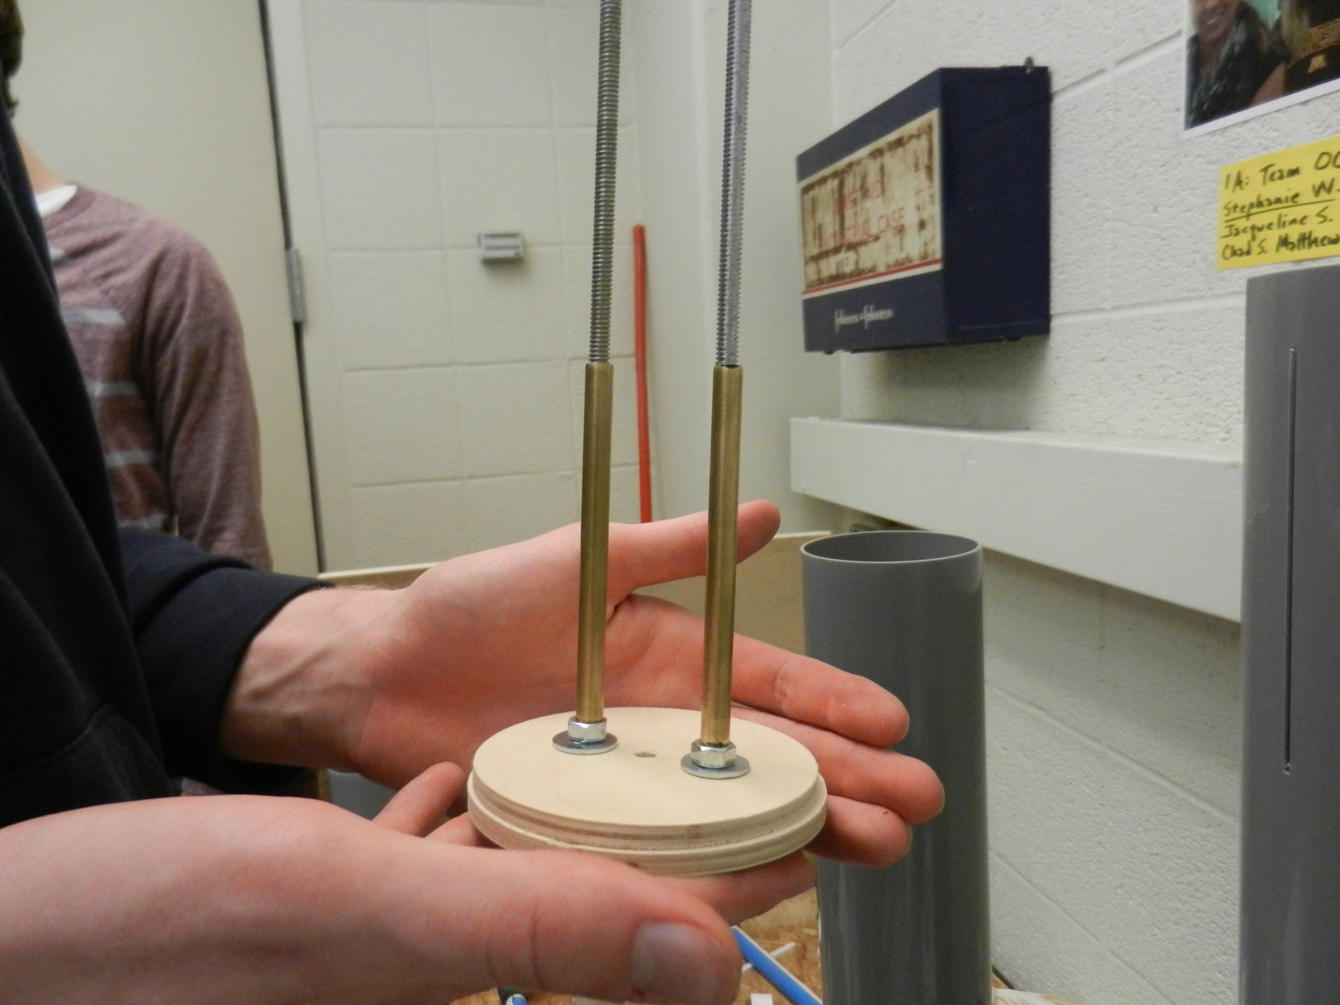
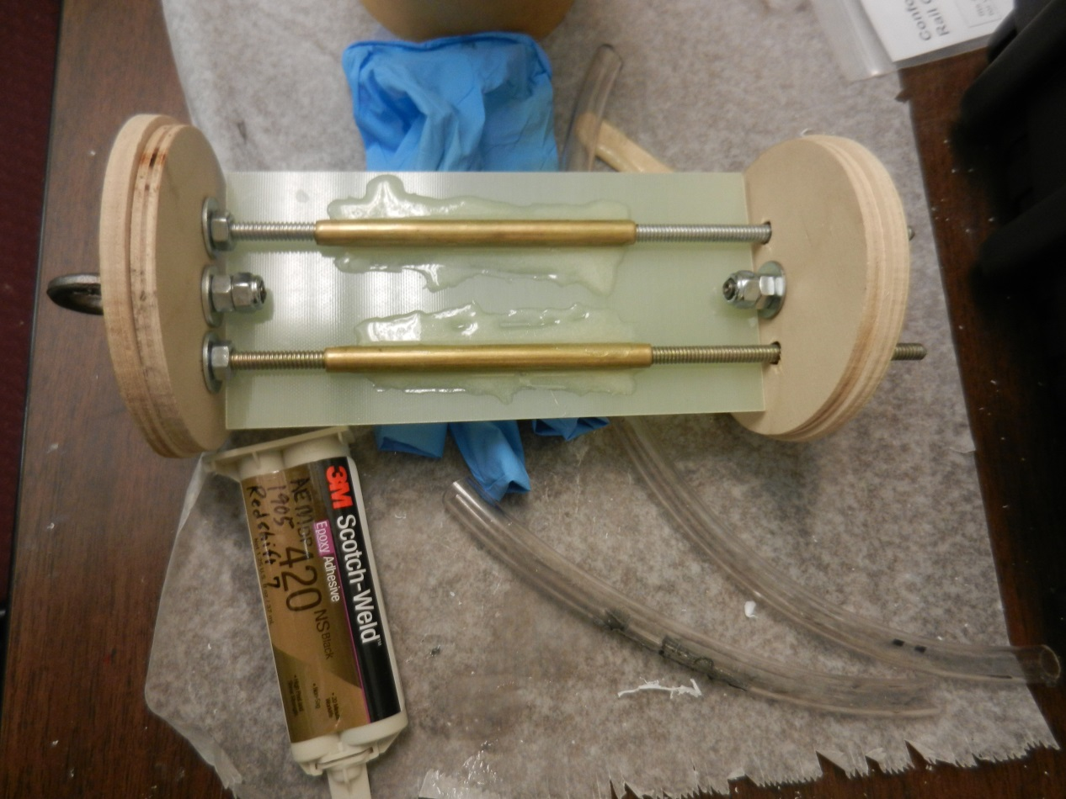
Avionics bay – early in construction Avionics bay – assembled besides electronics

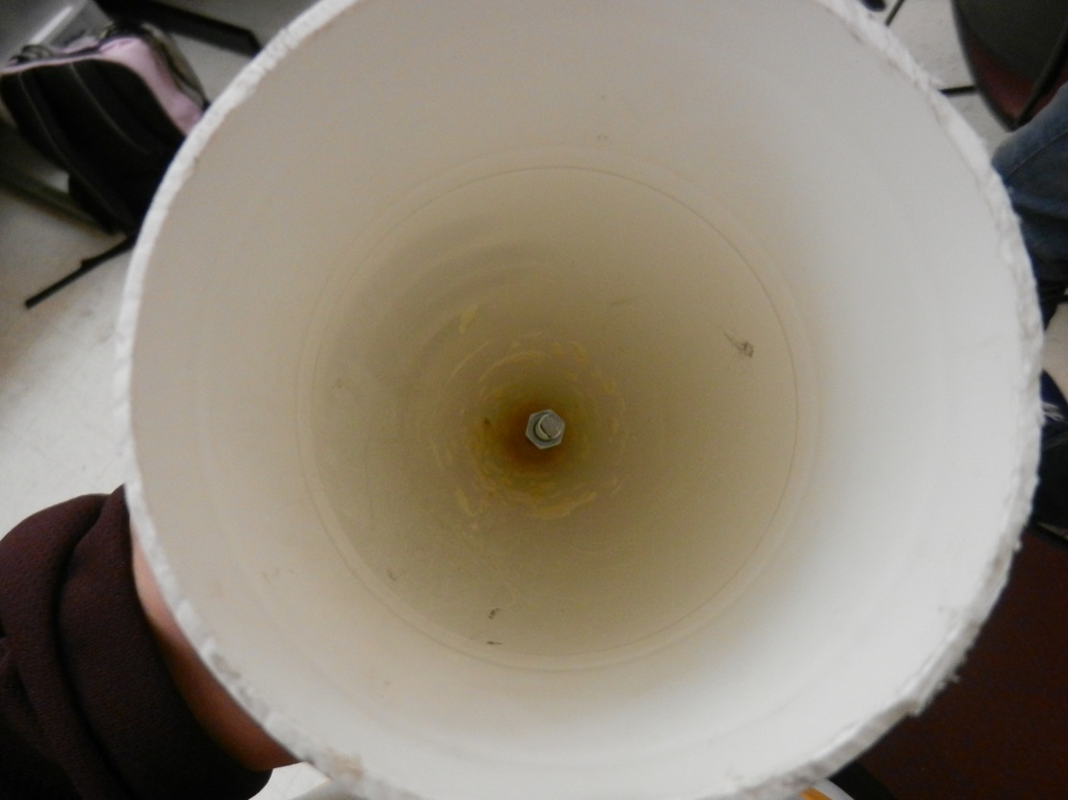
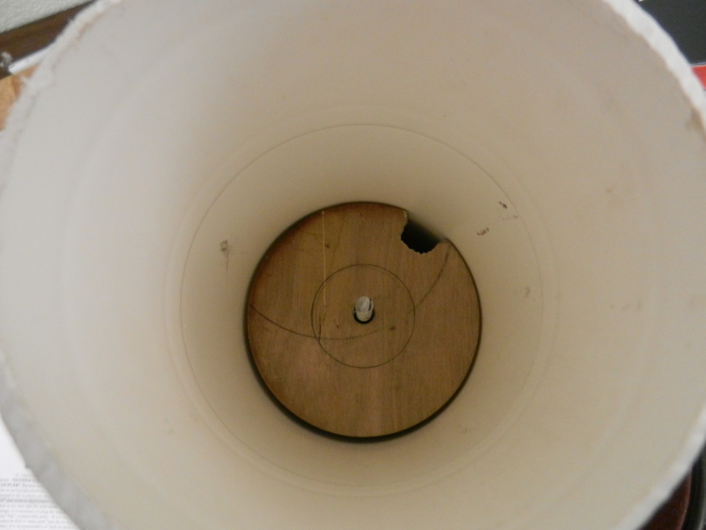

Threaded rod and bulk plate inserted inside nosecone
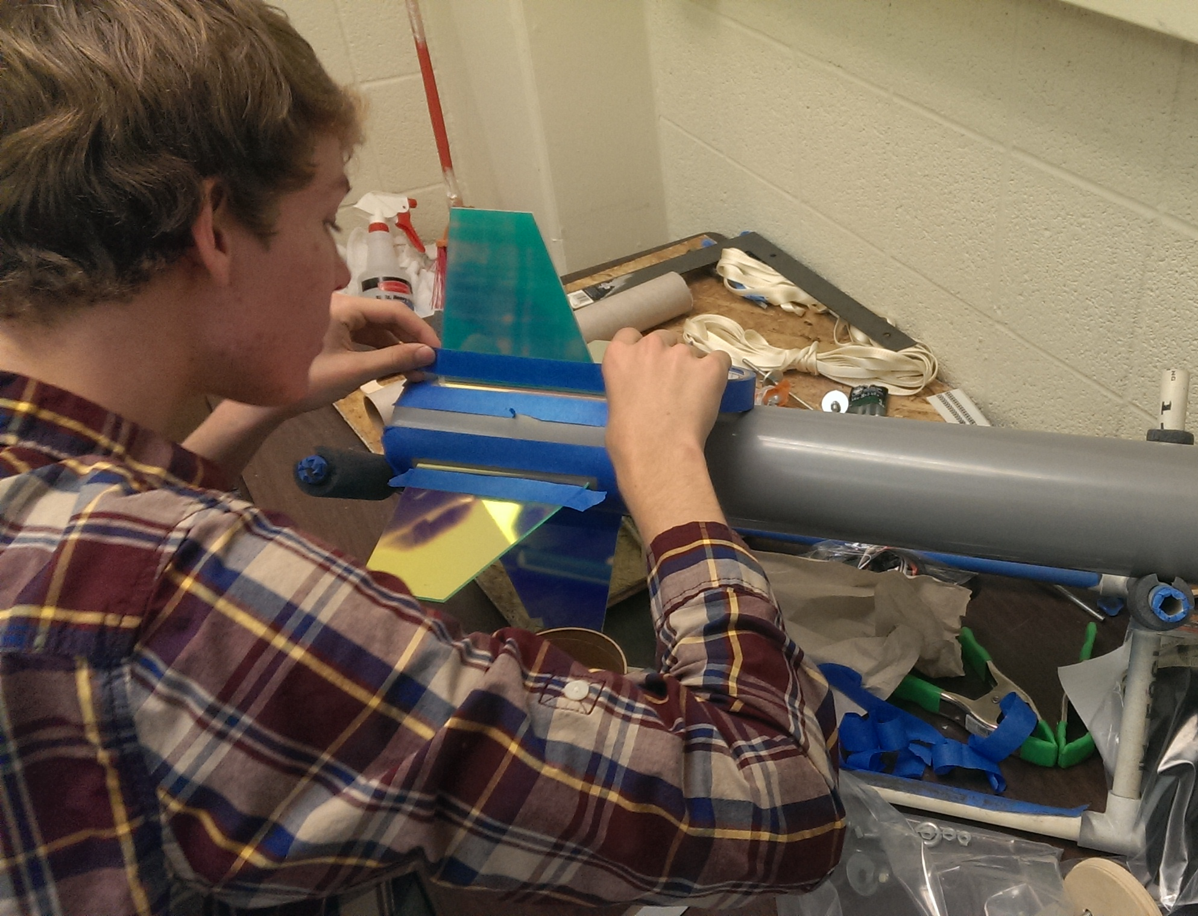
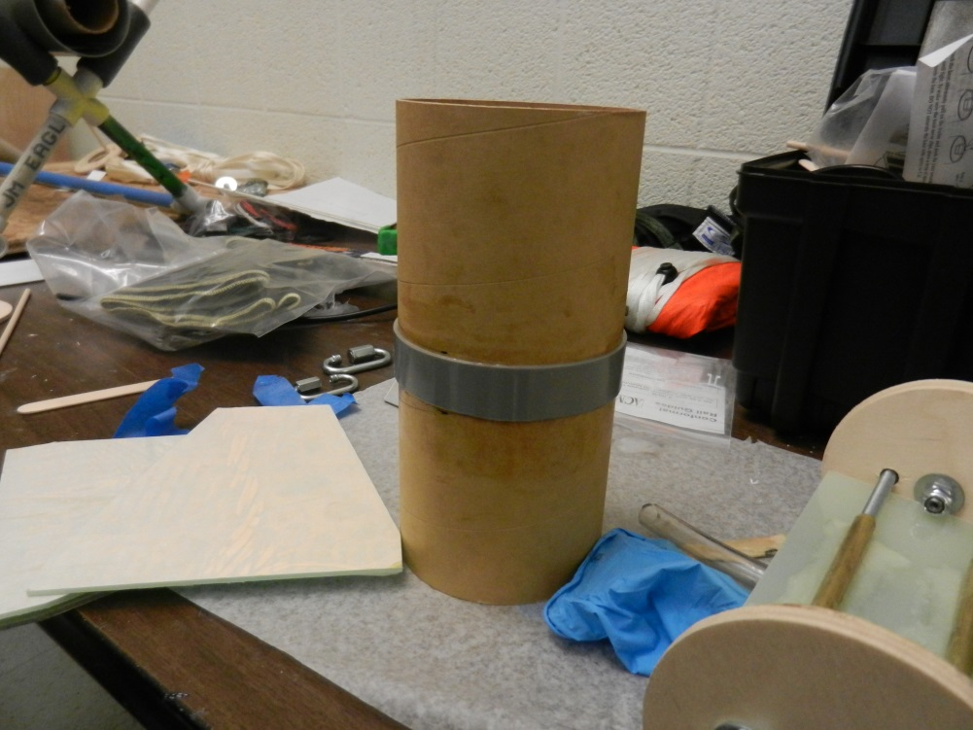
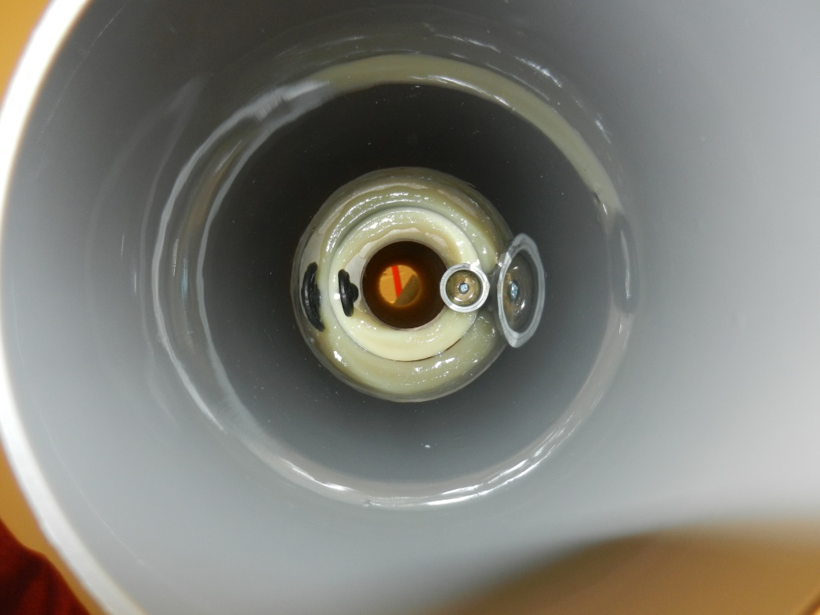
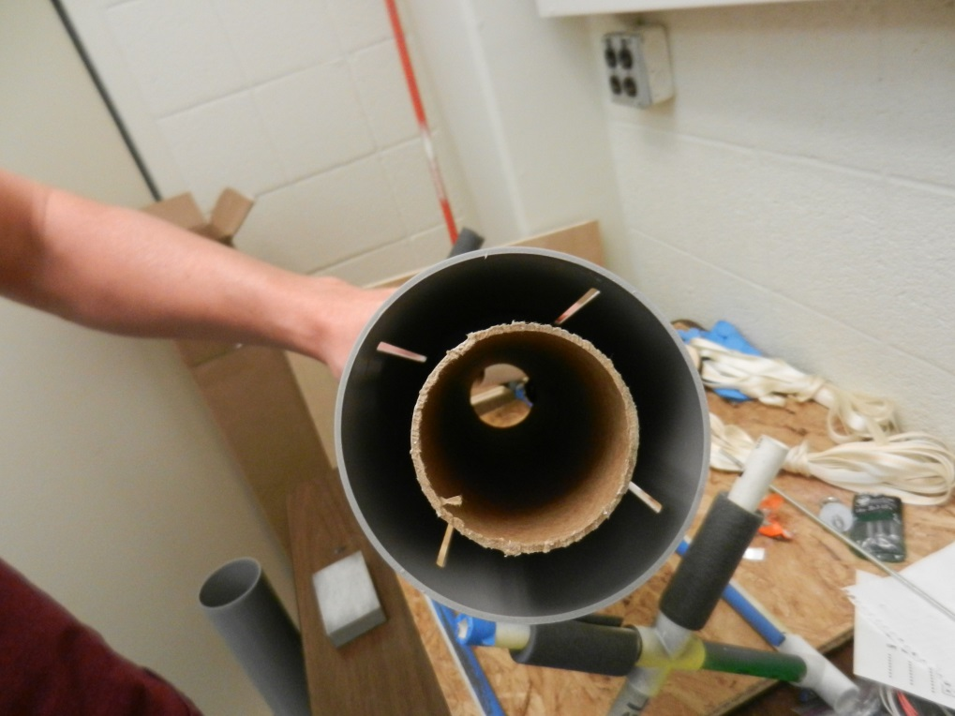
All fins epoxied to rocket
Sleeve epoxied onto avionics bay
Motor mount tube epoxied inside the body tube
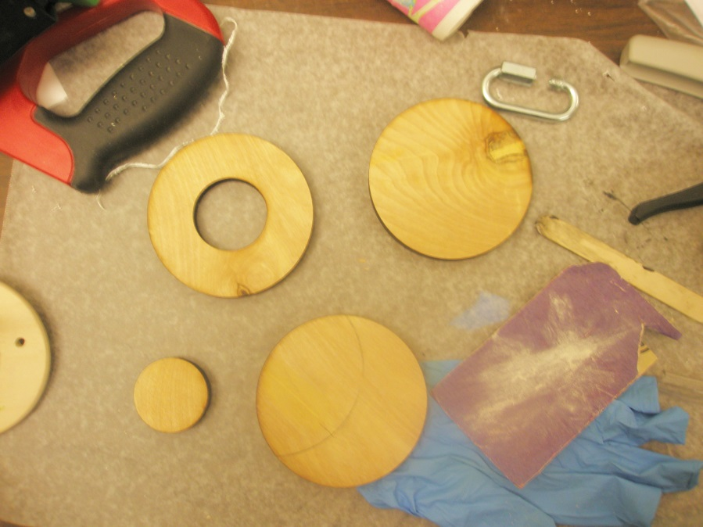
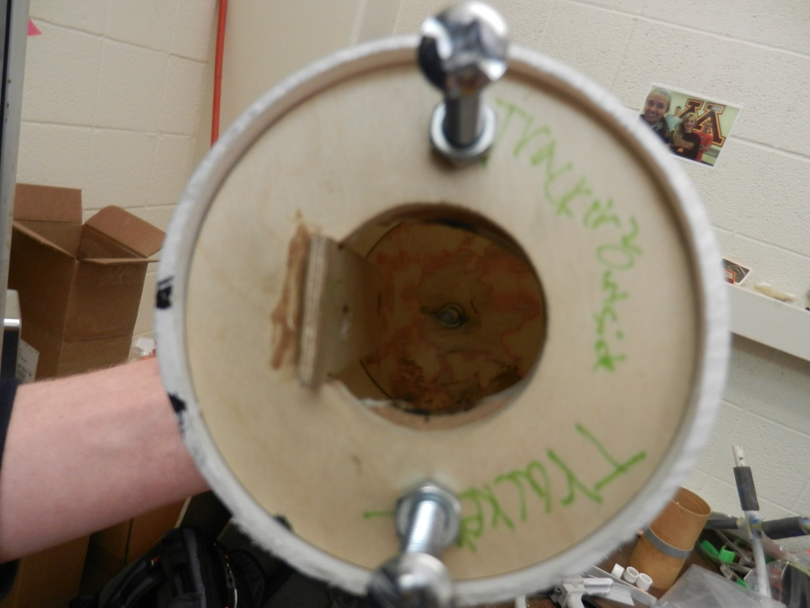
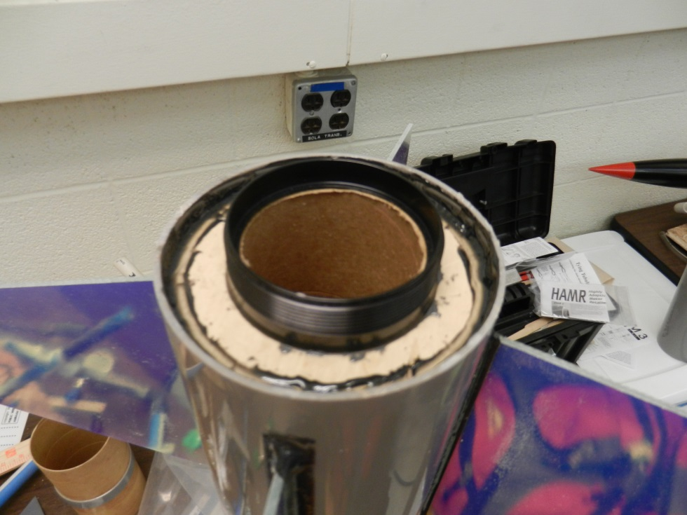
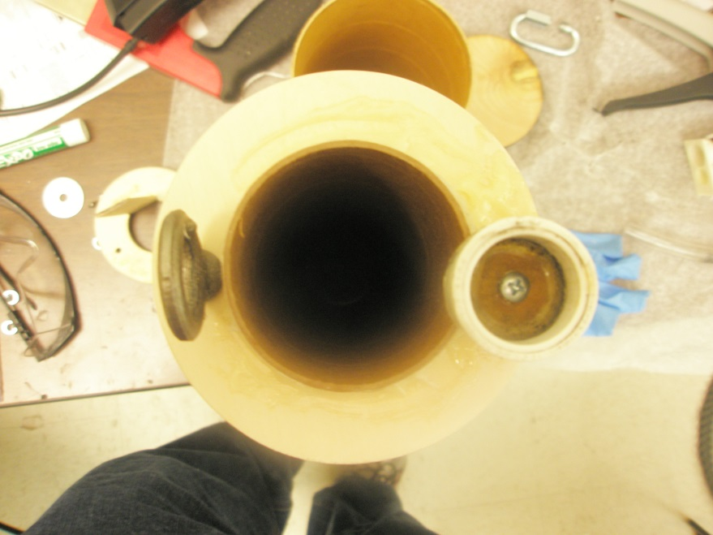
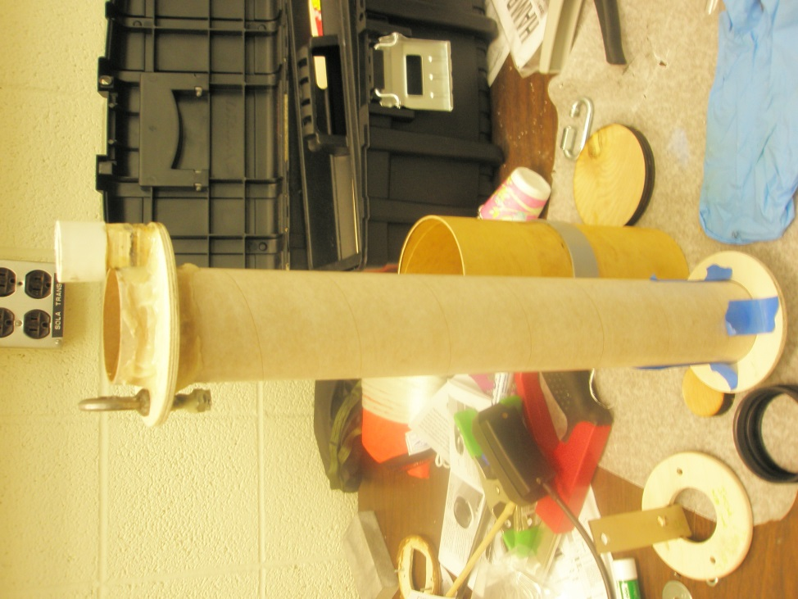
The HAMR motor mount and centering ring are attached.
The threaded rod and centering ring have been attached to the nose cone.
A threaded rod for the nose cone is being cut. Centering rings and bulk plates have been made.

The motor mount tube fully assembled The capsule for the ejection charge has been added.

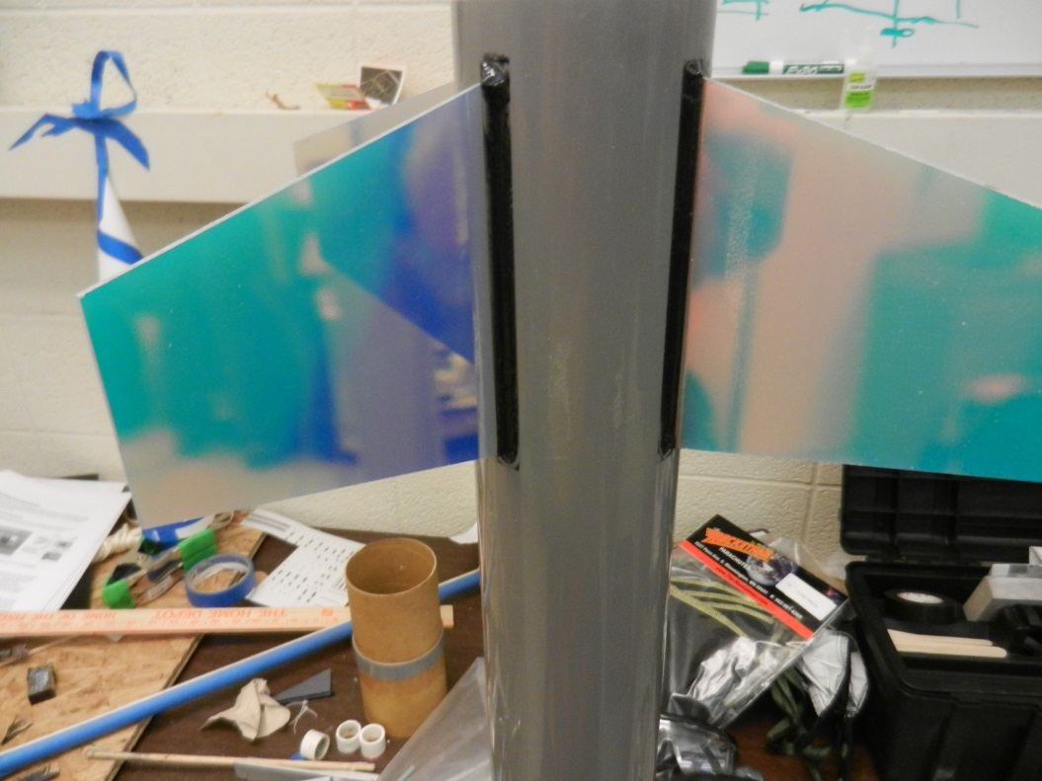
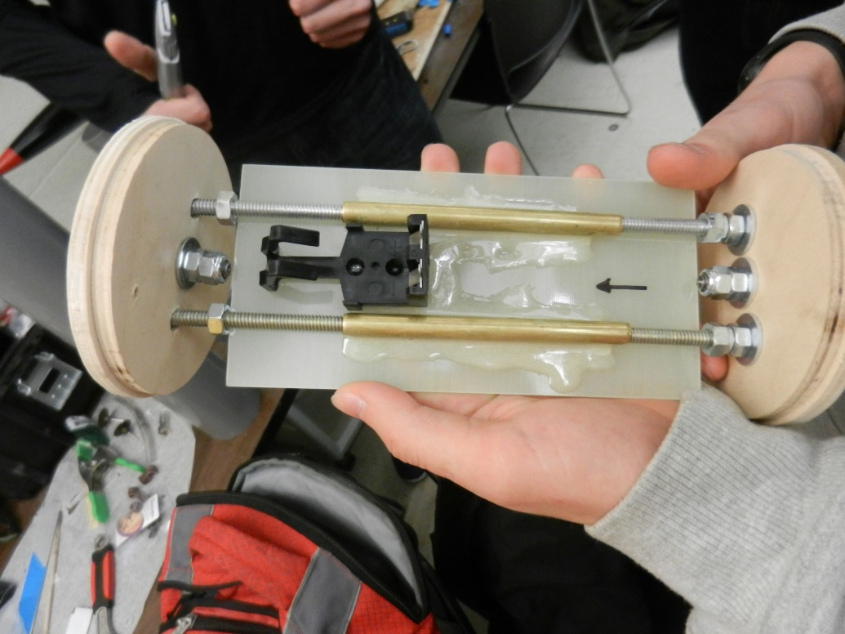
The avionics bay sheet during construction. The fins have been attached and clear coated.

7.0 Failure Modes and Risk Mitigation

Unexpected events happen regularly during rocket launches, so it is necessary to identify the risks, challenges, and potential failure modes associated with our design, and what we can do to mitigate those risks.

The most significant challenge in building our rocket will be balancing weight and safety. We need to keep a moderately high weight in the rocket while ensuring that it is safe to fly. The K motor that we are using will cause the rocket to fly beyond 3000 feet, so we need to dampen this as much as possible by adding weight, but not at the expense of safety. This can be done by keeping the weight under 1/5 of the thrust. The weight will be adjustable on launch day, and the amount added to the nose cone will depend on the flight conditions, as long as a safe thrust to weight ratio is met.

One possible failure that could happen to our rocket on launch day is drag separation of the airframe. If this occurs, then the two parts of the airframe will separate during the rocket’s rise, drastically increasing drag and thus decreasing the chance the rocket at reaching 3000 feet. It could also cause damage to the rocket by causing the shock cord to “zipper” the rocket.

To mitigate the risk of this happening, we will ensure the coupler fits “snugly but not tight” between sections of the airframe. Masking tape can be applied to the coupler to increase the friction between the two sections. Additionally, we will use shear pins and rivets to hold the rocket together during flight.

Another potential failure is if the ejection charge does not fire during the rocket’s flight, thereby causing the rocket to not separate and deploy either of the parachutes. If this occurs, then the rocket could possibly lawn dart and be a safety hazard. Additionally, the rocket will be damaged when it hits the ground. The failure of the ejection charge can be caused by two factors: failure of the altimeter or fault with the ejection charge itself. If the altimeter doesn’t record the correct height, then it won’t set off the ejection charge. We will have to make sure that we install the altimeter correctly right before the launch and install a vent hole to regulate the pressure in the altimeter bay so it doesn’t discharge prematurely. Additionally, we are using a backup ejection charge in case the main ejection charge malfunctions. We will grind down the ejection charges as necessary.
This information is summarized in the table below.
Concern | Consequence | Risk/Failure Mitigation
Weight | Too high a weight poses a safety concern, too low a weight causes our rocket to fly too high | Install an interchangeable weight system in the nosecone, keep thrust to weight ratio under 5:1
Drag Separation of Airframe | The increased air resistance will likely prevent the rocket from reaching 3000 feet, “zipper” effect | Use masking tape on the coupler to increase friction, use shear pins and rivets
Motor Ejection Charge Failure | Drogue and/or main parachute will deploy too early, too late, or not at all | Back up ejection charges
Altimeter bay failure | Drogue and/or main parachute will deploy too early, too late, or not at all | Ventilate altimeter bay

8.0 Expected Flight Results

The goal of the RedShift 7 rocket is to reach an altitude of 3000 feet, deploy a drogue chute at apogee, deploy a main chute at 700 feet, and land safely. The rocket will fly on a Cesaroni 1364K454-19A Skidmark motor, which will burn for 3.0 seconds after which the rocket will coast until reaching apogee. During the boost phase the rocket is expected to undergo a maximum acceleration of around 6.2 Gees and reach a maximum speed of around 450 ft/sec (0.40 Mach), which is well within the margin of safety for Quantum tubing. An onboard Raven3 altimeter will be programed to fire an ejection charge and deploy the 24-inch drogue chute when it senses apogee. In the event that the Raven 3 malfunctions and does not fire the drogue chute, the motor eject will serve as a backup. The motor comes from the manufacturer with a 19 second delay which will be ground down on launch day to fire about a second after the estimated apogee time. After the drogue chute deploys, the rocket will fall under drogue until the rocket reaches 700 feet at which point the altimeter will deploy the 84-inch main chute. In the event that the main chute does not deploy, the rocket will continue under drogue until impact with a predicted terminal velocity of about 56 feet per second. While this would likely be damaging to the rocket, it likely would not completely destroy the rocket. Assuming the main chute properly deploys, the rocket will impact the ground with a gentler predicted terminal velocity of 22 feet per second.

The predicted altitude of the rocket can be adjusted to accommodate various wind conditions by adding weight to the nose cone. Since there is no active altitude control mechanism aboard the rocket (such as air brakes), fine tuning this weight on launch day will be critical to reaching the 3000 foot goal. There will be a threaded rod in the nose cone to which lead weights can be added. The ideal added weight was found for each wind condition by trial and error in RockSim. The added weight and flight data for each wind condition is given below. Trials were not done for “no wind” since that is an unrealistic scenario or for “strong” or “damaging” winds as launching would not be allowed under those conditions.

Wind Condition | Weight Added to Nose Cone | Max Altitude | Max Speed | Max Accel | Time to Apogee | Down- range Drift | Speed Leaving Rail
Calm (0-2 mph) | 89 oz. | 2997.05 ft | 426.59 ft/sec | 5.84 Gees | 14.60 sec | 111.18 ft | 42.07 ft/sec
Light (3-7 mph) | 86 oz. | 3017.98 ft | 431.45 ft/sec | 5.91 Gees | 14.62 sec | 449.84 ft | 42.19 ft/sec
Slightly Breezy (8-14 mph) | 80 oz. | 2987.07 ft | 441.20 ft/sec | 6.04 Gees | 14.49 sec | 758.04 ft | 42.82 ft/sec
Breezy (15-25 mph) | 56 oz. | 2974.49 ft | 484.53 ft/sec | 6.66 Gees | 14.25 sec | 1133.72 ft | 44.74 ft/sec
Very Windy (25-30 mph) | 44 oz. | 3065.13 ft | 505.01 ft/sec | 6.95 Gees | 14.36 sec | 2498.28 ft | 45.85 ft/sec

As can be seen above, the ability to change the weight of the rocket is critical for reaching a consistent altitude despite unforeseen wind condition. However, we will not always know the exact wind speed at all levels meaning that our weight added will only be an estimate. On the other hand, the time to apogee is fairly constant across all flights. Likely a 15.5 second delay could be used regardless of the wind condition and it would deploy shortly after the altimeter fired at apogee. This would correspond to a motor eject delay of 12.5 seconds.

Here is a RockSim simulated flight profile under slightly breezy condition:

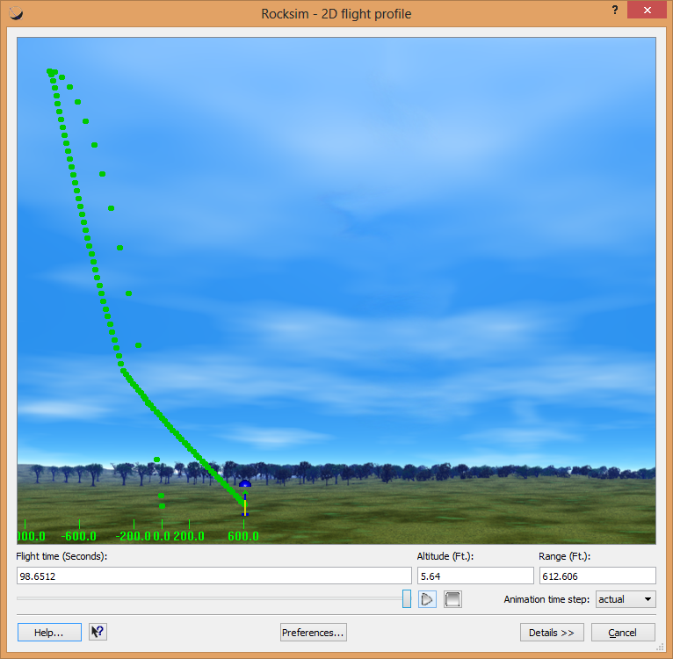
- Ejection Testing and Launch Day

In preparation for ejection charge testing we needed to calculate how much black powder would be required to separate the different pieces of the rocket. Calculations were made taking into account the volume of the tube that the explosion would be happening in. Once the amounts were calculated for both the main and drogue charges, a little bit more than needed was added to each number to ensure that the charge would be more than enough to separate the rocket. The black powder was measured using a scoop that holds a known weight of powder when level. The drogue charge required 1.5 grams and the main required 2.7 grams. These amounts of black powder were measured out into the separated fingers of a latex glove. Once the amount was in the glove finger an igniter was added and the two were secured together with electrical tape. Only one drogue and one main charge were created for the test even though the real flight would have an extra back up charge to the main.
The charges were secured in their places in the rocket using electrical tape. Rather than having the wires from the igniter run to the altimeter, the wires came out of holes in the side of the rocket so that we could set them off ourselves. Once in place outside, the drogue’s charge was set off first. It was successful and deemed the correct amount of powder to ensure separation. After this the rocket was repositioned on the stand and the main charge was set off. The main charge was successful in separating the rocket and was also deemed the correct amount to ensure separation.
On Saturday December 7, five of our seven team members began preparation for flight in the lab at 8:00 AM. There, we drilled holes to allow us to zip-tie the battery in the av-bay down drilled a larger hole in the av-bay collar to allow access the switch. Also, we weighed the entire rocket to determine how much weight we needed to add to the nosecone to make sure the rocket would come as close to 3000 feet as possible. After adding the weight to the nosecone, we also replaced a couple smaller carabineer clips with larger, sturdier ones from the AMRAAM3 and the Quasar before loading up our toolbox with everything we could possibly need and heading to the vans.
Arriving at the launch area (after pushing our vehicle multiple times) we began the final preparations for flight. Chad and Alex (from team Stark) began measuring out the ejection charges while the rest of our team took the rocket over to Gary’s van for him to inspect. His van turned into our main base of operations, and Matthew and Tyler started to prepare the motor, when we realized that the eject delay would have to be ground down. Unfortunately, no one had a 54mm delay grinder, so Gary went and used a 38mm grinder to do it for us. While that issue was being resolved, the rest of the team began to insert the ejection charges in the rocket, wire them up to the av- bay, and insert a hand warmer in the av-bay to keep the altimeter warm during flight. Upon attempting to reinsert the av-bay into the body of the rocket, we discovered that the bulk plate of the bay was not perfectly circular and would not fit into the rocket properly, so we had to sand it down to get it to fit again. While the rest of the team was finishing up with the av-bay, Matthew went over to Dr. Flaten’s van to turn on the GPS collar and get a lock on the handheld detector, then reinserted the collar into the nosecone. Finally, we folded our parachutes and packed them carefully in the rocket, making sure they were not too tight and would not tangle on ejection and attached a small camera to the side of the rocket with some Velcro and strapping tape. Now we were ready to head out to the launch pad.
At the launch pad, we discovered that we had attached the camera on the same side as the rail guides, preventing placement of the rocket on the rail, so we quickly ran back to the van to grab strapping tape and reattached the camera in a different place. Once the rocket was on the rail, we used a screwdriver to turn the switch and power on the altimeter, then ran the e-igniter up into the engine and walked back to the van, where we would launch it from. When the rocket launched, it looked beautiful with the brown-black smoke billowing out of the engine with sparkling flashes, but shortly after launch, we saw the rocket break apart in the air, pieces falling down, and the av-bay and nosecone descending under the drogue and very tangled main.
Recovery became pretty time intensive, going around a fairly large area picking up as many pieces of the rocket we could find. We easily found the av-bay, parachutes, and nosecone, then found the largest remaining section of the lower airframe and the engine assembly. The camera had fallen off the rocket, so our main objective became to locate that since it might contain some interesting video of the flight. While searching for the camera, we located almost all the pieces of the rocket except for one fin and a few small pieces of the airframe. Eventually, we did locate the camera, but unfortunately the video was really glitchy, probably related to the extreme cold. Finally, we returned to Akerman, after a long, and not-so-successful flight, but with some great experience (especially about when and at what temperature to not fly quantum tubing).
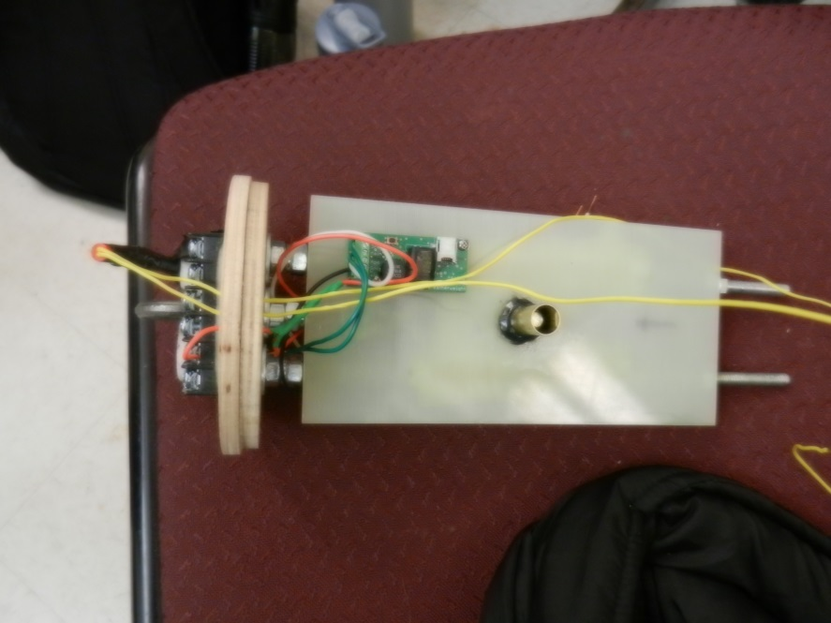
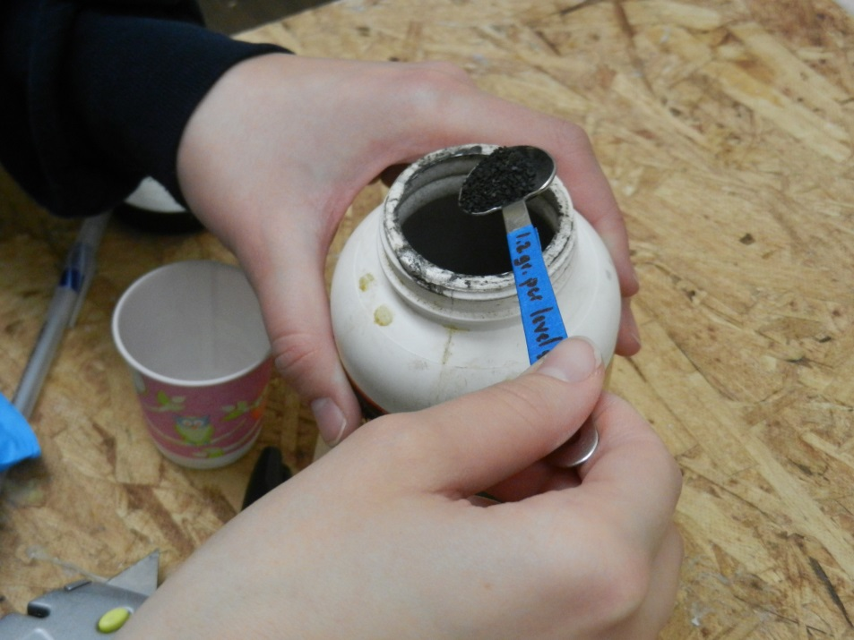
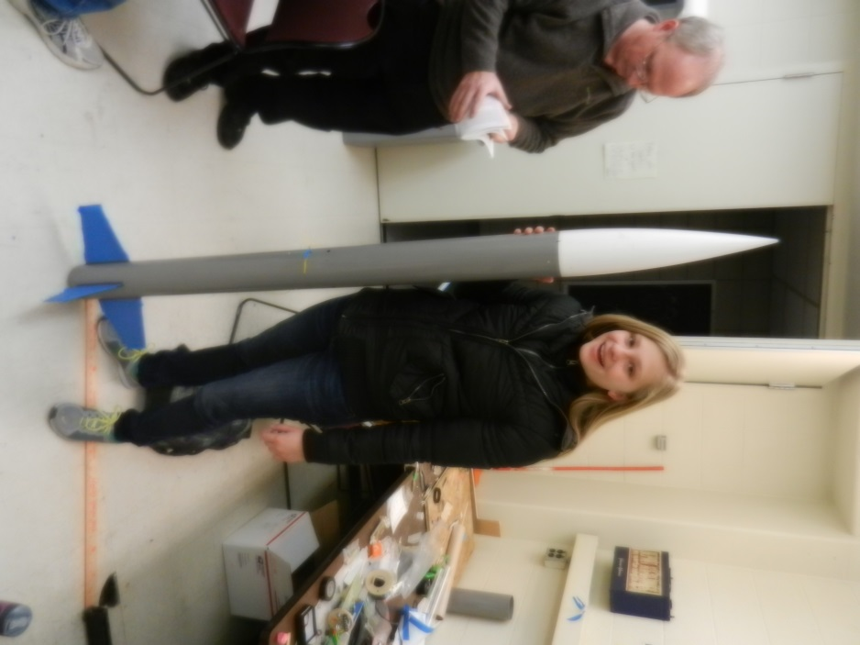
Avionics sheet wired before ejection testing
Fully assembled rocket before ejection testing
Measuring black powder for ejection testing
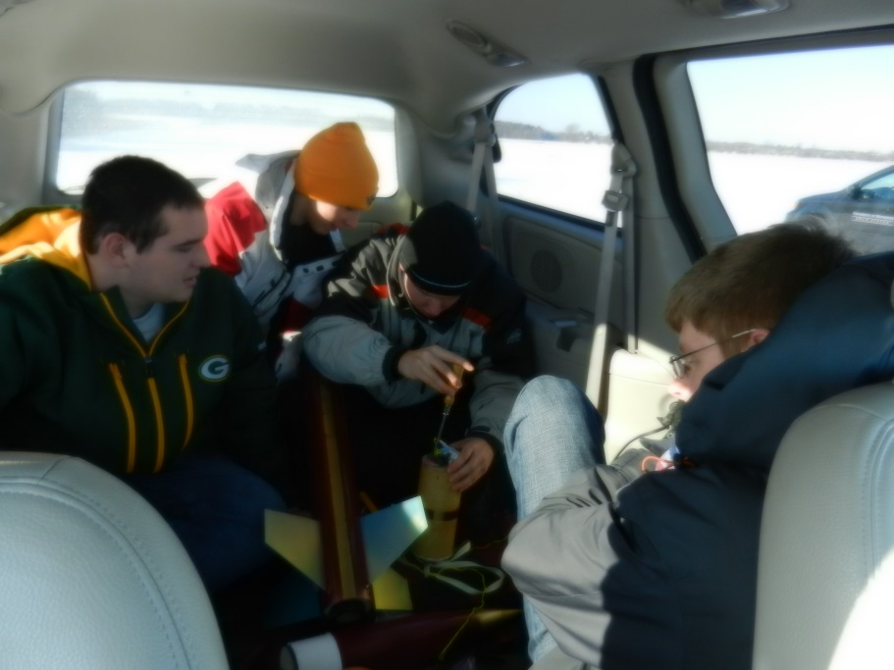

Preparing the rocket before launch Group photo with rocket
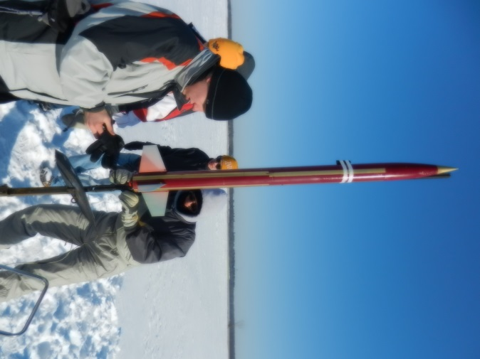
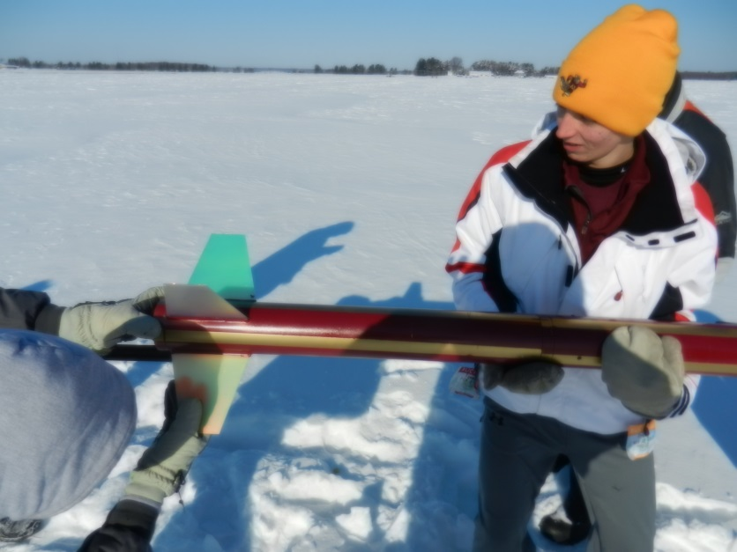

Loading the rocket onto the rail

Inserting the igniter
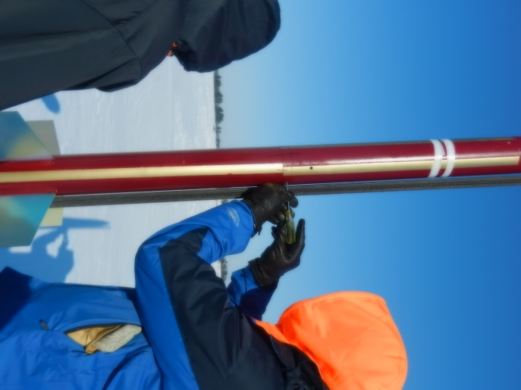

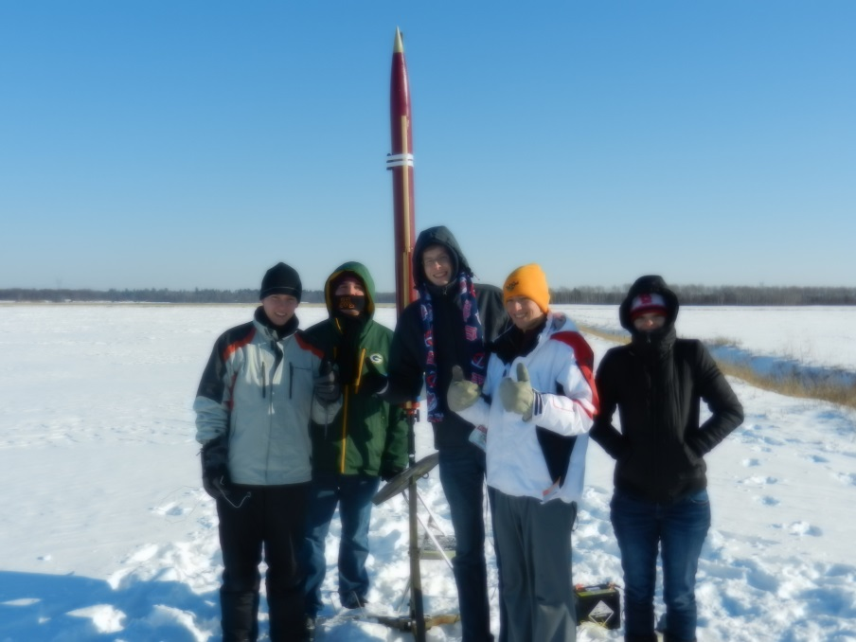

Group photo with the rocket
Dr. Flaten turning on the altimeter

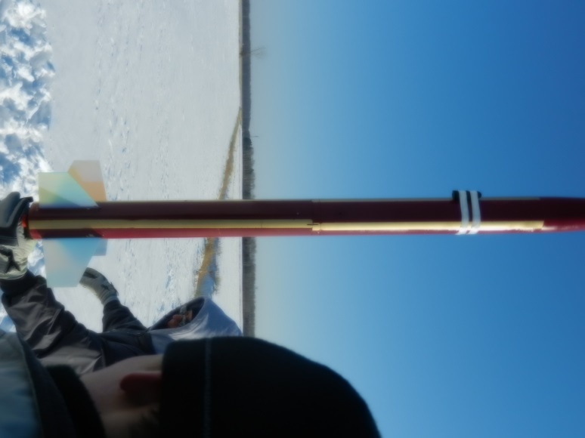
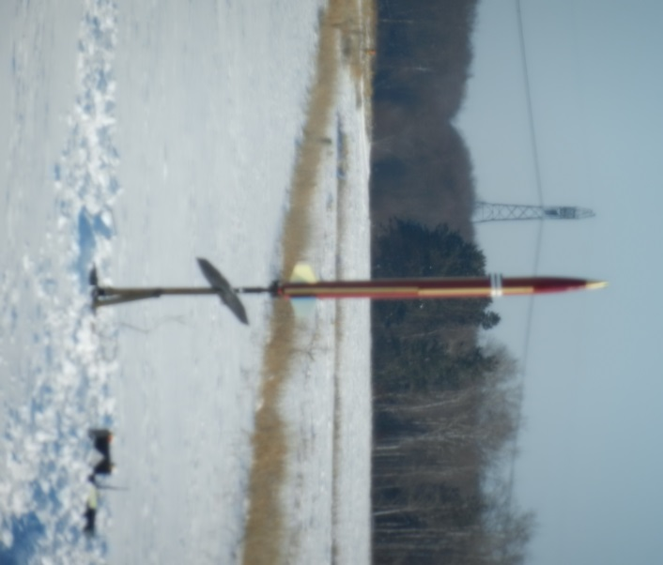

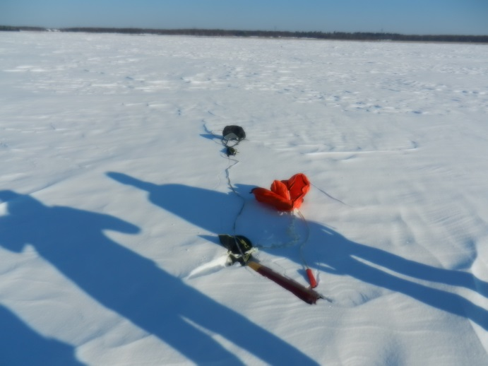
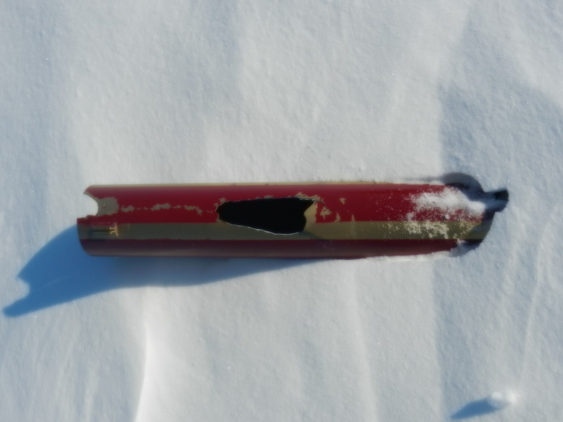
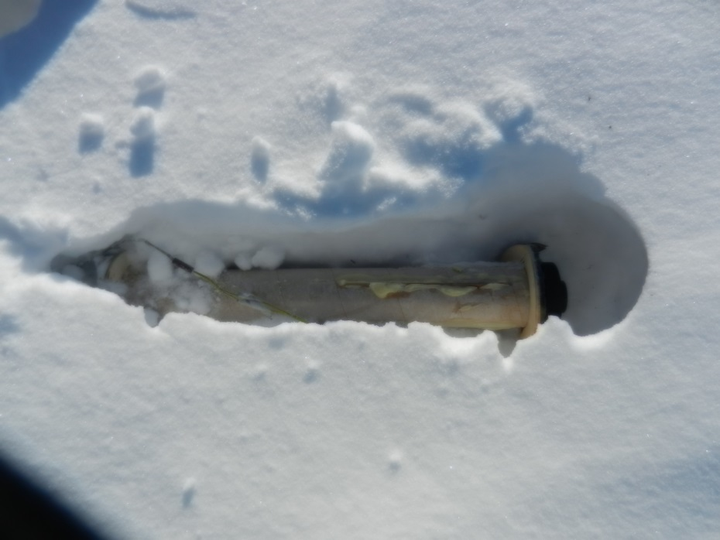
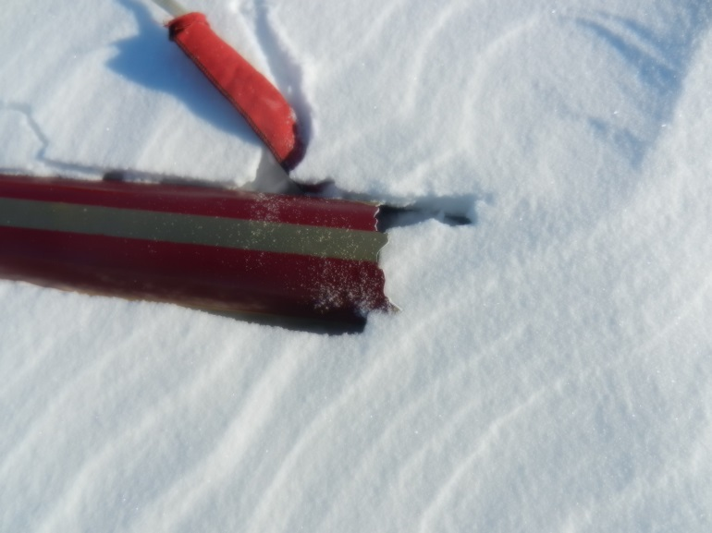
Motor mount tube (broken)
Piece of broken airframe tubing
Avionics bay, upper body tube, parachute
Piece of broken airframe tubing
Rocket on the rail Rocket just before flight
- Results and Analysis

The flight statistics have been obtained from two devices, a Raven 3 and an Altimeter 2, both of which use both an accelerometer and a barometric sensor. Data is displayed below, exactly as given by the altimeters, thought I will discuss some obvious discrepancies in the data further below.

 | Max Speed | Apogee | Burn Time | Descent Speed | Flight Duration
Raven 3 | 354 mph | 1700 ft / 2800 ft | 2.6 s | 35 mph | 28 s
Altimeter 2 | 738 mph | 2915 ft | 2.3 s | 37 mph | 27.2 s

As can be seen, there are some major discrepancies, even between our two altimeters, the two culprits being the maximum velocity and altitude of apogee. In reality, almost none of our data matches the expected data because we did not have a successful, complete flight. The rocket broke apart at a lower altitude causing the actual altitude to be more like 1300 feet and the breakup also caused the altimeters to also give some very wild reading at the point of separation. As can be seen in the graph below, for about 1 second, starting at 1.8 seconds to 2.8 seconds, the pressure in the av-bay increases some them suddenly drops off, causing altitude readings to jump in the opposite directions. As can also be seen, the altimeter attempted to ignite the drogue ejection charge, but since we actually found the ejection charge intact after the flight, we must conclude that something else had ripped the wiring from the terminals prior to activation. There are only three sources of explosion in the rear of the rocket, the drogue ejection charge, the motor eject, and the motor itself. The source of the explosion or pressure was proven not to be the motor eject because the ejection can be seen quite clearly in the video as the engine fell to the ground. So the only real option left is that something went wrong with the motor itself. However, the motor casing is intact (it would usually be melted during a cato if an o-ring failed), but there is some odd looking burn marks on the motor tubing. As an additional alternative, we checked if the main ejection charges could have caused the failure, but both main charges can clearly be seen to occur after the failure both in the video and in the Raven 3 data (again, shown below). Thus, conclude that the engine failed, causing some pressure build-up, which, combined with extremely cold temperatures and brittleness of the quantum tubing and force from the motor, resulted in the failure of the airframe.

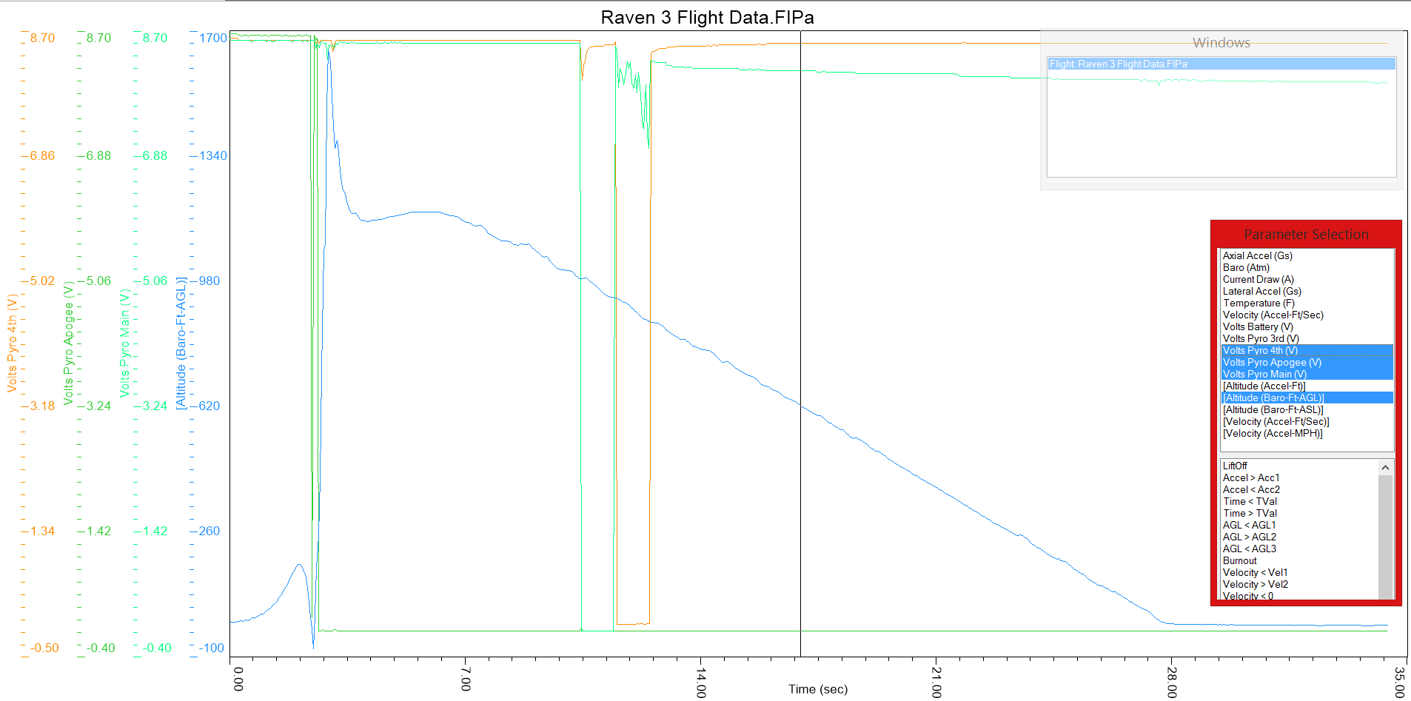
- Conclusions and Lessons Learned

In short, our team has learned to expect the unexpected when it comes to rocketry. Going in to this build we were conscientious of the fact that the rocket we built would be used in the competition. To this end we made sure to build it exceeding the minimum requirements. Throughout this build we learned much about the design process and all that goes in to a rocket. Because we were in charge of thinking of everything before we began we came to appreciate the foresight that goes into constructing a high power rocket. More quantifiable is what we learned about the electronic aspects of the rocket. In constructing the altimeter bay, a basic understanding of wiring was required, and in doing it we bolstered our confidence in our wiring skills. Further, we learned how to improvise during this build. Since we weren’t building a kit, not everything went together perfectly. For example the motor ejection charge wells didn’t fit, so we had to jerry-rig a way to fit them on top of the motor and top of the AV bay. Finally, we learned how to handle failure.
Our rocket failed completely, and is now un-flyable. Because we were planning to enter this rocket in the Midwestern Regional Rocket Competition we had hoped it would perform well in flight. Since it didn’t we will have to rebuild, so we have the unique opportunity to change anything we would like to do differently. In this new rocket we will build it to be much stronger. We plan to use a fiberglass body tube if possible, because it is stronger and has a smaller chance of becoming as brittle as the quantum tubing did. Also to make the rocket stronger we plan to make all the bulkheads and centering rings out of sturdier wood. One of the centering rings broke completely in half, and by building them stronger we hope to avoid them failing under high stress. Finally, because we have more time to finish the new rocket we may decide to implement air brakes in our new rocket, to more accurately control our apogee height.

Words of Wisdom:
- Teamwork makes the dream work
- Plan ahead and follow the plan
- When flying high-power rockets, Murphy’s law appears in force
- You can never start working too early
- When the temperatures drop, everything becomes that much harder to do

- Appendix – Supporting Calculations

Several important pieces of data are listed below, mostly based off of calculations done with the RockSim program. This program uses a modeling system that inputs parts that were used in our actual rocket.

The CG is located 38.27 inches from the nose tip, while the CP is located 59.06 inches from the nose tip. The static margin is calculated as follows:

Static Margin = (Xcp - Xcg)/D

Xcp and Xcg are the positions of the center of pressure and gravity, respectively, and D is the diameter of the rocket. In this case, our static margin is 5.20 because the diameter is 4.00 inches. Thus our rocket is considered to be over stable.
The thrust to weight ratio is calculated as the thrust of the motor divided by the rocket’s weight. Since we used the 1364K454-19A Skidmark motor, the initial thrust was about 139.5 pounds while the initial weight of our rocket was 18.57 pounds, yielding a ratio of 7.51. This is well over the safety limit of a ratio of 5, so our rocket meets the safety conditions in this regard.

We used a drogue ejection charge of 1.5 grams, while the backup is 2.0 grams. The drogue will deploy at apogee no matter what (around 3000 feet), and the main parachute will deploy at 700 feet. Based off of simulations, the motor eject backup to the drogue will set off around 15 seconds, and the backup to the main parachute will deploy 1.5 seconds after the main. Both the main and backup main ejection charges are 2.75 grams.

Based off of calculations performed through RockSim, the descent rate of the rocket under the drogue parachute is about 59 feet/sec, while the descent rate under the main is about 28 feet/sec.

