GL61 – AEM 4495 “pre-flight” – Saturday, March 16, 2013 – PocketFinder GPS record

Drive to launch site, a few points from flight itself, then drive back to the Twin Cities.
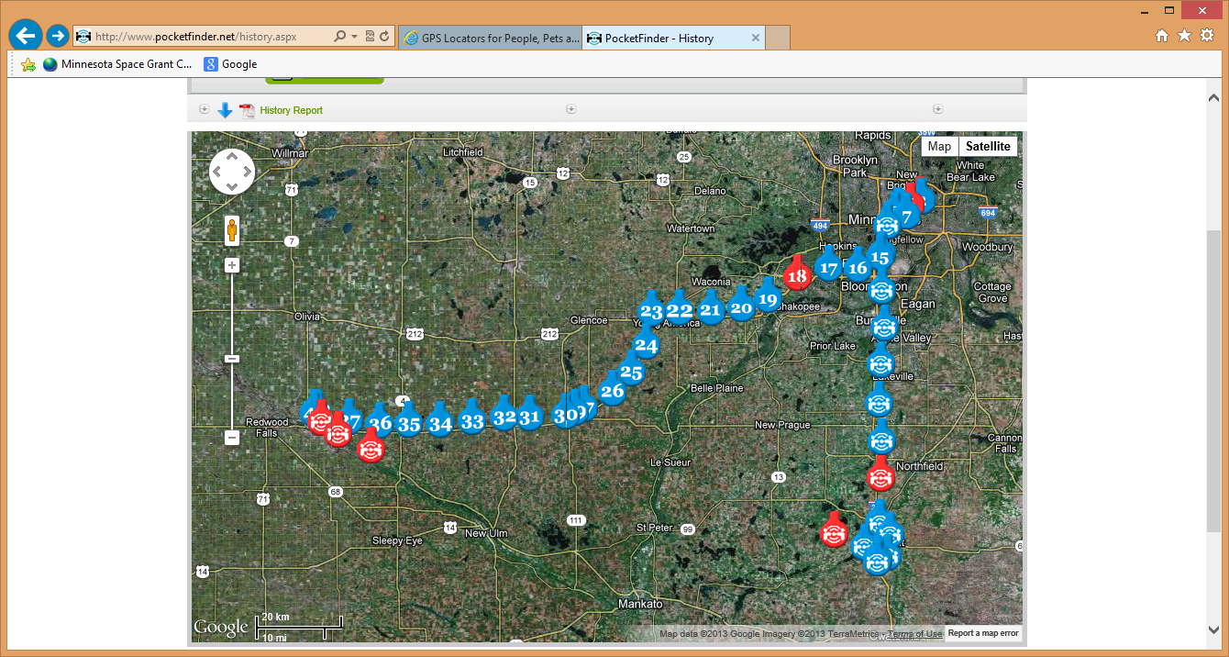

Start of flight
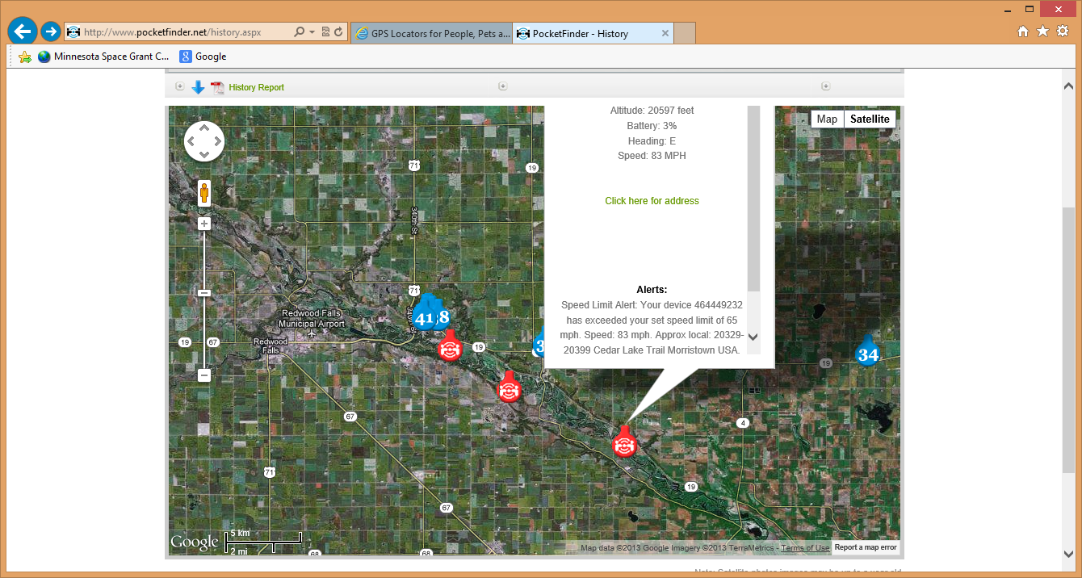

Picked up again on descent.
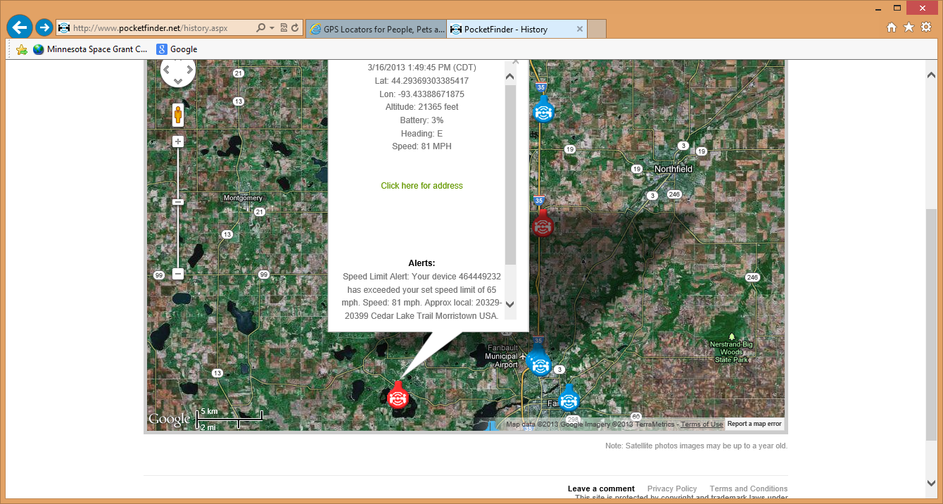

Almost landed at 1:59 p.m.
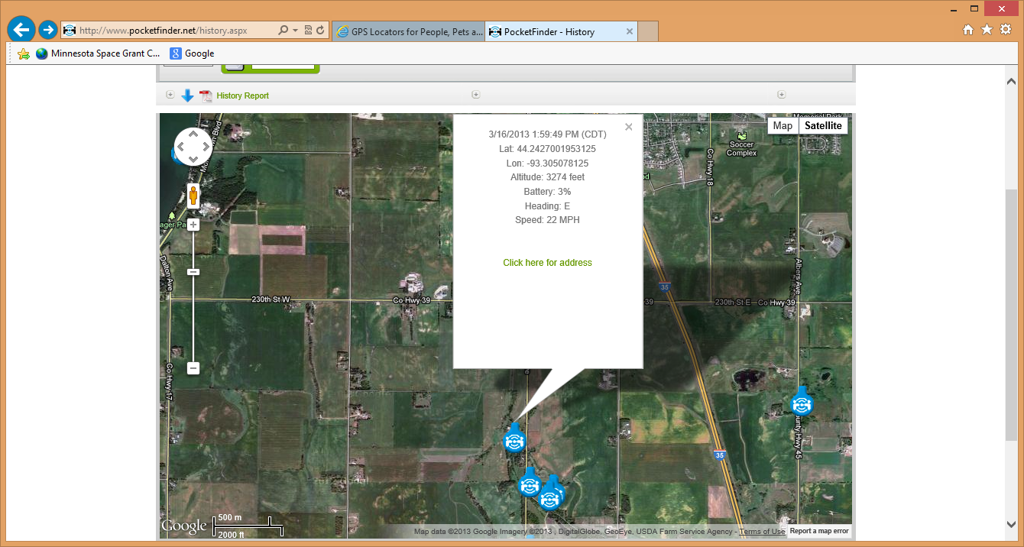

First from-the-ground data point at 2:04 p.m.
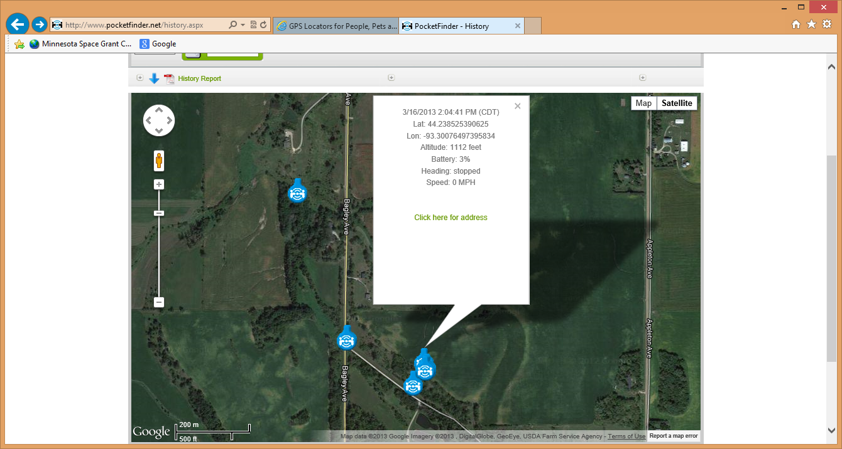

Pinpoint map of landing site – just beyond trees!
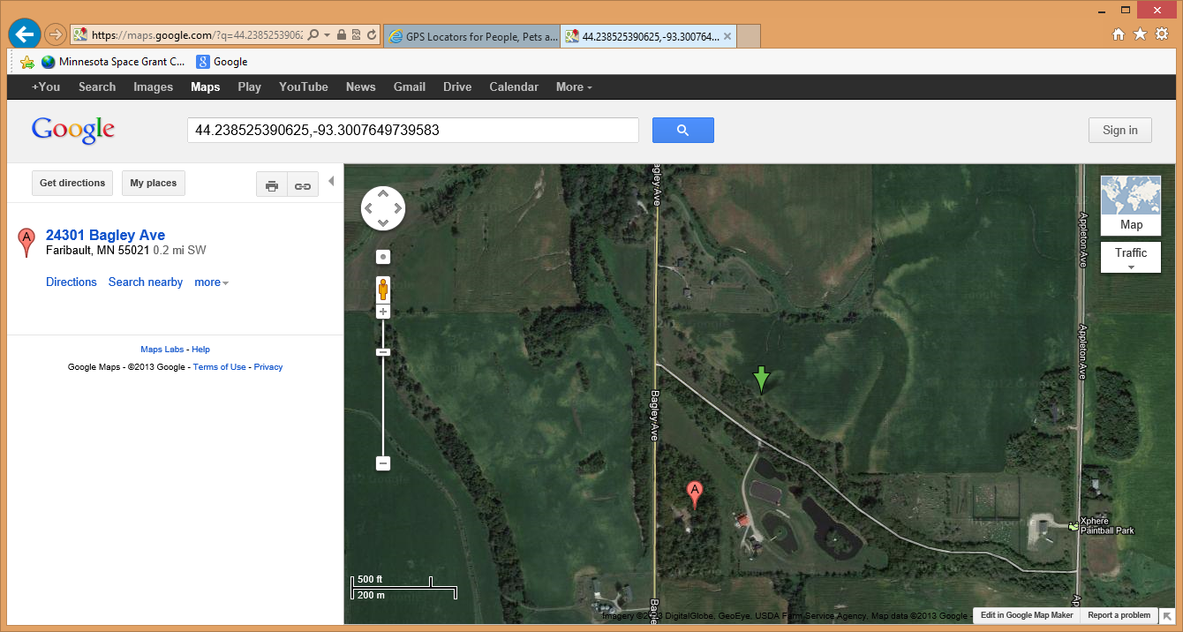

Pinpoint map of launch site, just before release.
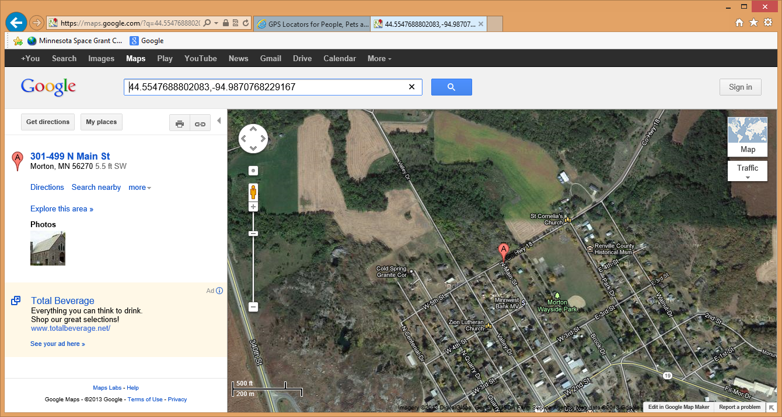

History from just before launch to just after landing. Few in-flight records (and those can be inaccurate anyway.)
From pocketfinder.com web site – unfortunately this includes latitude and longitude but not altitude (though the site knows that too).
72851765 | 3/16/2013 12:27:48 PM (CDT) | 44.55478515625 | -94.9872233072917 | stopped | 0 MPH | link
72853989 | 3/16/2013 12:32:41 PM (CDT) | 44.5548095703125 | -94.987255859375 | stopped | 0 MPH | link
72853990 | 3/16/2013 12:37:42 PM (CDT) | 44.5547688802083 | -94.9870768229167 | stopped | 0 MPH | link
72872508 | 3/16/2013 12:42:50 PM (CDT) | 44.5329671223958 | -94.9679036458333 | SE | 27 MPH | link
72872509 | 3/16/2013 12:47:47 PM (CDT) | 44.5077555338542 | -94.9180501302083 | SE | 47 MPH | link
72872510 | 3/16/2013 12:52:46 PM (CDT) | 44.4746256510417 | -94.81923828125 | E | 83 MPH | link
72872511 | 3/16/2013 1:49:45 PM (CDT) | 44.2936930338542 | -93.43388671875 | E | 81 MPH | link
72872512 | 3/16/2013 1:54:51 PM (CDT) | 44.2658772786458 | -93.3423502604167 | SE | 34 MPH | link
72872513 | 3/16/2013 1:59:49 PM (CDT) | 44.2427001953125 | -93.305078125 | E | 22 MPH | 23660 Bagley Avenue | Faribault, MN 55021 | link
72872514 | 3/16/2013 2:04:41 PM (CDT) | 44.238525390625 | -93.3007649739583 | stopped | 0 MPH | link
72874647 | 3/16/2013 2:09:41 PM (CDT) | 44.2383544921875 | -93.30068359375 | stopped | 0 MPH | 24301 Bagley Avenue | Faribault, MN 55021 | link
72874648 | 3/16/2013 2:14:43 PM (CDT) | 44.2383544921875 | -93.3007161458333 | stopped | 0 MPH | 24301 Bagley Avenue | Faribault, MN 55021 | link

