Predictions for GL71 – Sunday, Oct. 6, 2013

Predictions run Sunday morning, October 6, 2013, from Kenyon, MN (“12 hours out”) with weather data from Faribault
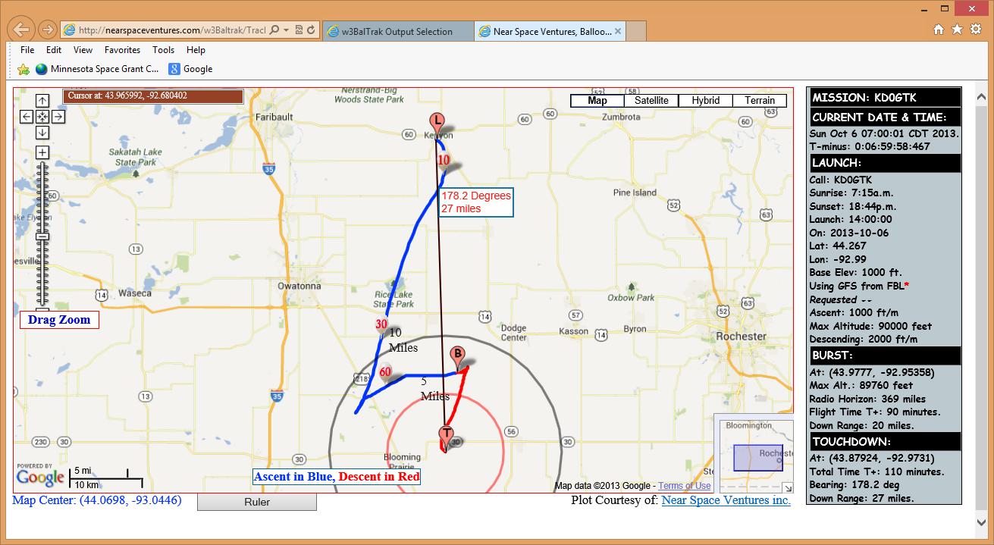

Predictions run Sunday morning, October 6, 2013, from Kenyon, MN (“12 hours out”) with weather data from Dodge Center
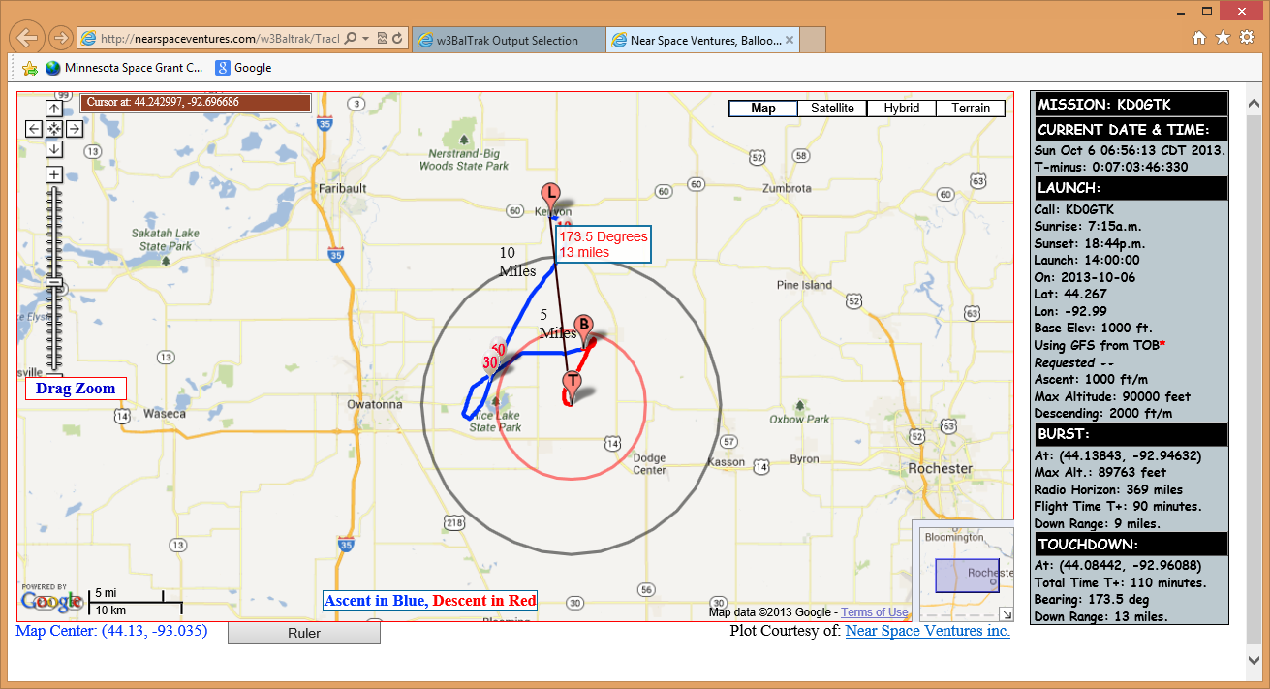

Predictions run Saturday morning, October 5, 2013 from Wanamingo, MN (“36 hours out”)
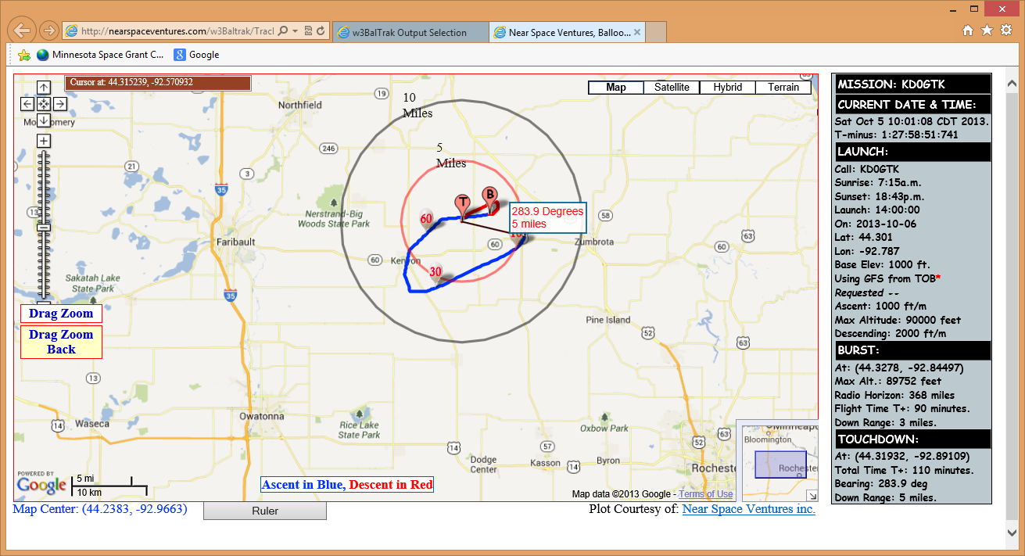

Predictions run Friday, October 04, 2013 from Brownton, MN
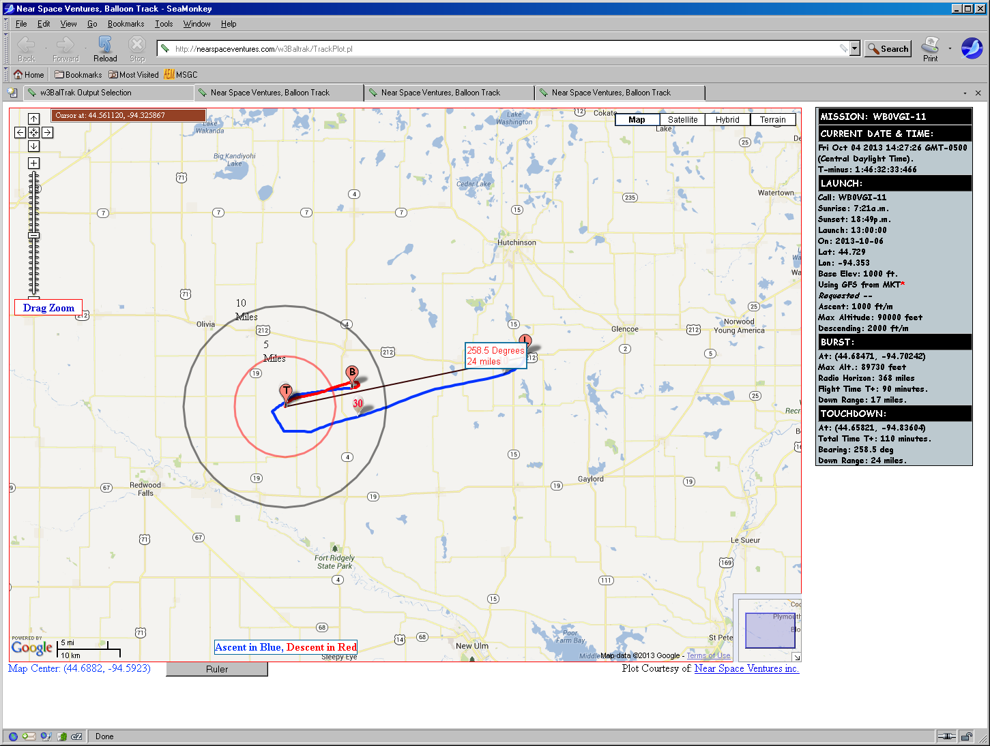

Predictions run Wednesday, October 02, 2013 from Faribault, MN
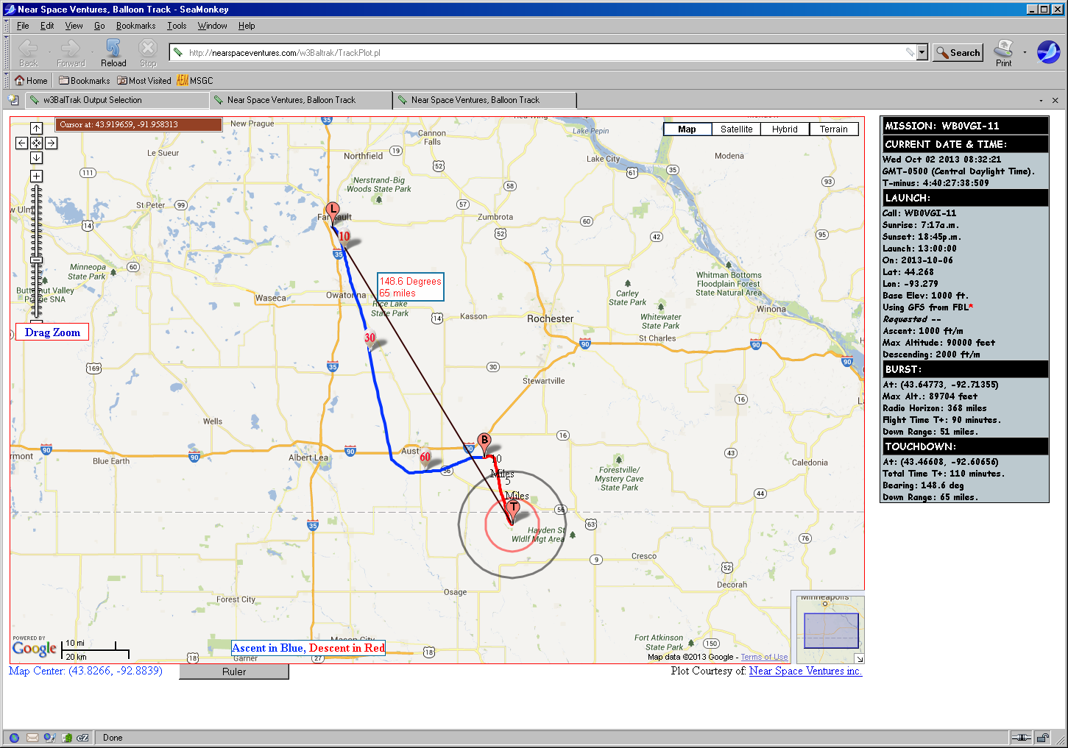
Predictions run Tuesday, October 01, 2013 from Belgrade, MN
