GL141 triple MURI internet SPOT screenshots from Aero3 and Aero4 June 13, 2019

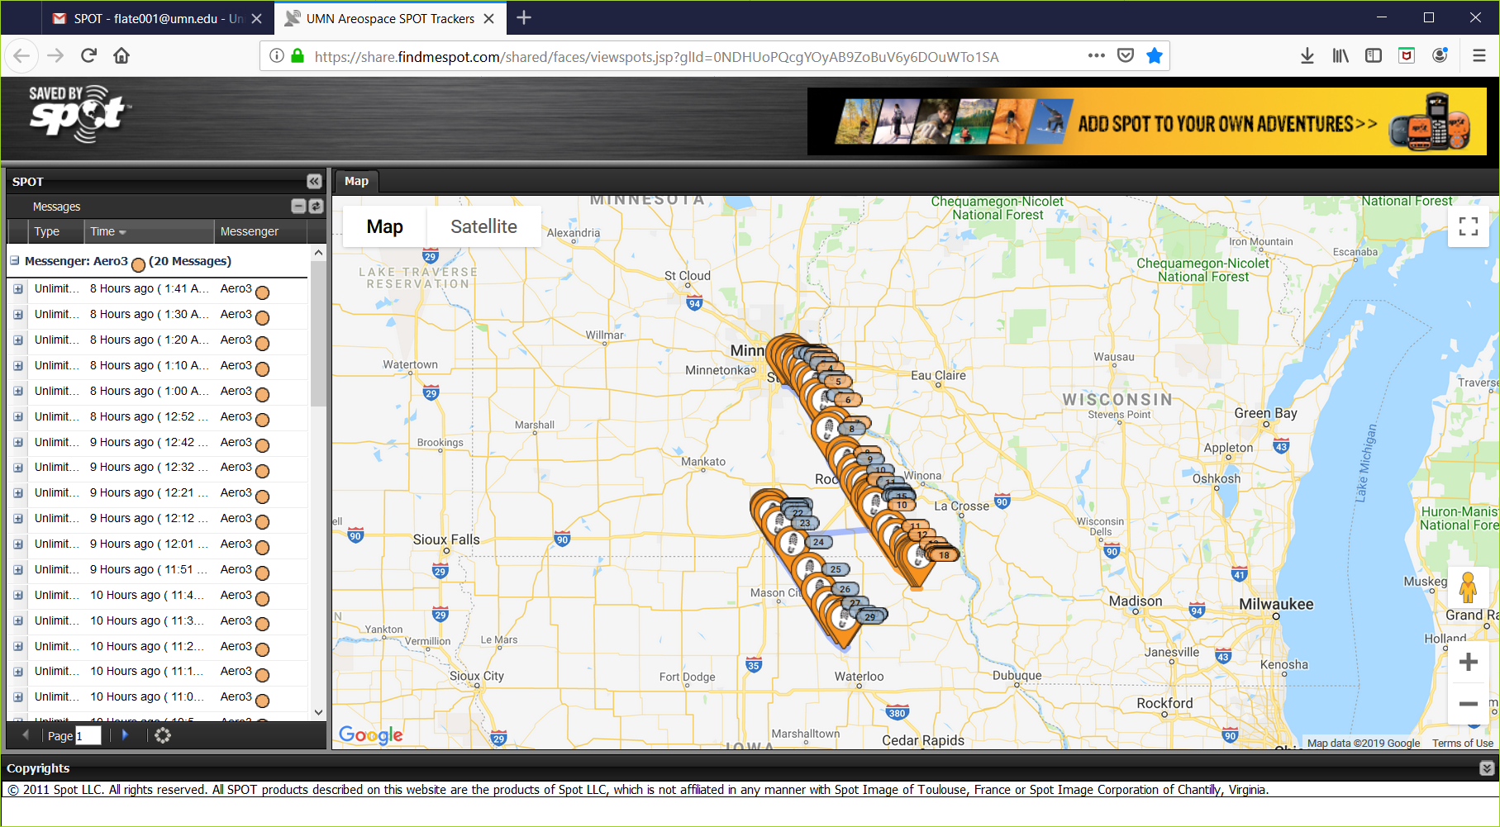

Evidence that SPOT finders don’t work “at altitude.”
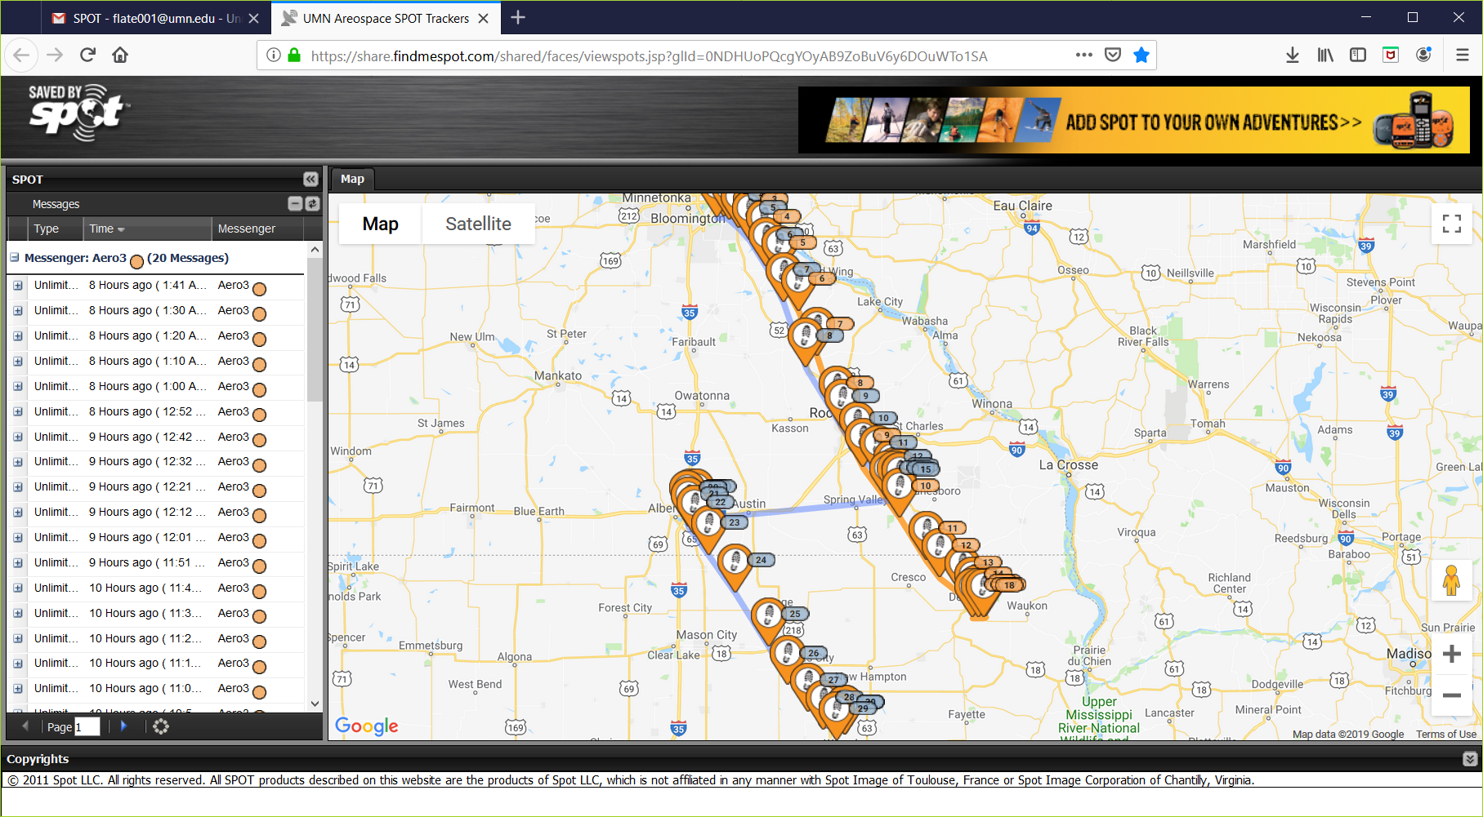

Odd record from Aero3 – NOT near-landing.
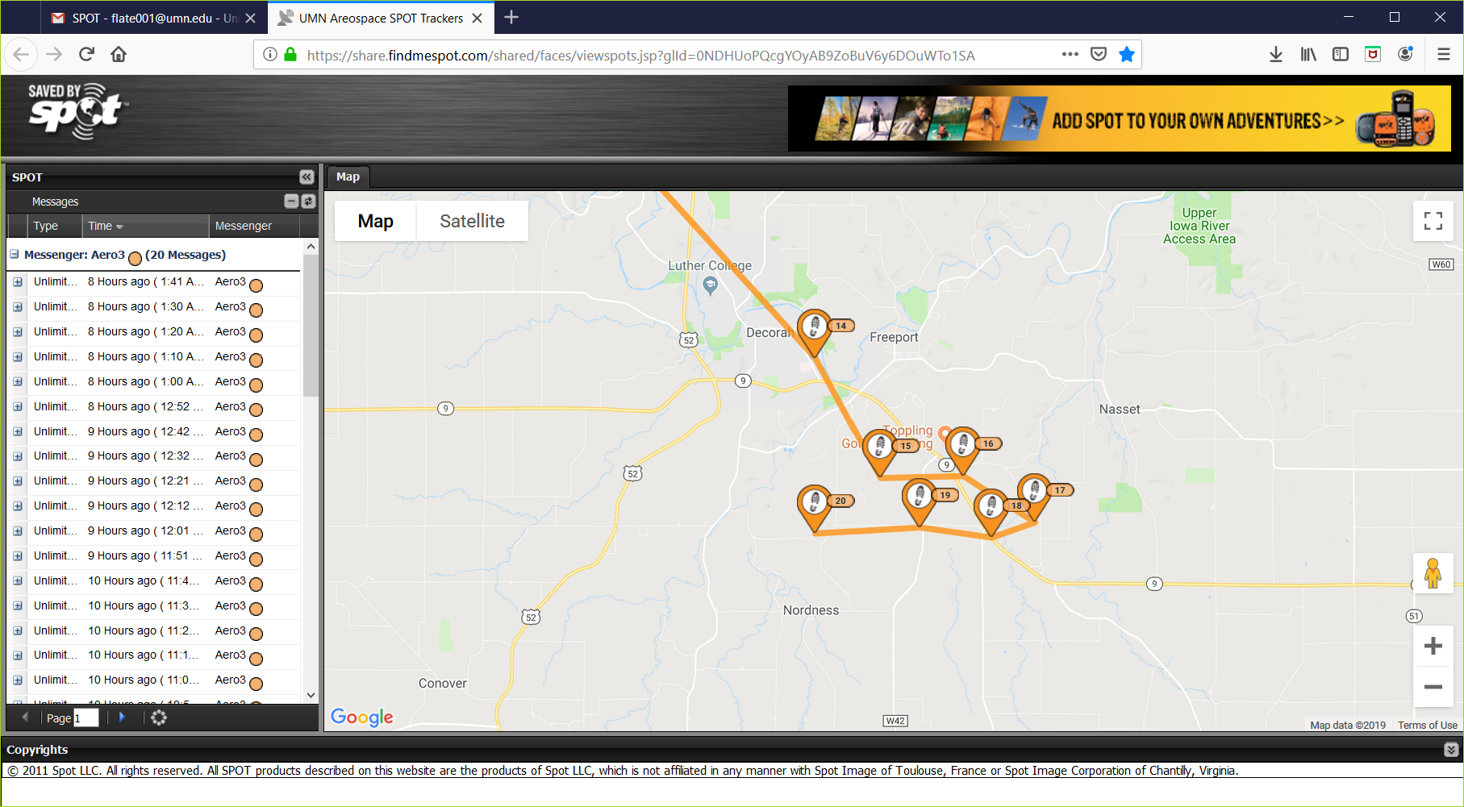
More-normal near-landing record from Aero4.
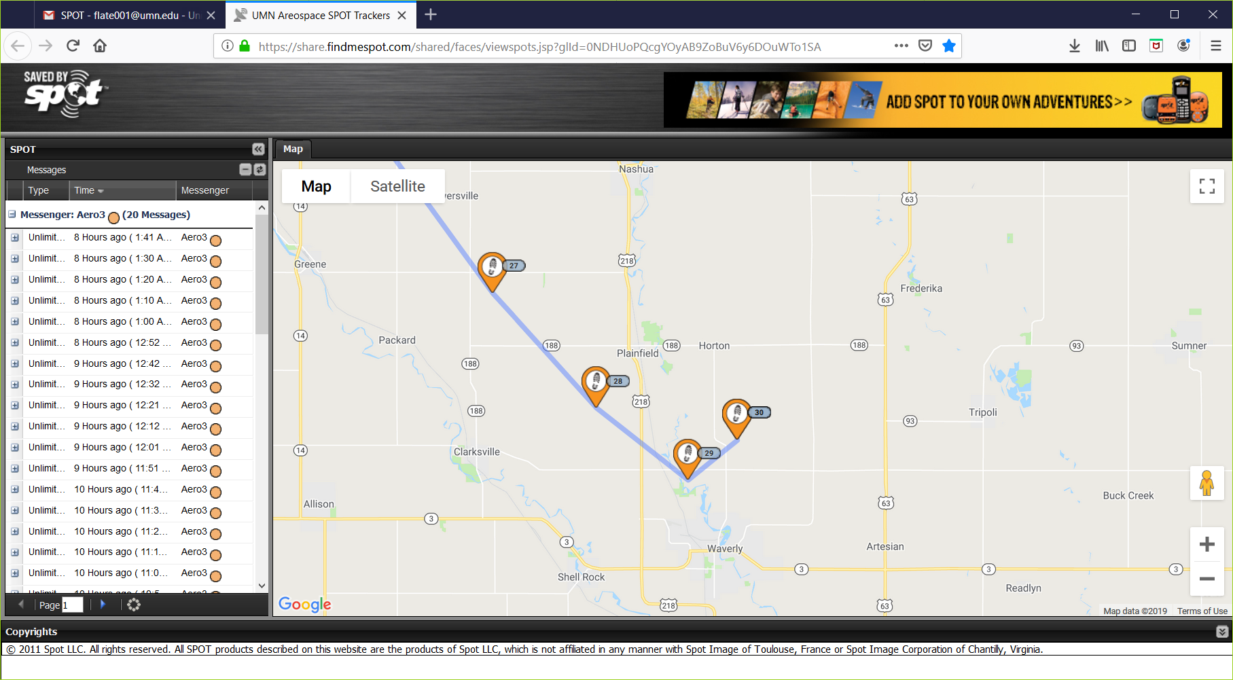

Aero3 came alive later (after a couple days of staying above 80,000 feet).
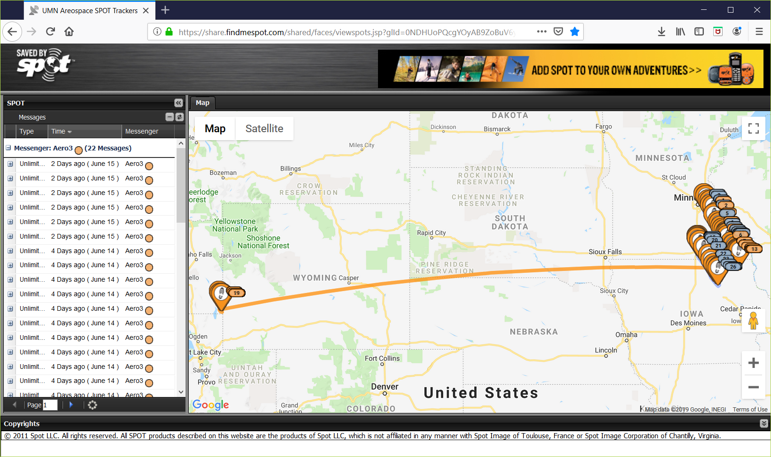

Some SPOT records as it approached 50,000 ft on modestly-slow descent (probably still under balloon). Then nothing… odd.
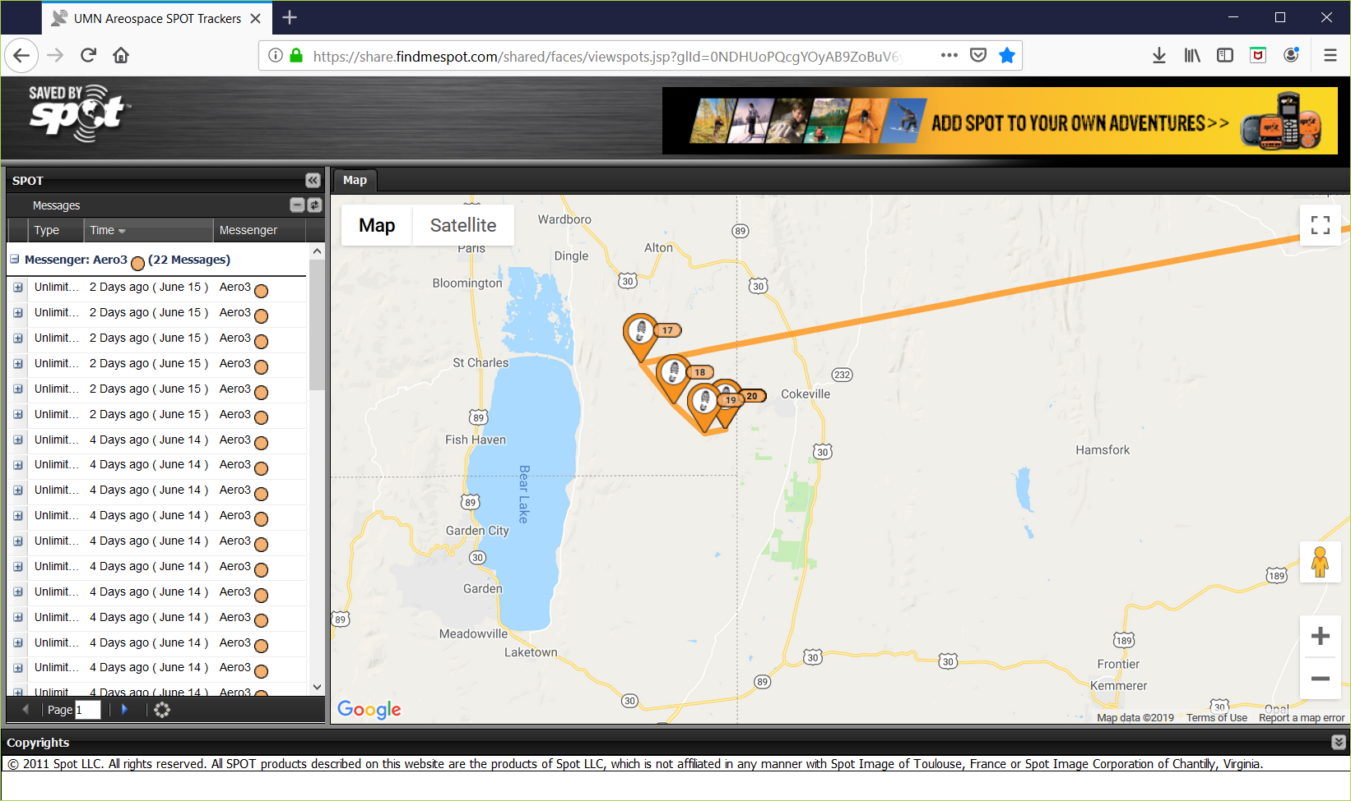

One more data point in mid-July – found and brought to a roadside? No one called it in. Students not sure payload was labelled.
