University of Minnesota and MN Space Grant Consortium

AEM 1905 Freshman Seminar: Fall 2008
Introduction to Spaceflight with Ballooning
Team Project Documentation
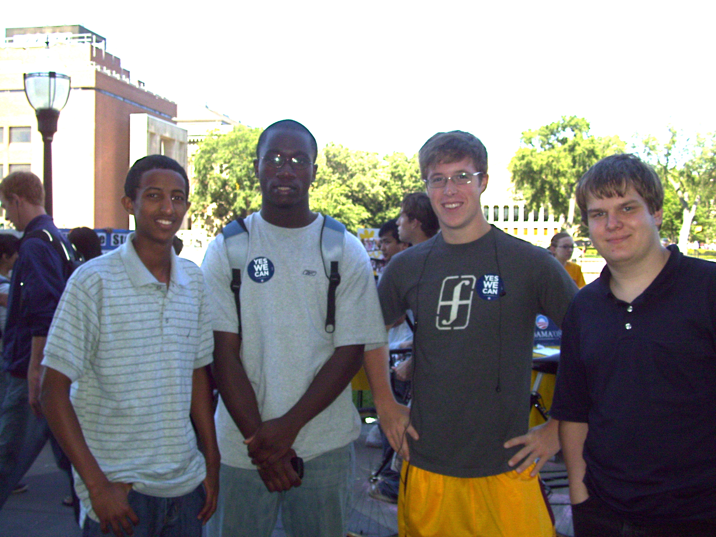

The Random Guys

Written by:
Philip Hansen, Ryan Lemerond, Jens Heig, Ayo Akindumila, Olani Aga

Report Date: December 2, 2008
Revision C

Table of Contents

- Introduction………………………………………………………………………1
- Mission Overview…..……………………………………..………..…………….1
- Payload Design.…………………………………………………………………...2
- Test Plan and Results……….……………………………………………………..4
- Project Management…..…………………………………………………………..5
- Project Budgets…….……………………..……………………………………….7
- Payload Photographs…………………………………..……………...….……….8
- Expected Science Results……………………………………………..…………13
- Launch and Recovery……………………………..………………………..….16
- Results and Analysis…………………………………………..……………….18
- Conclusions and Lessons Learned………………………………………………20
- Appendix………………………………………………………………………..21

Introduction:
What is NEAR SPACEFLIGHT?
Near spaceflight is the use of technology to fly a near spacecraft into and through near space, which is in between the region of the stratosphere and mesosphere that ranges 75,000-330,000 ft above see level. Some of the technologies that might be used in near spacecraft are flight computers, a weather station, and a video camera.

Today near spaceflight are becoming commercial activities and they are one way of exploring the space with low, cost at any time and almost every where in the world. Some of the benefits that one can get from going on spaceflight are going performing experiments, gaining experience on program management and gaining a sense of space. In addition to that the main information that one can get from space flight are accurate metrological information for weather forecasting stations. In this flight we can capture picture and collect data through out the entire journey.
Mission Overview:
We have constructed our payload box out of 1½ inch thick styrofoam home insulation, for we believe that this material will give us the best protection from the frigid temperatures of the upper atmosphere. Included in our payload is a Geiger counter, which will measure how much radiation our box is exposed to, a weather station used for monitoring the conditions outside of the payload, and a video camera whose purpose is to record how the horizon line changes as you travel further into near space. In order to survive the extreme temperatures, we have built a small heater which will keep the batteries and other components warm. To monitor the conditions inside of the box, we will use a HOBO, which sends data about the boxes internal temperature.

Our main objective for this mission is the Geiger counter experiment. We want to know how radiation exposure changes as you travel through the atmosphere, but will eventually reach a plateau. Our expectation is, as you travel higher into the atmosphere, the amount of radiation is going to increase. We also want to know if there are any particular layers of the atmosphere where exposure is less, or more. The video camera is our team’s secondary experiment. It is positioned so the camera will be facing out towards the horizon. The goal is to observe the different atmospheric layers and try to identify which one is which.

Payload Design:
There are many technical requirements are a box that is 6”x6”x6”. The volume has to be maximized to fit all the equipment in the space so everything will be packed in tightly. There are many difficulties that will have to be overcome as we go up through the atmosphere. The lower temperatures will need to be compensated by a heater and insulation. The pink insulation Styrofoam is what we are using for our payload compartment this should provide the necessary insulation. The heater will probably be placed near the camera to compensate for the temperature drop. The switch plate will go on the outside of the box and will be switching on the interior components.
The necessary parts for the flight are a flight computer to correlate & record information on the spacecraft. A heater will heat the components on the spacecraft. A Geiger counter will measure radiation in near space. A video camera will take pictures of the atmosphere as the balloon ascends. A weather station will take the temperature and pressure measurements at various altitudes.
The components will be largely interfaced through the flight computer. The BASIC Stamp 2 flight computer will take the switch plate to turn on and begin to start recording the weather station data and the Geiger counter data to record the information necessary to complete the experiments at altitude. The battery packs provide the power for the flight computer, and the heater. The HOBO temperature sensor is linked with the hobo data logger to collect the information about the inside of the spacecraft. The camera is an independent system that will be turned on by hand at the time of the launch. All this equipment will be situated within the box and the box will be shaped in such a way that the equipment will be able to measure the conditions we want to measure.
- Flight computer
- Geiger counter
- Heater
- DXG DXG-569V 5MPixel HD video camera with SD memory card
- Weather station
- Temperature probe and Data logger
- Battery packs for camera, flight computer, and heater
- 6’6’6 inch payload box
- Switch plate
Flight Computer
Geiger counter
Weather station
Switch plate

Batteries
Camera

Heater

How everything interacts in the payload.

The inside of the box
Flight computer
HOBO
Heater
Gei-ger cou-nter

Batteries

Camera

Weather station
Outer shell
The outside of the box from the side
Switch plate

Test Plan:
For testing we had to have the computers, heater, pressure sensor, and switch ready by October 16, and the box had to be ready by October 23. To test the computers Professor Flaten hooked them up to his computer and tried to get them to run with the script he had written to see if they were working properly. To test the heater all we had to do was plug it in and wait a few minutes to see if it got hot fast enough. To test the on/off switch we used a multimeter to see if all the connections were right and to tell when it was off and when it was on. To test the pressure sensor we had to just make sure it took readings and we also had to calibrate it using a know pressure. To test the payload box the professor put our box into liquid nitrogen with everything inside to make sure that the heater keeps everything warm enough to still function.
Test Results:
Our BASIC Stamp One we found out that it wasn’t quite working properly, but we only had a few minor solder bridges, which were easily fixed. Our pressure sensor was also working properly when tested, and our heater performed extremely well in the liquid nitrogen test never allowing the temperature to drop down below 10 degrees Celsius. Are on/off switch also worked properly during the test.

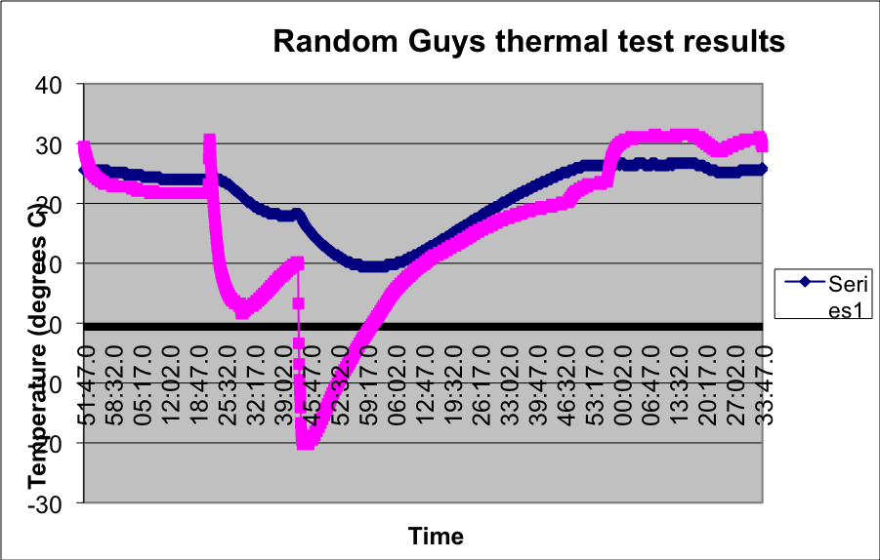

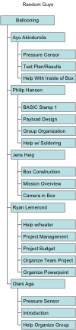Project Management

Schedule

Thursday, Sept. 25
We need to figure out what tests we’re doing by this date and who’s doing what.

Thursday, Oct. 9
Feedback on design and authority to proceed (ATP)

Thursday, Oct. 16
This is the day we need to have just about everything except the box ready to be tested.
We’re then going to have to fix anything that’s not working right.

Thursday, Oct. 23
Need to have the payload box ready to be tested by this date in cold temperatures. Also need to distribute who’s doing what for the Project Documentation.

Friday, Oct. 24
Team Project Documentation due electronically by 5 p.m. Make sure to turn in your individual parts to Ryan By 11 AM on Friday so he can piece it all together,

Thursday, Oct. 30
Flight Readiness Review have all individual slides ready by Wednesday
Everything with the box and equipment must be just about ready for final check-in tomorrow

Friday, Oct. 31
Payload weigh-in (and turn-in) by noon
We will not get the box back after this everything MUST be ready now.

Saturday, Nov. 1
Lauch Date

Friday, Nov. 7
Team Project Documentation due electronically by 5 p.m. Once again have individual parts into Ryan by 11AM on Friday

Thursday, Nov. 20 (Final Team Presentation slides due at noon)
Have your individual slides due by Wednesday so we can organize them.
Final Team Presentation

Tuesday, Dec. 2
Team Project Final due electronically by 5 p.m. and once again your individual parts are due by 11AM on Friday to Ryan

Project Budgets:
Item | Mass(kg) | Cost($)
Canon Powershot | .223 | 166
Basic Stamp One | .063 | 56
Batter Pack for Stamp One | .11 | 5
6x6x6 box of foam | .18 | 7
Geiger Counter | .114 | 150
Basic Stamp Two | .123 | 70
Heater Circuit w/Switch | .03 | 5
HOBO data logger | .027 | 105
Batter Pack for heater | .150 | 6
Total | 1.1 | 570

Payload Photographs
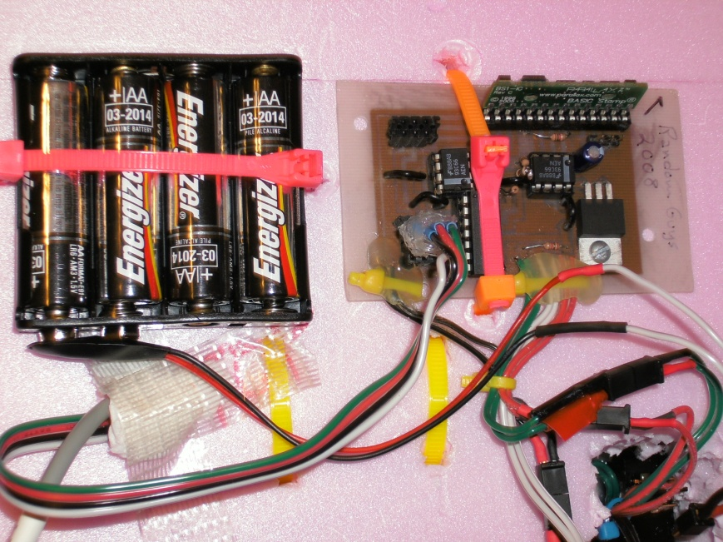
This is the flight computer and its battery pack it will log the Data that will be collected by the temperature and pressure sensor so that as the balloon ascends. This will record the temperature and pressure for later retrieval.

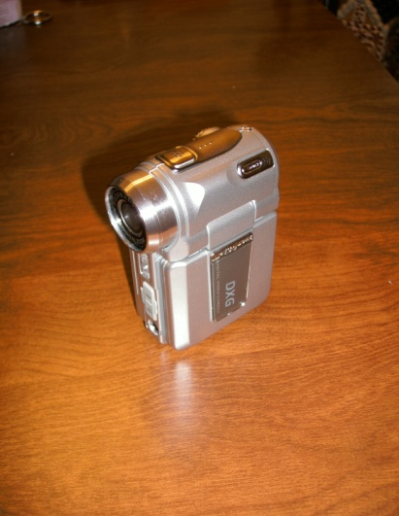
This is DGX MP4 digital video Camera that will record the ascent of the payload through the atmosphere we will extract pictures to do our analysis of the Atmospheric banding. This part failed but we may fly it again.
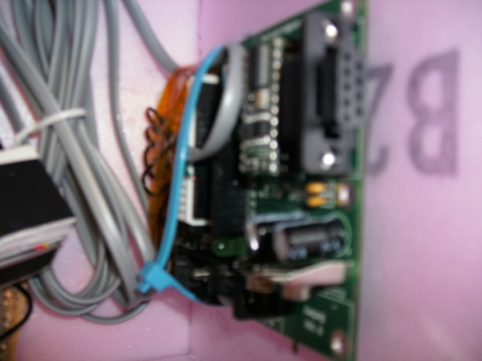
This is the Basic stamp two flight computer it has a counting circuit so it will be used to measure the radiation reading from the Geiger counter sensor.
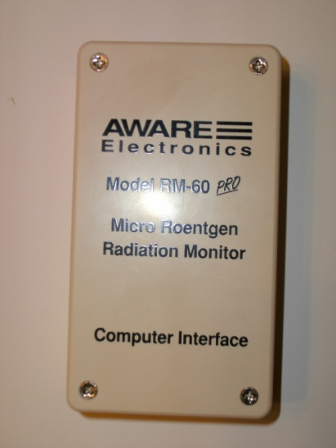
This is the Geiger counter for the payload it will measure the radiation to see the relationship between the altitude and radiation
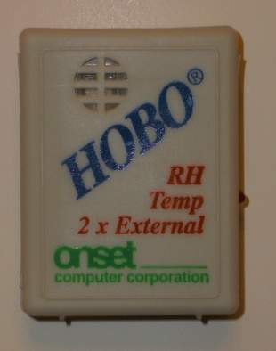
The Hobo will measure the Temperature inside and outside the Payload.
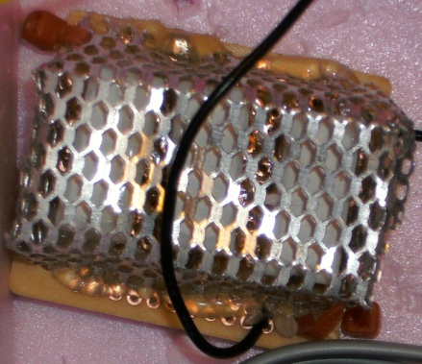
The heater that will keep the payload warm and actively keep the temperature where it needs to keep the payload functioning.
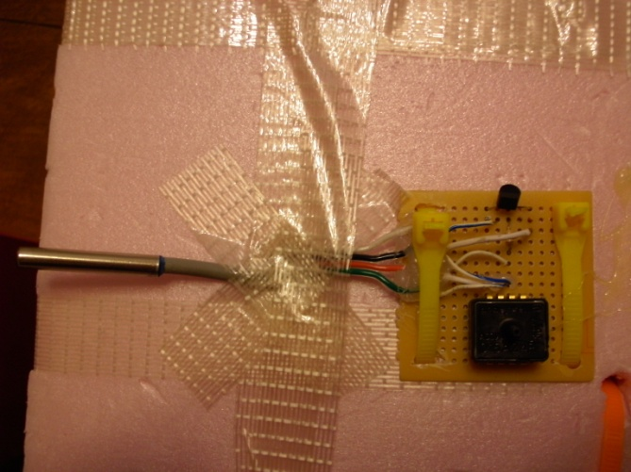
The Temperature and Pressure Sensor will measure the temperature and Pressure as we ascend and transfer those values to the Flight Computer.
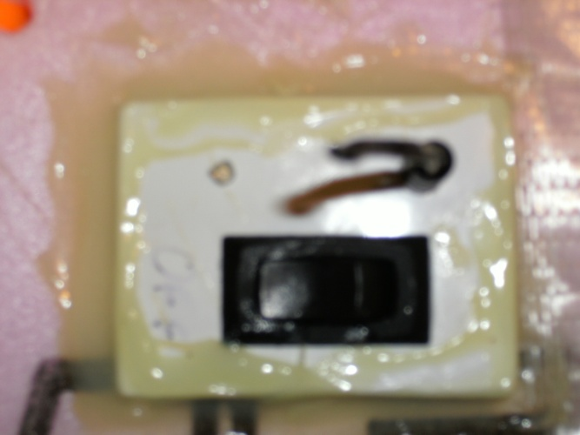
This switch plate will turn on and of the Flight computer and the pull pin will start measuring when the pin is pulled
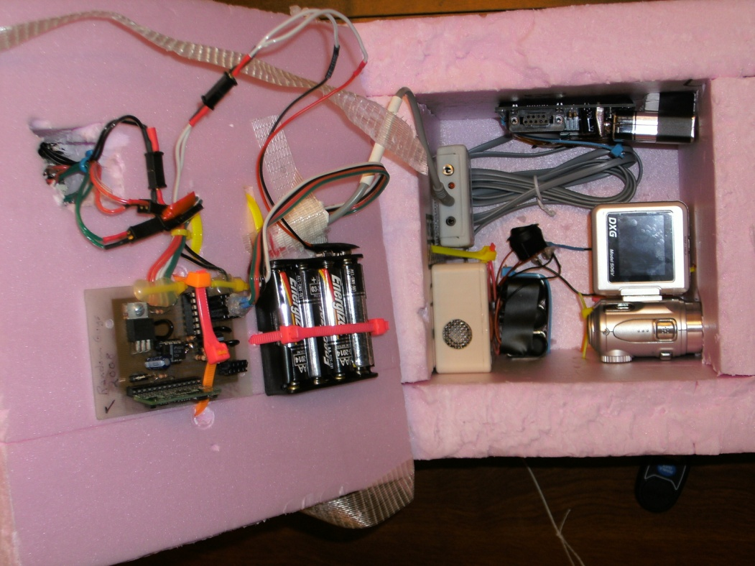
This is the interior layout of the Payload it is mostly secured with zip ties but the hobo is secured with Velcro.
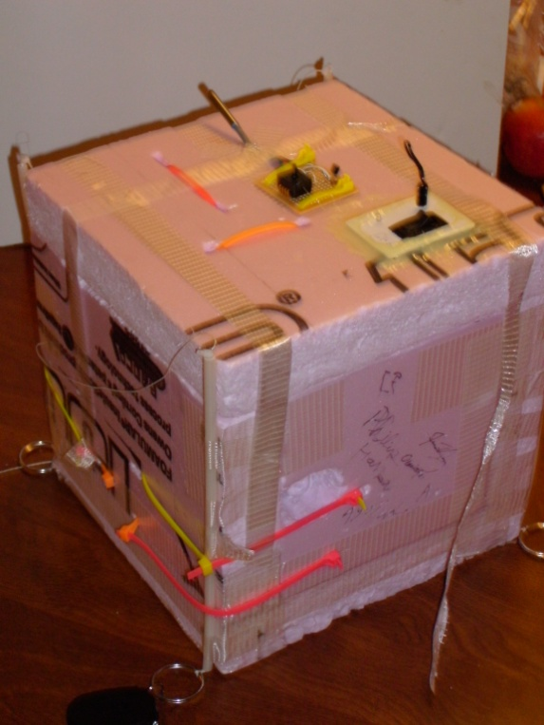
This is the exterior of the box and how it looks ready for flight.

Expected Science Results

The main goal of our experiment or project was to identify the change on the Horizon of the earth, Change in atmospheric pressure and temperature. As the result we expect some things to happen, generally our expectations are as follow:-Temperature, we expect the temperature to be variable at the different parts in the atmosphere, and generally we expect the relation to be indirect with altitude, that is as altitude increase the temperature will decrease and vise versa. It is also related to the time after the launch. (See from the graph)The other thing we expect to happen is the change in the pressure and it should be inversely like the relationship of temperature and altitude, we also expect the air pressure to drop around zero which is the same as vacuum air pressure. Horizon of the earth, according to the program our expectation is the horizon of the earth will increase as we go further up to the sky that means as the altitude increases the horizon of the earth also increases. The other thing which we expect to happen on the program is the darkness of the sky it will become dark black as we go up higher to the sky (in to the atmosphere). We also expect that in our main experiment with radiation that the radiation will steadily rise as the atmosphere gets thinner.

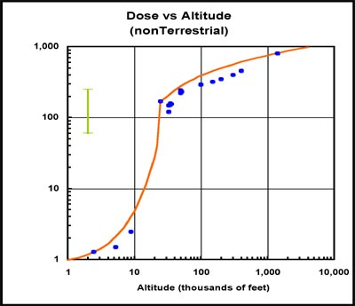

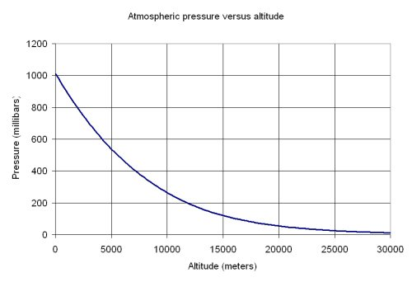

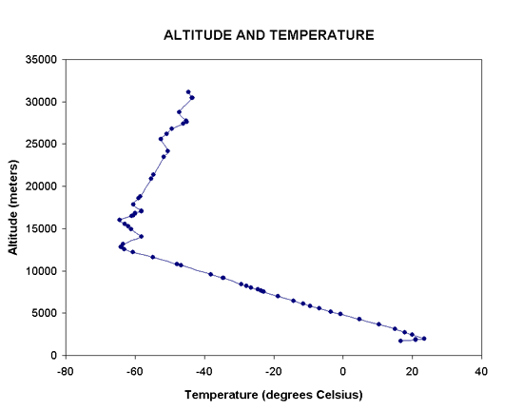
Launch and Recovery

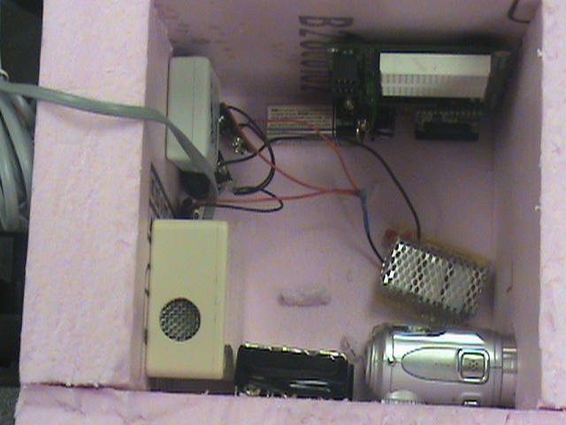
This is a picture of our box right before we launched it.

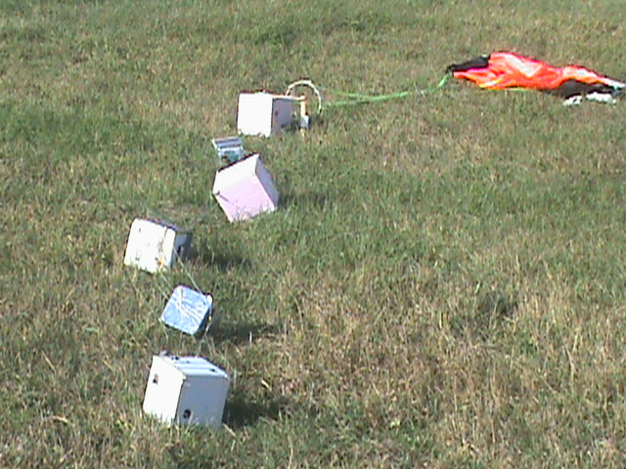
This is a picture of all the payloads and the parachute after they landed.

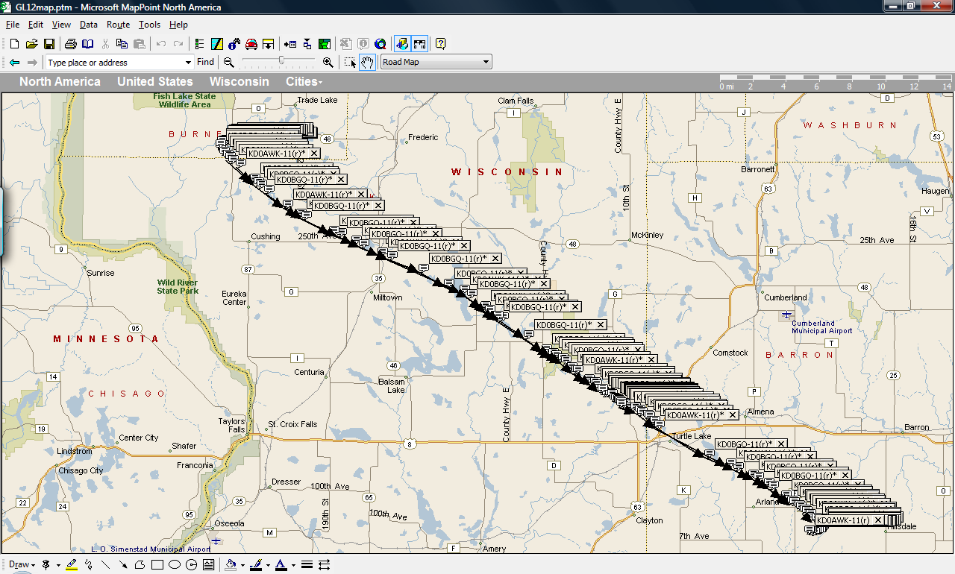

This is just a map of how our balloon flew.

The launch day went fairly smoothly. Almost everyone managed to make it that planned on it except for one person, and when we got to the launch site it was a clear, crisp day with almost no wind, which is perfect for launching balloons. Setup went extremely quick and we were able to launch in about an hour. Then a couple of hours later it landed almost where it was predicted to, andit touched down almost as smooth as went up hardly damaging anything.

Results and Analyis

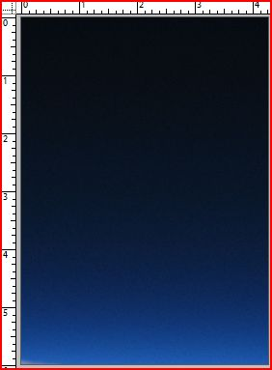
Photographic analysis

The tool used to do this experiment was a tool in Photoshop called the magic wand selector this tool picks out similar colors and selects them leaving an outline. This outline is then measured relative to the ruler that is on the edge of the picture this width is what was taken as the value and it was taken every ¼ inch down the picture and the approximate width was recorded and plotted relative to the distance from the edge of the picture going from space to the thick oxygen rich portions of the atmosphere. These values can extrapolated and go from the earth just as easily. That is why the graph represents a height starting from earth while the rulers are from the sky.

This is a graph of our Geiger counter experiment. As you can see the Geiger counter was getting so many hits that it maxed out our computer which is why we have so many zeroes.

Conclusions and Lessons learned

From our pressure sensor we learned that the pressure decrease exponentially with an increase in altitude. Our temperature sensor showed that the temperature drops steadily for awhile, but then actually starts to increase again. Our geiger counter experiment really didn’t work because the levels were so high that it maxed out the computer. Our camera experiment didn’t work because for some reason it didn’t record anything. If we were to change our payload and fly it again we would like to change how long the computer counted radiation hits so we could actually see how the radiation increases. Possible reasons why are camera didn’t work were because either we didn’t turn it on although

Words of Wisdom

¨Organize your team as soon as possible

¨Make sure that you don’t get behind

¨Don’t procrastinate

Appendix A:
Programs used in flight
Geiger counter code:
' {$STAMP BS2}
' {$PBASIC 2.5}

' Fills the EEPROM with ten second count measurements once every minute until all available slots
' are filled

EE_POS1 VAR Word 'For the BS2, EEPROM locations are referenced as words
RESULT VAR Byte 'Values are stored as bytes = value betweeen 0 and 255
GCT1 CON 15 'Geiger counter on P15
COIN CON 3
MTIME CON 15000 'Measure time for each count

INPUT 5

Waiting:
IF IN5 =1 THEN Waiting

'DEBUG "pin out", CR

RESULT = 0
EE_POS1 = 0

FOR EE_POS1 = 0 TO 359 'Fills first 360 slots

COUNT GCT1,MTIME,RESULT 'For 15 seconds, record geiger counts and place in variable result
'DEBUG "1 ", DEC RESULT, CR
WRITE EE_POS1, RESULT 'Write variable result to EE_POS1 slot

NEXT

Description:
This code runs on a basic stamp 2 flight computer this code was on the initial flight and ran into overflow problems. This took data twice a minute and when it hit the upper layers of the atmosphere it started giving zeros instead of data. This counted for up to 255 hits but after that it would not count any longer. This program then stored the count on the basic stamp flight computer to be retrieved later. This Failed but in a later flight an attempt was made to remedy the overflow problem by taking two data sets a minute one count per second and one count every ten seconds the rest of the minute would be idol.

Weather station basic stamp 1 flight computer:
' {$STAMP BS1}

SYMBOL ADC_CS = 5
SYMBOL Clocks = B4
SYMBOL CLK = 1
SYMBOL DATA = PIN2
SYMBOL VALUE = B2
SYMBOL Channel = B5
SYMBOL X = B6
SYMBOL I = B3
SYMBOL ShiftReg = W0
SYMBOL GetMSB = $800

Main:
'BalloonSat loop will infitiely wait for the balloon pin pull
BalloonSat:
DEBUG " pintest "
IF PIN3 = 0 THEN BalloonSat

Mission:
DEBUG "Mission loop (re)started:"
GOSUB Analog_IO
IF PIN3 = 0 THEN End_Mission
PAUSE 300

GOTO Mission

Analog_IO:
FOR X = 0 TO 72 'Each analog probe will store 36 data points
DEBUG "X = ",X, CR
FOR I = 1 TO 5
PAUSE 60000 'wait 1 minute each time through loop above
'PAUSE 1000 'Pause 1 second only, for testing purposes
NEXT I

FOR Channel = 1 TO 2 'Channel dictates which of the three Analog-to-Digital pins is read. The converter itself is connected to pin2 of BS1.
DEBUG "channel: ",Channel, CR
'Send_Channel. Clears Analog-to-Digital converter and prepares it for reading
LOOKUP Channel, ($C,$E,$D,$F),ShiftReg 'Sets which A-t-D Converter pin is being dealt with
ShiftReg = ShiftReg *256
LOW ADC_CS
DIR2 = 1
Clocks = 4

'ShiftOut. Continues to prepare Analog-to-Digital converter for reading (via pin 2)
DIR2 = 1 'Sets pin2 as output
FOR I = 1 TO Clocks
PIN2 = ShiftReg/GetMSB
PULSOUT CLK,10
ShiftReg = ShiftReg * 2
NEXT I

'Read Channel
'This loop reads a binary number from the analog to digital converter, one clock tick at a time onto pin 2.
'Value will hold the decimal value which is the voltage at the analog pin
DIR2 = 0 'Sets pin2 as input
PULSOUT CLK,1
Value = 0
FOR I = 1 TO 8 'Binary to decimal conversion
Value = Value * 2
HIGH CLK
Value = Value + PIN2
LOW CLK
' DEBUG Value, CR
NEXT I
HIGH ADC_CS
I = Channel - 1
I = I*72+X
WRITE I,Value
DEBUG "X= ", X, "I= ", I, "Value= ", Value, CR
NEXT Channel
NEXT X

End_Mission:
DEBUG "end mission"
END

Description:
This program takes data every 5 minutes and places it into the basic stamp 1 memory this value was retrieved later and used for data analysis. This program performed flawlessly on the first mission. It took data from the temperature and pressure sensor probes and took data till the probe hit the ground.

