University of Minnesota and MN Space Grant Consortium

AEM 1905 Freshman Seminar: Fall 2011

Spaceflight with Ballooning

Team Project Documentation

Team K^3 + C
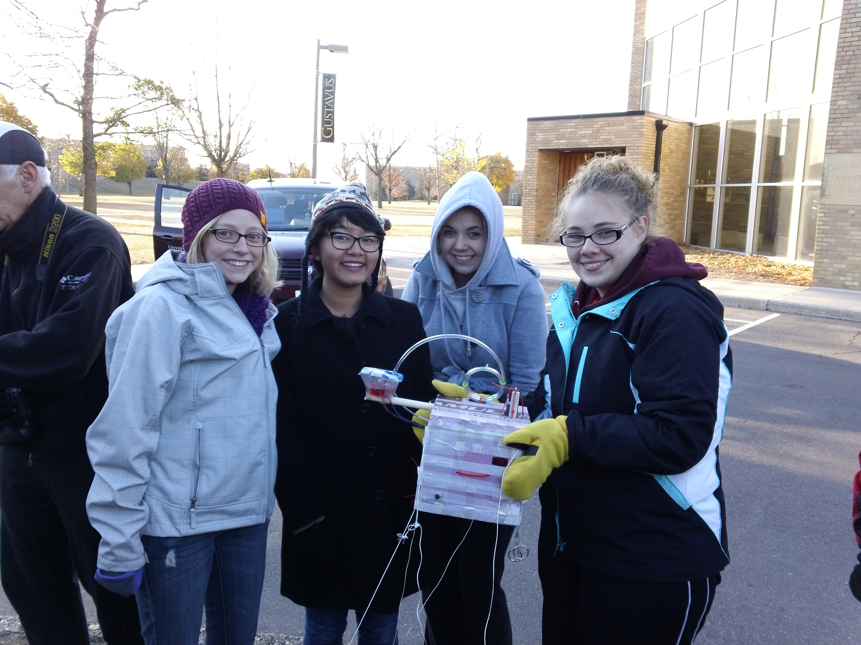

Written by:

Kim Gleffe

Carlie Bolin

Khin Oo

Katelyn Harder

Report Date: 12/02/11

Revision C

Table of Contents

- Team Assignments……………………………………………………………………3
- Introduction…………………………………………………………………………..4
- Mission Overview…………………………………………………………………….5
- Payload Design………………………………………………………………………..6
- Project Management…………………………………………………………………..11
- Project Budgets……………………………………………………………………….13
- Payload Photographs………………………………………………………………….14
- Test Plan and Results………………………………………………………………….18
- Expected Science Results……………………………………………………………..22
- Launch and Recovery…………………………………………………………………25
- Results and Analysis…………………………………………………………………..30
- Conclusions/Lessons Learned……..………………………………………………….37
- Appendix: Program Listings………………………………………………………….38

0.0 Team Project Documentation Writing Assignments

Team Name K^3 + C

Introduction Carlie Bolin

Mission Overview Carlie Bolin

Payload Design Katelyn Harder

Project Management Katelyn Harder

Project Budgets Katelyn Harder

Payload Photographs Kim Gleffe

Test Plan and Results Carlie Bolin

Expected Science Results Kim Gleffe

Launch and Recovery Khin Oo

Results and Analysis Whole Team

Conclusions and Lessons Learned Khin Oo

Oral Presentation Assignments

Conceptual Design Review (CDR) Katelyn Harder Khin Oo

Flight Readiness Review (FRR) Carlie Bolin Kim Gleffe

Payload Build Assignments

Overall team lead and ground testing lead Katelyn Harder

Flight computer (BalloonSat Easy) build Katelyn Harder

Weather station build Kim Gleffe

Payload box build Khin Oo

Photographer Carlie Bolin

Programmer (of flight computer(s)) Kim Gleffe

Camera and camera experiment Katelyn Harder

HOBO (payload “health” (internal temp)) Khin Oo

“Other” science experiment Carlie Bolin

Launch Day Assignments

Photographer Carlie Bolin

Prediction/tracking assistant Whole Team

Balloon filling and release assistant Katelyn Harder

Payload/stack handling specialist Kim Gleffe

Recovery specialist (needs to go on chase for sure) Khin Oo

1.0 Introduction

Many people dream of creating, constructing, and experimenting with space-related concepts to answer some of their burning questions about the ocean of emptiness that contains such mystery. However, many problems restrict our thirsting knowledge. The expenses, difficulty, and time it takes to carry out these missions limit our ability to launch aircrafts into space to test our creations and ideas. On the other hand, with today’s increasing rate of technology and tools, we are able to conduct experiments in near-space that produce exceptional results that are relative to the results we would experience in outer space.

According to the International Aeronautical Federation, Near Space is the area of our atmosphere that lies 75,000 ft. – 330,000 ft. above. The atmospheric pressure equals the vapor pressure of water at a temperature of 98.6 degrees F (Verhage 0:13). This means that at this region in space, your blood would boil. This line of altitude is called the Armstrong Line. Beyond this zone of transition the sky fades from dark blue to black. This is also where you can distinguish the curvature of the Earth.

It is in this area that we fly an array of craft such as blimps, sounding rockets, and high altitude balloons. Typically in experiments, the high altitude balloons are ideal. Helium-filled weather balloons provide an exceptional spacecraft because it is affordable and safe. Although it may seem like a very simple solution, there are still many things that need to be built in addition to this weather balloon. In addition of a near spacecraft, you will need a recovery parachute, launch equipment, and a telemetry station. According to Paul Verhage, the cost of near spacecraft is broken down into three main categories: avionics, airframe, and recovery systems. Avionics consists of the flight computer of the near spacecraft. This flight computer has a variety of objectives such as collecting data, responding to contingencies, finding out the status of the spacecraft, and telemetering flight and science data to stations on the ground. The airframe is the main part of the near spacecraft. They need to be lightweight and renewable. This is why Styrofoam is ideal because it does both of these duties, and provides a great insulation system to the interior. The recovery system is simply the parachute. It assists in the safe landing of the spacecraft so you can obtain your data and spacecraft. There are also other devices that vary with experiments, each being responsible for a task that will contribute to the final results.

Launching and experimenting in near space can give us similar results to what we would find if we launched a rocket into true outer space. The advantages of this to us as students are high, as it is inexpensive and relatively easy and amateur. It allows us to find answers to our burning questions that otherwise would be too difficult to obtain.

2.0 Mission Overview

We have multiple tasks we would like to accomplish in our near space mission. In order to ensure that these tasks will work correctly, we need to assure that the items in our payload and weather balloon will work effectively.

Our payload needs to be able to survive the extreme cold of near space. This temperature can drop down to -90 degrees F. Because of this, we need to have proper insulation that will keep everything in our box from freezing. Styrofoam will provide a good insulation and besides just keeping things warm, it also very light, while also being very strong. Another task our payload will need to be able to do is to have everything within it stay in place even during the violent motions caused after the burst of the balloon. To ensure this, we will need to make sure everything is secure. Another issue we need to accomplish in our flight is a safe landing. The parachute needs to be successful in order to do this. There are a few things that we can do to help guarantee that there will be a safe landing, like double-checking to see that the parachute is reliable and attached how it should be. Lastly, we need to make sure that our data will be recorded sufficiently by testing our equipment ahead of time. This will confirm that our data collectors will most likely be successful.

We will be conducting two experiments during our flight. One of them is about how water will change under extreme temperatures and pressure. We wonder, will it boil due to reduced pressure or freeze because of the low temperature? We are trying to verify the water pressure vs. temperature phase diagram. This chart states that at one point in the atmosphere a solid will go directly to a gas. We hope to demonstrate this by bringing water in a specialized tube along on the flight and filming it.

Our other experiment is to find out how sound travels in near space. We question if there will be changing in frequency and/or pitch of the noises. We are going to test and see if as the air gets thinner, some frequencies will be lost that we could normally hear on Earth. We will test this by using a sound maker and a voice recorder.

3.0 Payload Design

The design of our payload has a few different elements that have some requirements and limitations. First for our water experiment will have to have a water vessel that can't be completely sealed to allow the water to be affected by the temperature and pressure at the high altitudes. That is why we determined that we would use a circular Tupperware dish. We are also using pneumatic tubing and putting a hole in the top of the lid of the Tupperware to allow the water to be affected by the atmosphere of near space without spilling the water. Another requirement is that to be able to do our sound experiment we will need to be close enough to the balloon's siren to record the sound with our voice recorder.

This is how the system will interface with each other:

The BalloonSat Easy Flight Computer will store data that it receives from the weather station and will be powered by a 9-volt battery. The HOBO Data Logger will retain the information it receives from the HOBO temperature probes on board the payload. One of the HOBO probes will be inside the payload to collect the internal health of the box. Another probe will be placed inside the Tupperware full of water. This will allow us to see how the water temperature changes in effect to the changing temperature in the atmosphere. The final probe on the HOBO will be to collect the temperature outside the box. This is so that we have temperature data outside the payload to compare to the temperature we get inside the payload and the temperature we get from the water inside the Tupperware. The video camera will record the water sample during the entire flight and then after we will be able to watch the footage to see how the water reacted during the flight. The heater circuit will heat the interior of the payload and prevent freezing of the components due to the extreme temperatures and will be powered by a 3 pack of 9 volt batteries. The zigbee will be connected to the advanced sensor suite probes, which will consist of four probes. We will have two temperature probes on board one inside the water in the Tupperware and the other one outside the payload to collect outside temperatures, both, which will allow us to compare to our readings from the HOBO. The accelerometer will collect x, y, and z data about the orientation of the payload throughout the flight.

Here is a block diagram showing how all the parts relate and their primary purpose.

HOBO Data Logger

(Monitors "interior health" of payload)

HOBO Temperature Probes

(Will collect temperature data and send to HOBO data logger)

Flip Ultra Video Camera

(Records visual data of water experiment)

Zigbee

(Transmit advanced sensor suite data back to the ground)

Advanced Sensor Suite

(Probes collect temperature, relative humidity, and pressure data; sends data to zigbee)

3 Pack 9 Volt Battery

(Provides power for heater)

Heater Circuit

(Heats the inside of the payload to prevent freezing of components)

Accelerometer

(Collects x, y, and z orientation data)

Here is a list of all the components that we will use in the construction of our payload.

Components/Equipment
Heater Circuit
3 Pack 9 Volt Battery (for heater circuit)
Weather Station (temperature, pressure, relative humidity)
HOBO Data Logger (temperature, relative humidity - built in)
HOBO Temperature Probe (2)
Digital Voice Recorder
Buzzer (on another payload)
1" thick pink Styrofoam
Flip Ultra Video Camera
Zigbee
Advanced Sensor Suite (temperature, temperature, pressure, relative humidity)
9 Volt Battery (for zigbee)
Tubing, rigging strings, key rings, zip ties, glue
Pneumatic tubing
Tupperware
Accelerometer
PVC tubing (probe cover)
Water

Here is a view of the payload interior. This is how all the components will be laid out.
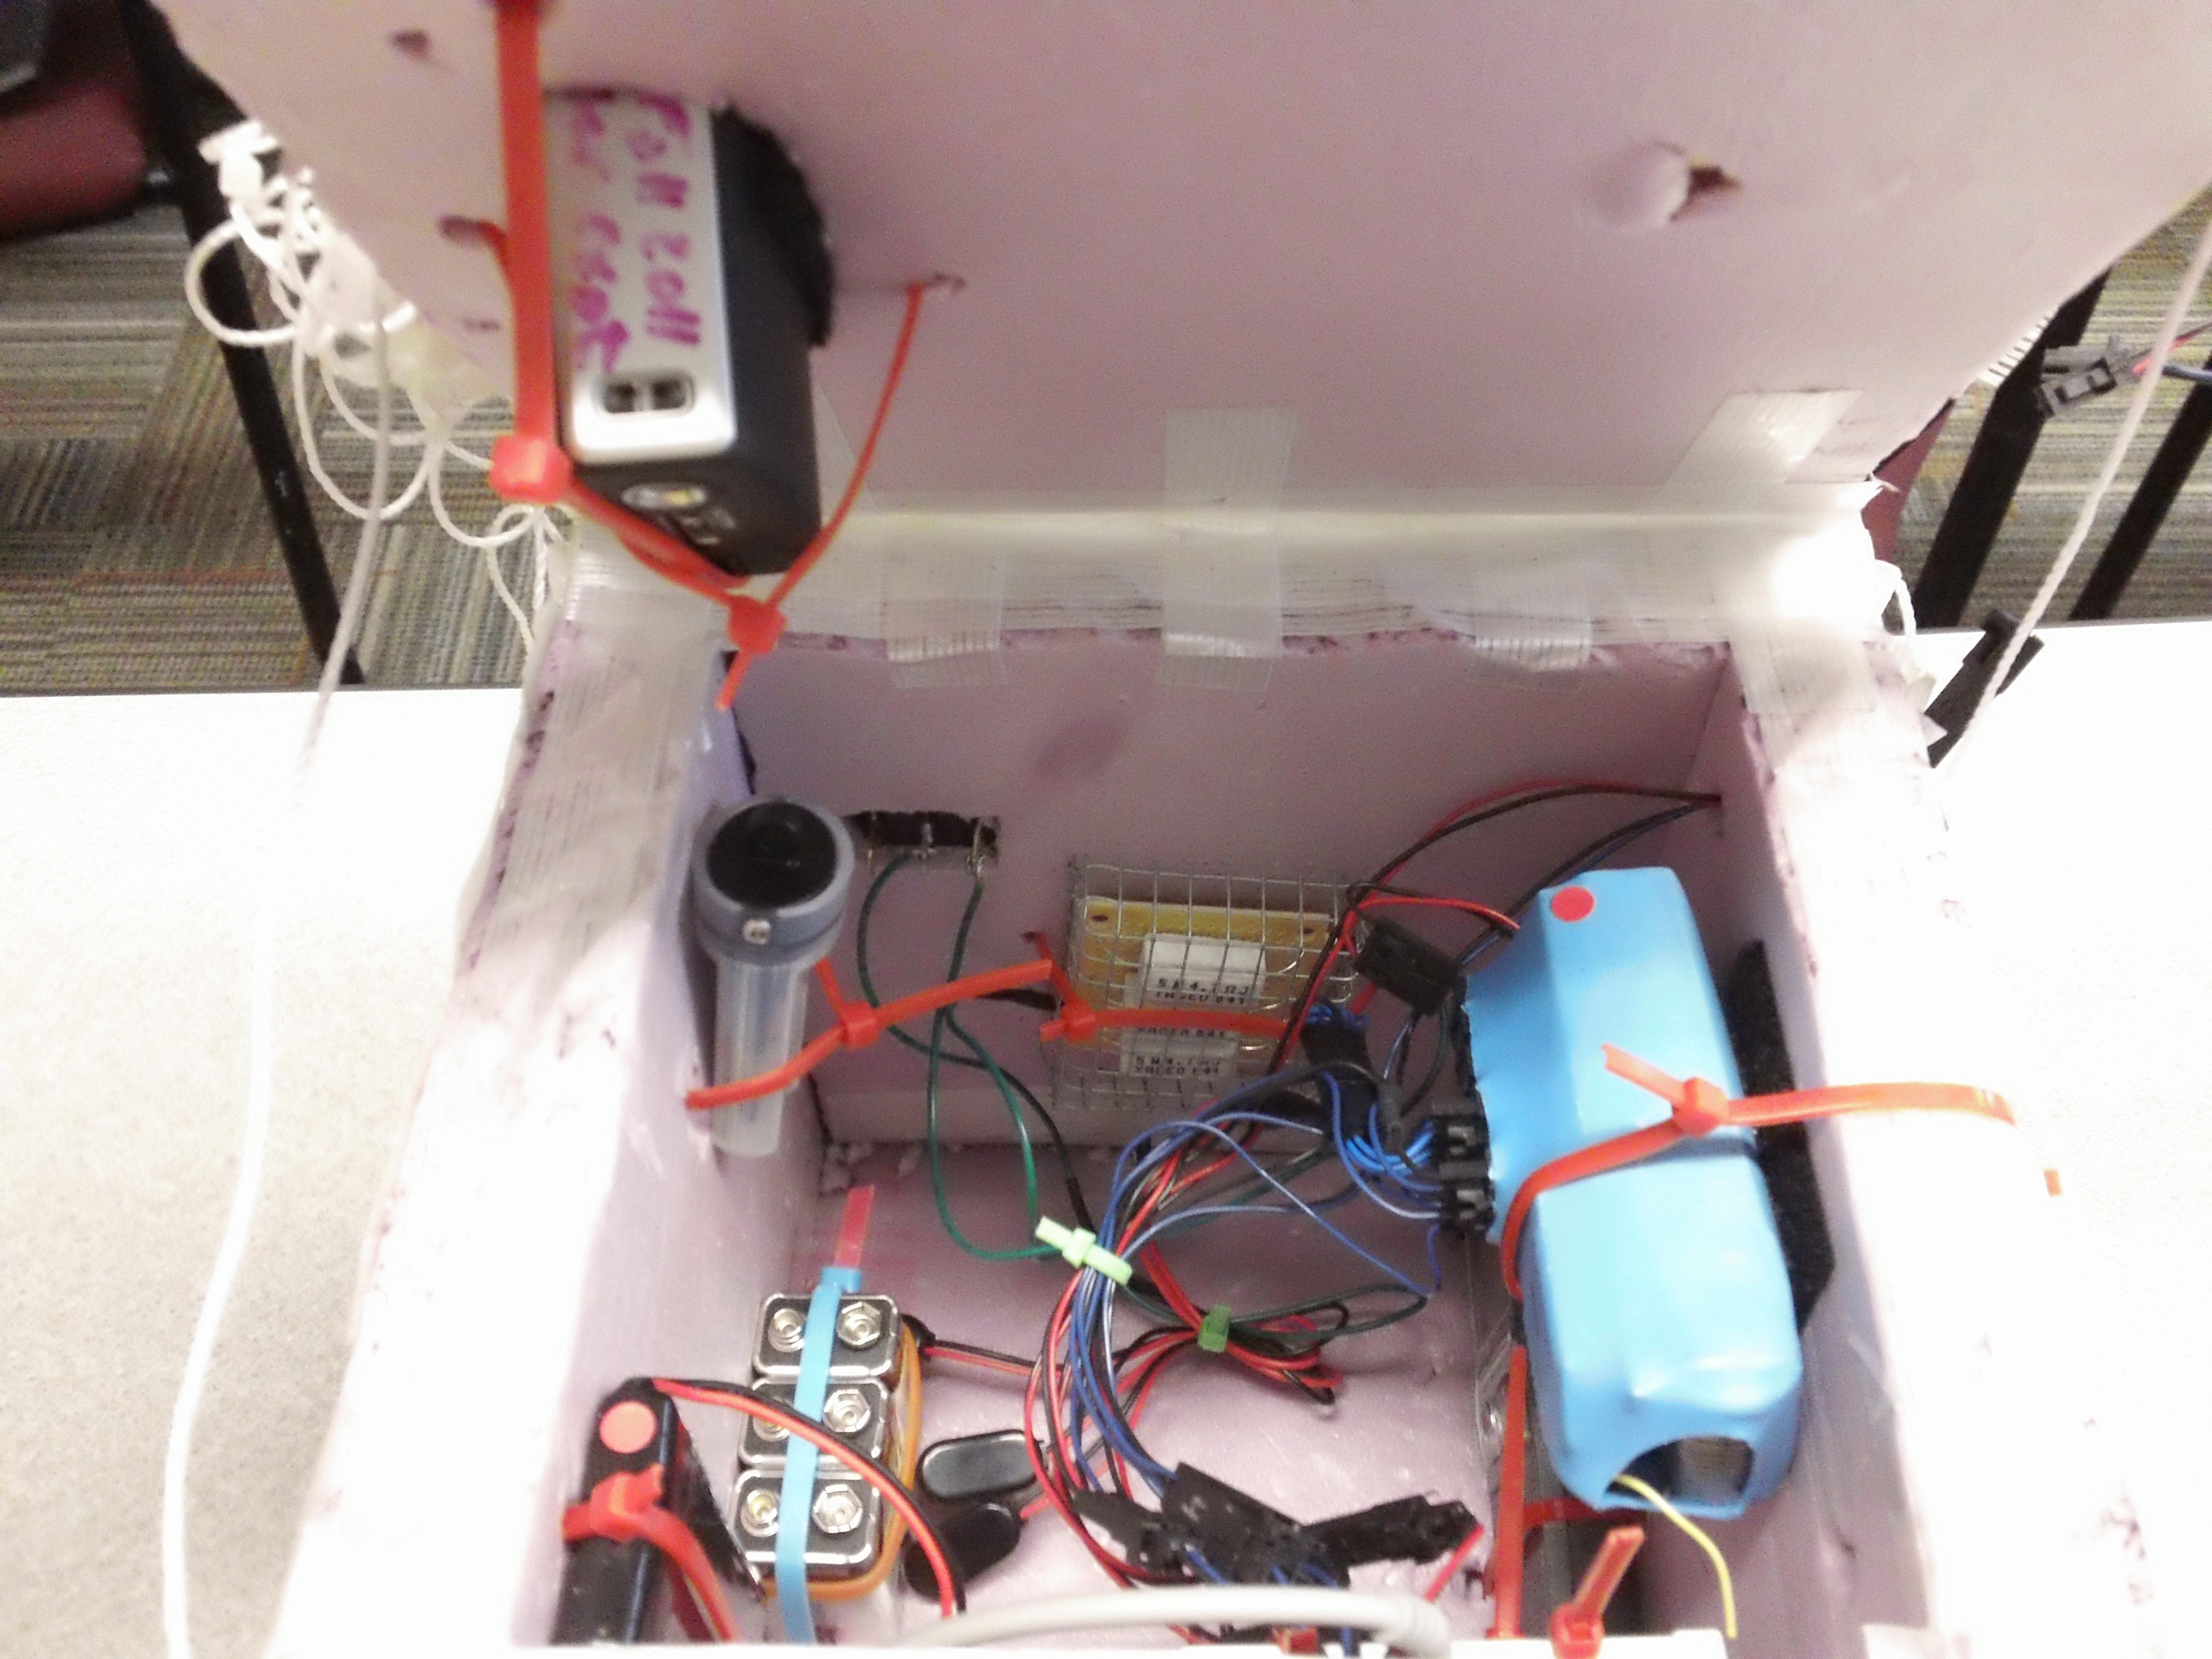

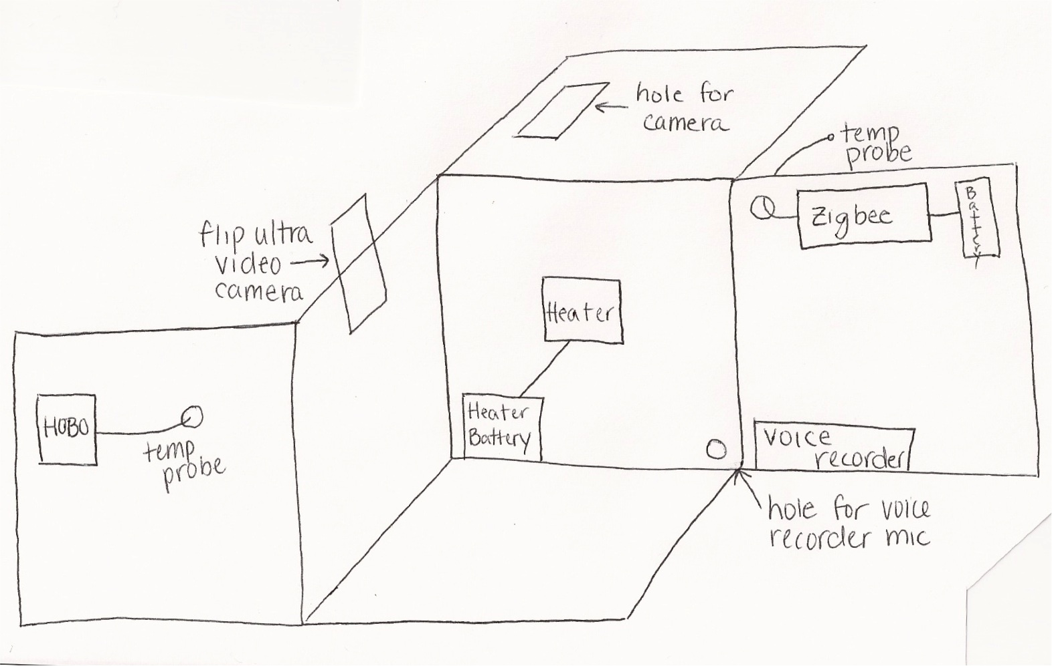

Here is how the water pneumatic tubing will be attached to the top of the payload.
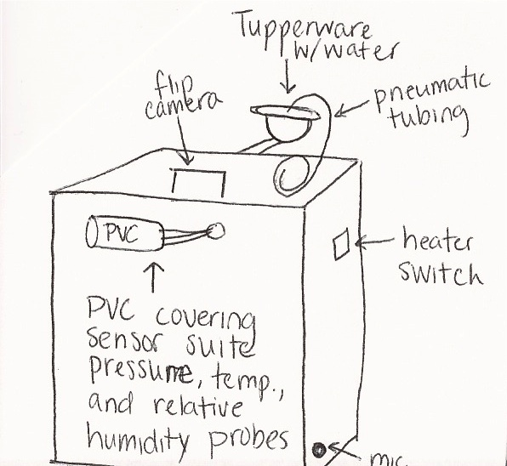
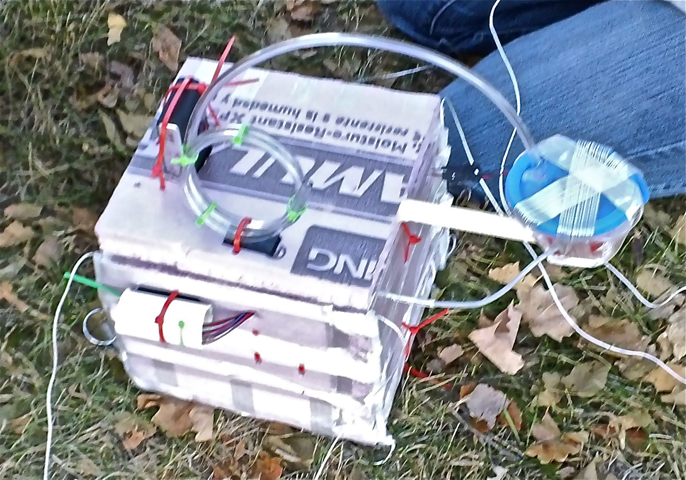

4.0 Project Management

Here is the schedule for the rest of the semester.
Date: | Description:
September 27th | Start soldering projects; Heater circuit completed
October 4th | Finish all soldering projects; Construct payload box exterior
October 8th | Finish payload construction
October 11th | Test soldering projects; Mechanical testing; Programming; Construction of experiments
October 18th | Finish construction; Programming; Integrate camera
October 25th | Weight payload make adjustments; Flight Readiness Review
October 27th | Payload final weigh in
October 28th | GPS hunt and flight predictions
October 29th | Flight Day!
November 1st | Data extraction; Discussion of gravity and orbits
November 4th | Project Documentation Revision B due
November 8th | Data analysis of information
November 22nd | Final Team Presentations
December 13th | Public reception at Akerman Hanger Lobby

Here is a chart depicting the duties that each of us will carry out during the class.

Katelyn
Khin
Carlie
Kim
- Team Contact
- Team Project:
  - Design
  - Budget
  - Management
- Payload Build:
  - Flight Computer/Weather Station
  - Team Lead/Ground-Testing Lead
- Launch Day
  - Payload/Stack Handling
Team Project:
Launch/Recovery
Conclusions
Payload Build:
Payload Box Build
HOBO
Launch Day:
Recovery Specialist
- Team Project:
  - Photographs
  - Expected Science Results
- Payload Build:
  - Camera Experiment
  - Programmer
- Launch Day:
  - Balloon Fill/Release
  - Prediction/
  - Tracking Assistant
- Team Project:
  - Introduction
  - Mission Overview
  - Test Plan/Results
- Payload Build:
  - Photographer
- Launch Day:
  - Photographer
Team K^3 + C

5.0 Project Budgets

Here is a table listing the predicted mass, the actual mass and cost of all the components that we used on our payload.

Components | Mass (kg) | Actual Mass (kg) | Cost
Heater Circuit | .027 | .027 | 5.00
3 Pack 9 Volt Battery  (For heater circuit) | .150 | .150 | 6.00
HOBO Data Logger | .048 | .048 | 130.00
HOBO Temperature Probe | .010 | .010 | 29.00
Digital Voice Recorder | .050 | .068 | 29.00
Buzzer | On another payload | On another payload | 5.00
1" thick pink Styrofoam | .150 | .150 | 8.00
Flip Ultra Video Camera | .175 | .175 | 140.00
Pneumatic Tubing (3 ft.) | .012 | .017 | 5.00
Circular Tupperware with Lid | .010 | .010 | 0.00
Zigbee | .126 | .126 | 300.00
Advanced Sensor Suite | .028 | .028 | 15.00
9 Volt Battery (for zigbee) | .046 | .046 | 2.00
Tubing, rigging strings, key rings, zip ties | .050 | .050 | 5.00
PVC (covering for probes) | .030 | .030 | 2.00
Water | .045 | .067 | 0.00
Total: | .957 | 1.002 | 681.00

6.0 Payload Photographs
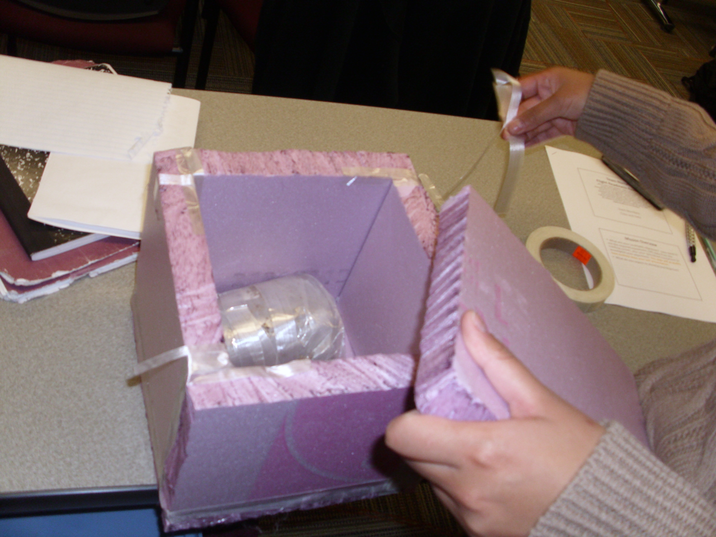

Figure 1 Taping the Styrofoam together to form the outer shell of the payload
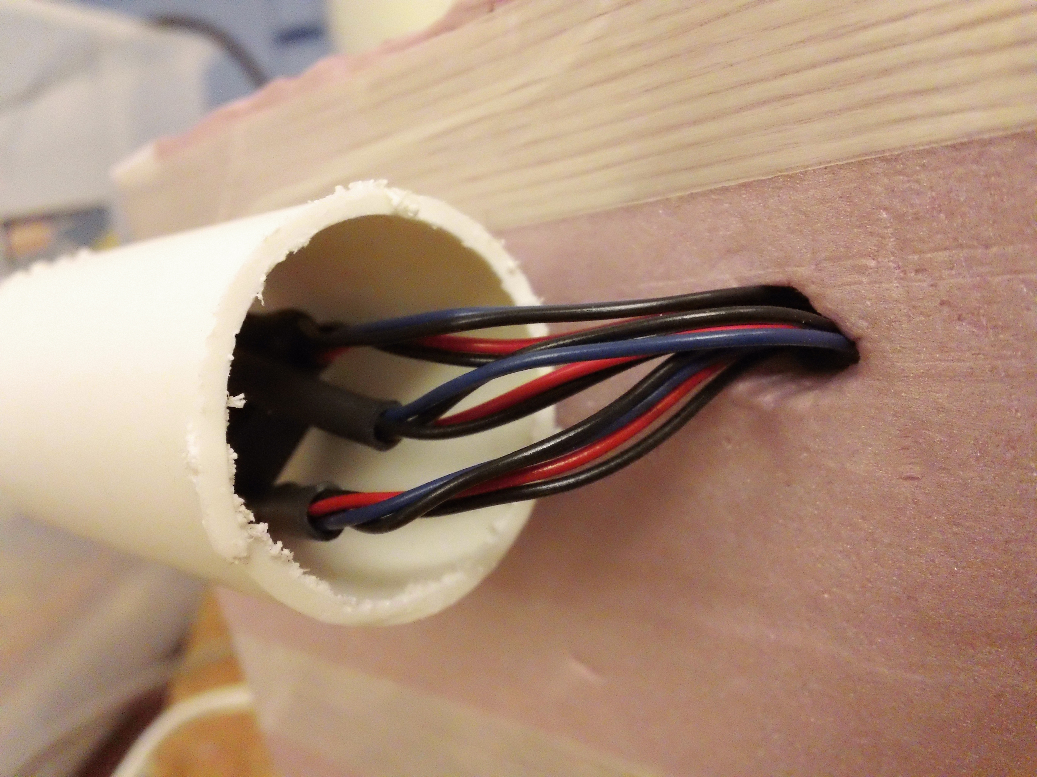

Figure 2 The PVC tubing provided a safety covering for our sensors that were on the outside of the payload
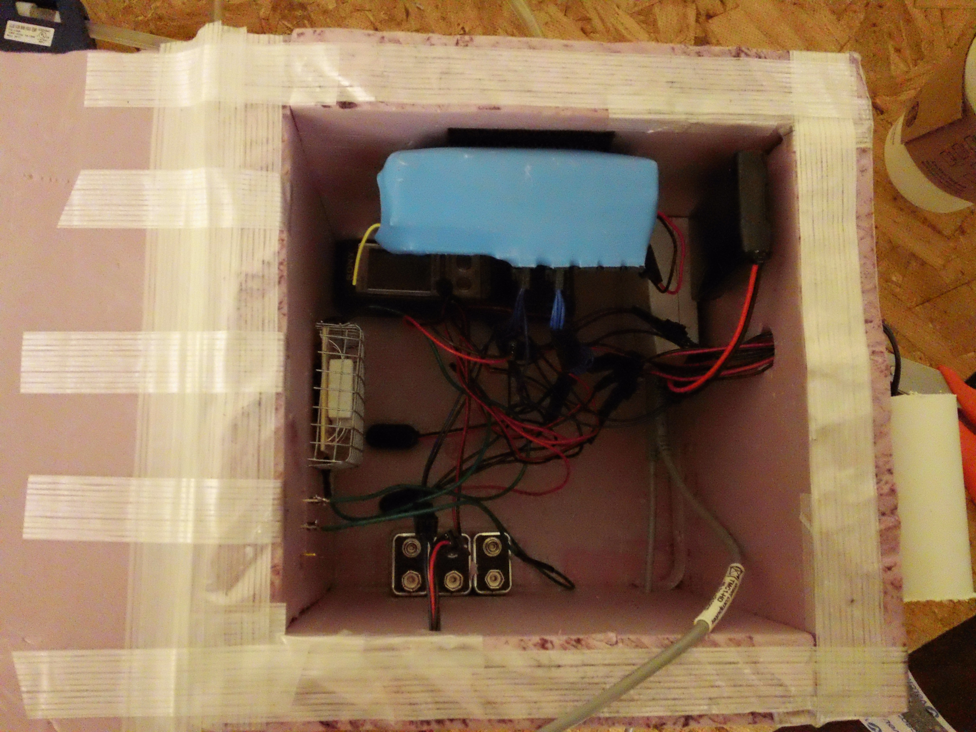

Figure 3 The inside of the payload before launch with all the components in the temporary placement
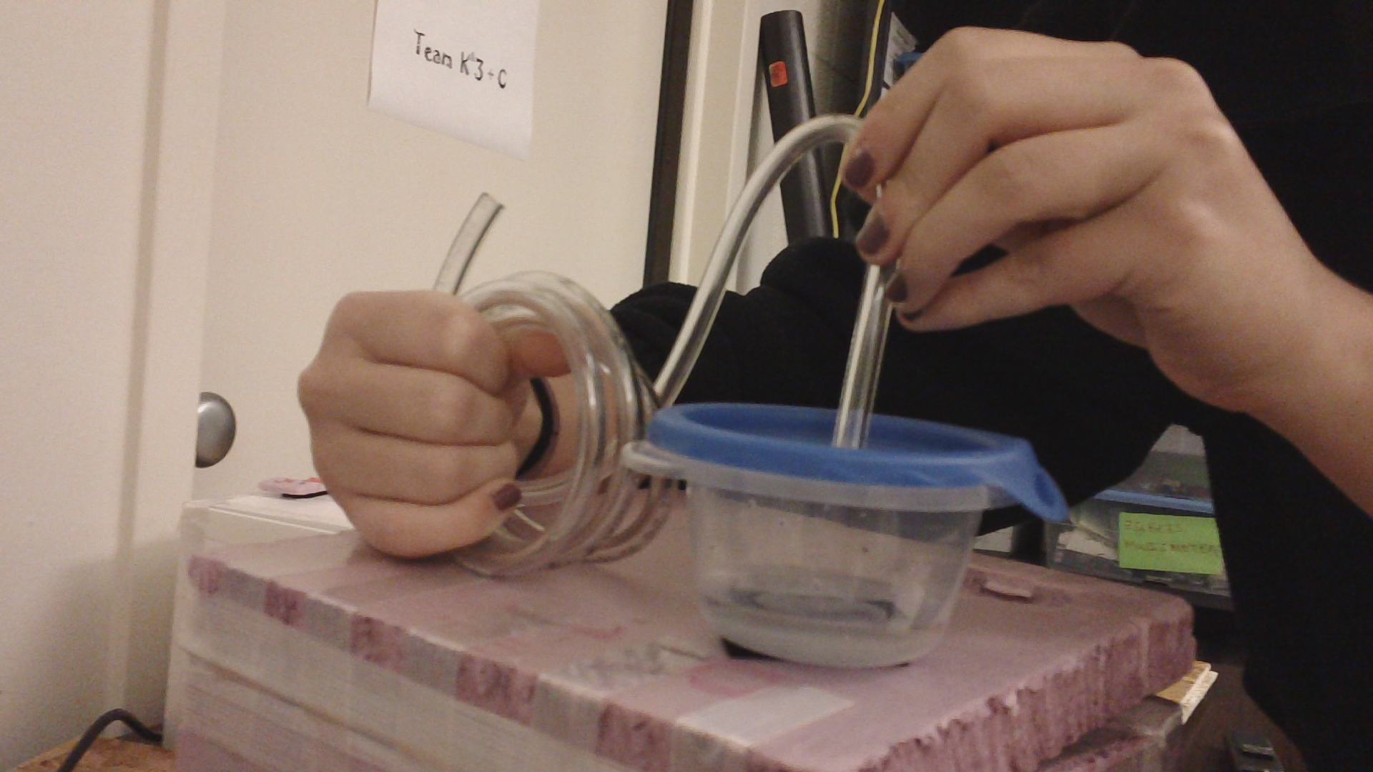

Figure 4 Placing the pneumatic tubing in the Tupperware so that when the water is in the container it will still be affected by the pressure and temperature without spilling the water

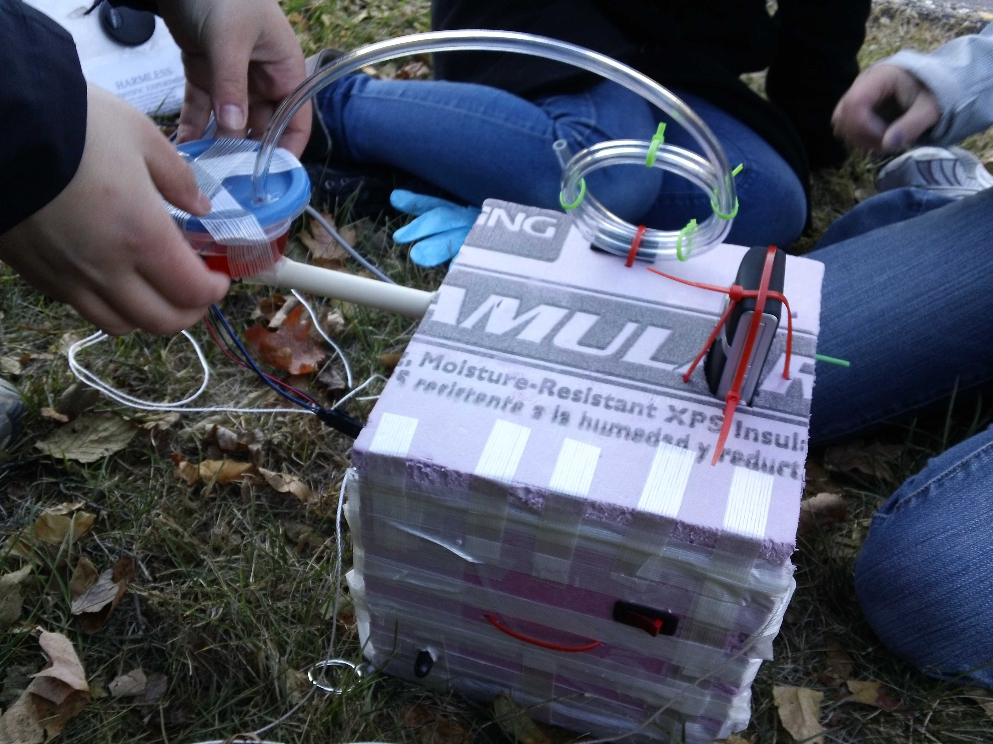

Figure 5 Putting the final touches on the payload right before launch
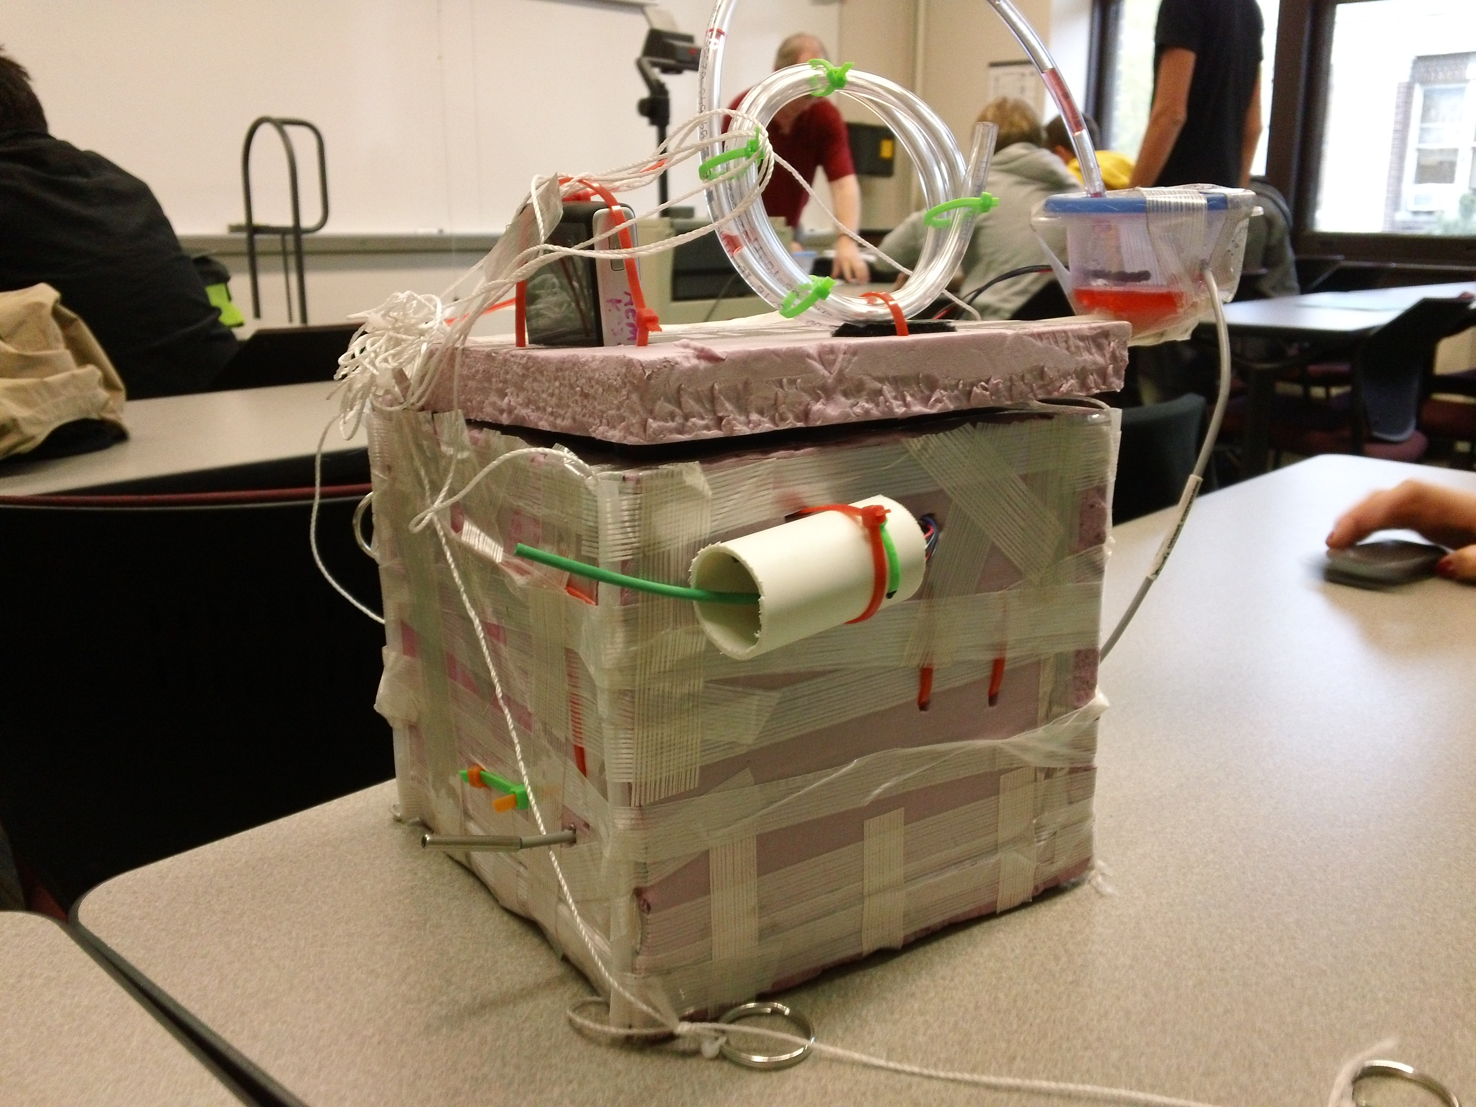

Figure 6 The payload recovered post launch; all the components survived!

Figure 7 An inside look at all the components post recovery from flight day

7.0 Test Plan and Results

To assure our parts inside our payload will work during the actual flight, we will do a variety of tests. The tough movement of the payload’s accent into near space and harsh conditions could possibly affect some of the devices and experiment pieces of the box. By testing beforehand, we can fix anything that would not work correctly, and this will give us a better chance at collecting good information for our experiments.

Testing Procedures for Each Part of the Payload:
- The payload’s resistance to harsh movement will be tested by throwing the payload down a flight of stairs (parts and systems will not be inside of the payload in case of unfortunate results)
- For our data loggers and camera, we will test these both by recording data for roughly a half hour to make sure they are capturing what they are supposed to, such as movement, colors, time, temperature, humidity, and relative humidity.
- For soldering projects; such as our weather station, heater circuit, and flight computers, we will check to make sure all the connection points are strong and sturdy so they will last through the whole flight and also test the heater to make sure that it is able to keep the payload's internal temp in a good range so that all the inside components will run smoothly
- For our buzzer, we will test to make sure the voice recorder picks up the sound and place the buzzer at various locations to see how far away the voice recorder will be able to hear the buzzer
- For our pneumatic tubing, which will hold our water in during the flight but still allow temperature and pressure to effect it, we could put water in it and toss it around a bit to make sure the water will stay in. We will also try putting the tube with water into a freezer to assure that it will freeze. To make sure it will allow pressure in, we could do some low-pressure testing but that would not be practical. It is safe to assume that the duties of the pneumatic tube will be successful because it is what the tube is originally for.
- To record the sound from the buzzer, we will record the buzzer sound and make sure that the voice recorder will be able to hear it. We will also make sure to look at the battery life so we can be reassured that it will last the whole flight.

Results:

- The results that the testing showed us before launch was as planned. These tests allowed us to confirm that our payload was ready for flight.

- The tests that were run before launch worked well. We had little to no problems with them. We were able to fix our payload and make our box as sturdy as we could to ensure that it would survive the flight. We threw our payload multiple times down a flight of stairs. It took four tries of throwing and modifying our box to have it survive the stair throw. After the fourth try, it survived. This told us that it was ready for flight.

- Our cameras and voice recorder ran long enough to capture what we wanted to capture, and the video had a great picture. We made it very steady on the box, so that this great picture would be stable enough to fully capture the water’s reactions.

- Our pneumatic tubing did exactly what we thought it would do. It held our water in the Tupperware but still allowed temperature and pressure to affect it. We did not have to test this much in the beginning because we knew it would work. This was the intention of the tubing when we bought it. It is what the tubing is made for. We knew it wouldn’t fail us because of this. We did, however, put a small amount of water in it and put it in the freezer to make sure that the water could freeze. Pressure tests would be too extensive.

- The buzzer was loud and obvious. Our voice recorder had no problem hearing it because of its distinctive sound. It is loud and distinguishing from all other noises.

- Our heater, flight computers, and other components inside of the box worked well. We had no problems with any of them. Everything was ready for flight.
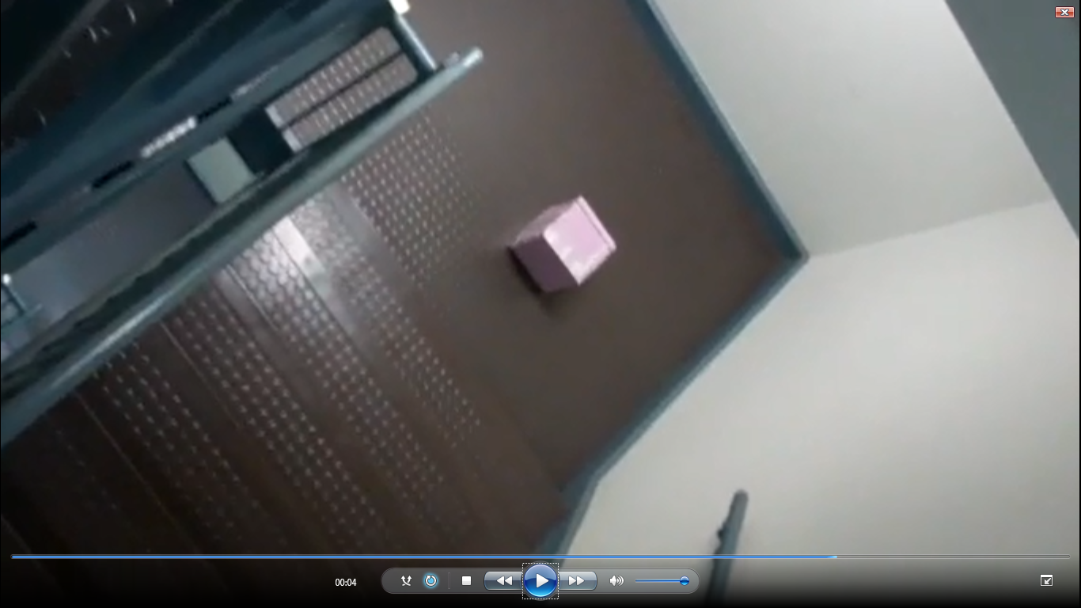
Figure 1: Our payload surviving the drop test
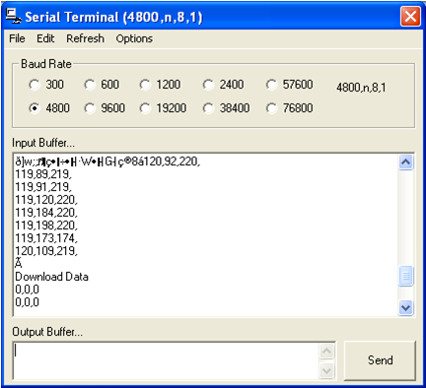
Figure 2: We tested our BSE Flight Computer; although it recorded data it was not successful in downloading data

Figure 3: During the cold soak you can see that the heater worked properly and kept the box from getting too cold

Figure 4: This is the coldsoak external temperature

8.0 Expected Science Results

- First Mission: show the water pressure versus temperature chart to be factual
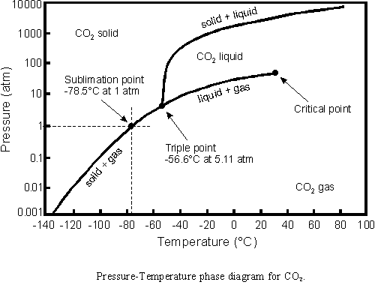
Figure 5: Phase diagram
http://withfriendship.com/user/cyborg/phase-diagram.php

- Expect: the phase diagram is factual and that at some point in the atmosphere, the water will change its state according to the chart

We are trying to show that at a point in the atmosphere, the water will go directly from a solid to a gas. In order to accomplish this mission, we sent up a video flip camera in our payload as well as red tinted water in a Tupperware container. The camera was sticking out of the payload at the top through a hole we made. This hole is snug enough so the camera will not move too much throughout the flight but it is also loose enough that the command buttons will not be accidently pressed by any movement of the camera against the Styrofoam of the payload walls. The water was tinted red with food coloring so we can see the phase changes more clearly. If the water was transparent, the state changes would be much more difficult to detect. In order for the camera to be focused on the water, we created a boom for the container and water to be on so that it is far enough away from the camera. The boom we made was an old PVC pipe and epoxy, lots of epoxy. We extended the boom out from the payload and epoxied the Tupperware with water on top of the PVC pipe. We then pushed the pipe through the top wall of the payload and epoxied that as well so everything would stay in place for the flight. In order to ensure that the pressure from outside would be able to access the water, we used coiled up pneumatic tubing. We coiled it so that the water would not be able to escape but the atmospheric pressure could still enter. According to encyclopedia.com, two different states can exist at the same exact time. In our experiment, we will show this to be factual.

- Second Mission: test if sound frequencies are lost as the air is increasingly thinned in space

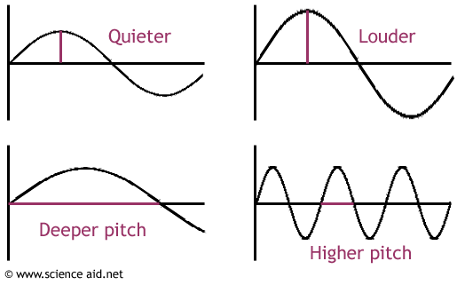
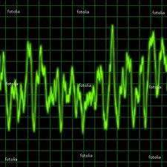

Figure 6: What the normal sound wave is on the ground
Figure 3: Different types of sound waves in the atmosphere
http://dpaudioa.blogspot.com/2011/02/frequency-amplitude-
http://us.fotolia.com/id/3365851

- Expect: to show that some frequencies are lost as the air pressure is thinned throughout the flight

For this mission, we are showing that some frequencies are indeed lost as the payload reaches the upper atmosphere. The way we went about completing this mission was by using a siren and a voice recorder. The siren we used was on a different payload but the voice recorder was still able to pick it up. The recorder was attached to the bottom of our payload with the microphone sticking out one of the sidewalls so it could pick up the frequencies more easily. We read in the February edition of the “Nuts and Volts” articles that as the air pressure gets thinner and thinner, the sound frequencies get less and less audible. We expect to be able to hear the changes as we listen to the recording and we will determine from there if it is true that sound frequencies are lost as the air gets thinner and thinner

- Temperature and pressure conditions at various atmospheric altitudes

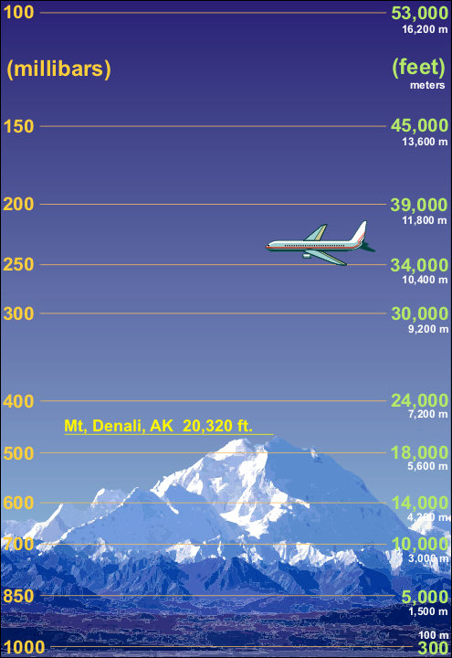
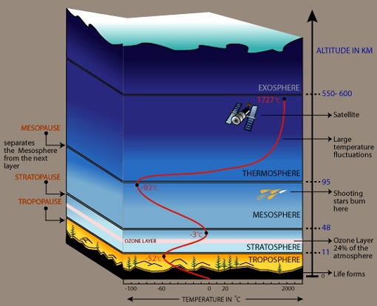

Figure 4: Temperature conditions
http://earthsci8.wikispaces.com/4++Ch.+17+-+Weather+%26+Climate

Figure 5: Pressure conditions
http://www.srh.noaa.gov/jetstream/atmos/pvsh.htm

These are the temperature conditions and the pressure conditions of the different layers of Earth. In each figure, the different altitudes are labeled as well as the temperature or pressure numbers corresponding to them.

9.0 Launch and Recovery

Launch

The day of our launch was Saturday, October 29th, 2011. It was a cold day, but with little wind. This worked to our advantage because there would be no wind to affect the flight pattern. We met at 6AM and collected everything and loaded it into the vans. It took longer than we all thought, but at about 6:45, we were ready to depart. We had four vans that would each hold one driver, and approximately 6 students. These vans gave us some shelter from the cold, as this particular day started off with a below freezing temperature. All six vans left the University of Minnesota campus at about 7 AM and made our way to Gustavus Adolphus campus in St. Peter, Minnesota; which was about 70 miles away or approximately a one hour and 20 minute drive.

When we arrived, we began the process of making last minute fixes to our payloads. For ours, we added our tinted water into the Tupperware that would be filmed closely to watch the physical changes it went through. We also turned on all of our equipment; such as our heater and our camera. After we taped our box, and thought it would be ready to go, we realized that we never turned on our voice recorder. Because of this, we had to un-tape our box and turn it on. We then taped it up again. After we taped it the second time, we got suspicious on whether or not our heater was working. So yet again, we un-taped the box and checked. We thought it would be better to be safe than sorry. It was working fine, so with our worries reassured, we taped our box up a third time. Lastly, we realized that we forgot to plug in our HOBO sensor; so once again, we had to un-tape our whole box and plug everything it. We made sure to check everything before we finally taped it up for the last time. This was a big hassle, but looking back, we are all glad that we took the time to look over everything before sending it up into near space.

Next, we attached everyone’s payloads together. We checked over all of the strings to make sure they would not become unattached during the flight. Everything was secure. We then blew up the weather balloon with two cans of helium. This took about a half hour to do, since the balloon was so big. Finally, everything was ready to go.
During the inflation of the balloon and the attaching of the payloads, a group of interested students gathered to watch our most anticipated moment. They watched as we fixed everything and tied the payloads together, and while Professor Flaten and a few other students worked on inflating the balloon.

Finally, we let the balloon go and all admirably watched it as it gently floated higher and higher into the sky. We cheered and clapped as this was what we had worked for during the whole semester. As it became invisible in the big sky, Professor Flaten started with the inflation of the middle schooler’s balloon and payload experiment. My group, however, loaded into the vans and began our drive to Hollandale. This location was about 80 miles away from St. Peter, or about an hour and a half. It was nice to be back into the warm vans, and we were all very excited to recover the balloon.

Recovery

We drove around for what seemed like hours. When we arrived in Hollandale, we realized that some errors had occurred. We were not getting any signal from our payloads. This was a problem because we would not be able to find it as easily. Some of the vans pulled over to the side of a road to discuss what we were going to do. We found the range of area that the balloon could have possibly landed. We agreed that each van was to search a certain area. This was going to be very tedious, but it would be worth it. There was expensive equipment on board that we didn’t want to lose or have damaged.
Our van began searching in the dusty and dirty fields. The corn stocks had been cut down, which made walking difficult because you had to focus on where you were stepping, while looking for the payload. We drove down many roads, and searched many fields. We continuously got out of the vans and made distance around the areas that we could not drive through. My group did not have any luck. Many things caught our eyes though, that resembled payloads from far away, but we were deceived.

We were scared our payload had landed in the woodsy parts of the small town, or the swamps or creeks. This could have potentially damaged our equipment and parts and may have disallowed us from getting the data we needed. This was a scary idea, but we had to stay positive. We couldn’t let our fears get in the way of recovering our projects.

We searched for about three or four hours. We didn’t stop to find a bathroom or get lunch. Many of us were running low on energy, but we kept going. We had walkie-talkies to communicate with everyone in the group. It seemed like no one was having any luck. At 4:00 PM, we agreed that we students would end the search. We were exhausted, food deprived, and ready to get back to our dorms. Professor Flaten, and whoever wanted to volunteer would stay back and continue the search until dark. As we left Hollandale and began our departure for home, we all had uneasy feelings. We desperately wanted to find our payload. It had a lot of very expensive equipment on board, and we were curious to see what data it had brought back. Our boxes and experiments that we had worked so long created, developing, building, and critiquing could possibly never be found. The project that we had put our hearts and souls into for the past seven weeks might not bring us back results. These horrifying thoughts stayed with us as we pulled into a small town to grab some food for our growling stomachs. As we got back into the vans to leave, we got some very exciting news. Our payload had been recovered! Not long after we had left, Professor Flaten and Sean found it lying in the middle of a field unharmed. It was very exciting to know that we would continue with our experiment, and have our results we had anticipated. We got back into the vans feeling accomplished and excited.

We found out that during the random turbulent-filled part of the flight, the antenna had fallen off. This stopped the GPS signals from reaching us, which made it hard to locate. Although our recovery was unlucky and difficult, we eventually found the payload. It was a long day, but everything was worth it.

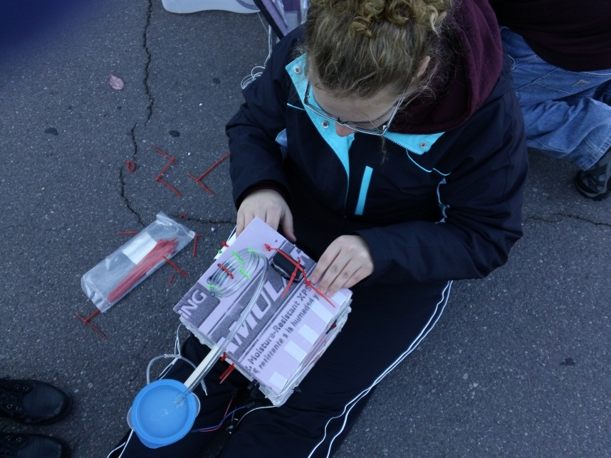
Figure 1: Putting the final touches on our box during launch day

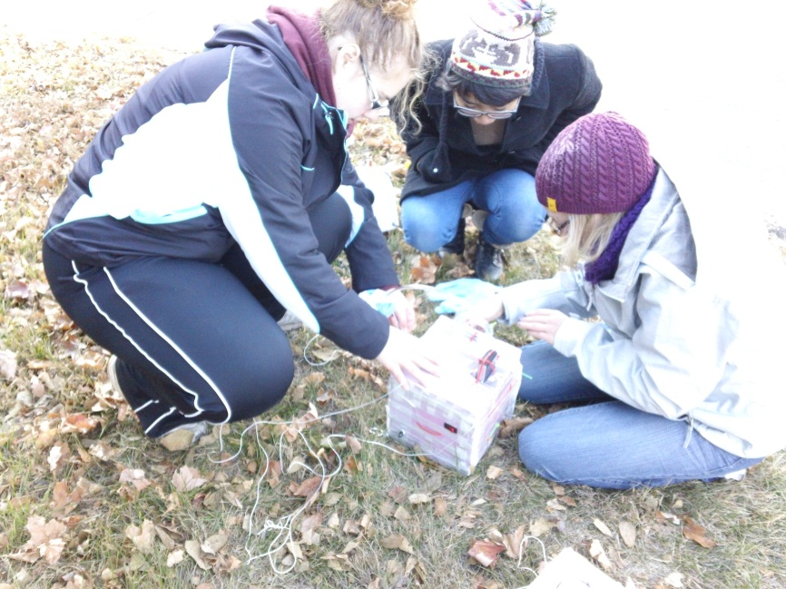
Figure 2: Taping our box right before launch

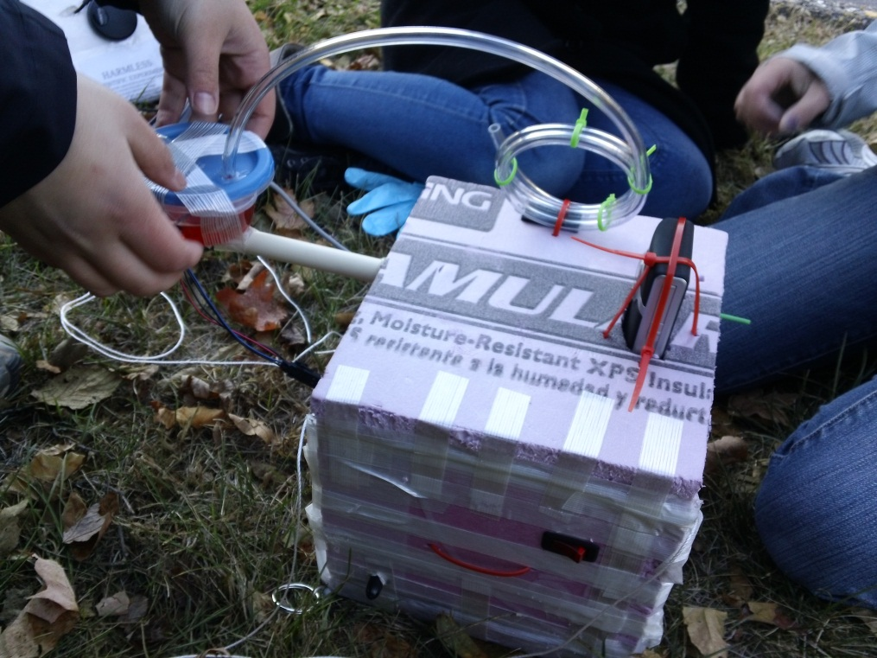
Figure 3: The final product

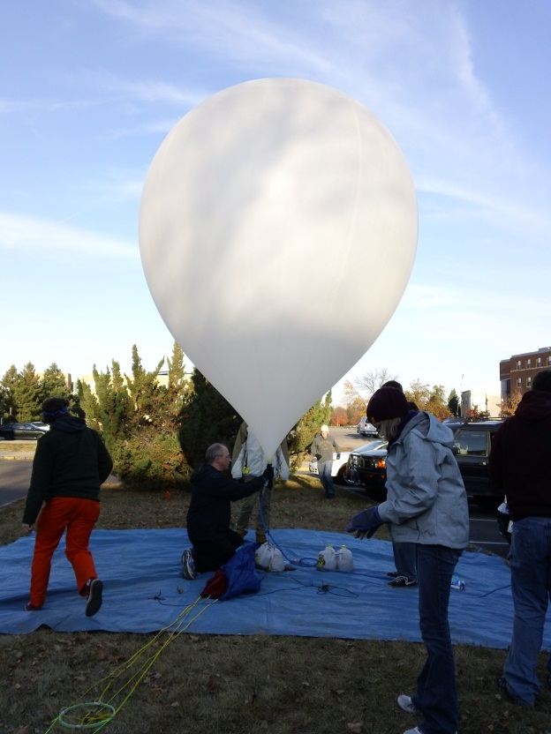
Figure 4: Inflating the balloon

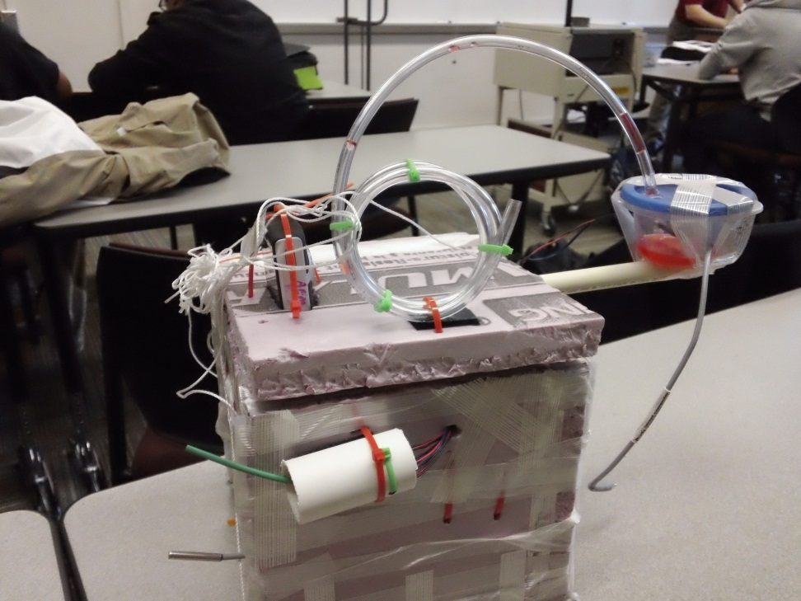
Figure 5: The payload after recovery

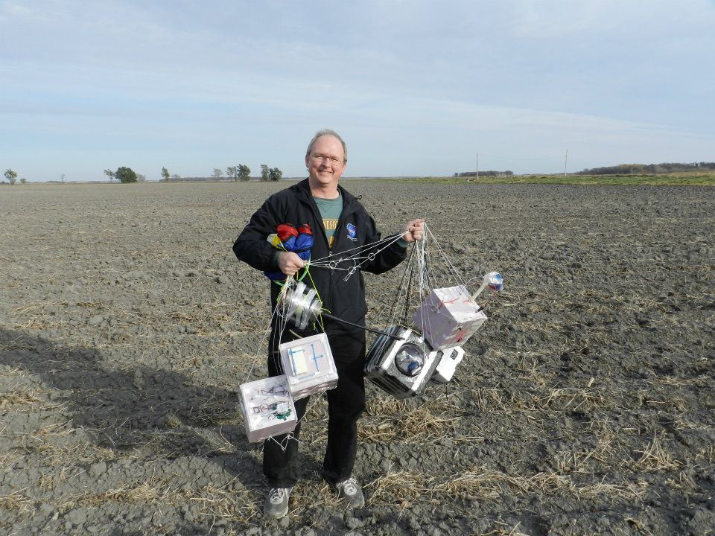
Figure 6: Professor Flaten with recovered payloads

10.0 Results and Analysis

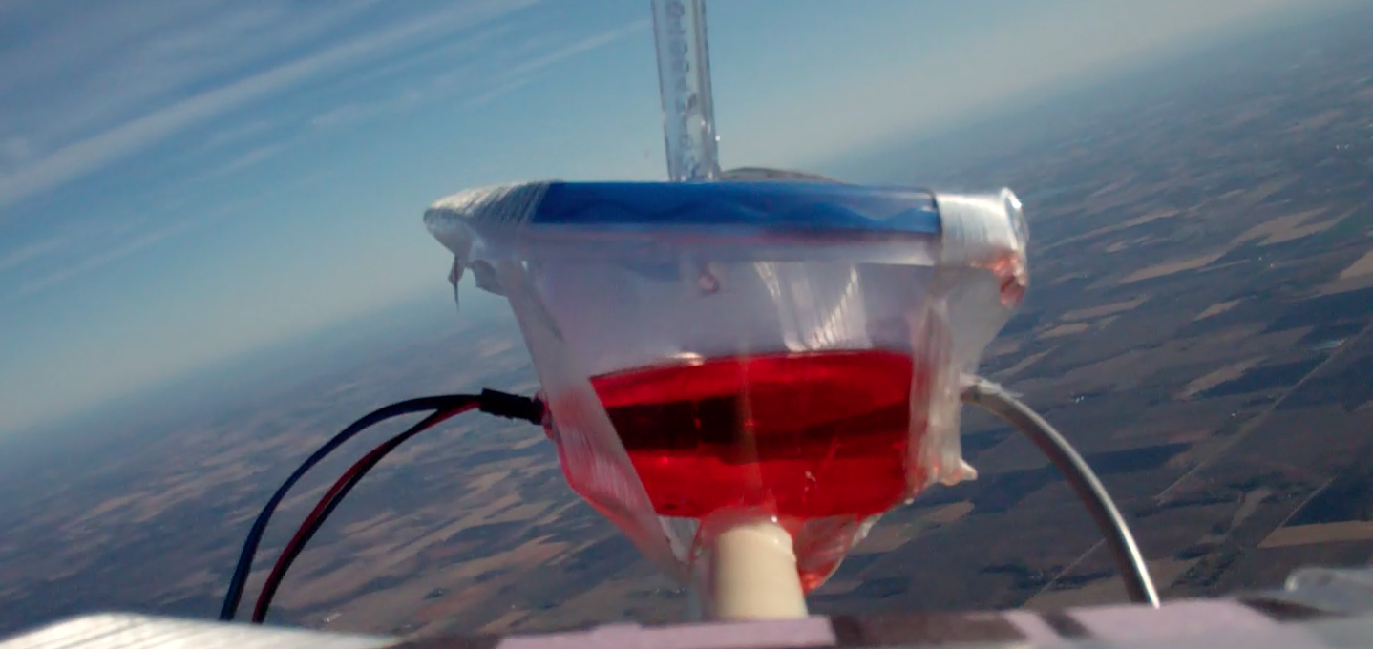
Figure 7: Dyed water is completely liquid at the beginning of the ascent

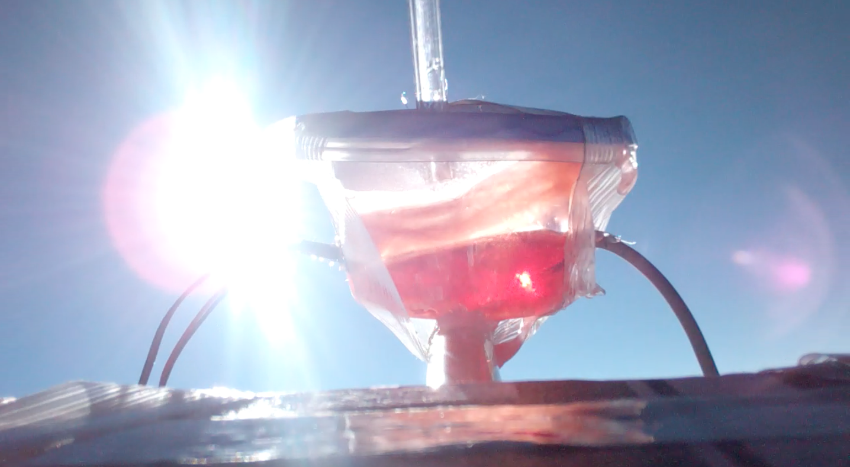
Figure 8: The dyed water is starting to freeze during the middle of the ascent

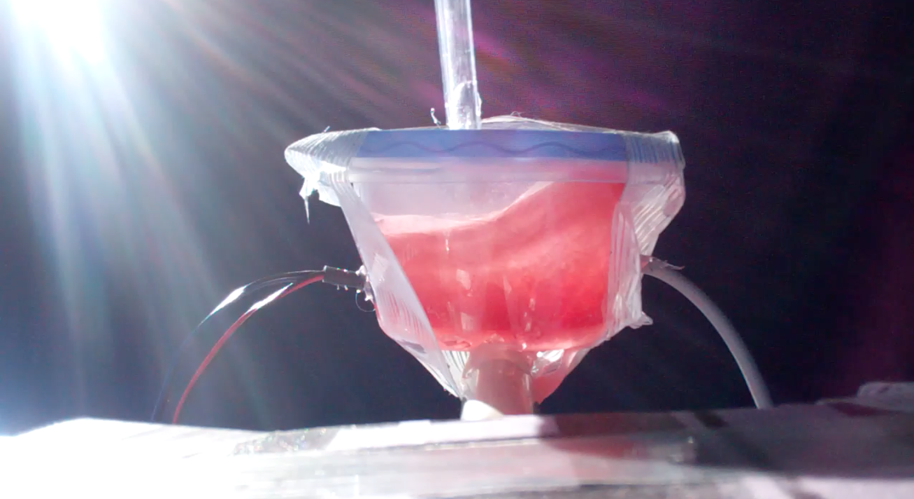
Figure 9: The dyed water is completely frozen about 10 min. before burst at approximately 95,000 feet

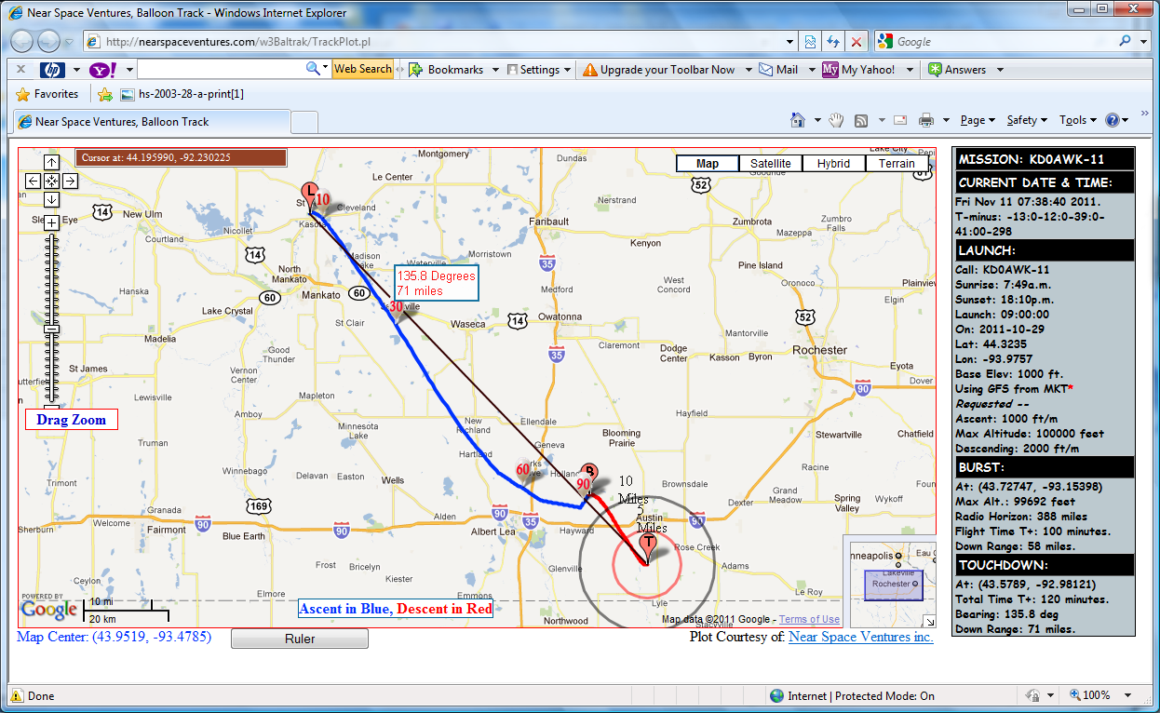
This is a screenshot of the original prediction – 1000 ft./min ascent to 100,000 ft.
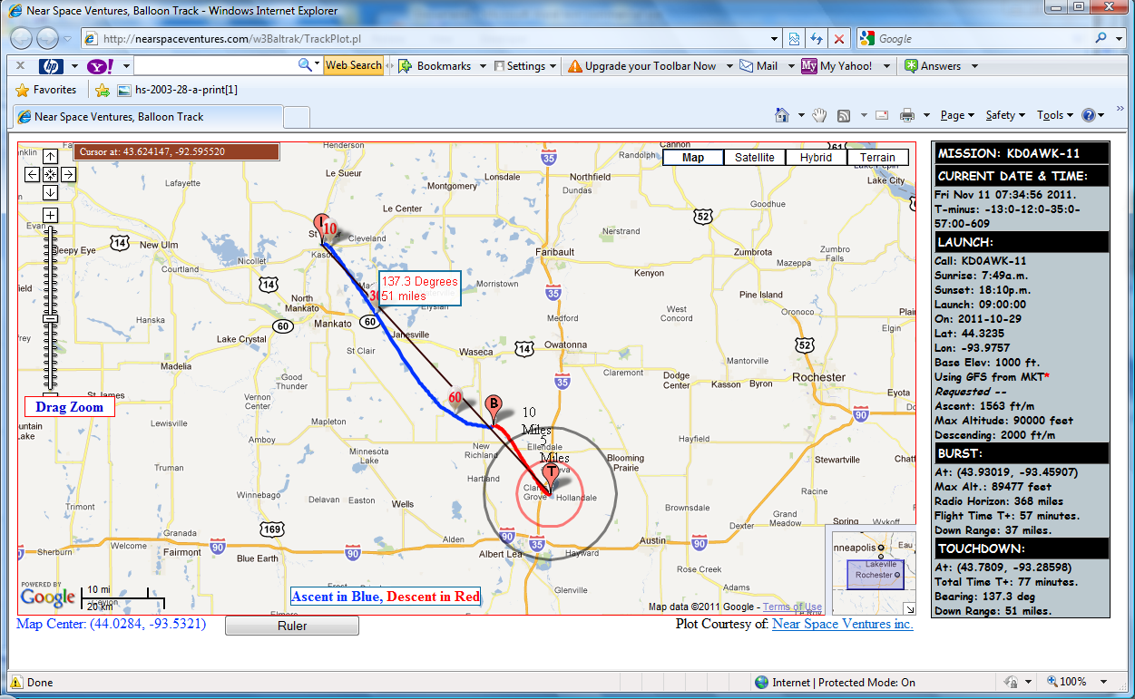

This is a screenshot of the real prediction, using the actual flight parameters (1563 ft./min ascent to 90,000 ft.).

The next few graphs all show data from a sensor related to the time during the flight. All of these graphs are pretty close to what we were expecting.
Graph Legend
Blue Arrow | Launch
Red Arrow | Burst
Green Arrow | Landing

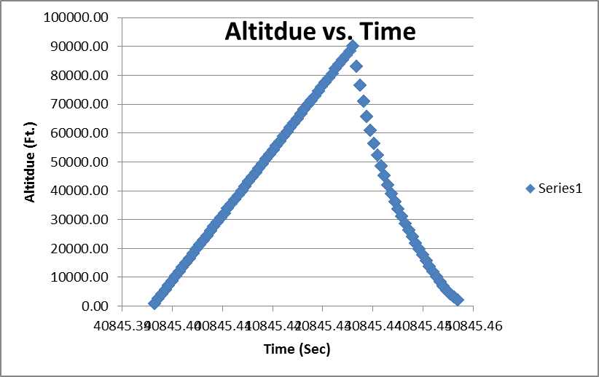
This is a graph of altitude vs. time for the actual flight.

Here is a graph showing time vs. relative humidity. As you can see it has the general w shape that this graph should have. At the bottom it does have a lot of data points that aren’t valid, but this is due to the sensor dropping out.

The top graph is showing the relationship between time vs. water temperature. You can see that the water gets colder as it travels up in the atmosphere, but when compared to the graph below which shows time vs. external temperature it doesn’t get as cold. This is because the water has to all reach freezing before it can actually freeze and then get colder.

Here is a graph showing the relationship between time and pressure. As you can tell it has the u shape that a time vs. pressure graph should have. As the graph reaches the ground again the data points stop recording data this is because it reached the ground and was out ofmemory space to record any more.

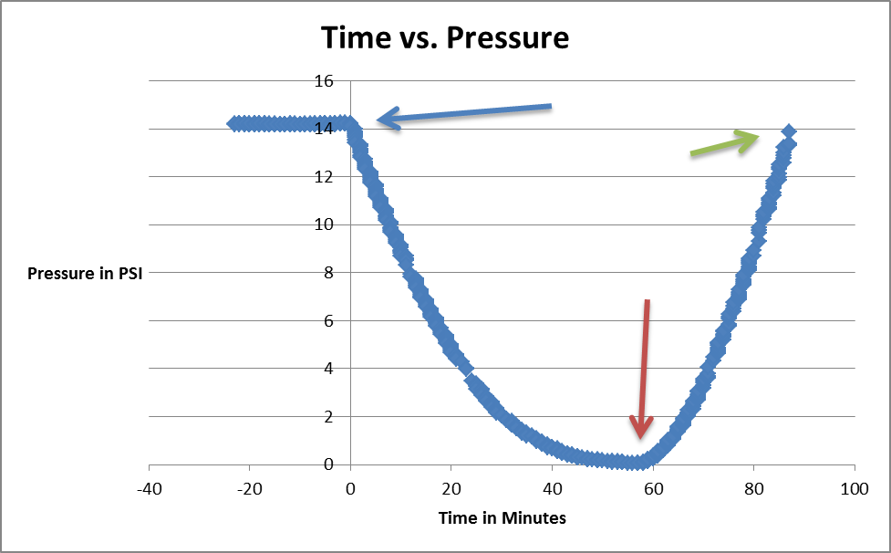

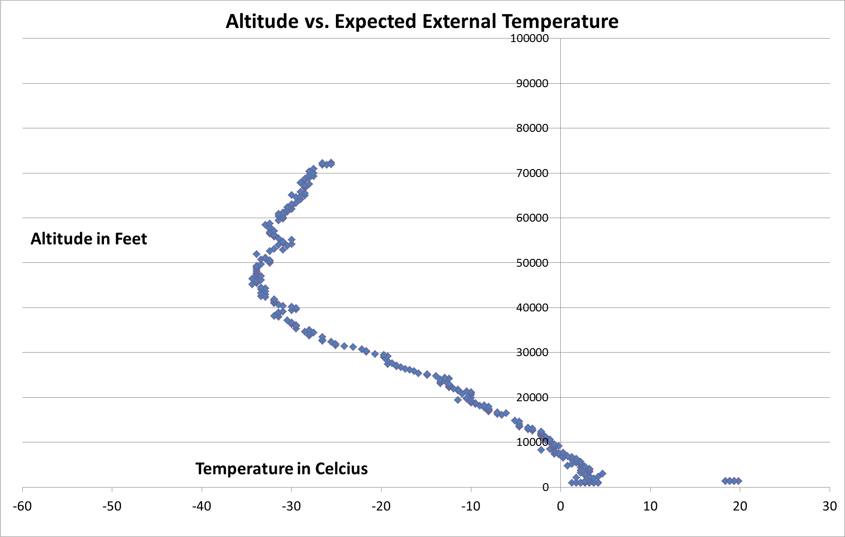

Here is a graph showing the altitude vs. expected external temperature. This is how our altitude vs. external temperature should have turned out, but it is a little different.

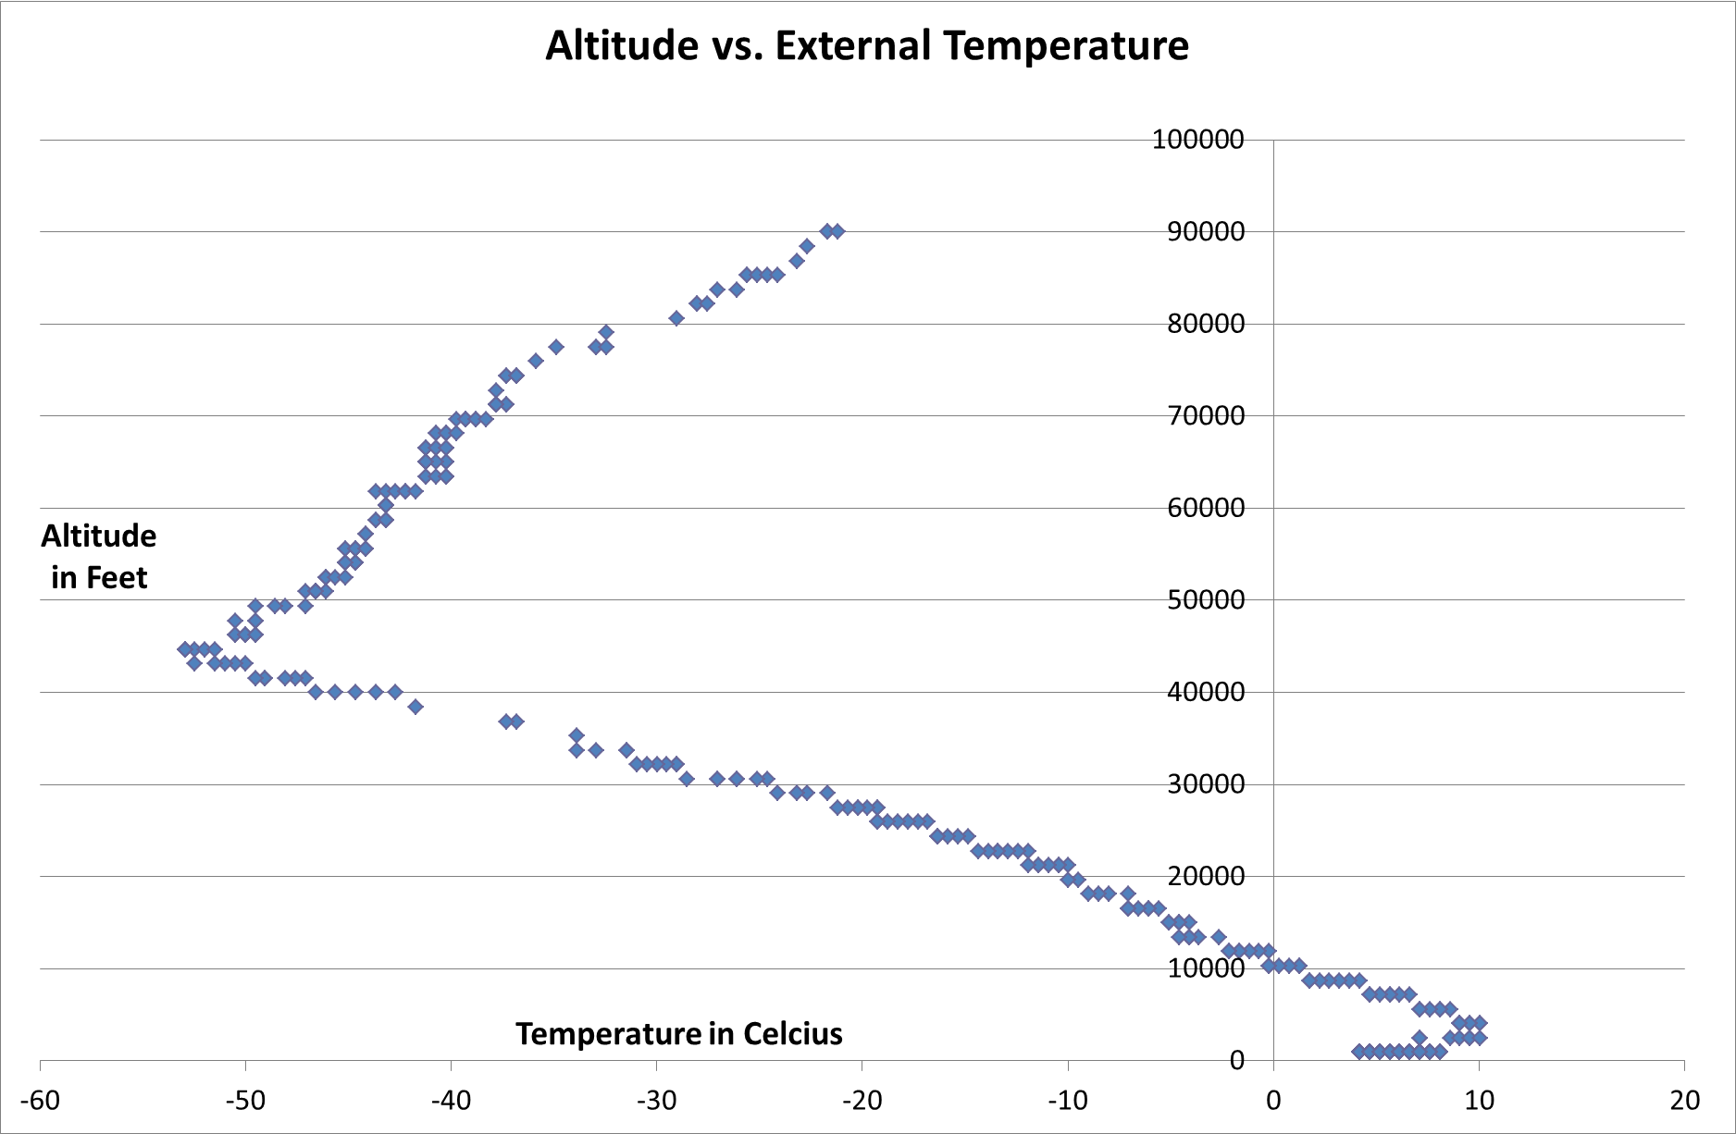

The top graph shows altitude vs. external temperature. It was a little different than the expected graph. This is due to sensor and how often it recorded data.

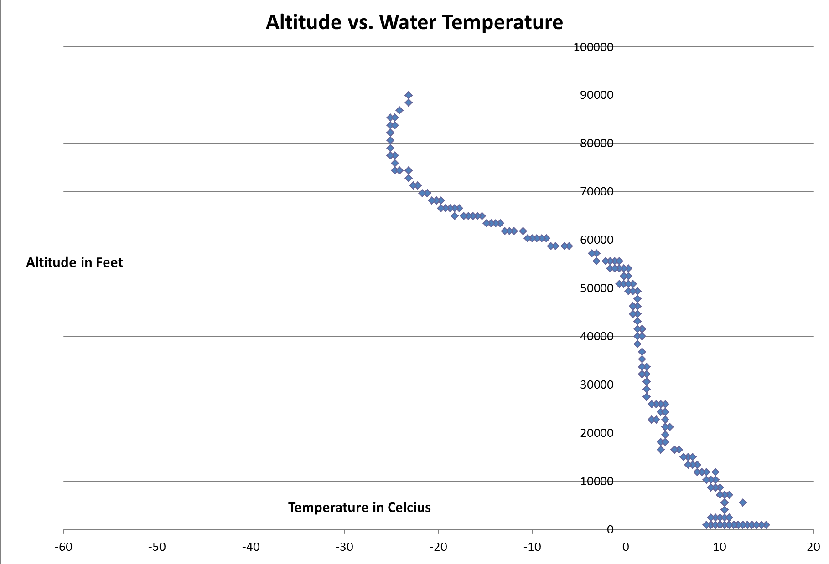

This graph shows altitude vs. the water temperature. You can see that the straight vertical set of points is when the water is freezing and then as soon as it freezes completely it starts to get colder.
11.0 CONCLUSIONS/LESSONS LEARNED

In our experiment, the water in the Tupperware did change states, but it did not change in the way that we had anticipated. The conditions in the atmosphere were not what were needed to make the water change states from a liquid to a gas. The pressure and the temperature in near-space caused the water to change from a liquid to a solid. As anyone would expect, the water froze as the near-spacecraft went higher and higher into the atmosphere. If the pressure and temperature were just right, we believe that the water would change in the way that we had anticipated. If we were to do another experiment, there are many different variables we could change. We could use a vessel of a different shape, size, or opacity, and perhaps then the water will be easier to observe. Next time, we would make sure to measure the water after the launch, even if some spilled into the pneumatic tubing. Another option is to try a different liquid besides bottled water. We were thinking it would be interesting to put a mixture of Jell-O powder and water into the vessel to send up to near-space, and observe how the mixture changes states in the atmosphere. Perhaps a tasty treat would await us in the payload after launch. In our experiment, we were also hoping to analyze sound frequencies in space. We believed that some frequencies would be lost as the near-spacecraft reached higher altitudes. As far as we could tell, the voice recorder that we used in our experiment clearly recorded the sound of the buzzer. However, we had difficulties getting the sound files off the device. We tried installing the device’s software and plugging the device into four different computers, and not one of them succeeded in getting the voice files off the device. However, without using any software, we are still able to listen to the file and make some basic conclusions. As the near-spacecraft reached higher altitudes, we were still able to pick up sound. Though the creaking of the Styrofoam interfered with getting the clearest audio file, we are still able to conclude that the sound waves become more distant as the near-spacecraft goes higher into the atmosphere.

WORDS OF WISDOM

- When making graphs, always use computer mice instead of track-pads. You will save yourself a lot trouble and time.
- Think of everything before you start making holes, for they are permanent. If you make too many mistakes, you may end up having to construct a new box top entirely.
- Get friendly with Excel. You will spend a lot of time with the program, so you may as well learn the different shortcuts and tricks to making your graphs a success.

12.0 Appendix: Program Listings

- Pressure vs. Temperature Water Chart: http://withfriendship.com/user/cyborg/phase-diagram.php

- Sound Wave Picture: http://us.fotolia.com/id/3365851

- Different sound wave lengths Picture:http://dpaudioa.blogspot.com/2011/02/frequency-amplitude-

- Air Conditions Chart:http://earthsci8.wikispaces.com/4++Ch.+17+-+Weather+%26+Climate

- Pressure Conditions Chart: http://www.srh.noaa.gov/jetstream/atmos

