University of Minnesota and MN Space Grant Consortium

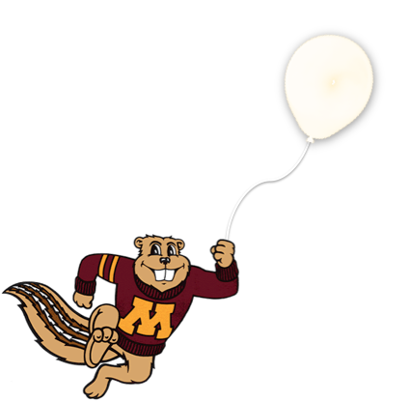
AEM 1905 Freshman Seminar: Fall 2010
Spaceflight with Ballooning
Team Project Documentation

Galactic
gophers

Written by:
Alex Ngure
Casey Sutherland
Nate Warner
Tad Nielsen

Report Date: 12/7/10
Revision C
Revision Log

Revision | Contents | Due Date
A | Conceptual Design | Friday, Oct. 15, 4 p.m.
B | Build/Testing Report | Friday, Nov. 5, 4 p.m.
C | Flight/Analysis Final Report | Friday, Dec. 3, 4 p.m.

User Notes (entire document adapted from Colorado Space Grant documentation):

This template describes the topics which should be discussed during the evolution of your documentation. The following sections have a Rev (Revision) letter following the section description. This indicates when this section is expected to be apart of this document. If a section is required in Rev A, then that section should be written for Rev A then updated if necessary in subsequent revisions. As your project becomes more defined, return to previous sections and update them accordingly.

Each time when you submit your Team Project Documentation, remove any unnecessary template notes and to-be-written sections. For example, if you are submitting Rev A, don’t include sections not requested until Rev C.

This report is due in electronic form (Microsoft Word, not pdf) at the times listed in the table above. Please follow this template format exactly.

Write your text sections just like this page – single spaced, 1 inch margins, 12 point font of your choice, leaving single blank lines between paragraphs.
Table of Contents

- Team Assignments 4
- Introduction 6
- Mission Overview 6
- Payload Design 7
- Project Management 11
- Project Budgets 14
- Payload Photographs 15
- Test Plan and Results 17
- Expected Science Results 21
- Launch and Recovery 23
- Results and Analysis 26
- Conclusions and Lessons Learned 35
- Citations and Acknowledgements 36
- Appendix: Program Listing 37

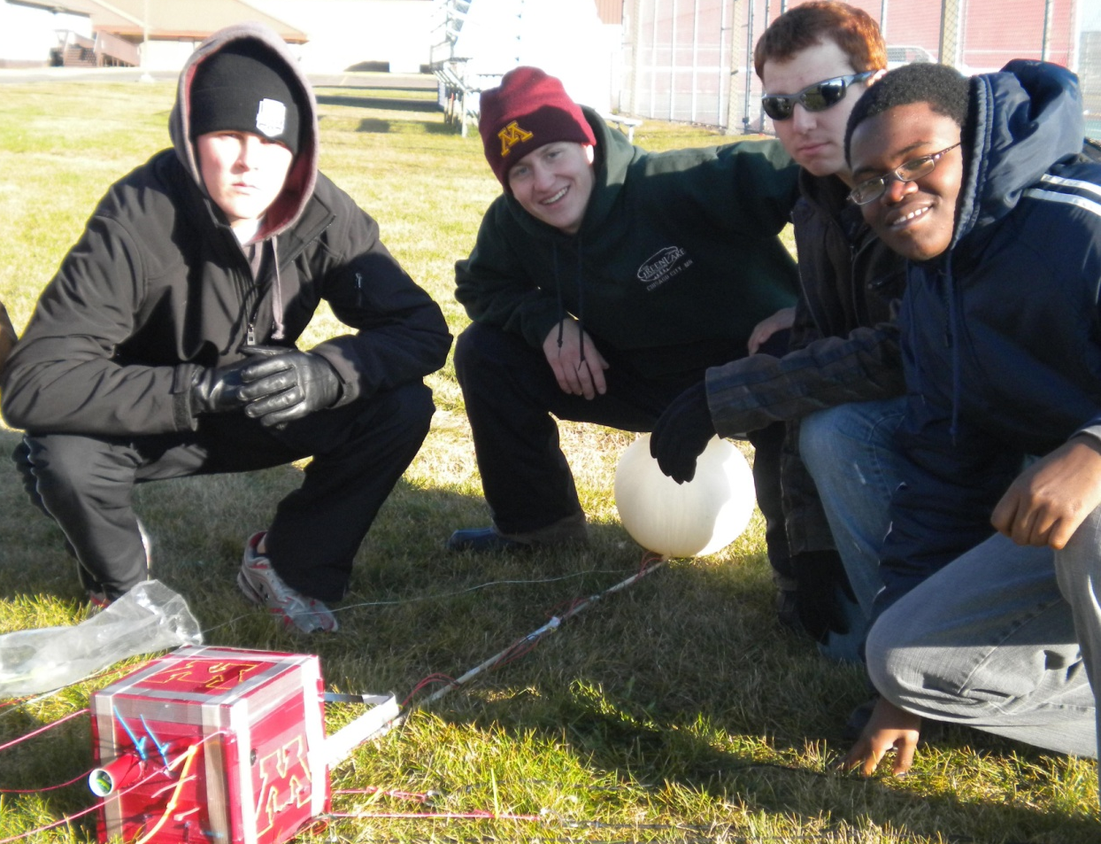

0.0 Team Project Documentation Writing Assignments

Team Name Galactic Gophers

Assign one lead author to each section except for Results and Analysis (that needs to be worked on by everyone!). Each person should be the lead author on two sections. Notice that the sections vary widely in length and complexity. (Rev 0)

Introduction Casey
Mission Overview Alex
Payload Design Tad
Project Management Joe*
Project Budgets Joe*
Payload Photographs Tad
Test Plan and Results Nate
Expected Science Results Casey
Launch and Recovery Nate/Tad*
Results and Analysis Nate
Conclusions and Lessons Learned Alex

Oral Presentation Assignments
Assign two team members to help make slides for each of the first two oral presentations. All group members need to pitch in when working on the final oral presentation. (Rev 0)

Conceptual Design Review (CDR) Tad Nate
Flight Readiness Review (FRR) Alex Casey

Payload Build Assignments
Assign one person to be the overall “team lead” (AKA “team contact”). Their job is to keep tabs on the whole project and keep the teaching staff informed as need be, to organize team meetings, to make sure everything gets done in a timely manner, and once the build is complete to be in charge of ground testing. Assign each of the other four team members to “lead” one item in the first 4 tasks and one item in the last 4 tasks listed below. (Rev 0)

Overall team lead and ground-testing lead Tad
Flight computer (BalloonSat Easy) build Alex
Weather station build Joe
Payload box build Nate
Photographer Tad
Programmer (of flight computer(s)) Casey
Camera and camera experiment Joe
HOBO (payload “health” (internal temp)) Alex
“Other” science experiment Nate

Launch Day Assignments
Assign each team member a specific responsibility for launch day. (Rev 0)

Photographer Tad
Prediction/tracking assistant Casey
Balloon filling and release assistant Casey/Alex*
Payload/stack handling specialist Alex
Recovery specialist (needs to go on chase for sure) Nate

* Due to Joe dropping the class, other group members had to fill in for him on certain things. Tad and Nate also made necessary changes to his parts from Revision A of the Project Documentation.

1.0 Introduction
Space flight is a costly endeavor that only is truly achieved by government agencies that have billions of dollars as well as hundreds of engineers and scientists at their disposal. The endeavor to reach space can be likened to Columbus’s voyage to the new world, it’s an effort to make new discoveries and push humanity’s progress forward. We as students do not have the resources anywhere near what government agencies do, but that does not exclude us from reaching space, or space-like conditions. Near space is what we call the space in the high portion of our planet’s atmosphere. It exhibits space-like conditions with diminished atmospheric pressure, extreme cold, and exposure to radiation. In this class we plan to make a payload that will be sent up into near space and take data measurements that we will be able to analyze. Unlike the iconic rocket engines with the big clouds of smoke that accompany them used to send humans and probes into space, we will be using a weather balloon that is far more cost efficient as well as calmer on the ascent.
The main difference from rocketed ascent and weather balloon ascent is that rockets blast up at incredible speeds and then return to earth in a calmer fashion, while balloons rise relatively slowly until the drop in external pressure causes the balloon to pop and the payload to fall violently back to earth. Unlike with rockets, our payloads have to be a certain weight because a full weather balloon can only hold so much helium, which can only carry a certain amount of weight up into near space, while rockets just require additional thrusters and fuel.
Near space may have already been explored by government agencies but that doesn’t mean they’re done with it. There is always something more to be learned or something new to be discovered. Where they have moved on to bigger and better things (outer space and the planets in our solar system.) we, as students, have been given a chance to make the new discoveries on our own without government funding. Not only that, it is our opportunity to learn and better ourselves for when we have the chance to move out into outer space and on to the planets beyond earth.

2.0 Mission Overview
We utilized the flight to perform two experiments: To test the validity of the ideal gas law (PV=nRT), and to accurately determine the rate of change in sky darkness with respect to altitude. To perform the first experiment, a helium filled balloon with a weather station placed inside of it, was positioned outside the payload box on a boom. The weather station monitored conditions inside the balloon (pressure, temperature, and relative humidity). The data was sent to the Zigbee radio inside the payload box, which then transmitted the data to the ground. Volume was monitored by a video camera inside the payload box. We expected the ideal gas law to hold for most of the flight upwards. However, once the balloon had reached extreme near space conditions, we expected that the ideal gas law would no longer be completely valid. Helium would violate at least one of the three main assumptions for the ideal gas law. The assumption that molecules are perfectly elastic would not hold given the extremely low temperatures in near space, the molecules would become inelastic. To carry out the second experiment, we used a video camera. The camera was housed inside the payload box and recorded video footage of the sky and a continuous color scale from sky blue to black. The scale was firmly placed on the payload box. Comparisons will be made between the actual color of the sky and the color on the scale. We expect a gradual increase in darkness as the altitude of the balloon increases.
The payload box had to house a flight computer, a HOBO, a Zigbee radio, a video camera, as well as support a boom where key elements of both experiments were placed for the duration of the flight. The box needed to be able to withstand extremely low temperatures and low pressures, as well as high winds. Although none of the equipment inside the payload box was temperature sensitive, a heater was placed inside the box. The temperature inside the box was recorded. The most critical part of our mission was the payload box which needed to be structurally sound. Our team performed structural tests to ensure that the box would be able to safely house all the equipment required for the flight. We also ensure that the payload was able to survive a turbulent descent and landing.
From the mission as a whole, we expected to acquire approximately two hours of video footage for analysis. The video camera simultaneously recorded changes in the size of the balloon and darkness of the sky. Temperature, humidity, and pressure information was transmitted to the ground from the Zigbee radio and extracted from the HOBO data logger.

3.0Payload Design
Our payload stands apart from the other groups. It will have the same mass rescrictions and will mostly carry all the same components but there are a few things that stand apart on our module, The Galactic Gopher. The first thing you will most likely notice is the boom that is hanging off the side of our box. This boom is vital to both of our main experiments. The first of these two expirements will be to observe the rate of change in color of the Earth’s atmosphere as altitude increases. We will do this by hanging a colorscale off of the boom and seeing how color changes in our video as altitude increases. The second of our two expirements will be to test the validity of the Ideal Gas Law (PV=nRT). We will do this by attaching a helium balloon to our boom and watching how it expands as altitude increases. Our helium balloon will also double as a lift for our module. Due to the helium in the balloon it will allow us to put more mass into our boom to make it take up less of our mass allotment. The second thing that is fairly noticable and was already hinted at is our video camera. This will come in handy to capture the colorscale as it changes and the balloon as it pops. If we were to fly a still camera, it is nearly impossible to catch the frame when the balloon is popping, which is why we choose the Flip Ultra video camera which will record up to 2 hours of footage. We are limited to 1 kg mass and we should be able to make this work if we are able to find a lightweight and sturdy materail for use as a boom. Also, for extra stability we will most likely run a fishing line from the end of the boom to the cable that is suspending all of our boxes. If you look below you can see our layout for our module and how we plan to have things placed within the box. This picture is as drawn to scale as closely as possible. It includes the styrofoam box that we will be using as or payload and all of the things that will go into it. You can see a block diagram of how the components in our box work with each other and what their main functions are within the module.

Parts/Equipment List
Styrofoam-used to hold all the components and also protect them
Tubing, rigging, etc.-used to tie box below the helium balloon
Heater circuit-keeps all the components in our box from freezing
Four 9V batteries- supplies power to the zigbee interface boards, and a heater circuit
Weather stations- measure temperature, pressure, and relative humidity
Flip Ultra video camera- used to record helium balloon and sky (with colorscale)
HOBO data logger- collects temperature data through a probe and itself for future analyzation
HOBO temperature probe- can collect temperature outside the box
Zigbee radio- sends information ( temperature, pressure, and relative humidity) back to the ground
Zigbee interface boards- used to power the two weather stations and zigbee radio
Boom- will be used to hold our helium ballon and run weather station cords to the weather station inside of the balloon
Helium Balloon-will be used to test the validility of the Ideal Gas Law, we will use probes to find pressure and temperature and a camera to find volume
Color scale- used to observe the rate of change in color of the Earth’s atmosphere as altitude increases, colors range from sky blue to black
Functional Block Diagram

4.0 Project Management

ProjectDocumentation
Building Assignments
Launch Day Duties
SEPTEMBER
SUN | MON | TUE | WED | THU | FRI | SAT
12 | 13 | 14  Sample payloads | 15 | 16 | 17 | 18
19 | 20  Team Meeting: discuss potential experiments | 21  In class demos, discussions, soldering activity | 22 | 23 | 24  Heater finished | 25
26 | 27  Team Meeting: finalized experiments, discussed payload building | 28  Distribution of Project Documentation Template, planning | 29 | 30
OCTOBER
SUN | MON | TUE | WED | THU | FRI | SAT
 |  |  |  |  | 1 | 2
3 | 4  Team Meeting: prepare for CDR | 5  Present FDR, authority to proceed, receive parts and materials for payload | 6 | 7 | 8 | 9
10 | 11  Team Meeting: check on progress of payload building | 12  Flight computer and weather station completed, testing | 13  Everone’s part of Revision A emailed to Tad or Nate | 14 | 15  Revision A due  Payload strength test | 16
17 | 18  Team Meeting: in lab, testing, | 19  Cold soak test | 20 | 21 | 22  In lab: film inflating balloon | 23
24 | 25  Team Meeting: prepare for FRR | 26  Tubing and rigging put on | 27  Last components strapped in, yank test | 28  Box painted, boom tested | 29 | 30  Launch Day
31
NOVEMBER
SUN | MON | TUE | WED | THU | FRI | SAT
 | 1 | 2  Extracted flight data from payload | 3  Everone’s part of Revision B emailed to Tad or Nate | 4 | 5  Revision B due | 6
7 | 8  Team Meeting: discuss data, begin analysis | 9  In class data analysis | 10 | 11 | 12 | 13
14 | 15  Team Meeting: continue data analysis, turn in visuals/graphs | 16 | 17 | 18 | 19 | 20
21 | 22  Team Meeting: prepare for FTP | 23  Final Team Presentation | 24 | 25 | 26 | 27
28 | 29 | 30
DECEMBER
SUN | MON | TUE | WED | THU | FRI | SAT
 |  |  | 1  Everone’s part of Revision C emailed to Tad or Nate | 2 | 3  Revision C due | 4
5 | 6 | 7 | 8 | 9 | 10 | 11
12 | 13 | 14  Public Reception | 15 | 16 | 17 | 18

5.0 Project Budgets
Parts for Payload |  |  | Mass Estimate (kg) | Prices
Foam Core |  |  | .180 kg | $7
Tubing, Rigging, etc. |  |  | .050 kg | $5
Heater Circuit |  |  | .027 kg | $5
Five 9V Batteries |  |  | .250 kg | $10
Weather Station |  |  | .015 kg | $40
BalloonSat Easy Flight Computer |  |  | .033 kg | $30
Flip Ultra Video Camera |  |  | .175 kg | $170
HOBO Data Logger |  |  | .048 kg | $130
HOBO Temperature Probe |  |  | .010 kg | $29
Zigbee Radio |  |  | .126 kg | $300
Boom (material TBD) |  |  | <.086 kg | $3
Total |  |  | 1.0 kg | $726

The heaviest parts of our payload are the batteries, video camera, and Zigbee radio. If we are unable to get our boom light enough to remain under the 1 kg weight limit, we may request that Dr. Flaten allows us to remove the Zigbee radio from our payload. The reason that we have not yet determined the material of our boom is because we have lots of options and haven’t tested them yet. We could either put theboom above our camera and let the balloon hang down, or use a helium balloon and put the boom below our camera. We also need to check how far the balloon must be from the camera in order to be seen.

It turns out, what we ended up flying was much different from our original expectations. The following is a list of the actual components included in our payload, as well as the final mass and cost.

Parts for Payload |  |  | Mass (kg) | Prices
Foam Core |  |  | .180 kg | $7
Tubing, Rigging, etc. |  |  | .050 kg | $5
Heater Circuit |  |  | .027 kg | $5
Three 9V Batteries |  |  | .150 kg | $6
Weather Station |  |  | .015 kg | $40
Weather Station |  |  | .015 kg | $40
Flip Ultra Video Camera |  |  | .175 kg | $170
HOBO Data Logger |  |  | .048 kg | $130
Zigbee Radio |  |  | .126 kg | $300
Zigbee interface board |  |  | .046 kg | $6
Zigbee interface board |  |  | .046 kg | $6
Battery |  |  | .050 kg | $2
Boom (including weight of balloon) |  |  | .209 kg | $3
Total |  |  | 1.137 kg | $720

The differences between this list and the previous list revolve around the decision to not fly our BalloonSat Easy flight computer. Instead, our data was sent to the ground by our Zigbee radio. We also flew two weather stations, one which was attached to the side of our payload, and another that extended all the way down to our boom and into our balloon. Because we had two weather stations to connect to the Zigbee radio, we had to use two Zigbee interface boards to connect them. However, we only needed to use one battery for the interface boards because we soldered their wires together.

Our final mass is greater than 1.0 kg and is not within the limits that were originally set, but due to the needs of our experiment, we were granted this extra allowance. While in the air, our mass will be less because the balloon will be filled with helium. We learned that the helium will not be strong enough to lift the boom, but it will at least somewhat offset the weight of the balloon, which is included in the 1.137 kg.

Our payload was flown a second time, and there were two modifications made for this flight. First, our boom was built differently in an attempt to make it more stable (which made it heavier). Second, our BSE was included due to the problems that we had with our Zigbee during the first flight.

6.0 Payload Photographs

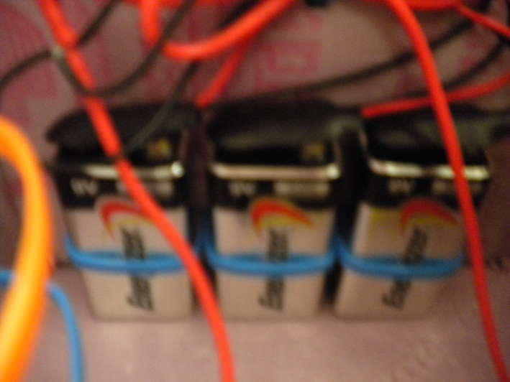
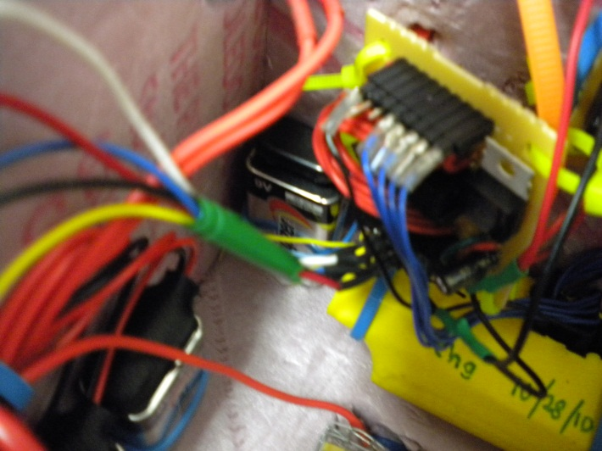
Batteries for the heating component and the Zigbee interface boards.

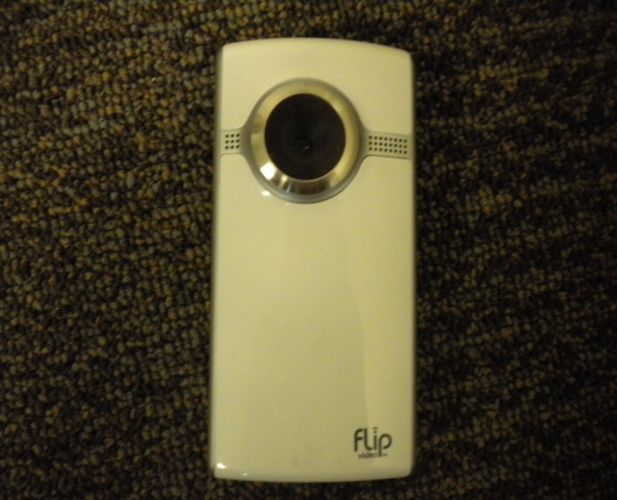
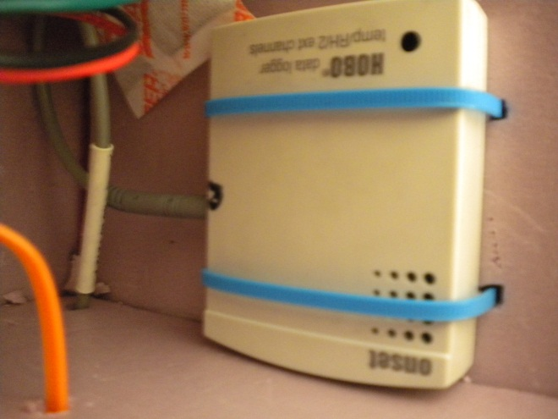

HOBO data logger used for storing in-flight temperature.
Flip Ultra video camera for recording video during flight.
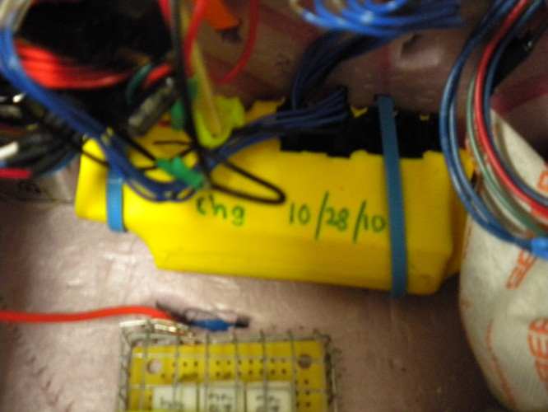
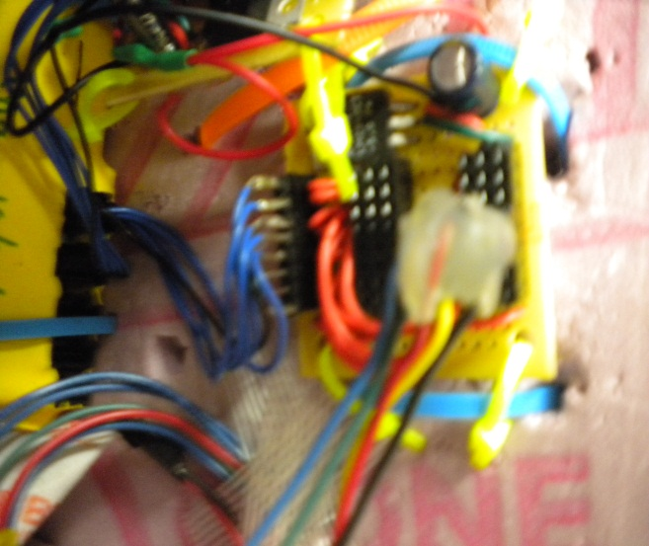
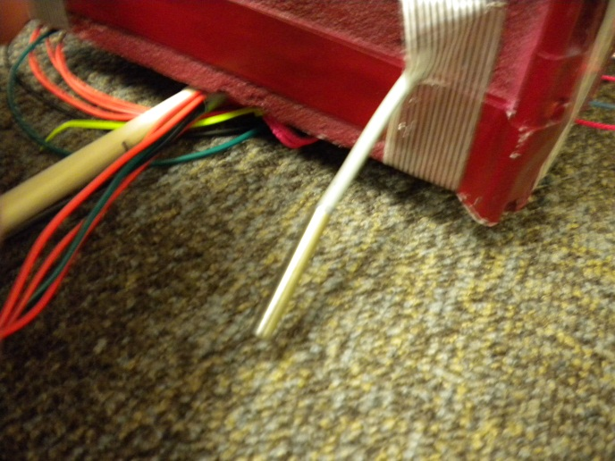
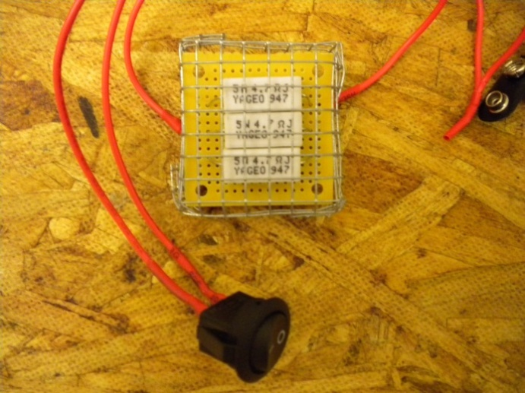
Heating component used to keep all components in the box from freezing.
Zigbee radio used to send in-flight data to theground.
Probe is used to measure temperature outside of the box.
Zigbee interface board that connects the battery and weather stations to the Zigbee.
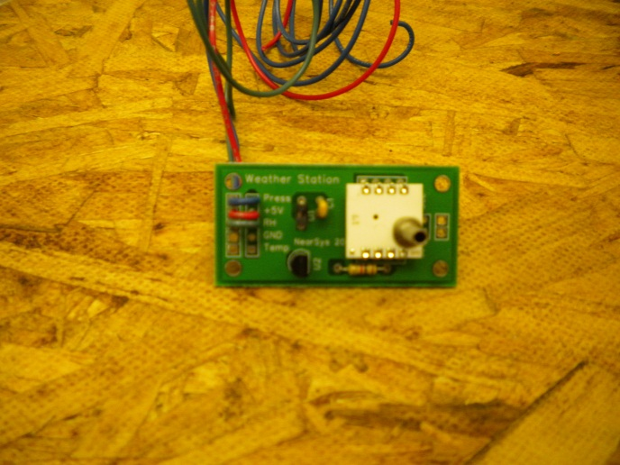
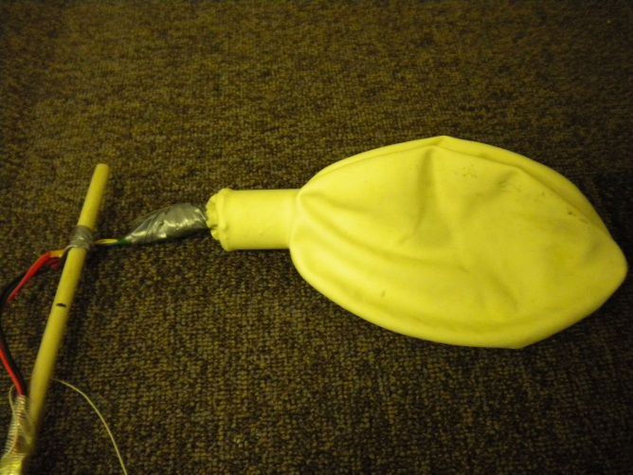
Weather station that is used to measure temperature, pressure, and relative humidity.
Small latex balloon used to prove the Ideal Gas Law.

Completed payload, ready for launch.

7.0 Test Plan and Results
There are many different parts that need to be tested to be sure that they will work during our flight. The first thing that we will test is the heater. This will be relatively easy to test because all we will have to do it hook it up to the batteries and make sure that the resistors begin to warm up. Next, we need test the in flight computer and weather station, which will be done in class with the help of one of the TAs. Our weather station will not completed in time for in class testing, so we will have to do this on our own. We can test it by hooking up the sensors and probes and trying to produce data. We will need to be able to measure temperature, pressure and relative humidity during the flight, which are all things that we should be able to measure on the ground if our systems are working correctly. After we collect this data, we can also try to vary it and see if our readings respond accordingly. For example, we could try to warm the temperature probe in our hands or put the pressure sensor in a bag that is over-inflated or has the air sucked out of it. After testing our systems, we must also test the payload box itself. According to Dr. Flaten, after we have figured out how everything will fit inside our box, we will remove everything, fill it with sand and throw it down a staircase to simulate how it will hold up to high winds and a rough landing. Once we have tested these main components, we will need to test our camera, HOBO, and Zigbee radio. The camera test will be simple, as we will only need to make sure that it turns on and that it will work with our planned experiments. Specifically, it will need to take video. If we can see the red light on the front of our camera and look at the screen on the back, we will know whether it is recording. After checking this, we will need to be sure that an inflated balloon will fit within the frame that we see on the screen. We will determine the length of our boom based on how far away the camera must be from the balloon. We will also need to be sure that our sky-blue-to-black color scale shows up in the camera and that each of the colors is distinguishable. Next, to test our HOBO, we can try taking mock data like what is described above with our weather station. To test our Zigbee radio, we could take data in one location and try to send it across campus. The final test will be to make sure we are prepared to turn everything on right before the launch. For this, we will have to test our heater switch and pull before launch pin. The tests here are self-explanatory. We will also want to be sure that it is easy to reach inside of our box to turn on our camera.

Need to Test
_____ Heater (including switch) _____ Camera
_____ In flight computer _____ HOBO
_____ Weather station _____ Zigbee radio
_____ Payload box _____ Pull before launch pin

Although the flight computer was not initially planned to be included in our payload, it is a good thing that we tested it because we ended up flying it on Gopher Launch 34D.

The simplest test that we performed on our payload was the test of its structural strength. For this test, we filled our box with 1 kg of sand and threw it down one flight of stairs. Seth helped us set up this test and observed. The result of this test was very encouraging: not even a dent. For the testing of our flight computer, Philip inspected various areas to make sure they looked right. He also tested different things, for example, making sure the light came on. Based on this in class testing of our flight computer, we found a few minor errors and had to go back to the lab to fix them. We also had our weather station tested by Philip, and it was determined that our weather station was fully functional. Our heater and HOBO were tested at the same time when Seth put our payload inside a cold chamber and checked to be sure that everything would continue to work despite the elements. Other things tested before going into the chamber were the heater switch and the pull before flight pin in our flight computer. The resulting HOBO data from this test proved not only that our HOBO would work, but also that our heater worked. A sample of some of this data is shown here in graphical form.

Based on this data we are very confident that both our heater and our HOBO work. Assuming that the box was dropped into the cold soak at approximately 1600 seconds and removed at approximately 2100 seconds, we see an accurate response in our HOBO data in the first graph. Our confidence in our heater comes from the second graph shown, which tells us that even as outside temperature fluctuates significantly, temperature inside the box stays relatively stable.

We tested our camera in the lab one day by attaching the boom to the bottom of our payload, holding the balloon in the position that it will be on launch day, and filming as the balloon was inflated until bursting. Kyle helped by pumping helium into the balloon. From watching this film, we saw that with the balloon five feet from our camera, its diameter will still be measureable even at its largest size. We learned from our camera test that there was one modification that we would want to make. This would be to tip the boom down slightly so that as our balloon grows during the flight, it grows into the camera screen rather than growing out of the screen. To illustrate the problem, the following picture shows what our camera saw when the diameter of the balloon was 33 inches (expected popping diameter is 36 inches).

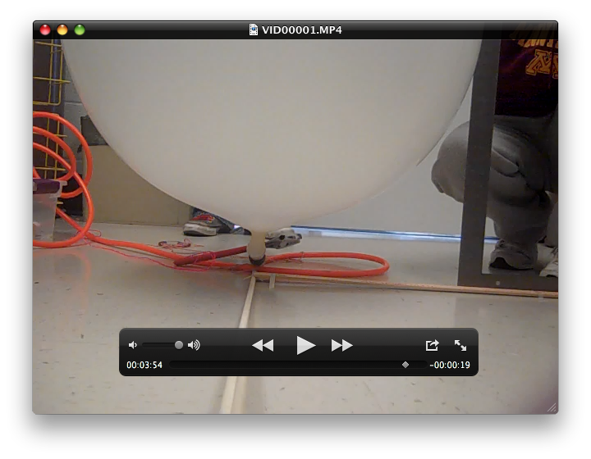The final part to test was our Zigbee radio, which was done in the lab by Dr. Flaten. After the box was assembled, we needed to do a “yank” test to check the rigging and to be sure that our boom would not fall off during the flight. With all of these tests completed, we feel that all of our systems are ready for flight. There are a few tests that we do not feel are necessary, like a radiation test for example. The main reason this is unnecessary is because Dr. Flaten has a lot of experience with ballooning and has never had any problems with radiation in the past.

During the actual flight, some problems arose that we hadn’t tested for. The most serious problem was that as soon as our payload got off of the ground, our balloon was tipped over by the wind. We had expected that our helium balloon would be lifted upward and therefore be in our camera screen, but instead, when the balloon tipped over, we could only see a tiny bit of it in our video from the flight. We could have tested for this by using a leaf blower on our payload to simulate wind.

Another problem that we had that couldn’t have been tested for was that our balloon didn’t pop due to a tiny hole in it. If we would have tested the balloon to make sure it would be able to pop, rather than leak, the test results wouldn’t have mattered because the balloon would have already been popped and we would have needed a different one.

8.0 Expected Science Results
Our payload like everyone else’s is fitted with sensors to measure the standard atmospheric conditions (temperature, pressure, and relative humidity) as the balloon and payload ascends into the upper reaches of the atmosphere. These measurements can be predicted with a fair amount of accuracy, knowing that a multitude of similar tests have been carried out before ours and have been well documented. If everything goes according to plan on flight day we expect our balloon to float upwards with an average velocity of about 12 feet per second (90000ft/7200s) reaching roughly 90000 feet before the balloon pops due to pressure difference in the balloon and plummets back to the ground. As stated the common environmental data can be easily predicted on a generalized basis.

Expected results for environmental data:
Temperature is an easy value to predict, we foresee a slow but steady drop in temperature as the balloon and payload rises higher and higher into the thinning atmosphere, and after the balloon pops a quick increase in temperature as the balloon gets closer to the earth. Pressure is also an easy value to predict because as we already know the higher one goes into the atmosphere the less oxygen and other gases there are. Therefore, pressure will decrease steadily with relation to altitude. The expected result is that at 1,000 feet above sea level we expect to see a pressure of .964 atmospheres (28.86 in. Hg) decreases down to .0167 atmospheres of pressure (.50 in Hg) at 90,000ft and thus returning to the original .964 atm when it lands. Finally, relative humidity is also expected to rise slowly until it reaches a peak and then drops back to its baseline when it comes back to the ground.

Altitude Pressure Temp.
(ft) (in. Hg) (F.)
0 29.92 59.0
1,000 28.86 55.4
2,000 27.82 51.9
3,000 26.82 48.3
4,000 25.84 44.7
5,000 24.89 41.2
6,000 23.98 37.6
7,000 23.09 34.0
8,000 22.22 30.5
9,000 21.38 26.9
10,000 20.57 23.3
11,000 19.79 19.8
12,000 19.02 16.2
13,000 18.29 12.6
14,000 17.57 9.1
15,000 16.88 5.5
16,000 16.21 1.9
17,000 15.56 -1.6
18,000 14.94 -5.2
19,000 14.33 -8.8
20,000 13.74 -12.3
25,000 11.10 -30.15
30,000 8.89 -47.98
35,000 7.04 -68.72
40,000 5.54 -69.70
45,000 4.35 -69.70
50,000 3.43 -69.70
55,000 2.69 -69.70
60,000 2.12 -69.70
65,000 1.67 -69.70
70,000 1.31 -69.70
75,000 1.03 -69.70
80,000 0.81 -69.70
85,000 0.64 -64.80
90,000 0.50 -56.57
95,000 0.40 -48.34
100,000 0.32 -40.11

[Source 1]

[Source 2]

Expected results from individual experiments:
One ofthe experiments we are choosing to do is the ideal gas law test (PV=NRT) with a separate balloon extended on a boom in the frame of a digital video camera to capture its expansion with the increase in altitude. The balloon will have a weather station placed inside it to measure the conditions inside while a sensor outside the box will record data about the conditions outside the balloon. We expect to see that with altitude the balloon will increase in volume as to stay constant with the pressure and temperature outside. Like the balloon that we will be using to carry our payload up, it will pop due to the forces inside the balloon pushing out and lack of force outside holding it together.

Our second chosen experiment is to determine the change in the shade of blue the sky is in respect to altitude. To do this test we have a color bar ranging from light blue to dark blue to black, and throughout the flight compare the sky to the color bar. We preformed this task by taking screenshots of our flight video while the balloon ascended. Every 3 to 5 minutes, we stopped the video when the balloon was facing away from the sun and in the middle range of colors shown on the screen. The result of this experiment is very predictable as we foresee the sky beginning at light blue and getting close to black and then moving back to light blue as it falls back to earth.

9.0 Launch and Recovery
On Saturday, October 30th, we launched our payload. We began in the morning, meeting at Akerman Hall around 6:30 AM. The day started on a low note, as we realized our team member Joe was not present for the second activity in a row and we began to understand that he has left us. We were even more disappointed to not have a hot breakfast in the van, which would have consisted of pancakes.

As we waited for the last class members to arrive, our boredom and sleep deprivation led to some unusual events. The highlights included throwing stones at other stones and Tad taking a nap in the dumpster. Luckily, Mark did his best to keep everyone’s spirit up with his enthusiastic whistling. Finally, when we had all of the equipment ready, we realized that our valuable team member Alex, was no longer present. He had gone to move his car to a less illegal parking space. Then, as Alex undoubtedly was walking back to Akerman Hall, Joey led us all on a wild chase around campus to look for him. The chase was only finished when we returned to Akerman and found Alex in the exact spot in which we should have been waiting for him.

With all of our team intact, the vans departed on their mission to the launch site of GopherLaunch 33. Although we were not in the van with the muffin lady (certainly a good thing to prevent irritation by other passengers), we were nonetheless treated to muffins as the vans trekked northwards. After many muffins, granola bars, and pretzels, the majority of the crew drifted into sweet dreams of ballooning. We even wondered if our driver, Joey was asleep. After much needed naps, we woke to the sight of a perfect field in the back of a high school. As demonstrated by Seth, the vans did not have bathrooms. Seth took advantage of this in his attempt to fertilize the grass.

Soon, it was onto business. Dr. Flaten had gotten to the site prior to us and had much of the vital equipment already in place. When finding our box, we noticed that there were a few dings and broken pieces but they were a quick fix and the mission resumed. After determining the order of the payload stack, we hooked the rigging together while the balloon was inflated. After inflation and turning all of the payload components on, the stack was ready to be released. The release went smoothly as there was very little wind, and soon we were back in the van following the balloon to its final destination.

Back in the van, it was hard to take another nap because of all the excitement with tracking the balloon. In Mille Lacs County, there was many a detour, and we figure to have gone in quite a few circles during our attempt to leave the launch site. The lucky few who had brought a lunch, were quickly gobbling them down, while the other passengers scrapped for the other granola bars and pretzels.

As the time in Mille Lacs County dragged on, the nerves and excitement turned to anger towards our van drivers because they were refusing to tell us where we were, where we were headed, and most importantly, details on the status of our balloon. We will always have to assume that they simply just didn’t know these answers. As the frustration heightened, some of the passengers began to turn on the others. A staple of the classic American family road trip, there were numerous cries of “Are we there yet?” floating around the van.

The best strategies for passing of the time turned out to be playing Tic-Tac-Toe as well as pranking the other passengers. Alex tried to read a book, which was a good idea in theory, but turned out to be quite difficult in practice with all of the mischief afoot. Seeming to be a light at the end of our tunnel, we soon emerged at the edge of the detours which we had imagined to be a dark scary forest, where we were a balloon stack that was stuck in the branches. After escaping the clutches of the Mille Lacs County Transportion Department, the drive was much more peaceful.

Soon, we found ourselves driving through scenic farmland, which was better to look at than construction equipment. We thought that we were now on the homestretch and the journey would be great, until hours later, when we were still driving, and then the disaster struck. When we lost the signal from our payload stack, our mission was in serious danger. The drivers tried to trick us into a false sense of security, but we were very worried. The drive continued, hoping that we would soon rediscover the tracking signal for our balloon. To make matters worse, we also lost power in one of our computers.

At that point, with the spirits at rock bottom, we stopped near Barron, WI to get lunch. Barron, WI had been our targeted landing site, but the balloon was actually not anywhere near us. It had been rediscovered with the tracking system, and was still about an hour worth of driving time away. To rejuvenate the crew, we decided to get lunch at Subway and McDonald’s. Now, there was word from the front lines that Philip was in hot pursuit of the target. We decided to continue to the destination at top speed.

In a matter of minutes, however, we were again stopped, and debating the possibility of turning around early, as Philip had already found the payloads and retrieved them from a small tree. We all got out of the van and waited for Dr. Flaten to break the news. The news was bittersweet, and much more bitten than sweet. At this point of the day, we were all exhausted, but so close that we could sense the bacteria on Team Hindenburg’s payload. We had been excited to find the balloon and finish the chase, but we had to face the reality that we would not be able to encounter the balloon in its natural habitat. After a final team picture to commemorate the day, we got back in the vans, and turned around.

In a few hours, we were back in the Twin Cities. We brought with us empty boxes of granola bars, empty bags of pretzels, empty water bottles and empty hands as we were not accompanied by our payload.

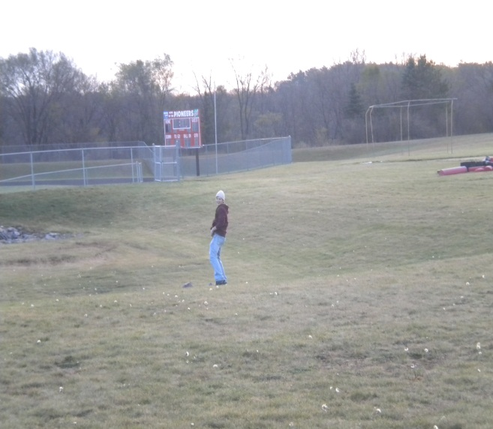
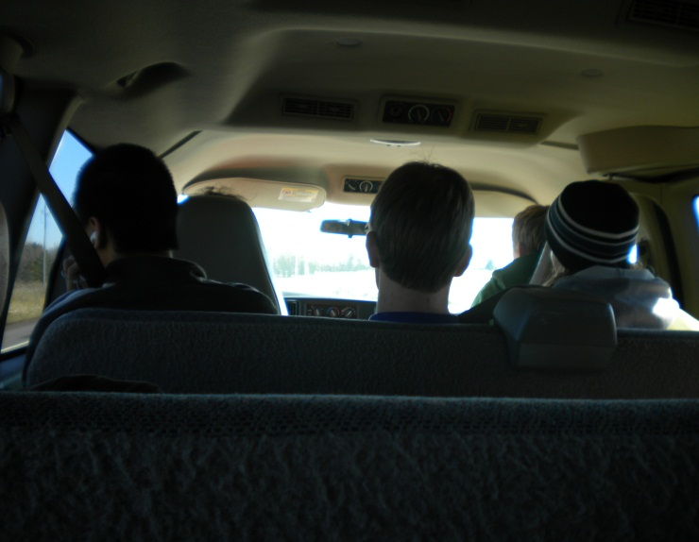

Driving out to the launch site Did Seth have too much to drink?

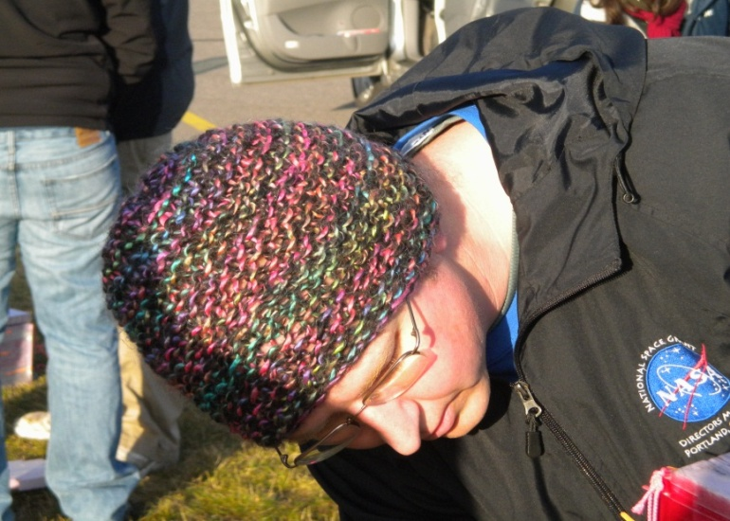
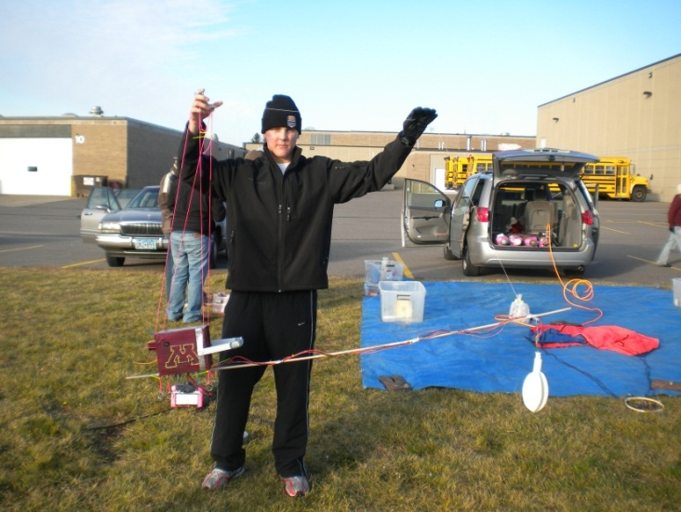

Tad showing off our payload. Dr. Flaten inspecting our payload.

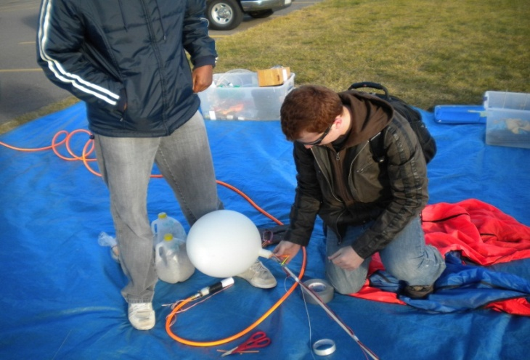
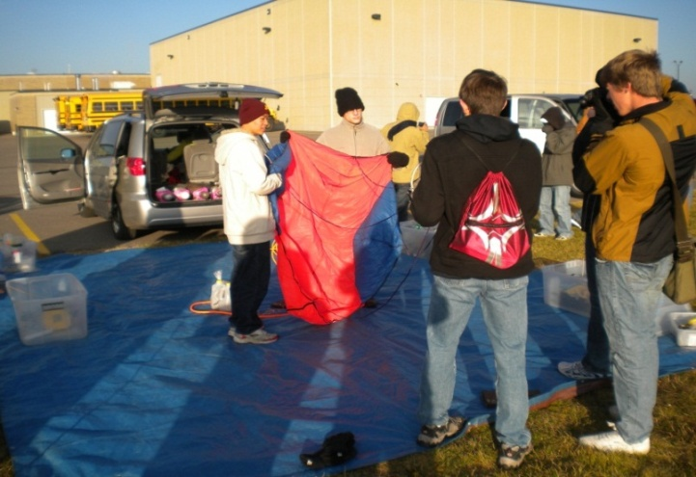

Team Hindenburg helping prepare the Casey and Alex working on our
parachute. balloon.

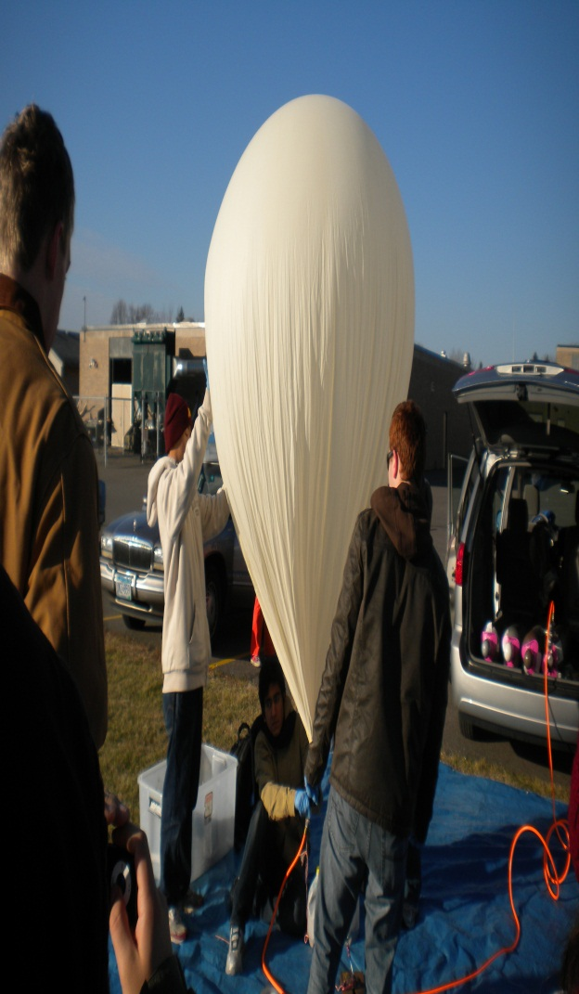
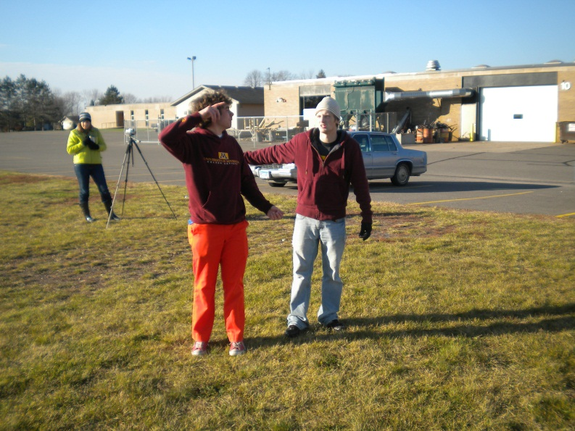

TAs discussing the plan for the launch. All of the teams working together.

10.0 Results and Analysis
Our payload was flown in two separate launches: Gopher Launch 33 and Gopher Launch 34D. In the following section, we will use data from both flights.

Path, Time and Altitude:

This data comes from Gopher Launch 33. It is more appropriate for us to use this data because we were actually able to participate in the launch and chase of this flight.Gopher Launch 33 began in Pierz, MN and was predicted to land in Barron, WI. However, the landed actually occurred near Lake Holcombe, WI, which is about a one hour drive past Barron, WI. The path of the flight is shown here:

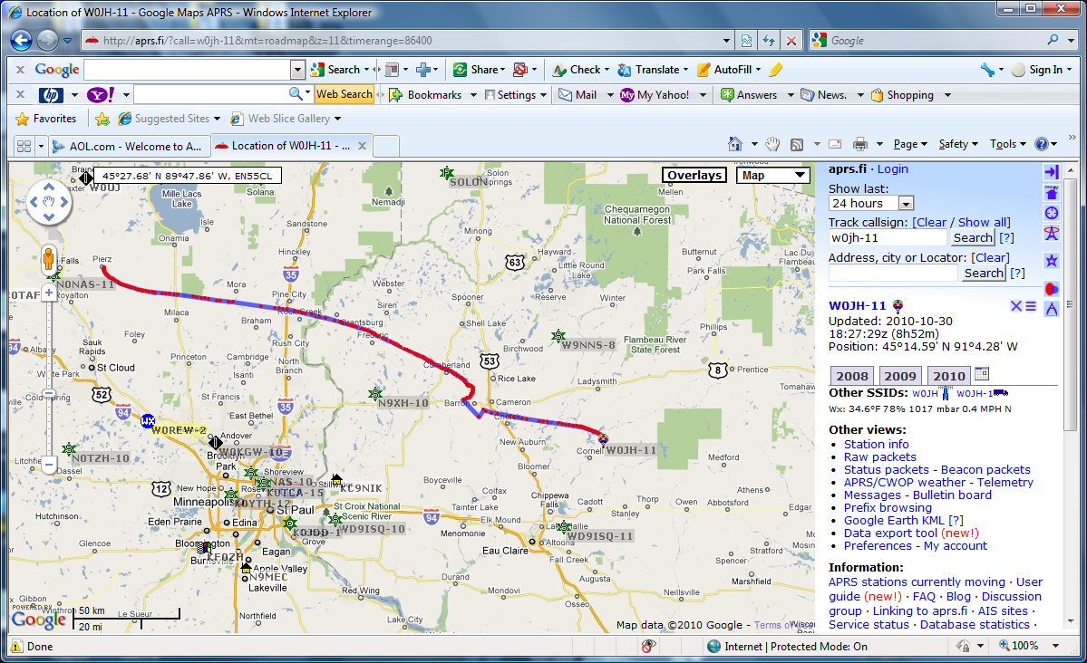

To find the altitude of the flight at any given time, we were provided with three equations by Dr. Flaten. Each of these equations corresponded with a specific part of the flight. By applying these equations to the total flight time, we were able to find the altitude at all points in the flight. A graph of altitude vs. time is shown below:

This graph tells us many things about the flight. If we could see more specific numbers, it would tell us that the total flight time was 145.5 minutes. We know that before the balloon pops, the altitude is increasing, and after it pops, the altitude will decrease rapidly. Looking at our graph, we know that the balloon must have popped at 112 minutes and at an altitude of just over 90,000 feet.

Temperature, Pressure and Relative Humidity:

In Gopher Launch 33, our data did not all get transmitted by the Zigbee radio, so for this analysis, we have no choice but to use data from Gopher Launch 34D. As we began our analysis, we noticed a problem with the raw data that had come from our Zigbee radio: it was off-scale due to the radio only being able to transmit from 0 to 3.5 volts. One example of the effects of this is that in the beginning of our flight, all of our raw pressure values were‘1023,’ as shown below.

Our Zigbee radio worked, and we were able to get data from our external weather station, but because we are not sure of its accuracy, we will use the weather station data from Team Hindenburg, gathered with a BSE. We will consider this our external weather station. Our weather station that was inside the balloon was also gathering data with a BSE and will work fine.

Our temperature data shows many of the features that we expected but also one very unusual characteristic. As expected, the temperature dropped as altitude increased, up to an altitude of about 50,000 feet, reaching a minimum temperature of approximately -50°F. Then, the payload passed into the Stratosphere and temperature began to increase with altitude until popping around 75,000 feet when the temperature was approximately -25°F. Looking at the Temperature vs. Time graph, we see that burst must have occurred around 72 minutes into the flight, which is confirmed by our video. It is this last fact that makes the one unusual part so puzzling. The data from these graphs suggest that the temperature remained constant for nearly the first 10,000 feet of the ascent, which is not expected at all. However, there is evidence to support this claim. First, we calibrated the time for the data by making t=0 (launch time) the point where the pressure value first dropped. After this point, the temperature remained fixed for almost another 10 minutes (10,000 feet). Other support for this claim is that Team Hindenburg’s BSE data showed the same trend; temperature remaining constant long after the pressure began to drop. Also, the results of our Ideal Gas Law experiment were much like we had expected, even though they were dependent on the temperature. Finally, after the time had been adjusted, our Time vs. Temperature graph said that the burst should have been just over 70 minutes into the launch, a prediction that was confirmed by our video from the flight.

With all this evidence, it is hard to assume that this is a mistake, but it is even harder to understand why the temperature would have remained constant until an altitude of 10,000 feet. We are unable to think of any solid explanation for this, and it may have to be left as an open question.

This relative humidity data was not as important in our experiments, but it nonetheless tells us things about the flight. For example, where we see spikes in relative humidity, for example near 30,000 feet, we could expect that there was a cloud layer we were passing through. We can check this by looking at our video. Our payload reached 30,000 feet between 20-25 minutes after launch. As expected, the screen shot below from 20 minutes into the fight shows clouds just overhead:
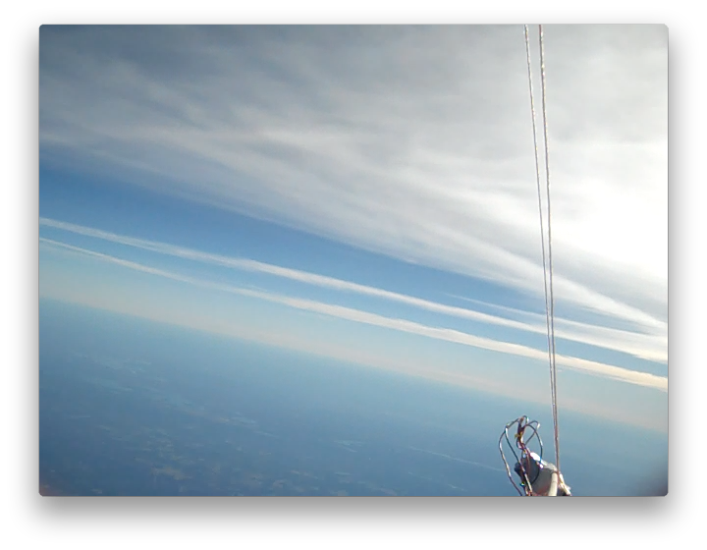
The most interesting data that our group collected was pressure data, due to the fact that we had both an internal (inside balloon) and external (regular) weather station.

The above graph shows both the internal and external weather stations’ pressure readings. We can see that the pressure was greater inside the balloon than outside, which makes sense because the rubber of the balloon is trying to “unstretch” itself and is applying more pressure on the air inside. We see that for around 72 minutes – the time that the altitude is increasing – both the internal and external pressures decrease approximately equally, but the internal pressure is always slightly higher. Then, at burst, the internal pressure immediately becomes identical to the external pressure. This is because when the large balloon burst, our smaller balloon also burst and the “internal” weather station became exposed to the same conditions as the external. For the remainder of the flight after burst, the internal and external pressures decrease as altitude decreases and virtually no difference between them is detected.

Ideal Gas Law Experiment:

For this experiment, we had filled a balloon with helium and put it on the end of a boom so that our camera would film it. From this, we would know the volume of the gas in the balloon, and from the weather station inside, we would know the temperature and pressure. Then, we could test the Ideal Gas Law; PV = nRT. In Gopher Launch 33, our weather station data didn’t transmit, so we will use data from Gopher Launch 34D for this experiment. Unfortunately, our balloon tipped over, and we were unable to film it for the majority of the flight. Luckily for us, Team Hindenburg has video that shows our balloon. In order to use their video however, we will first have to figure out how to get the volume of our balloon with it.

Our intention was to relate the size of the balloon in our during-flight video to film that we had taken in the lab. What we had to do instead was find the initial size of the balloon using our in-lab and Galactic Gopher during-flight video. Once we knew the initial size, we looked at the initial balloon size in the Team Hindenburg video and established a relationship between the balloon’s diameter in the Team Hindenburg video and the balloon’s actual diameter that allowed us to calculate actual diameter based on what we saw in the Team Hindenburg video. Then, we found the diameter at many different times. From this we calculated the volume, and we already had the temperature and pressure from the weather station data. Since R is a known constant, and we assume n to be constant, we can verify the Ideal Gas Law if (PV)/T is constant.

In this graph, we see that (PV)/T is nearly constant, ranging between 0.05 and 0.06 (atm*L)/K. This value and unit mean virtually nothing to us, but because the trendline is approximately flat, we can conclude that the Ideal Gas Law held true.

Darkness of Sky Experiment:

This experiment will be performed using data from Gopher Launch 33, because our payload reached a higher altitude in this launch. To perform the analysis, we first needed to acquire data on the altitude of our payload at any particular time during the flight. This information was provided by Dr. Flaten in the form of equations that converted time since launch into a value for altitude. We were able to use this data as a link between the altitude and the video on our video camera. At any time in our video, we could know what the altitude was by finding the time elapsed in the video since the launch. When we knew how much time had passed, we could look in the spreadsheet to see what altitude the payloads were at after that amount of time.

After making this connection, the next step was to look at different slides of our video and compare the color of the sky in the center of the shot to the colors showing on the color strip. Here is an example of what the video slides looked like.

In this picture, we first see that the time displaying is almost 80 minutes. Our tape ran for nearly ten minutes before the launch, so this picture corresponds to 70 minutes. (The altitude at 70 minutes was 59,145 ft.)

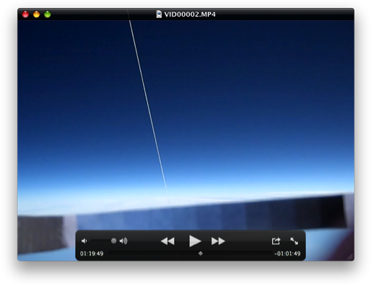The color scale in the picturehas been labeled for easier reference. We can see that the color of the sky is approximately 75% black, so in the spreadsheet next to 70 minutes (and 59,145 feet) we would record 75%.
0 10 20 30 40 50 60 70 80 90 100

We did this at somewhat standard intervals, but because we avoided using parts of the video where the lighting of the sun was inconsistent, the intervals are not all the same. However, we have a large number of data points that are fairly equally spread throughout the flight.Since this data comes from humans making an estimation of the sky color, not all of our points will be entirely accurate, but we think we have taken enough samples that the effects of this random error will be minimal. Here is our data presented in two different formats:

Altitude (feet) | Sky % black |  | Altitude (feet) | Sky % black |  | Altitude (feet) | Sky % black
1223 | 10% |  | 29680 | 40% |  | 59901 | 75%
2300 | 10% |  | 34103 | 50% |  | 65798 | 80%
6608 | 15% |  | 37788 | 50% |  | 67272 | 80%
11992 | 15% |  | 43317 | 55% |  | 73169 | 85%
17646 | 20% |  | 46634 | 60% |  | 74643 | 90%
19531 | 25% |  | 49582 | 70% |  | 78329 | 95%
24521 | 30% |  | 52530 | 70% |  | 85700 | 100%
26732 | 35% |  | 56216 | 75% |  | 89385 | 100%

As we had expected, the rate of change in the darkness of the sky is mostly constant which is why we have a linear trendline in our graph of Darkness vs. Altitude. The slope of that trendline is .0000112. This tells us that for every increase of one foot in altitude, the sky becomes .00112% darker. More meaningfully, for every increase in altitude of 1000 feet, the sky becomes 1.12% darker, on average. In our data, we noticed that by the time the payload had reached about 80,000 feet, the sky was 100% dark. After that point, the sky obviously cannot become any darker.

Error:

In both our Ideal Gas Law and our Darkness of Sky experiments, we are bound to have some error because part of our data comes from methods that aren’t perfect. In the Ideal Gas Law experiment, we had to measure the diameter of a balloon as it appeared on the computer screen. Due to the small scale, we couldn’t be very precise with this measurement. In the Darkness of Sky experiment, we had to estimate the darkness percentage of the sky, which we were unable to know exactly. Each of these things cause some error in our results, but we can assume it is mostly random error and therefore, at least our trendlines should be fairly accurate.

11.0 Conclusions and Lessons Learned
On the first flight, GL33, one of the main problems with the experiment were that the balloon had a small leak. This meant that as the payload gained altitude, the volume of gas contained within the balloon did not increase, gas escaped through the leak. This was one of the factors that contributed to there being no usable data from which to accurately examine the ideal gas law. In retrospect, the balloon should have been checked for leaks prior to the flight. Another contributing factor to the failure of GL33 in regards to team Galactic Gopher was that both the balloon and boom swayed and tipped during the flight, resulting in no usable video footage of the balloon being recorded. A way to avoid this would have been to test the ability of the boom to withstand high velocity winds as well as the balloon’s ability to stay in place during these conditions. Our testing of other key components of the payload such as the HOBO data logger, the weather station, and the payload box itself were key in the successful execution of the second experiment; the rate of change in sky darkness with regards to altitude, as well as the collection of conditions data i.e. temperature and relative humidity.
On the second flight, GL34D, the problem of the boom and balloon tipping and swaying out of view of Galactic Gopher’s payload box camera’s view occurred once again. On the second flight however, team Hindenburg had been taking video footage of the main balloon as well as team Galactic Gopher’s ideal gas law experiment. Team Hindenburg’s video footage was invaluable and extremely helpful in analyzing the ideal gas law experiment. From this flight, we learned that multiple recordings and angles of the experiment can prove invaluable if this experiment is done again. In case one camera fails, for whatever reason, there are others to be relied upon. If all cameras take video footage, then the multiple views can be used for results check and confirmation. Another extremely important lesson learned from this flight is the importance of cooperation between groups, had Hindenburg not taken footage of our experiment, GL34D would have produced no reliable data on the part of the ideal gas law experiment.

Words of Wisdom

- Intra-group communication is important and crucial to the success of the mission.
- Test every aspect of your payload box, from strings to the flight computer. No matter how insignificant a test may seem, it may prove vital to your experiment and mission.
- Doing assignments and turning them in on time is key to success in AEM 1905, and indeed any other class.

12.0 Citations and Acknowledgements

[1] Williams, Jack. USA Today. N.p., 5 May 2005. Web. 5 Nov. 2010. http://www.usatoday.com/weather/wstdatmo.htm
[2] Brooks, Cassidy, and Isabel Huff. "standard atmosphere tables." physics UMT. UMT, 2 Feb. 2006. Web. 7 Dec. 2010. <http://www.physics.umt.edu/borealis/RH%20Lab%20Report_06.pdf>
[3] http://aem.umn.edu/courses/aem1905/fall2010/PayloadCostMassSizeListing2010.xls

Many questions that we had were answered by Dr. Flaten
We received help in the lab from Cait, Joey, Kyle, Philip and Seth
We used video and weather station data taken by Team Hindenburg in Gopher Launch 34D to help with our analysis.

13.0 Appendix: Program Listing
In GL 34D, we flew our flight computer due to the problems we experienced with the Zigbee radio in GL 33. Below is the program that our computer ran. This program records the temperature, pressure and relative humidity data that is taken by our weather station. It holds this data as a value of voltage. This program takes the data every 15 seconds.

symbol record=w0 'This is the section where the variables
are declared
symbol index=w1
symbol value=b4

BalloonSat:
symbol Max_ADC = 2 ' maximum adc channel usedstarting with 0
symbol Mission_Delay = 15000 ' length of pause in mission loop 15 seconds

Mission_Prep:
i2cslave %10100000,i2cfast,i2cword ' set memory speed to 400 kHz
if pin7 = 1 then Download_Data ‘and one word records

flashed: 'this section is the section that waits
high 3 'for commit pin to be pulled
pause 1000 'the flahser is also in this section
low 3 ' it flashes at a specific rate
pause 1000
if pin7=0 then flashed

Mission: ' will change pattern of flashing when data
is being taken
gosub Analog ' collect analog voltages
write 0,record ' store the number of records collected
gosub On_Flash ‘ pause.....
goto Mission ' ....before starting all over

Analog:
for index = 0 to Max_ADC ' loop for number of analog voltages to
record
readadc index,value ' get next adc value
gosub Record_Data ' go store the value
next ' until last voltage is recorded
return ' return to main mission loop

Record_Data:
if record = 3000 then End_Mission ' check that aren't writing too many records
to memory
record = record + 1 ' increment record number
low 0 ' unwrite protect memory
writei2c record,(value) ' write the next record to memory
pause 10 ' wait 10 ms for write
high 0 ' write protect memory
return ' return to the calling calling subroutine

On_Flash:
high 3
pause 1000 'flash twice than a long pause
low 3
pause 500
high 3
pause 1000
low 3
pause 12500
return

Download_Data:
sertxd ( cr,lf)
sertxd (cr,lf)
sertxd ("Welcome to Balloonsat Easy Data Download Routine ",cr,lf)
sertxd ("Data Download will be in 3 seperate interface sections",Cr,lf)
sertxd ("After the data section is completed copy input buffer to a text file",Cr,lf)
sertxd ("Then clear input buffer and replace the commit pin when read back resumes remove
commit pin ",Cr,lf)
Sertxd (" Clear the input buffer and replace the commit pin")

gosub flasher

sertxd ("Data section 1 of 3",Cr,lf)

for record = 1 to 1000

readi2c record,(value) ' read the recorded record
sertxd (#value,",") ' serial out the data record
record = record + 1
readi2c record,(value) ' read the recorded record
sertxd (#value,",") ' serial out the data record
record = record +1

readi2c record,(value) ' read the recorded record
sertxd (#value,Cr,lf) ' serial out the data record
next
sertxd ("Data section 1 of 3 Complete",Cr,lf)
gosub flasher

sertxd (Cr,lf)
sertxd ("Data section 2 of 3 ",Cr,lf)

for record = 1000 to 2000

readi2c record,(value) ' read the recorded record
sertxd (#value,",") ' serial out the data record
record = record + 1

readi2c record,(value) ' read the recorded record
sertxd (#value,",") ' serial out the data record
record = record +1

readi2c record,(value) ' read the recorded record
sertxd (#value,Cr,lf) ' serial out the data record

next
sertxd ("Data section 2 of 3 Complete",Cr,lf)
gosub flasher ' waits to replace the commit pin
' than remove commit pin
sertxd (Cr,lf)
sertxd ("Data section 3 of 3 ",Cr,lf)

for record = 1999 to 3000

readi2c record,(value) ' read the recorded record
sertxd (#value,",") ' serial out the data record
record = record + 1

readi2c record,(value) ' read the recorded record
sertxd (#value,",") ' serial out the data record
record = record +1

readi2c record,(value) ' read the recorded record
sertxd (#value,Cr,lf) ' serial out the data record

next
sertxd ("Data section 3 of 3 Complete",Cr,lf)
gosub flasher

sertxd (Cr,lf)
sertxd ("Data Download Complete",Cr,lf) ' until last data record read out
gosub LT_down

LT_down:
high 3 'flash 3 times than pause
Pause 1000 'signifies completed
low 3 ' download data
pause 500
high 3
pause 1000
low 3
pause 500
high 3
pause 1000
low 3
pause 10000
Goto LT_down

flasher:
pause 1000
if pin7=1 then flasher 'waits the for commit pin
return

End_Mission: 'this is if data was recorded during the whole flight
low 3 ' this shows that the memory is full
pause 10000 ' and that the flight computer functioned properly for the flight
high 3
pause 1000
goto End_Mission

'this program has a problem
' it writes the record location to internal memory not to the
' 16 bit 1 word memory chip on the balloonsat easy 2.0 flight computer board
'there forethe data should exist for any

end ' end of mission

